Detailed Scheduled
Topics:- | Set Operation: UNION, UNION ALL, INTERSECTION, MINUS clause

Use the following tables and solve below given queries.
Worker (Id, Name, Wages_Per_Hr)
Job (Job_Id, Job_Type)
Assigned (W_Id, J_Id, Start_Date, Status, Total_Hrs)

1. Display all the workers’ Id assigned for Job 1 and 2 both (J_Id =1 and J_Id=2)
2. List the workers who are working for J_Id =1 and not for J_Id = 2
3. Display the workers Id who are working for more than 6 hours and status is pending. And Union them all with the worker’s Id who are working for less than 6 hours and status is completed

Use following tables to solve below given queries.
FYRankers (Enrol_No, Name, SPI)
SYRankers (Enrol_No, Name, SPI)
- Display the name of the student who is ranker in ‘FY’ or ‘SY’
- SELECT NAME FROM FYRANKERS UNION SELECT NAME FROM SYRANKERS;
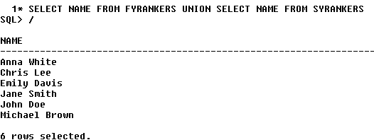
- Display the name of the student who is ranker in ‘FY’ or ‘SY’ including duplicate data
- SELECT NAME FROM FYRANKERS UNION ALL SELECT NAME FROM SYRANKERS;
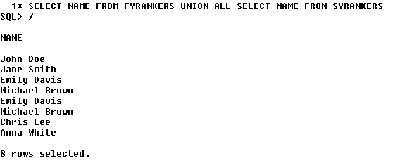
- Display the name of the students who is ranker in ‘FY’ or ‘SY’ and having SPI more than 7
- SELECT NAME FROM FYRANKERS UNION SELECT NAME FROM SYRANKERS WHERE SPI>7
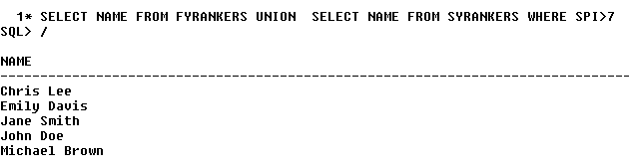
4. Display the name of the student who is ranker in both FY and SY
5. Display the name of the student who is ranker in FY but not in SY
6. Display the name of the student who is ranker in SY but not in FY

Use the following tables and solve below given queries.
customer (cust_id, name, city, country)
supplier (supp_id, name, city, country, cust_id)
- Display distinct city of both the customer and supplier table in sorted order.
- select distinct(city) from customer1 union select distinct(city) from supplier order by city;
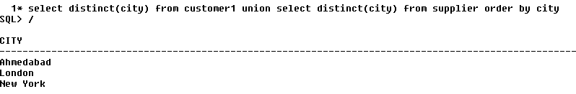
- Display city of both the tables with duplicate data.
- select distinct(city) from customer1 union ALL select distinct(city) from supplier;
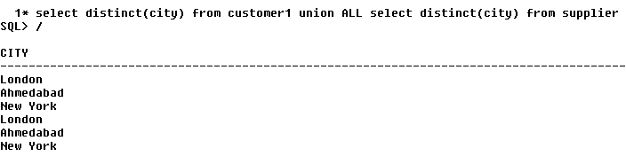
3. Display the details of Ahmedabad city of both customer and supplier table.
4. Display the name of students who have enrolled for ‘html’ course.
5. Display customer details who are living in ‘ahmedabad’ and name start with ‘A’.
6. Find the details of the supplier who are not customer.

