* Login - done
* Logout- done
* Press never on Password Popup - Done
* Find Table – Done
* Click on Home button-Done
* Input keep waiting in run mode – issue – Fixed
* Get Value available -done
* Check in every 5 min if not available
* In case
* Start bet only when 5 result are done
* Identify Bet period
* Take result.- done
* Save result in our Excel.-done
* Close Excel – getting error – Done
* Skip value already covered
* In Excel
  + Exit point
    - Exit on 40th Hand without Tie (include first 5) , if $$$ >= 0
    - If 40th hand is -Ve then as soon as it reaches to 0 or >0 wait and exit
    - STOP LOSS-As soon as reach to -30 or <=-30 then exit
  + If banker is winning with 6 value than put 0.5 in H column or put 1 in H
  + Formula need change to multiple by H value with INT conversion fields
* Bet Amount to be verified
* Total amount to be verified
* When banker win with 6 value than only 50% of bet money will be received
* IF 120 times of base is greater than money added in app then don’t bet, Mail
* Random select 0 to 5 and wait for this period before putting bet
* Before starting next timer if previous result not shown then refresh
* If within minute if no new result added in 1 min refresh, if no newresult added refresh in 1.5 mins and 2 min if still not new result than logout



How to avoid chrome is controlled message

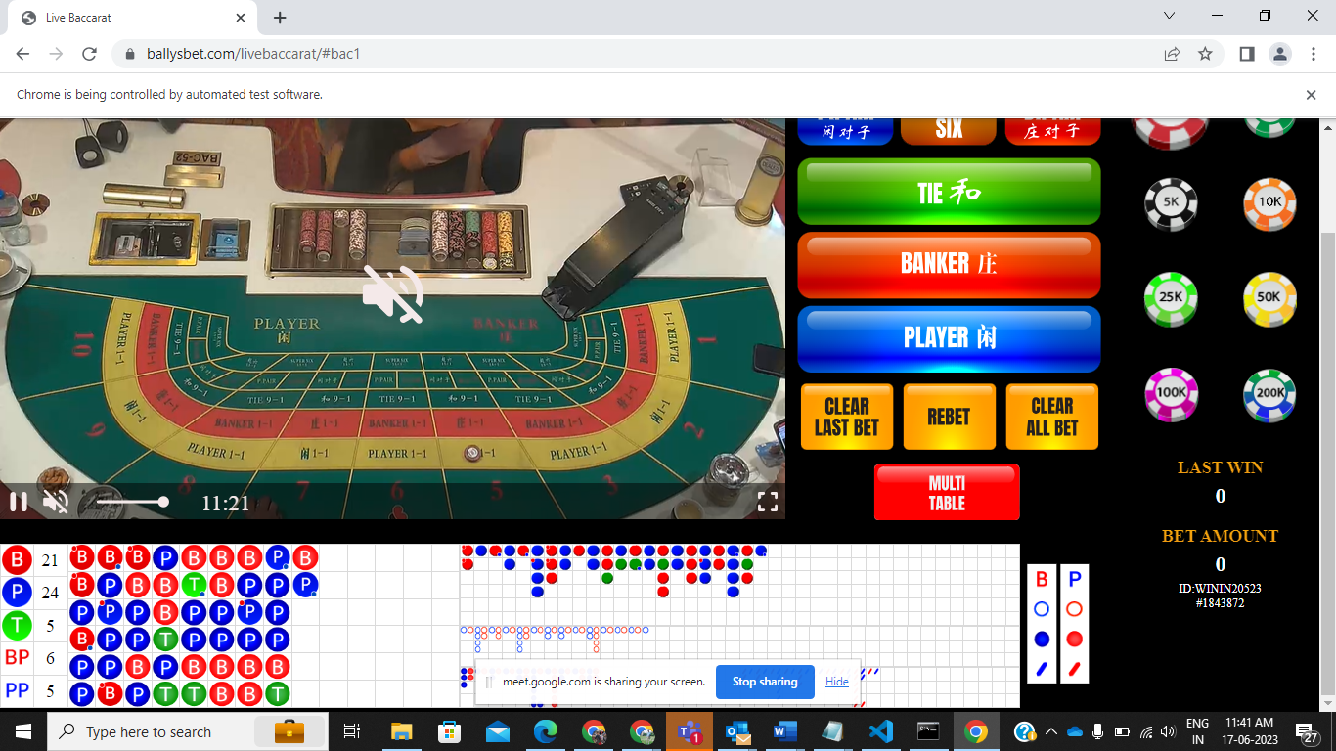



* Take starting unit as input from user and select table accordingly support use will give 5000 than program can select any of 1000 to 5000
* Program also calculate value and check with amount shown and send mail if there is discreapancy
* Create one dashboard for showing bet, amount, value, result
* If there is Capcha manual overright
* Take bet from I column of BaccaratWinPro_Dashboard-OnePlayerV4.0 – WB and put result in BaccaratWinPro_Dashboard-OnePlayerV4.0 – WB
* If $$$ of BaccaratWinPro_Dashboard-OnePlayerV4.0 – WB.xlsx >= 10 or <=-10 come out from shoe consider target ot stop loss met, clear result in BaccaratWinPro_Dashboard-OnePlayerV4.0 – WB.xlsx
* Save all result shoe and date wise
* 5. Screen recording when shoftware start
* 6. Internet connection
* 7. Mobile-OTP

USER DASHBOARD

* Select Unit from this interface this will be drop down with given values
* Set Session Target example +100 and stop-Loss in units and logoff after this target and mail
* Number of shoe played with Results
* Present Unit count (Profit or Loss)
* Present account current balance
* Present shoe main road

Build Mobile App Games, Revenue model is adds

https://www.youtube.com/watch?v=bJwM6W-GyIU

Studio Binder

Priority

1. Dashboard – Django and DB
2. Table select – 4 or less
3. Unit Basis Table select
4. Exit Plan
5. Session – IF -120 UNIT OR +360 ACROSS THE SHO
6. Should be shown on dash board that place and verfied

**FINAL EXIT CRITERIA**

**SESSION EXIT**

1. Session closes at either -100 or +200 units
2. If the Available amount is <= 100* Unit selected

Shoe

1. #Exit on 40th Hand without Tie (include first 5) , if $$$ >= 0
2. #STOP LOSS-As soon as reach to -10 or <=-10 then exit
3. #If 40th hand is -Ve then as soon as it reaches to 0 or >0 wait and exit
4. If it reaches +10 at any point in time, if reaches last highest -3
5. IF 120 times of base is greater than money added in app then don’t bet, Mail
6. #Exit of all bets of Shoe complete

driver.find_elements(By.XPATH,"//*[name()='g' and @id='beadPlate']//*[name()='use' and @id='beadPlate_5']")