Below are changes needed

1. Once it’s searches all the 3 tables, it must go back to home at sleep for 60 seconds ( note : it must go to home and wait, and not wait in last C table ) and again continue table search loop after sleep - done

2. Lobby code changes as u said - Done

3. If inactive pop up comes any times then click that place and continue the process

4. If session expired pop up comes, then click close the browser and start the new it again and continue the game. (note to find this session expired, u have to keep it open and u can do any ur other works for 30 mis, in between u have to click the screen for screen inactive 3 times, after that this session expired will come)

5. Verify bet is not working, let’s connect when ur starting will explain the issue - NR

6. After closing loop, again it started new session by its own- Done

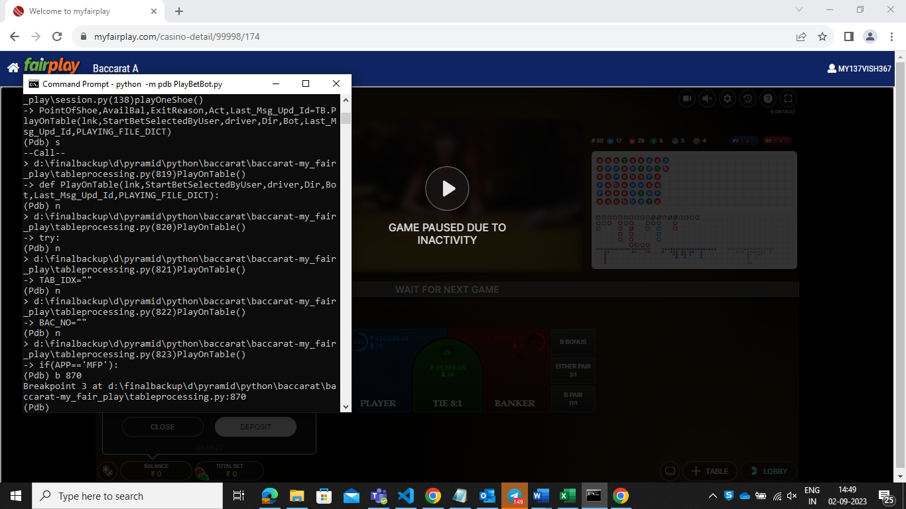

7. Waiting for Start the shoe HandCnt:68

Step -5 After HandCount-in Loop

Waiting for Start the shoe HandCnt:68

Step -5 After HandCount-in Loop

Waiting for Start the shoe HandCnt:68

Step -5 After HandCount-in Loop

Waiting for Start the shoe HandCnt:68

Step -5 After HandCount-in Loop

Waiting for Start the shoe HandCnt:68

Step -5 After HandCount-in Loop

Waiting for Start the shoe HandCnt:68

Step -5 After HandCount-in Loop

Waiting for Start the shoe HandCnt:68

Step -5 After HandCount-in Loop

Waiting for Start the shoe HandCnt:68

Step -5 After HandCount-in Loop

Waiting for Start the shoe HandCnt:68

Step -5 After HandCount-in Loop

Waiting for Start the shoe HandCnt:68

Step -5 After HandCount-in Loop

Waiting for Start the shoe HandCnt:68

Step -5 After HandCount-in Loop

Waiting for Start the shoe HandCnt:68

Can't Play On :Baccarat B Due to Exception-Moving Next

:ndgvs3tqhfuaadyg::baccarat:

Coin:500 Exists in Table ndgvs3tqhfuaadyg::baccarat

Inside If

Step -1.1 After No Error in setFrame://*[@class="img-fluid" and @src="https://cdn.hub88.io/evolution/evo_livebaccaratc.jpg"]

Step-2.1 No error going into Tab

Step-3 After going into Tab

After clickSwitchView

Step -4 After HandCount

Can't Play On :Baccarat C HandCnt:10

Before PlayOnTable

//*[@id='60i0lcfx5wkkv3sy::baccarat']

Before Wait for old data remove

It selected table B

Waited for next shoe

After new shoe starts, it says exception and goes out for next table

And later again check before wait for old data remove of before selected table -- Done

7A: Excel sheet not opening in baccarat C table only

A & B it’s working

8.

Baccarat C table, excel sheet not opening

* Exception issue above sent u the terminal message - Done
* Verify bet not working on 500 rs coin, it says element not found -- Since Select coin is only used once before playin game so putting more wait
* Inactive issue, which must be only there before the bet starts -- Added first time or in case of exception in placing bet
* Sleep 60 seconds in home between each cycle of tables search is not working. - Done