* Rule of 72
  + If getting 12% return than in 72/12 = 6 Years money will be double
  + It should be minimum 6 years

Fundamental Analysis

* Value Investing->
  + Should buy less than Intrinsic Value
  + PE – Price to Erarning=Price/Earning – Lesser is better ; LESS THAN IS GOOD
    - It will be -ve if earling is -ve
  + PB-Price/Book- Lesser is better; 1 or 2 is good
  + Debt to Equity🡪Debt/Equity Should be less, check repaying capacity
  + Current Ratio🡪 Current Asset/Current Liability; More is better >1 is must
* Balance Sheet-User screener
  + Sale and Profit should increase
  + Total asset should increase
  + Total Liability should reduce
  + Free Cash flow should be more, should increase
  + Revenuw should increase every year
  + Net Income should increase
  + Asset should be greater than liabilities
* Business
  + What is Business?
  + What is need?
  + Will we need this business in future?
  + Is company has monopoly
  + Competitor is very strong of less
    - If sale is 20 Cr and Competitor Sale is 200 Cr
    - Cash flow 15 Cr Competitor has 1000 Cr
* Promoters -One who started.
  + Sharing should increase.
  + Pledging should less
* Foreign institutor or Mutual fund are involve than it will increase
  + Increase

Technical Analysis

* Chart
* Price Action
* When to buy, When to sell, Till the time hold
* Identify Trend
  + Up trend
  + Down
  + Side way or Consolidation Trend
    - High line Resistance
* Support & Resistance
  + Trend Line work as support
* Trade
  + Trend Trading
  + Reverse Trading
  + Breakout or break down trade

Elixir Capitals

The Intelligent investor

How to satisfy question that in low risk you are taking low risk

PMS – PORTFOLIO MANAGEMENT SYSTSEM

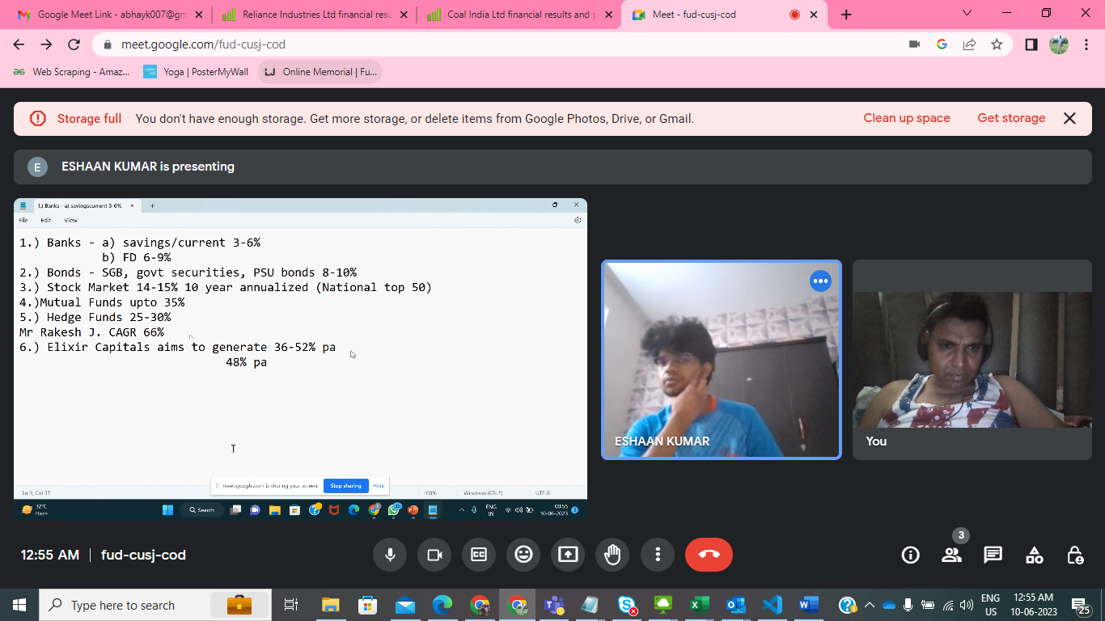

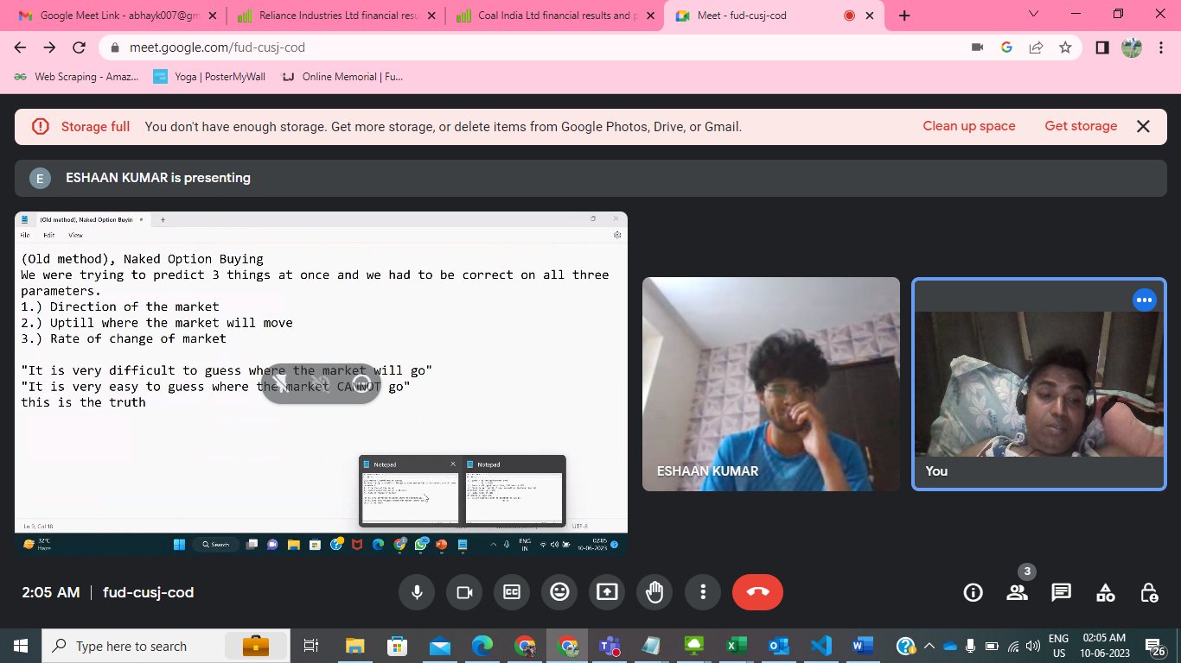

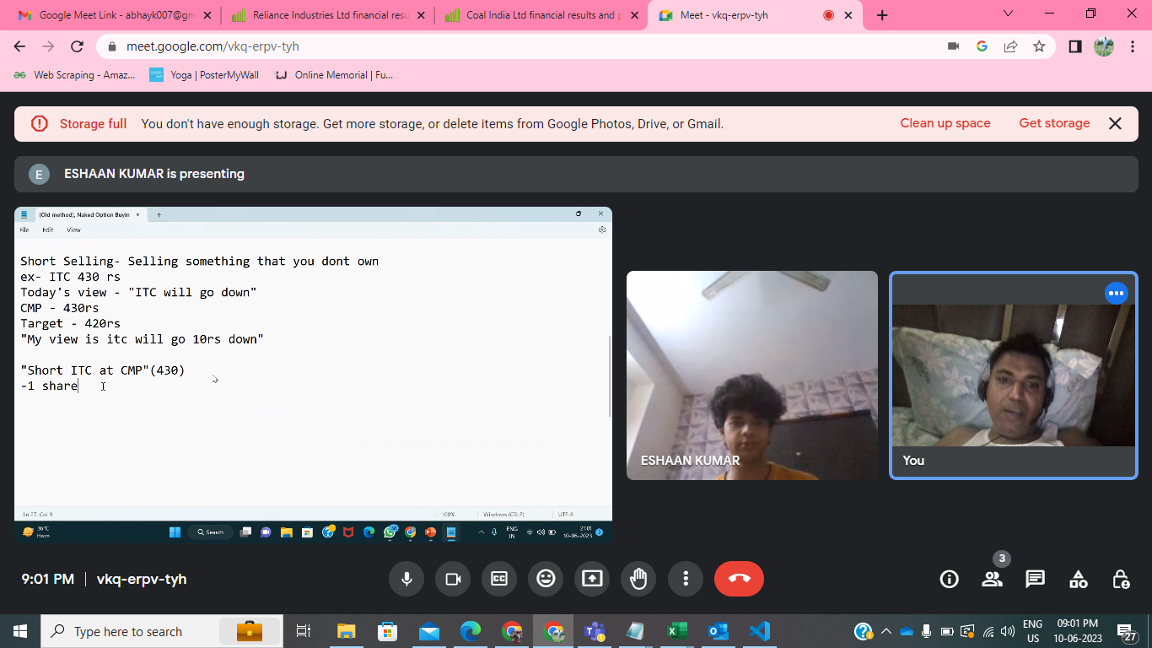

Option

CALL BUYER

EXERCISE PROCES

2% OF BET

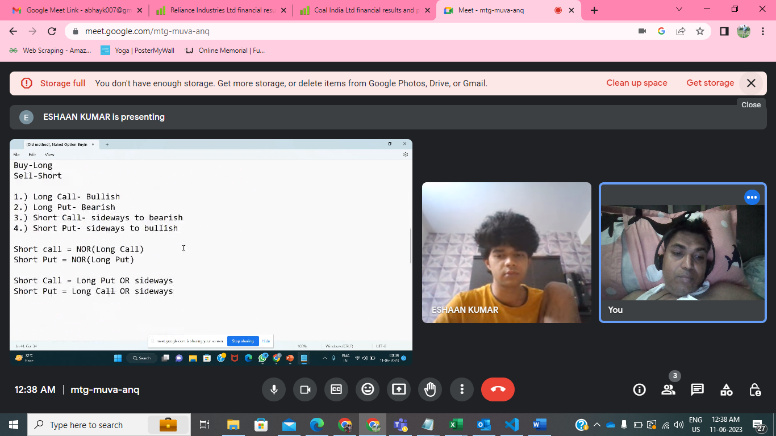

SHORT SELLING AND OPTION SELLING

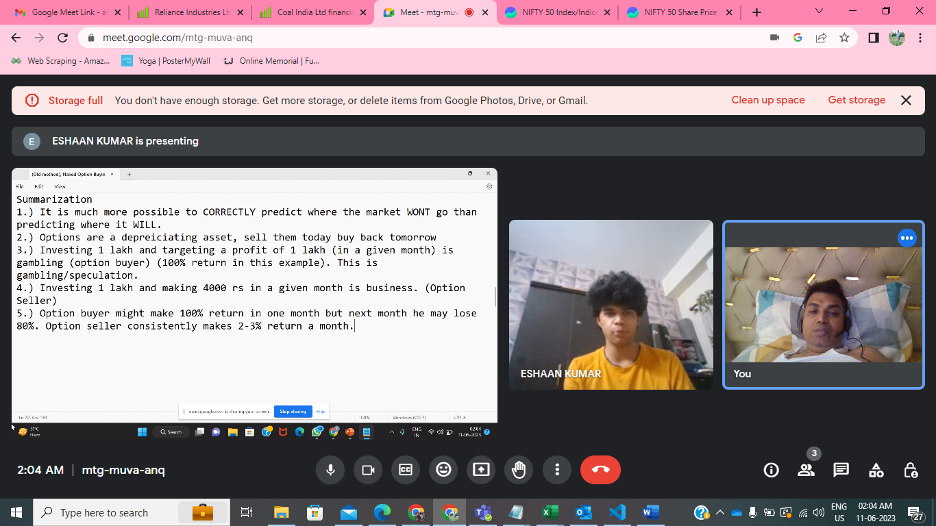

* Nifty 50
* Technical analysis
* Short selling
* Regulated by RBI and SEBI

Future

* NEAR , NEXT & FAR
* FUTURE-LAST THURSDAY
* If Thursday is holiday than Wednesday

US MARKET

* Capital.com
* Intraday
* Swing
* VBAP – CLOSE OF VBAP THEN BUY
* TRAILING STOP LOSS
* STOP LOSS ON PREVIOUS CANDLE
* MARGIN
* Option strategy
* Greeks

1. Black to white -Leave
2. What to show – SAVING-3-6%, 6-8%,Mutual fund,
3. Client
4. Receipt
5. CAGR-66% of Rakesh Jhunjhunwala
6. Sub Broker Eligibility & Cost
7. GST& Current account
8. Paper Trading –
9. Interest – in our strategy

Code rule

* EMA(9,) – any candle’s low point touch than back
* If check any previous candle of day -1 is also
* ATM - +/-1 ONE STRIKE OF CURRENT PROCED
* Call – Buy – View is bullish
* Call – Sell – Not bullish
* IN the money option – Jo Nikal– we will n ever short ITM option
* Out of the money – jaha tak nahi pahiuche – we will always short OTM option
* Max OI – OTM is resistance
* Call – max -OI -OTM – Resistenca-19000
* Put -Max -OI -OTM – Support – 18700
* If last date market ended higher than start than use call or put
* If last market closure value is closure to Upper standard deviation of previous day than call
* If last market closure value is closure to lower standard deviation of previous day than call

GOD Strategy for Nifty

We take position ONLY on the day of expiry. Theta decay is max on the day of expiry.

we will short only OTM options. (Rule 1)

[VIX/19.1] = 0.6% (0.6 is just an example)

VIX value changes everyday but in most cases it is less than 16.

FORMULA = VIX/sqrt(365) which is approx VIX/19.1

NIFTY on that day can move either 0.6% up or 0.6% down (again 0.6 was just an example, VIX value can vary but the formula remains same i.e VIX/19.1

We start this strategy at 1100 am. We check a movement if it is up, we prefer call side otm shorting ELSE put.

Hide

* Short Iron Condor
* Entry/Exit Blur
* IVP >40
* Stretegy Blur
* Option strike values all 4 , Blur
* Technical Trading Blur