Experiment 1

**Aim**: Design and implement a lexical analyzer for given language using C. The lexical analyzer should ignore redundant spaces, tabs and newlines.

Algorithm

1. Start
2. Read the file name of the program: `filename`.
3. Open the file `filename` in read mode.
4. If the file does not exist or the user does not have the permission to open it, goto step 15.
5. Read a character from the file into `ch`.
6. While `ch` is not `EOF` (end of file) do
7. If `ch` is '/' and the next character is also '/' then skip the line as a single line comment.
8. If `ch` is '/' and next character is '*' keep skipping characters till '*' and '/' occurring together is encountered: multiline comments.
9. If `ch` is '#' skip the line as a preprocessor directive.
10. If `ch` is '"' keep printing the `ch` till the next '"' is encountered. The strings are printed as it is.
11. If `ch` is alphanumeric append `ch` into `token`.
12. Else do
    1. If `token` is a keyword print `kwd`.
    2. Else if `token` is an identifier print `id`.
    3. Else if `token` is a number print the number.
    4. Else if `ch` is an operator, print operator token.
    5. Else if `ch` is ',' or ';' print `ch`.
13. Read the next character into `ch`.
14. Goto step 6, end while.
15. Close the file.
16. Stop

Input file

program.c

// Program to calculate the sum of two numbers

#include <stdio.h>

#include <string.h>

#include <ctype.h>

void main() {

/* This is a

multiline comment */

int num1, num2, sum;

num1 = 10;

num2 = 20;

sum = num1 + num2;

}

Output

Enter the file name of the program: program.c

----- ANALYSED OUTPUT -----

kwd id,id,id;id oper-equ 10;id oper-equ 20;id oper-equ id oper-add id;

Screenshot

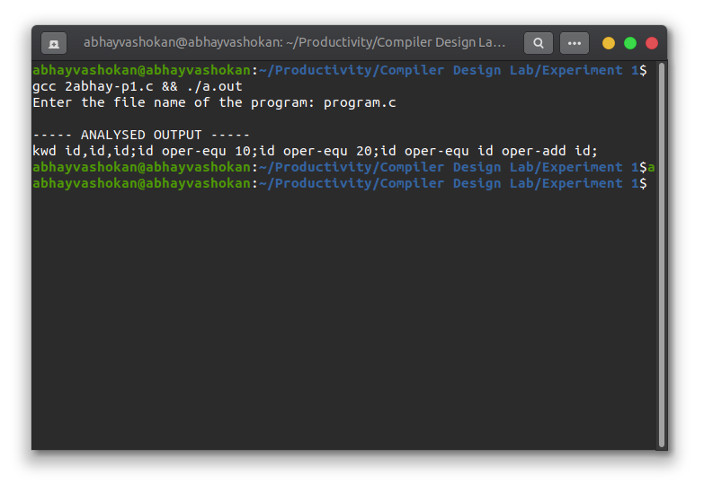

Readme

1. Compile and run the program using the command

**gcc 2abhay-p1.c && ./a.out**

2. Input the correct path of the file to be analysed.

3. The stream of tokens obtained is displayed in the terminal.

**Result**: Successfully created a lexical analyzer for given language using C.