Design Patterns

Version No.: 1.0
Date of Release: 01/04/2014

REVISION HISTORY

Date | Version No. | Summary of Changes
01/04/2014 | 1.0 | Initial Version

TABLE OF CONTENTS
Summary of Changes 2
1.0 Introduction 4
CHAPTER I 4
Introduction 4
CHAPTER II 6
Object Oriented Analysis 6
CHAPTER III 6
Object Oriented Design 6
CHAPTER IV 9
Object Oriented Design Principles 9
CHAPTER II 11
Association, Aggregation and Composition 11
CHAPTER II 12
Abstract Factory 12
CHAPTER III 12
Factory Method 12
CHAPTER IV 16
Singleton Pattern 16
CHAPTER V 17
Decorator Pattern 17
CHAPTER VI 19
Template Method Pattern 19
CHAPTER VII 22
Facade Pattern 22
CHAPTER VII 23
Adapter Pattern 23

Introduction
We are going to explore the Design Patterns. We are assuming that reader of this document knows basics of Development Life cycle.

CHAPTER I

Introduction

“…reduced application downtime, increased scalability and performance,
and tight yet flexible security controls"

Design patterns are solution of pre-define problems in specific way.

The IT industry has given a number of patterns, principles, and best practices which have been discovered, named, and catalogued. We can say this is guide lines or dictionary to solve common and complex problems with specific way by breaking into uniform and small problems with solutions. If you remember definition of Object-Oriented programming it seems same. We can say that this is Next step of it.

We are dividing this book in following portions.

- Object Oriented Analysis
- Object Oriented Design
- Design Principles
- Design Patterns
- Best Practices

I am working on Dot net platform so I will use Dot net C# as language for examples. You can use same things in Java or others. In Best practice chapter might be some things are purely related to Dot net but if you will read it, it will help you in other languages also.

History of Design Patterns
Design patterns are introduced by for 4 Genius and experience programmer. Now this is also known as Gang of four Design patterns. Name of four Geniuses are follow.

- Erich Gamma
- Richard Helm
- Ralph Johnson
- John Vlissides

There are total 23 design patterns are introduced by Gang of four in three category.

- Creational Patterns: These deals with object construction and referencing.
- Structural Patterns: These deals with the relationships between objects and how they interact with each other to form larger complex objects.
- Behavioral Patterns: These deals with the communication between objects, especially in terms of responsibility and algorithms.

We are going to check each pattern with example.

Creational
Here Creational pattern has five flavors.

- Abstract Factory: Provides an interface to create families of related objects.
- Factory: Enables a class to delegate the responsibility of creating a valid object.
- Builder: Enables various versions of an object to be constructed by separating the construction for the object itself.
- Prototype: Allows classes to be copied or cloned from a prototype instance rather than creating new instances.
- Singleton: Enables a class to be instantiated once with a single global point of access to it.

Structural
Here Structural pattern has seven flavors.

- Adapter: Enables classes of incompatible interfaces to be used together. This pattern is covered in this chapter.
- Bridge: Separates an abstraction from its implementation, allowing implementations and abstractions to vary independently of one another.
- Composite: Allows a group of objects representing hierarchies to be treated in the same way as a single instance of an object. This pattern is covered in Chapter 5.
- Decorator: Can dynamically surround a class and extend its behavior. This pattern is covered in Chapter 5.
- Facade: Provides a simple interface and controls access to a series of complicated interfaces and subsystems. This pattern is covered in Chapter 6.
- Flyweight: Provides a way to share data among many small classes in an efficient manner.
- Proxy: Provides a placeholder to a more complex class that is costly to instantiate. This pattern is covered in Chapter 7.

Behavioral
Here Structural pattern has seven flavors.

- Chain of Responsibility: Allows commands to be chained together dynamically to handle a request.
- Command: Encapsulates a method as an object and separates the execution of a command from its invoker.
- Interpreter: Specifies how to evaluate sentences in a language.
- Iterator: Provides a way to navigate a collection in a formalized manner.
- Mediator: Defines an object that allows communication between two other objects without them knowing about one another.
- Memento: Allows you to restore an object to its previous state.
- Observer: Defines the way one or more classes can be alerted to a change in another class.
- State: Allows an object to alter its behavior by delegating to a separate and changeable state object.
- Strategy: Enables an algorithm to be encapsulated within a class and switched at run time to alter an object’s behavior.
- Template Method: Defines the control of flow of an algorithm but allows subclasses to override or implement execution steps.
- Visitor: Enables new functionality to be performed on a class without affecting its structure.

So to remember number of division you can use following line.

Design Patterns
Design Patterns= 5 Creational + 7 Structural + 11 Behavior

CHAPTER II

Object Oriented Analysis

Abstract Factory: This pattern helps when client needs to create objects which are somehow related. Here one more condition is that client does not know exact which types needs to create.

CHAPTER III

Object Oriented Design

As we understand Object Oriented Analysis then what is OOD? Actually, Analysis phase concentrates mainly on “What” needs to be done. And Design phase tells “how” to do things.
And to do the best job we should know Design Principles, Design pattern and Best practices.
We are going to learn these things in this book.

There are following key points of Object Oriented Design.

- Design phase concentrates on the physical model of the system.
- Design phase is a blue print of eventual implementation.
- Understand the Non-Functional requirements like technical environment.
- Capture requirements for individual sub-system.
- Identify/Describe key Interfaces/abstract classes, Inheritance, associations, aggregations between individual sub-systems.
- Create a frame work for Intended system.
- Identify/Describe syntax for classes, attributes and Methods.
- Identify/Describe and document scope identifiers for all method and attributes.
- Identify/Describe and document sequence of events as they happened.

Basic Design Guidelines

There are a number of guidelines, which can make design robust. We are going to explore some of them.

- A class is not only for Methods.

This is common issue found with developers who are moving from traditional non-OO way. It means developers only include methods but don’t include attribute.
In Following Example class does not have any attribute. If you are reviewing any UML diagram you can ask reason to do this and put your review comments.

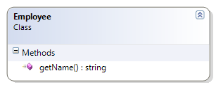

This violates the concept of encapsulation and there for must be avoided.

- A class is only for Methods should Static.

As Just discussed there should not be class only with functions, but there are some cases where we required only methods in class such as global/Shared operation, in this case developer should create static class.

At the same time if any Method is not using any attribute of class this Method should be static.

- Make Interface/abstract methods Concise and Complete

This is most important aspect of designing, Designer needs to insure that the interface of the class should be kept to minimum without compromising on its functionalities. This is because the basic reason for designing a class is in order to get something concise and useful done. If class will have too many public methods it mislead developer at the interface is in complete it will not solve the problems.

- Hide the Implementations

Interfaces of class involve public methods but implementations of these methods as well as about attributes can decide at time of Designing of class. A class becomes useful if it can change its implementation without changing its interface.

- Design Error Handling

This also most important aspect of Application design, every application encounters problems of different nature. The designer and developer of class should anticipate such situation at the time of design only. The basic concept of this is that Application should either correct itself so that it can proceed or exit gracefully, without losing any information that is relevant to the users.

- Document a class

Documentation of class is as important as documentation of other aspect of an Application. This helps developers as well as maintaining application.

- Class should Cooperate with other classes

There are very rear situations when an application has isolated classes. Class should design with concept that any other class would communicative with it e.g. by using associations/aggregations.

- Design with Reuse in Mind

When designing a class, designer should try to make that class as generic so it can reuse. But he/she needs to make sure that there should not be compromise with problems/ solutions. For example we need to design pizza order Method, divide this method into multiple part such as Prepare, Bake, cut and box.

- Design with Extensibility in Mind

When designing a class, designer should try to make that class as generic so it can extend. But he/she needs to make sure that there should not be compromise with problems/solutions. For example if developer designing person class it could extend to employee, manager or student.

- Abstract out Non-portable Code

If a class is to contain non-portable code such as environment specific code, It is better to put this in separate class (generally called as wrapper). The main class will call this wrapper class to perform the non-portable piece of code. This help us to make portable to the class.

CHAPTER IV

Object Oriented Design Principles

As we understand Object Oriented Design and Guidelines, Industry has introduced some Design principles on the basis of Design Guidelines. We are going to understand some common design principles here.

Keep It Simple Stupid (KISS )
The goal of Kiss principle is that try to keep each small piece of code simple but not simplistic, unnecessary complexity should be avoided. This helps us to write easy maintainable code.

Don’t Repeat Yourself (DRY)
The goal of DRY principle is that to avoid repetition of any part of knowledge/code/logic by abstracting out things that are common and placing those things in a single location. This principle is not only concerned with code but any logic that is duplicated in a system; ultimately there should only be one representation for every piece of knowledge/code/logic in a system.

You Ain’t Gonna Need It (YAGNI )
The goal of YAGNI principle is that only include functionality that is necessary for the application and put off any temptation to add other features that you may think you need. A design methodology that adheres to YAGNI is test-driven development (TDD). TDD is all about writing tests that prove the functionality of a system and then writing only the code to get the test to pass.

Tell, Don’t Ask(TDA)
The goal of TDA principle is that it is closely aligned with encapsulation and the assigning of responsibilities to their correct classes. The principle states that Developer should to tell objects what actions you want them to perform rather than asking questions about the state of the object and then making a decision yourself on what action you want to perform. This helps to align the responsibilities and avoid tight coupling between classes.

Separation of Concerns (SoC)
The goal of TDA principle is that It is the process of breaking a piece of software into distinct features that encapsulate unique behavior and data that can be used by other classes. Generally, a concern represents a feature or behavior of a class. The act of separating a program into discrete responsibilities significantly increases code reuse, maintenance, and testability.

S.O.L.I.D.
This is combination of five principles.
- Single Responsibility Principle (SRP)
- Open/Closed Principle (OCP)
- Liscov Substitution Principle (LSP)
- Interface Segregation Principle (ISP)
- Dependency Inversion Principle (DIP)

Here we will look these one by one.

Single Responsibility Principle (SRP)
This principle states that there should never be more than one reason for a class to change. This means that you should design your classes in such a way that each class should have a single purpose.

Open/Closed Principle (OCP)
This principle states that software entities (classes, modules, functions, etc.) should be open for extension but closed for modification. The "closed" part of the rule states that once a module has been developed and tested, the code should only be changed to correct bugs. The "open" part says that you should be able to extend existing code in order to introduce new functionality.

Liscov Substitution Principle (LSP)
This principle states that functions that use pointers or references to base classes must be able to use objects of derived classes without knowing it. For example, if S is a subtype of T, then objects of type T in a program may be replaced with objects of type S without altering any of the desirable properties of that program.

Interface Segregation Principle (ISP)
This principle states that Clients should not be forced to depend upon interfaces that they don’t use. This means the number of members in the interface that is visible to the dependent class should be minimized. For example, the service interface that is exposed to the client should contain only client related methods not all.

Dependency Inversion Principle (DIP)
The Dependency Inversion Principle states that:

- High level modules should not depend upon low level modules. Both should depend upon abstractions.

- Abstractions should not depend upon details. Details should depend upon abstractions.
It helps us to develop loosely couple code by ensuring that high-level modules depend on abstractions rather than concrete implementations of lower-level modules. The Dependency Injection pattern is an implementation of this principle

Example - The Dependency Injection pattern is an implementation of this principle

CHAPTER II

Association, Aggregation and Composition

Before Jumping to Design patterns, we will just take one look on Association, Aggregation and composition. These three concepts are widely used in design patterns. Actually these three concepts are little bit confusing also for developers.

Association
Association is a relationship between two objects. That allows one object instance to cause another to perform an action on its behalf. This relationship is structural, because it specifies that objects of one kind are connected to objects of another and does not represent behavior.
In other words, association defines the multiplicity between objects. For example of Teacher and Student, multiple students can associate with single teacher and single student can associate with multiple teachers but there is no ownership between the objects and both have their own lifecycle. Both can create and delete independently.

One-to-one, one-to-many, many-to-one, many-to-many all these words define an association between objects. Aggregation is a special form of association. Composition is a special form of aggregation.

Aggregation
Aggregation is a specialize form of Association where all object have their own lifecycle but there is ownership and child object cannot belongs to another parent object. Let’s take an example of Department and teacher. A single teacher cannot belongs to multiple departments, but if we delete the department teacher object will not destroy. We can think about “has-a” relationship.

Composition
Composition is again specialize form of Aggregation and we can call this as a “death” relationship. It is a strong type of Aggregation. Child object does not have their lifecycle and if parent object deletes all child objects will also be deleted. Let’s take again an example of relationship between House and rooms. House can contain multiple rooms there is no independent life of room and any room cannot belongs to two different house if we delete the house room will automatically delete.

Need to add UML Diagrams for all.
http://guruzon.com/1/oop-concepts/inheritance-and-composition/aggregation-vs-composition-vs-association-difference-comparison-between

CHAPTER II

Abstract Factory

Abstract Factory: This pattern helps when client needs to create objects which are somehow related. Here one more condition is that client does not know exact which types needs to create.

CHAPTER III

Factory Method

There are following key points of Factory Method.

- Factory Method is Creational Pattern.
- It has one Factory class with one Static method which return object.
- Method return type is Interface/Abstract class.
- Method use If Else or Switch Statement to create objects.
- Factory class is exposing to client and Client use this class to create objects.

Objective:
- The main objective of the Factory pattern is to hide the complexities of creating objects. It means keyword “new” doesn’t use in client side.
- The client doesn’t normally specify a particular class to be created.
- The client will code against an interface or abstract class and leave the responsibility to the Factory class to create the concrete type.
- Typically a Factory class has a static method that returns an abstract class or interface.
- The client usually, but not always, supplies some kind of information; using the supplied information the Factory then determines which subclass to create and return.
- The ability to abstract away the responsibility of creating subclasses allows your client code to be completely ignorant of how dependent classes are created. This follows the Dependency Inversion principle (DIP) that you will read about later in this chapter. Another benefit of the Factory Method pattern is that you centralize the code for the creation of objects; if a change is required in the way an object is generated, it can be easily located and updated without affecting the code that depends on it.

Factory Method Used In Dot Net
The ASP.NET Cache uses the Singleton pattern; creating a new Guid uses the Factory pattern; the .NET 2 XML classes use the Factory pattern.

Now we will one example of Factory Method Pattern. To show example we are using Visual studio 2010.

Create one Project with six Files.

- clsProducts.cs
- ClsProductA.cs
- ClsProductB.cs
- Enum.cs
- ClsFactoryProduct.cs
- Client.cs

Following is source code of all files.

clsProducts.cs:
This is abstract class which is the key of Factory method. We can use Interface also to implement this pattern.

clsProducts.cs

public abstract class clsProducts
{
public abstract int Price();
}

ClsProductA.cs
ClsProductB.cs
These are classes which inherit/implement our abstract class/interface.

ClsProductA.cs

class ClsProductA : clsProducts
{
public override int Price()
{
return 100;
}
}

ClsProductB.cs

class ClsProductB : clsProducts
{
public override int Price()
{
return 200;
}
}

Enum.cs
This is Enum. This helps developer to use proper values as required.

ClsProductB.cs

class ClsProductB : clsProducts
{
public override int Price()
{
return 200;
}
}

ClsFactoryProduct.cs
This is also key class. This class used by client to choose exact class object as required. This class has one static function which expose to client to select the object as required.
Here , I have created two static method only to show example, in real-life , developer just want one of them. These functions are showing example of if/else and switch statement.

ClsFactoryProduct.cs
public class ClsFactoryProduct
{
/// <summary>
/// Method by using If and Else.
/// </summary>
/// <param name="productType"></param>
/// <returns></returns>
public static clsProducts getProductsByIfElse(ProductType productType)
{
if (productType == ProductType.ProductA)
{
return new ClsProductA();
}
else if (productType == ProductType.ProductB)
{
return new ClsProductB();
}
else
{
throw new ApplicationException("Please select proper Product type "+ productType.ToString());
}
}

/// <summary>
/// Method by using Switch
/// </summary>
/// <param name="productType"></param>
/// <returns></returns>
public static clsProducts getProductsBySwitch(ProductType productType)
{
switch (productType)
{
case ProductType.ProductA:
return new ClsProductA();
case ProductType.ProductB:
return new ClsProductB();
default:
throw new ApplicationException("Please select proper Product type "+ productType.ToString());
}

}
}

Client.cs
Above all classes are example of Factory Method pattern. This class shows how to consume Factory Method classes.

Client.cs
class Client
{
clsProducts _objProducts;
decimal discountedPrice;

public clsProducts objProducts
{
get
{
return _objProducts;
}
set
{
_objProducts = value;
}
}

void CreateObjects()
{
objProducts = ClsFactoryProduct.getProductsBySwitch(ProductType.ProductA);

}
}

Now we will see UML class diagram.

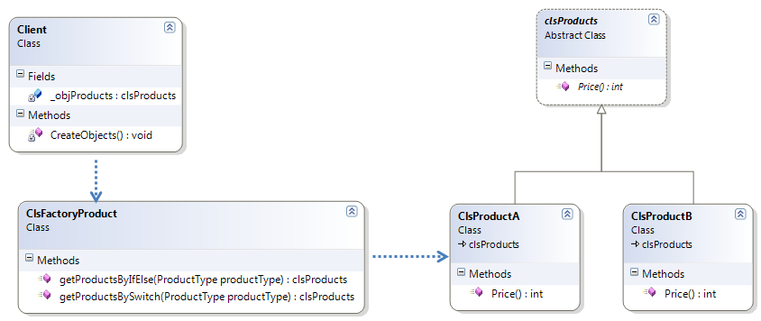

Examples:
- The .NET 2 XML classes use the Factory pattern.

CHAPTER IV

Singleton Pattern

There are following key points of Singleton Pattern.

- Singleton Pattern is a creational Pattern.
- It has one class with private constructors so no one can create object of class.
- This class can have one static method which return same object.
- Class can have one or more Static Methods to do required operations.

Objective:
- The main objective of the Singleton pattern is maintaining and sharing same properties/states throughout application.
- The client doesn’t have access to create Object of this class.

Singleton pattern Used In Dot Net
The ASP.NET Cache uses the Singleton pattern; creating a new Guid uses the Factory pattern; the .NET 2 XML classes use the Factory pattern.

Now we will one example of Singleton Pattern. To show example we are using Visual studio 2010.

Create one Project with six Files.

- clsProducts.cs

clsSingleton.cs
public class clsSingleton
{

static int Hits;
private clsSingleton()
{

}

public static void Hit(){
Hits++;
}

public static int TotalHit(){
return Hits;
}
}

CHAPTER V

Decorator Pattern

There are following key points of Decorator Pattern. This pattern can use by using Extension Method Functionality in Dot net.

- Decorator Pattern is a structural Pattern.
- It allows new behavior to be added to an existing object on the fly.
- The Decorator pattern enables new behavior to be added to an object dynamically via composition.
- The pattern achieves this by either inheriting from the same base class or implementing a shared interface in conjunction with injecting an instance of the class to be decorated. In other words, the Decorator pattern is the process of wrapping an existing class with a class that extends the behavior or state.
- Multiple decorators can be added to a class to combine extended behavior.

Objective:
- The main objective of the Decorator pattern is extending structural of class to add new behavior.

Singleton pattern Used In Dot Net
The ASP.NET uses extension methods which is the best example of it.

Just see with example, Here I am using same example which are used for Factory Pattern.
In that example Product has only one property which is Price now if we are requiring to add new property discounted price, we do not need to change all classes instead we can take help of Decorator pattern by implementing Extension Method. Please follow Example explained in Factory Method Pattern. Here I have just added one more class “ClsExtensionProduct” with new method “GetDiscountedPrice”. As well as I am changing client class to show decorator pattern.

clsExtensionProduct.cs
static class ClsExtensionProduct
{
public static decimal GetDiscountedPrice(this clsProducts products,decimal discount)
{
return products.Price() * discount;
}
}

Client.cs
We have added Just one line in this class to show use of Decorator Pattern.

Client.cs
class Client
{
clsProducts _objProducts;
decimal discountedPrice;

public clsProducts objProducts
{
get
{
return _objProducts;
}
set
{
_objProducts = value;
}
}

void CreateObjects()
{
objProducts = ClsFactoryProduct.getProductsBySwitch(ProductType.ProductA);
///Example of Decorator Pattern
discountedPrice = objProducts.GetDiscountedPrice(0.9m);

}
}

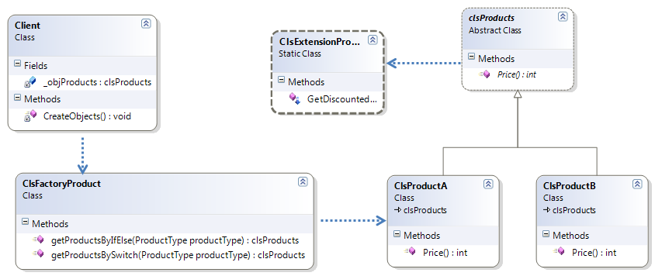

CHAPTER VI

Template Method Pattern

There are following key points of Template Method Pattern.

- Template Method Pattern is a behavioral Pattern.
- This pattern applies when major of logic/ algorithm is pre-defined and some steps needs to add on Subclasses basis.
- This pattern takes help of one abstract class, one template method and one or more abstract methods.

Objective:
- The main objective of the Template Method pattern is creating template Functions and then inject some steps in it..

Create one Project with four Files.

- clsProducts.cs
- ClsProductA.cs
- ClsProductB.cs
- Client.cs

Following is source code of all files.

clsProducts.cs:
This is abstract class which is the key of Template Method. Here “Margin” is Template Method and “Cost” and “DiscountedPrice” are supporting Methods for template.

clsProducts.cs

public abstract class clsProducts
{
public decimal Margin()
{
return DiscountedPrice() - Cost();
}

public abstract int Price();
public abstract decimal Cost();
public abstract decimal DiscountedPrice();
}
‘
ClsProductA.cs
ClsProductB.cs
These are classes which inherit our abstract class and implement supporting Methods.

ClsProductA.cs

class ClsProductA : clsProducts
{

public override int Price()
{
return 100;
}

public override decimal Cost()
{
return 30;
}

public override decimal DiscountedPrice()
{
return 90;
}
}

ClsProductB.cs

class ClsProductB : clsProducts
{
public override int Price()
{
return 200;
}

public override decimal Cost()
{
return 100;
}

public override decimal DiscountedPrice()
{
return 190;
}
}

Client.cs
We have added Just one line in this class to show use of Template Method pattern.

Client.cs
class Client
{
clsProducts _objProducts;
decimal Margin;

public clsProducts objProducts
{
get
{
return _objProducts;
}
set
{
_objProducts = value;
}
}

void CreateObjects()
{
objProducts = ClsFactoryProduct.getProductsBySwitch(ProductType.ProductA);

///Example of Template Method
Margin = objProducts.Margin();
}
}

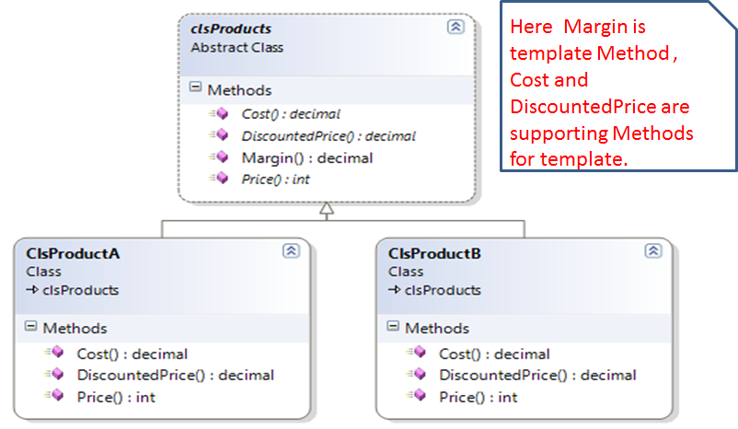

CHAPTER VII

Facade Pattern

There are following key points of Facade Pattern.

- Facade Pattern is a Structural Pattern.
- This take help of Association and inheritance to achieve this.

Objective:
- This pattern helps when multiple type of works need to do by same type of operations. Looks confusing?
- This helps when team is working with existing sub systems or working with multiple other applications.

To show example, we are using very simple example to join two operations to understand easily. Here we are extending our Factory Method Example. Just See below.

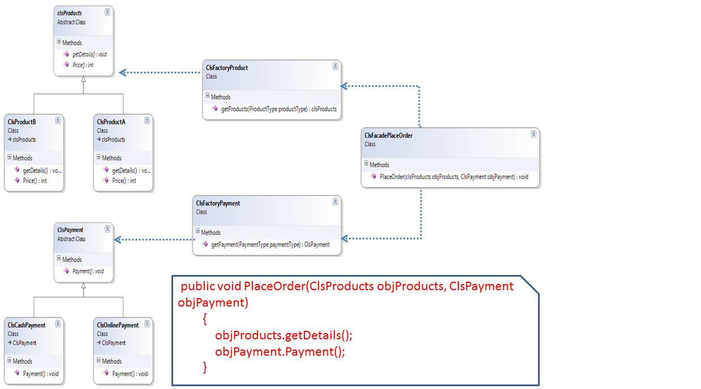

CHAPTER VII

Adapter Pattern
There are following key points of Adapter Pattern.

- Adapter Pattern is a Structural Pattern.
- One Method to execute multiple operations.

Objective:
- This pattern applies when End objects require to do logical multiple operations for completion one task, this pattern combine these Operations and provide facility to call all options using one Method.
- This helps to maintain sequence and encapsulation of task list.

CHAPTER VII

Strategy Pattern
There are following key points of Strategy Pattern.

- This pattern also known as the Policy Pattern.
- Strategy Pattern is a Behavior Pattern.
- This pattern defines a family of algorithm.
- This pattern is little closer to Template Method pattern.

Objective:
- This pattern applies when we want to dynamically change the algorithms used in an application.
- This pattern take help of abstraction of class.
- This pattern helps to choose algorithms which client wants.

Create one console application with following Files.

- ClsStrategy.cs
- ClsConcreteStrategyA.cs
- ClsConcreteStrategyB.cs
- ClsConcreteStrategyC.cs
- ClsContext.cs
- Client.cs

Following is source code of all files.

ClsStrategy.cd:
This is abstract class, which is the key of Strategy pattern. Here “AlgorithmInterface” is strategy method and it has implementation in other custom classes.

ClsStrategy.cs
abstract class ClsStrategy
{
public abstract void AlgorithmInterface();
}

ClsConcreteStrategyA.cs:
ClsConcreteStrategyB.cs:
ClsConcreteStrategyC.cs:
These classes are custom strategy classes which has implementation of strategy.

ClsConcreteStrategyA.cs
class ClsConcreteStrategyA : ClsStrategy
{
public override void AlgorithmInterface()
{
Console.WriteLine("Called ConcreteStrategyA.AlgorithmInterface()");
}
}

ClsConcreteStrategyB.cs
class ClsConcreteStrategyB : ClsStrategy
{
public override void AlgorithmInterface()
{
Console.WriteLine("Called ConcreteStrategyB.AlgorithmInterface()");
}
}

ClsConcreteStrategyC.cs
class ClsConcreteStrategyC : ClsStrategy
{
public override void AlgorithmInterface()
{
Console.WriteLine("Called ConcreteStrategyC.AlgorithmInterface()");
}
}

ClsContext.cs:
This class is key of strategy pattern. Client create object of this class to call required algorithm. This class has object of strategy. Therefore, it can call actual implementation.

ClsContext.cs
class ClsContext
{
private ClsStrategy objClsStrategy;

public ClsContext(ClsStrategy strategy)
{
this.objClsStrategy = strategy;
}

public void ContextAlgorithm()
{
objClsStrategy.AlgorithmInterface();
}
}

Client.cs:
In this pattern, client always use context object to call strategy implementation. Client pass, which sub class implementation it wants as, required.

Client.cs
class Client
{
static void Main(string[] args)
{

ClsContext objcontext;

objcontext = new ClsContext(new ClsConcreteStrategyA());
objcontext.ContextAlgorithm();

objcontext = new ClsContext(new ClsConcreteStrategyB());
objcontext.ContextAlgorithm();

objcontext = new ClsContext(new ClsConcreteStrategyC());
objcontext.ContextAlgorithm();

Console.ReadKey();

}
}

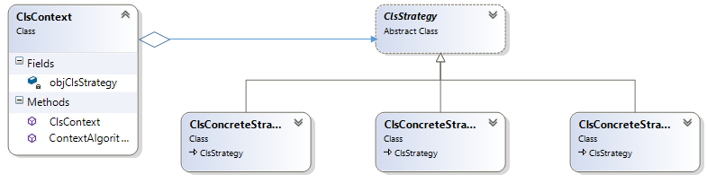

CHAPTER VII

Strategy Pattern Vs Template Method

TEMPLATE METHOD and STRATEGY both solve the problem of separating a generic algorithm from a detailed context. We see the need for this very frequently in software design. We have an algorithm that is generically applicable. In order to conform to the Dependency Inversion Principle (DIP) we want to make sure that the generic algorithm does not depend upon the detailed implementation. Rather we want the generic algorithm and the detailed implementation to depend upon abstractions.

Key Difference:
- Strategy pattern use context class to call subclass implementation. Template method does not require having context class.
- Template Method is use when sequence of task required operation from subclass. Strategy pattern use to encapsulate implementation of individual operation.
- In strategy pattern algorithm written in sub classes.
- In template pattern algorithm is written in base class and require data or part of algorithms written in sub class.

CHAPTER VII

Strategy Pattern Vs Factory Pattern

Strategy Pattern and Factory Pattern look same but it has following key difference.

Key Difference:
- Strategy Pattern is a Behavior Pattern. Factory Pattern is a Creational Pattern.
- Strategy Pattern is used to decide run time Operation. Factory Pattern is used to get run time object.
- Just have look on intent of both Pattern.

Strategy: "Define a family of algorithms, encapsulate each one, and make them interchangeable. Strategy lets the algorithm vary independently from clients that use it."
Factory Method: "Define an interface for creating an object, but let subclasses decide which class to instantiate. Factory Method lets a class defer instantiation to subclasses."

CHAPTER VII

Strategy Pattern Vs Decorator Pattern
Strategy Pattern and Decorator Pattern has huge difference.

- In strategy pattern algorithm written in sub classes and one of them will be used.
- Decorator pattern functionality Witten in multiple classes and client invoke all functionality which are added run times.
- Decorator pattern use collection of sub classes vs strategy pattern used only require sub class object.

CHAPTER VII

Strategy Pattern Vs Dependencies Injection
Strategy Pattern and Dependency Injection is seems like same following is the only difference.

- Intend of Strategy pattern is dynamically change algorithms.
- Instead Dependencies Injection only talk about decouple the classes not necessary to change algorithm.

CHAPTER VII

Strategy Pattern Vs Inversion of Control
Strategy Pattern and Inversion of control is seems like same following is the only difference.

- Intend of Strategy pattern is dynamically change algorithms and it could add as requires via code logic.
- Instead Inversion of control inject dependencies at runtime but used configurations for injection means we need to change configuration files to inject decencies.

CHAPTER VII

Delegate Vs Interface

