ASP.NET Core is the new web framework from Microsoft. ASP.NET Core is the framework you want to use for web development with .NET. It is an open-source web framework which can be run on Windows, Mac, or Linux.

.NET Core Overview

.NET Core is a new version of .NET Framework, which is a free, open-source, general-purpose development platform maintained by Microsoft. It is a cross-platform framework that runs on Windows, macOS, and Linux operating systems.

The .NET Core Framework composed of the following parts:

[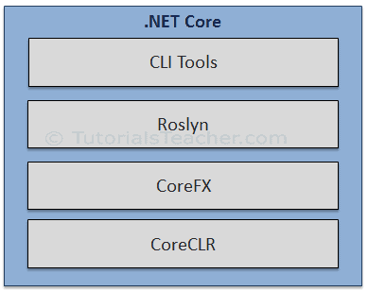](https://www.tutorialsteacher.com/Content/images/core/dotnet-core-components.png).NET Core

* CLI Tools: A set of tooling for development and deployment.
* Roslyn: Language compiler for C# and Visual Basic
* CoreFX: Set of framework libraries.
* CoreCLR: A JIT based CLR (Command Language Runtime).

Understanding Service Lifetime

Built-in IoC container manages the lifetime of a registered service type. It automatically disposes a service instance based on the specified lifetime.

The built-in IoC container supports three kinds of lifetimes:

1. **Singleton:** IoC container will create and share a single instance of a service throughout the application's lifetime.
2. **Transient:** The IoC container will create a new instance of the specified service type every time you ask for it.
3. **Scoped:** IoC container will create an instance of the specified service type once per request and will be shared in a single request.