BDA LAB-week3

Commands:

show dbs

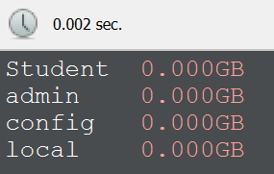

show tables

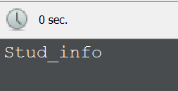

db.Stud_info.insertOne(

{

Rollno: 1,

Age:20,

ContactNo: 8767898765,

Email: "abcde@gmail.com"

}

)

db.Stud_info.insertOne(

{

Rollno: 10,

Age:20,

ContactNo: 9767898765,

Email: "abcdf@gmail.com"

}

)

db.Stud_info.insertOne(

{

Rollno: 11,

Name: "ABC",

Age:20,

ContactNo: 9867898765,

Email: "rollel@gmail.com"

}

)

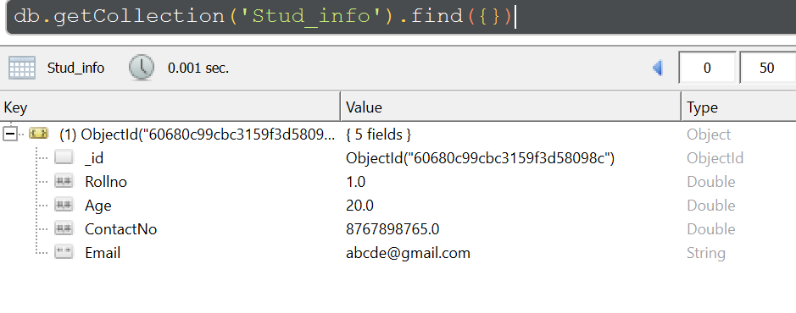

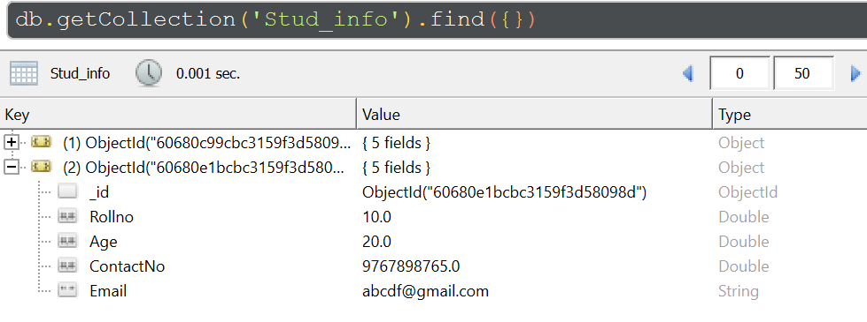

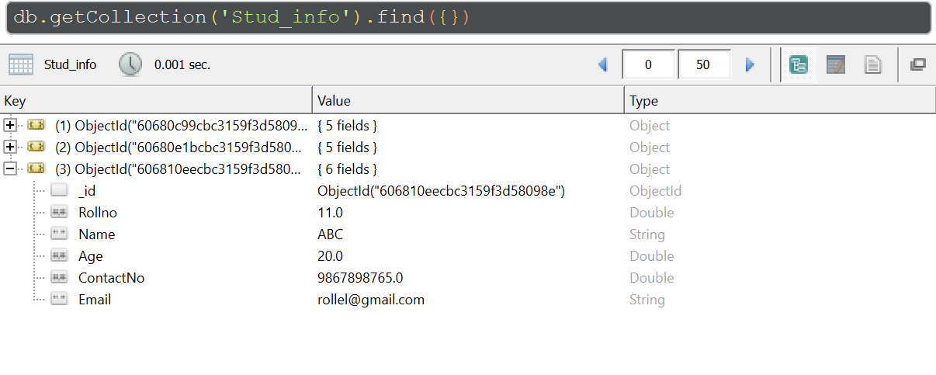

db.Stud_info.update(

{"Rollno":10},

{$set: { "Email" : "bcdef@gmail.com"}});

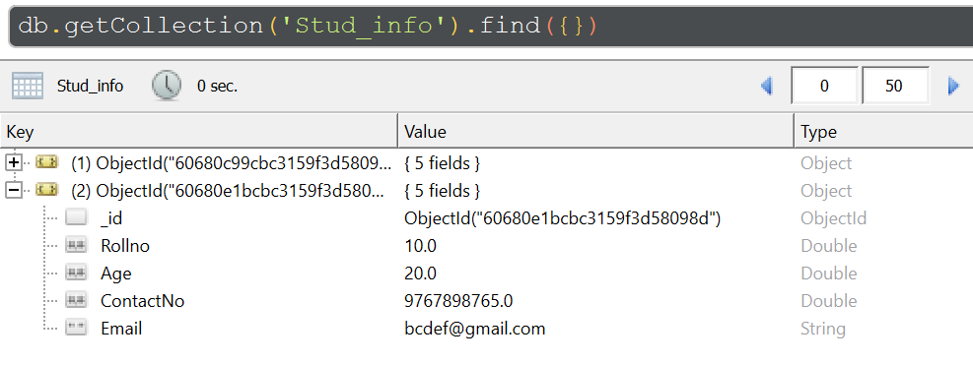

db.Stud_info.update(

{"Rollno":11},

{$set: { "Name" : "FEM"}});

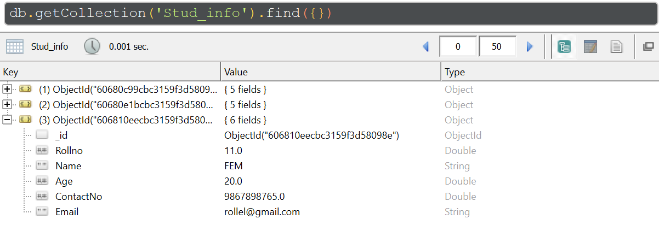

>mongoexport --db=Student --collection=Stud_info --type=csv --fields=Rollno,Age,ContactNo,Email --out=C:\Users\abhay\Documents\studentinfo.csv



db.Stud_info.drop()

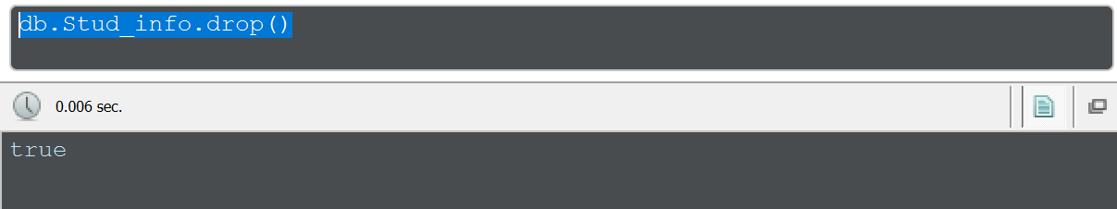

mongoimport -d Student -c Stud_info --type csv --file=C:\Users\abhay\Documents\studentinfo.csv –headerline

