**Output**

Server output

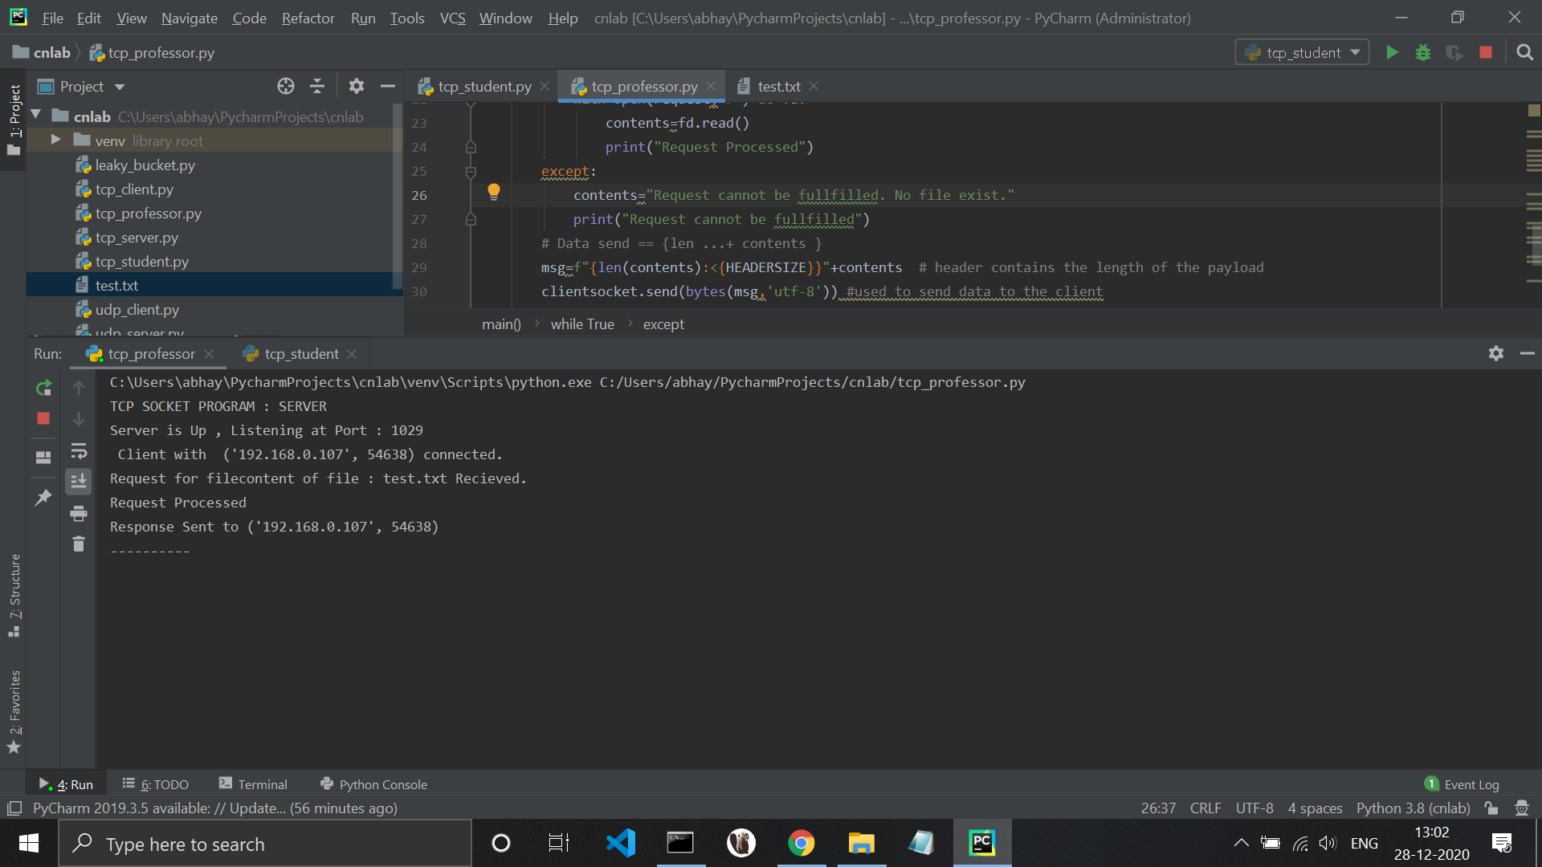

Client Output

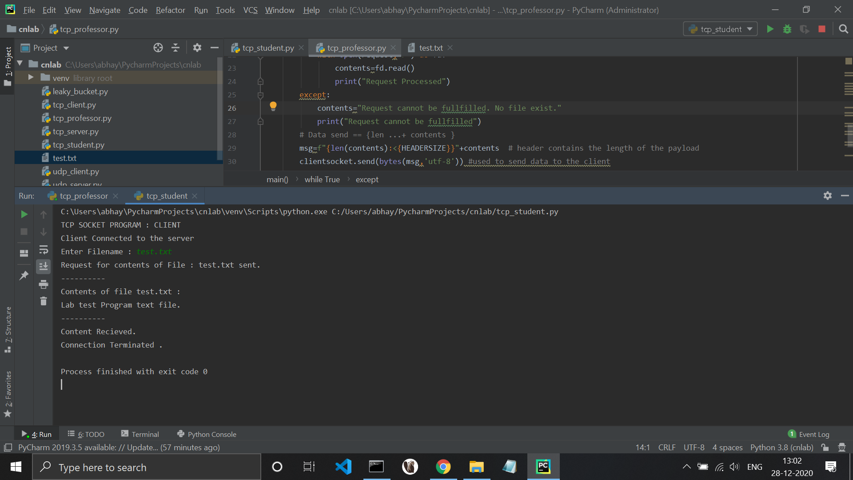

**Conclusion** –

1. The inter pc connection cant be established as server is part of private network and ip address is public. And public ip address is not enough to create a socket connection.
2. If the systems working as client and sever were in the same LAN , that is both are private network then it would accept the request , establish the connection and process it.
3. When using stand alone system same system works as server and client so it establishes a connection with itself that is always true hence the output shown is for standalone system.