**Error Scenarios:**

**Case 1: GET /products/999 (nonexistent)**

GET <http://localhost:8080/products/999>

RESPONSE: 500 Internal Server Error

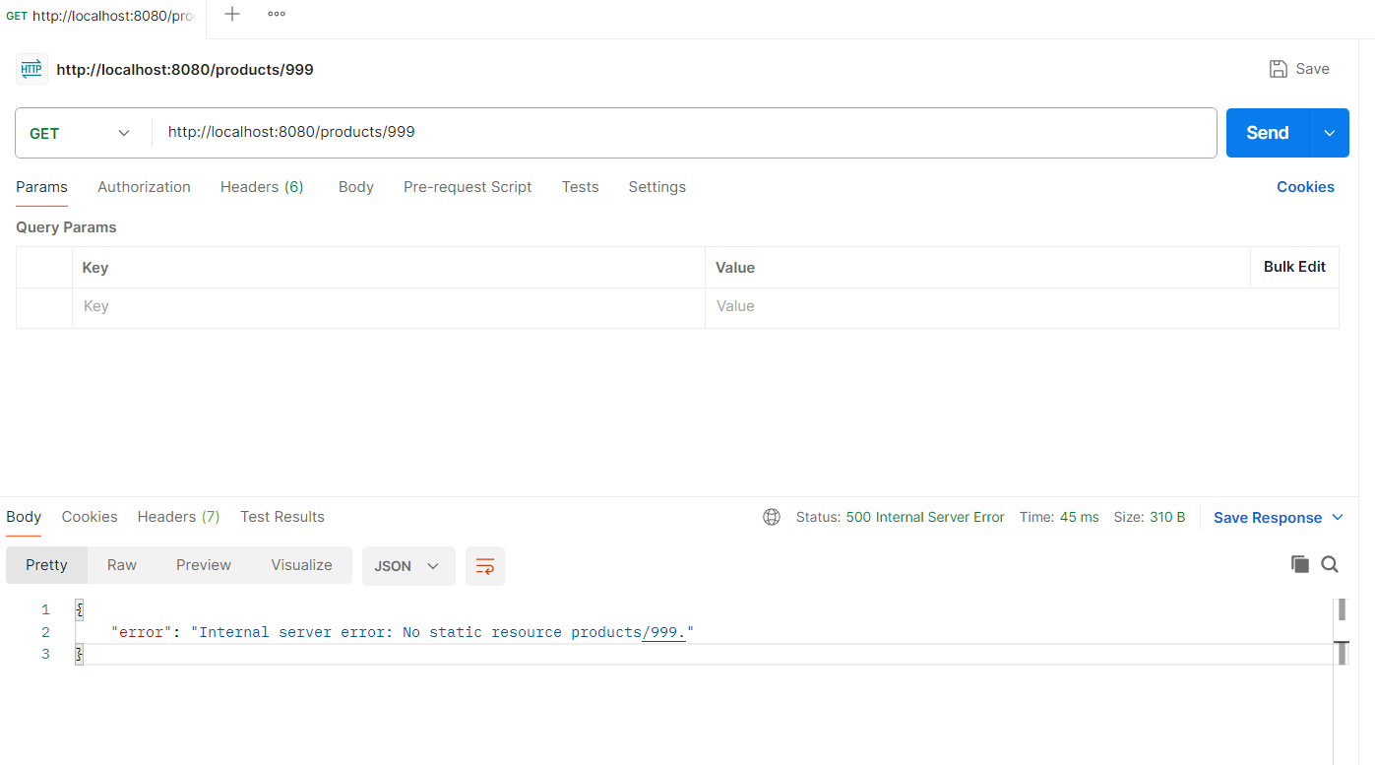

**Case 2: POST /orders with invalid JSON**

POST http://localhost:8080/orders

{}

RESPONSE 400 Bad Resquest

{

    "productId": "productId must not be null"

}

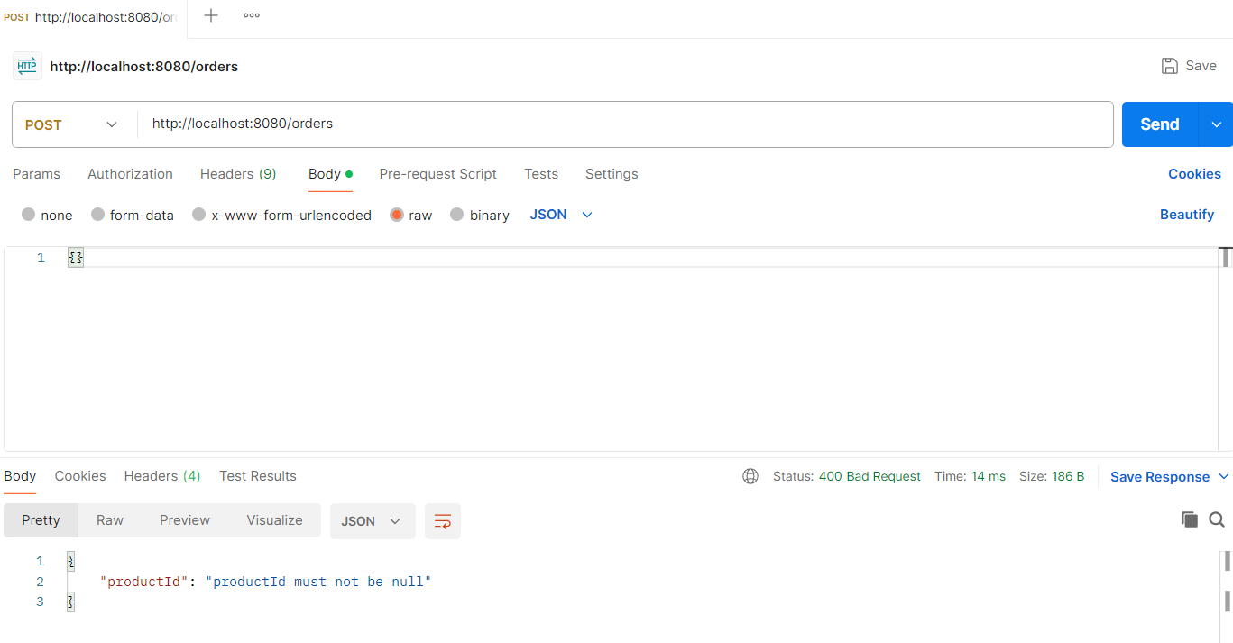

**Case 3: GET /orders/abc (invalid ID)**

GET <http://localhost:8080/orders/abc>

RESPONSE 400 Bad Request

{

    "error": "Invalid parameter: id"

}

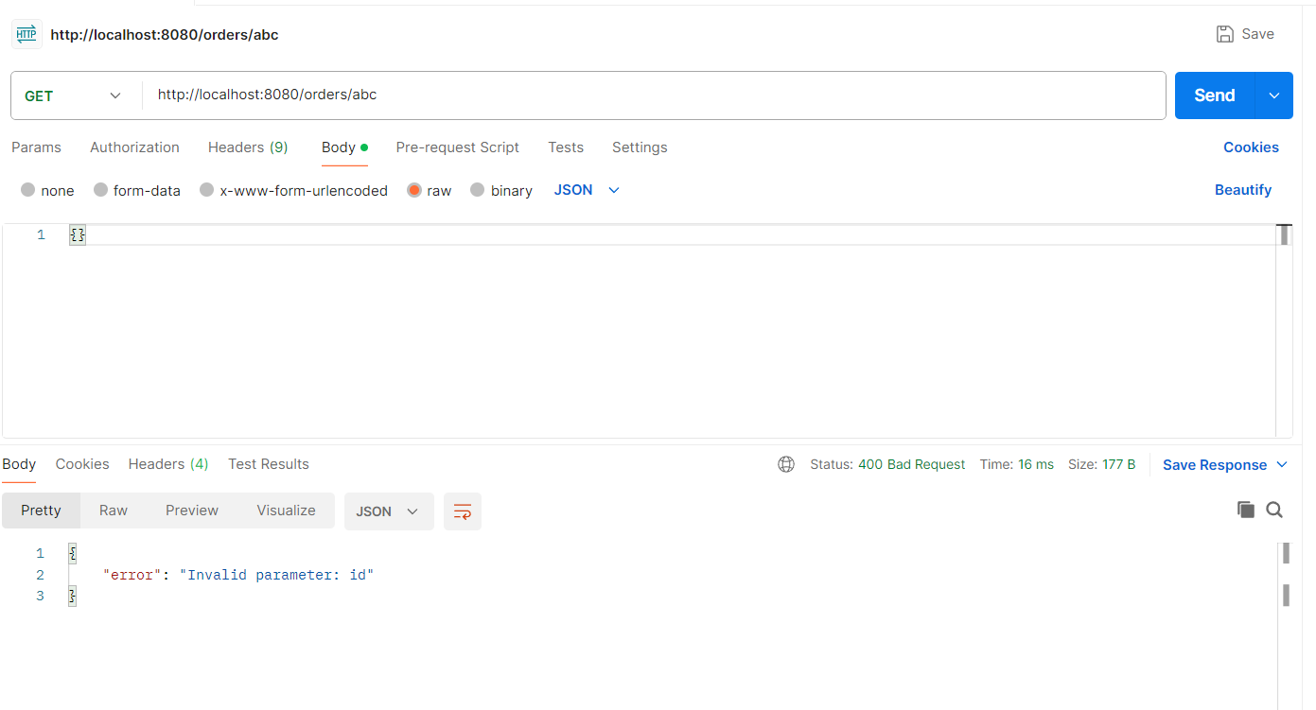

**Case 4: GET /orders/2 (When order does not exist)**

GET http://localhost:8080/orders/2

RESPONSE 404 Not Found

{

    "error": "Order not found"

}

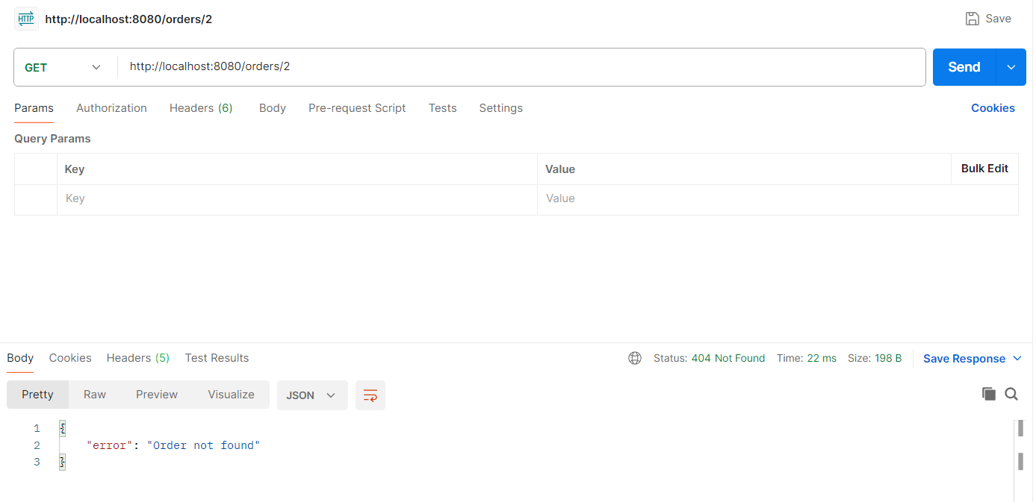

**Case 5: POST /products when price is 0**

POST <http://localhost:8080/products>

{"name": "Keyboard", "price": "0"}

RESPONSE 400 Bad Resquest

{

    "price": "Price must be greater than 0"

}

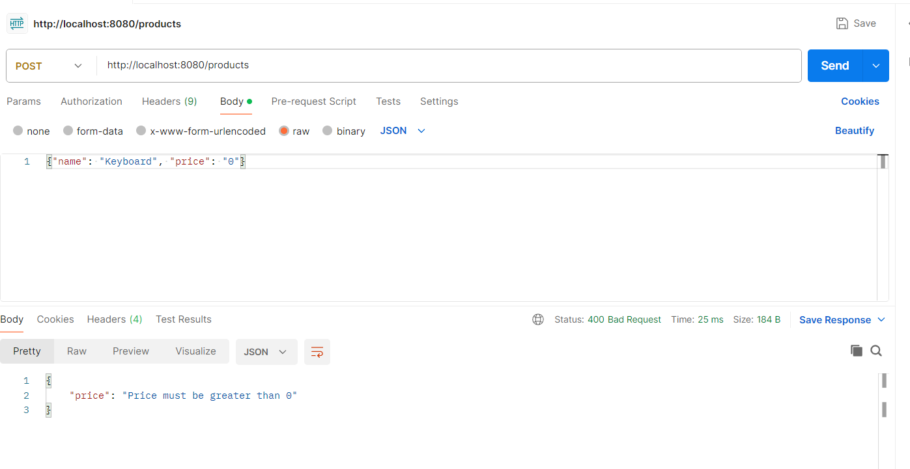

**Case 6: POST /products when price is not present**

POST <http://localhost:8080/products>

{"name": "Keyboard", "price": ""}

RESPONSE 400 Bad Resquest

{

    "price": "Price is required"

}

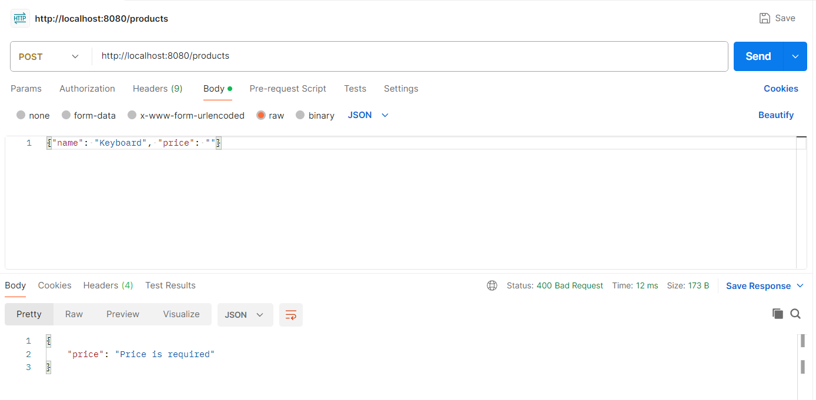

**Case 7: POST /products when name is not present and price is 0**

POST <http://localhost:8080/products>

{"name": "", "price": "0.0"}

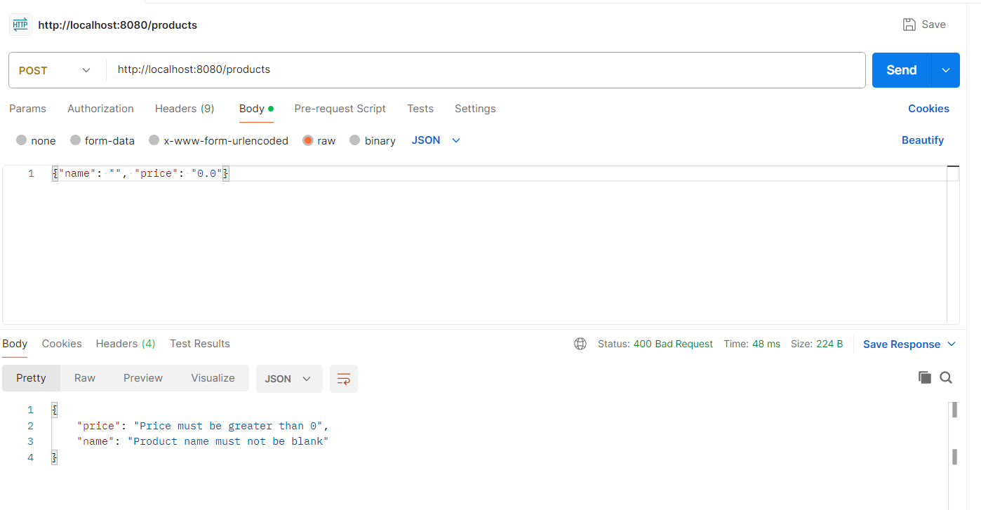

**HAPPY PATH (ASYNC FLOW):**

**STEP 1: Create a product**

POST <http://localhost:8080/products>

{"name": "Keyboard", "price": 49.99}

RESPONSE: 200 OK

{

    "id": 1,

    "name": "Keyboard",

    "price": 49.99

}

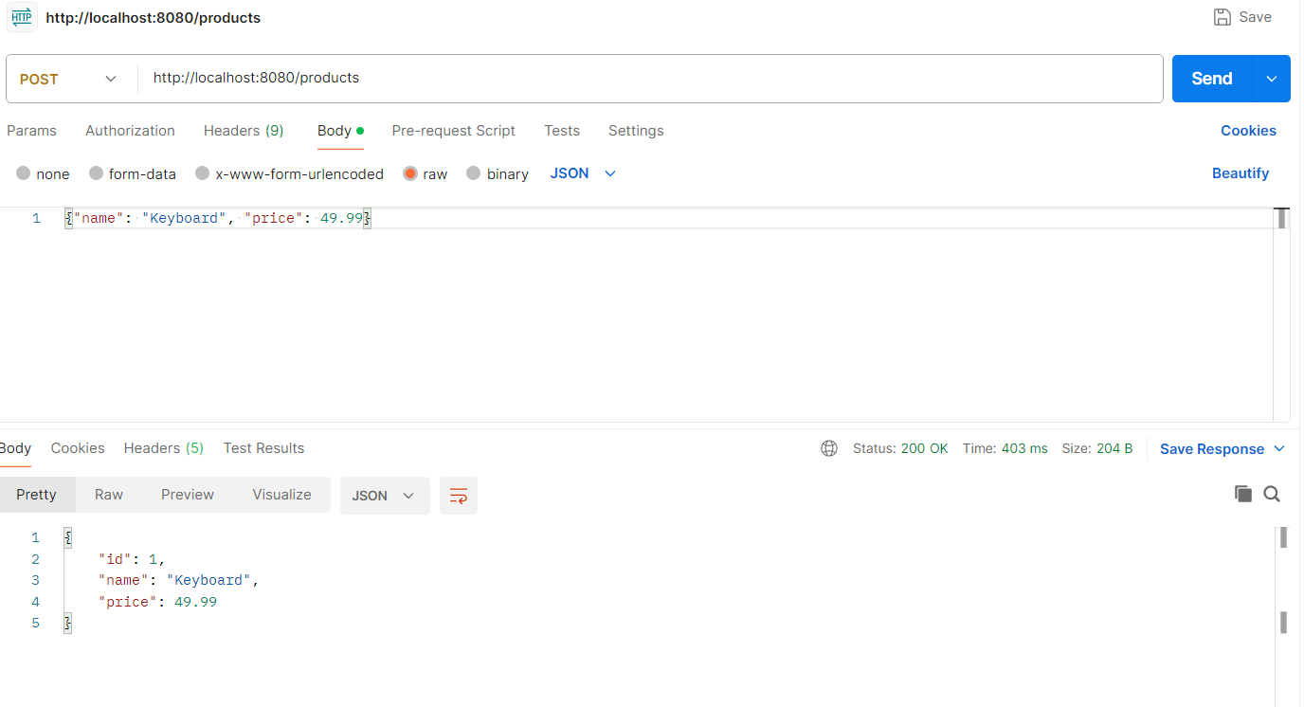

Product is inserted in Product table

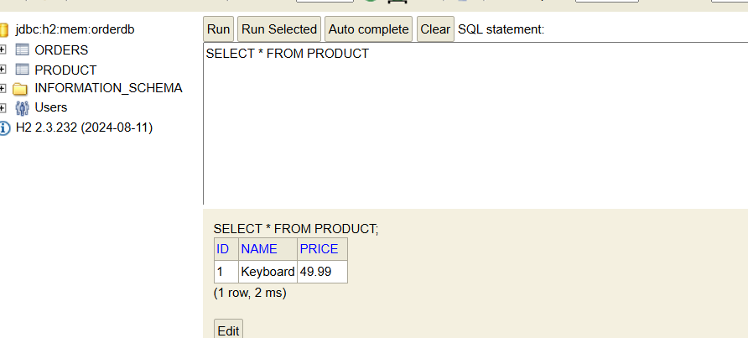

**Step 2: Create an Order**

POST <http://localhost:8080/orders>

{"productId": 1}

RESPONSE 200 OK

{

    "id": 1,

    "productId": 1,

    "status": "FAILED"

}

Order is created in ORDERS table

First with PENDING status

Then status changed to PROCESSING

Sleeps for 2 seconds then sets status to COMPLETED or FAILED

To capture every status in DB, I have added a delay for 2 secs before updating to PROCESSING, hence total duration in response is 5s. We can get rid of that change and just add logs on status changed

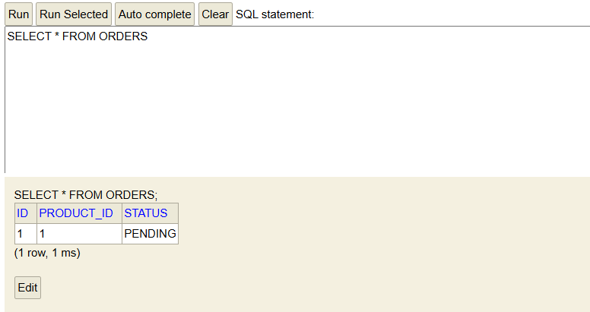

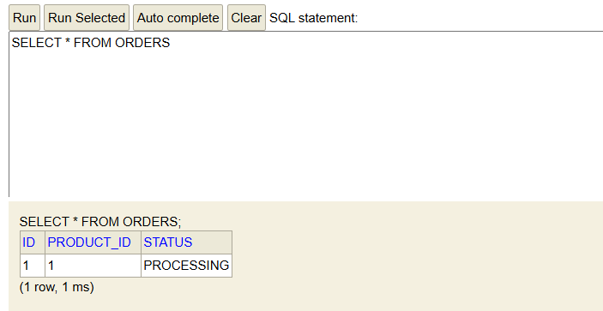

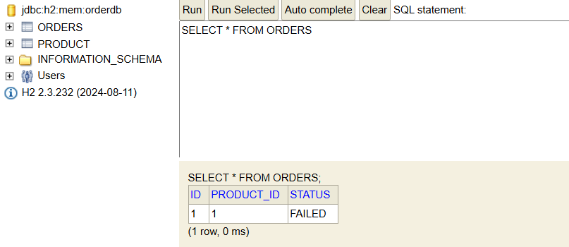

2nd Run

