Prerequisite: A file named MATMAST.txt is present in D:

It has the following contents.

MATV5 1 FERT SHORTDESC KG 02

MATV6 1 FERT SHORTDESC KG 02

MATV7 1 FERT SHORTDESC KG 02

MATV8 1 FERT SHORTDESC KG 02

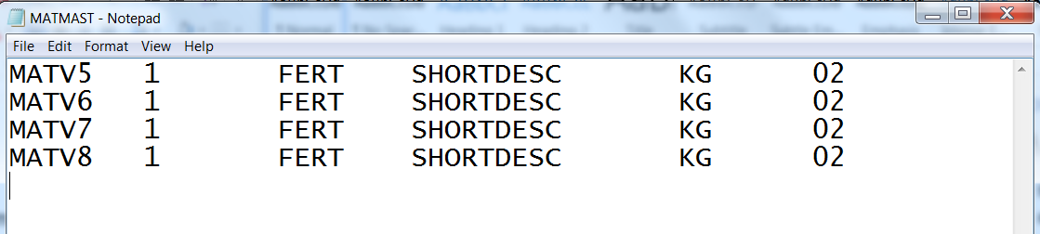

It is a tab separated file.

After you execute ZTR_FILEHANDLING_UPLOAD, the following screen is displayed.

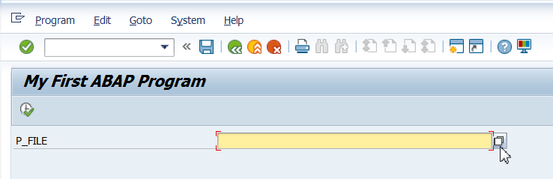

Select the path and the file.

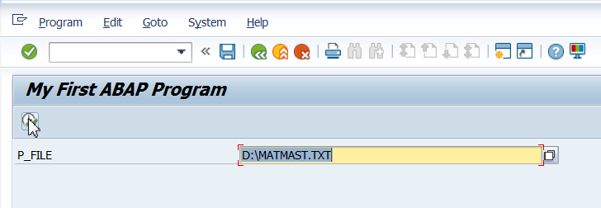

After you click execute, the file gets uploaded on Application Server.

Go To TCode, AL11. Double click on directory DIR_HOME.

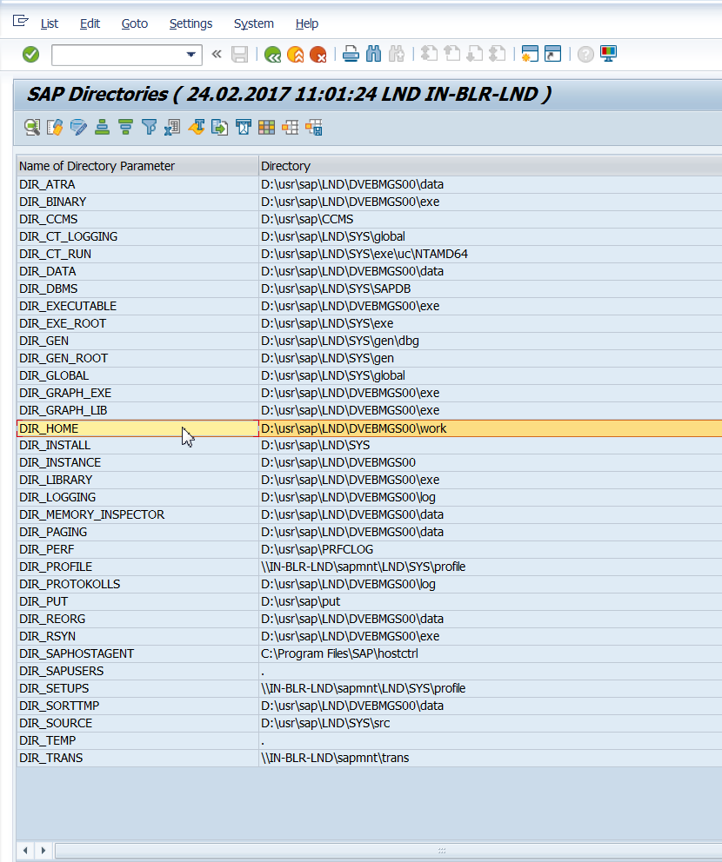

Double click on the name of the logical file name that was given in the program.

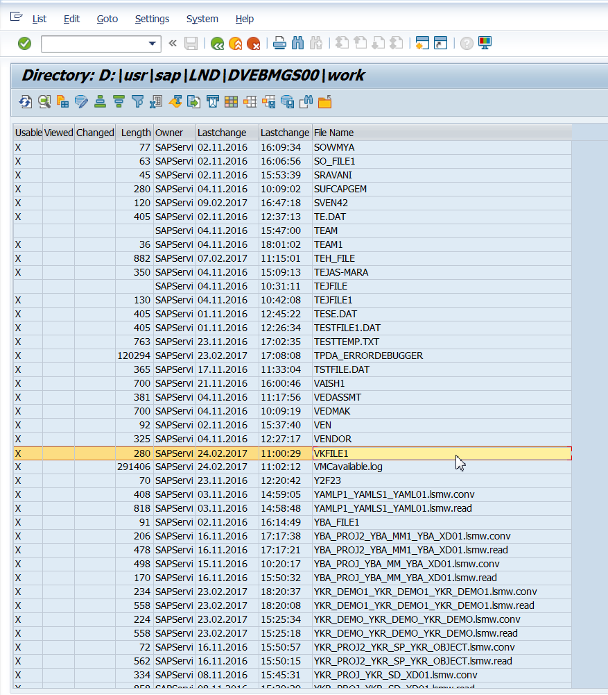

Observe the contents. The directory indicates the path on the application server.

