1. Go to SE80
2. Create a program
3. Create with Top Include. Give a name for Top Include.
4. Mention the Type of Program as Module Pool
5. Code in Top Include with below code

*&---------------------------------------------------------------------*  
*& Include Z104329MPTOP                                      Module Pool      Z104329MODULEPOOL1  
*&  
*&---------------------------------------------------------------------*  
PROGRAM Z104329MODULEPOOL1.  
data : lv_name type char20,

lv_Date type sy-datum.

1. Create Screen. Give screen number 100.
2. Screen Type is Normal. Click on Layout.

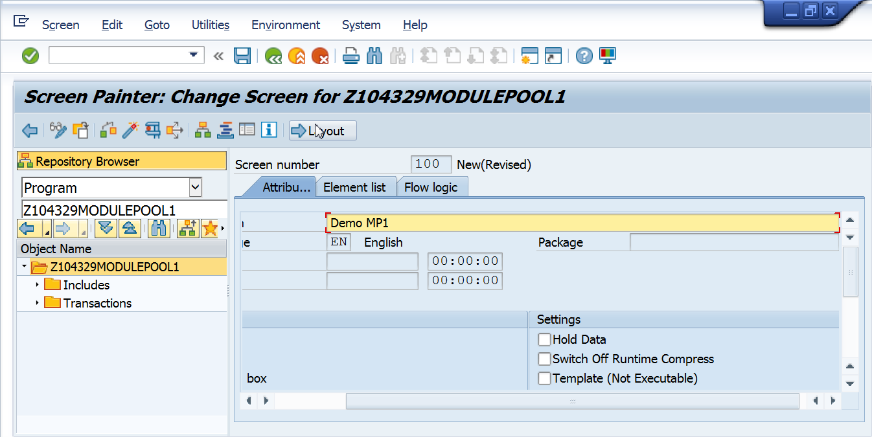

Create screen as below. Use Text Field and Input Output Field.

Give the names of I/O field as lv_name.

Give datatype of I/O field as SY-DATUM.

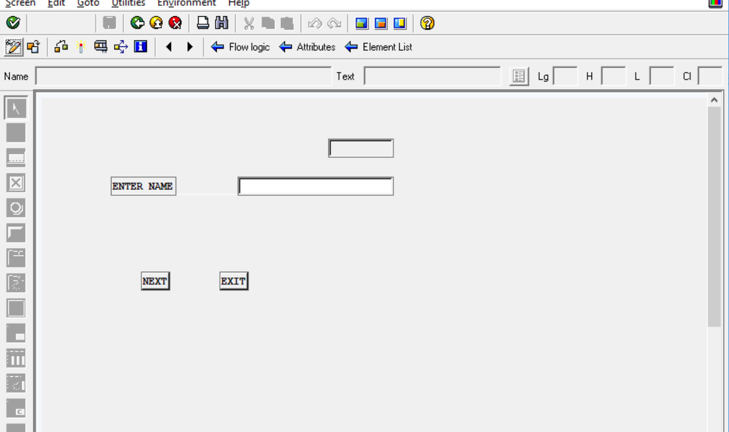

Create Pushbuttons for Save and Exit.

In the flow logic, uncomment

MODULE STATUS_0100.  
MODULE USER_COMMAND_0100.  
*\**

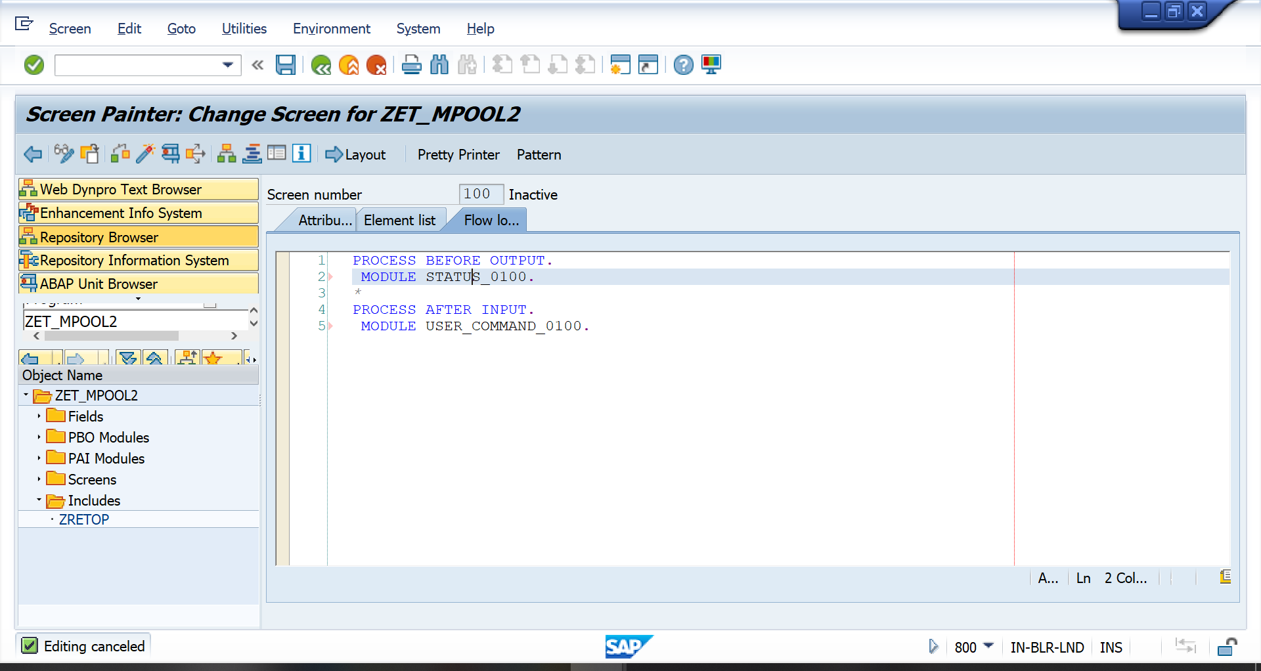

Double click on MODULE STATUS_0100..

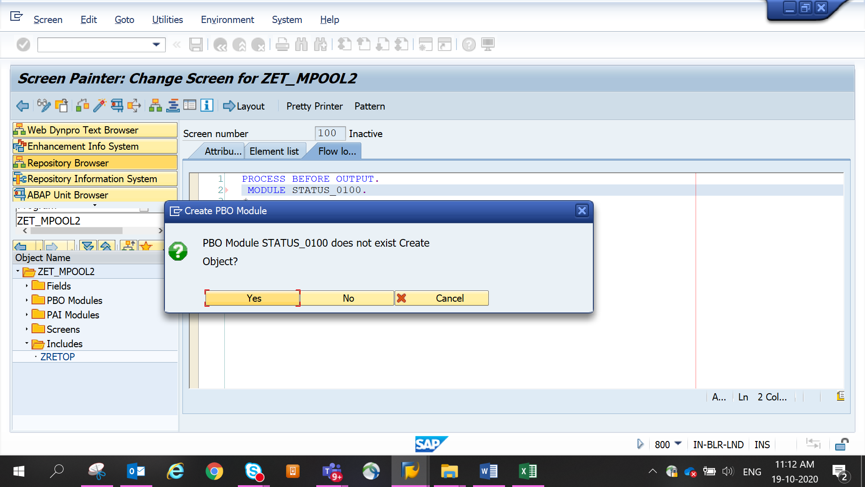

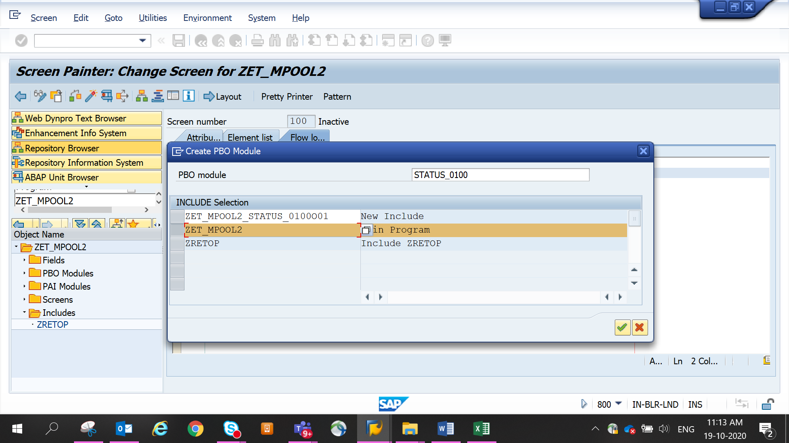

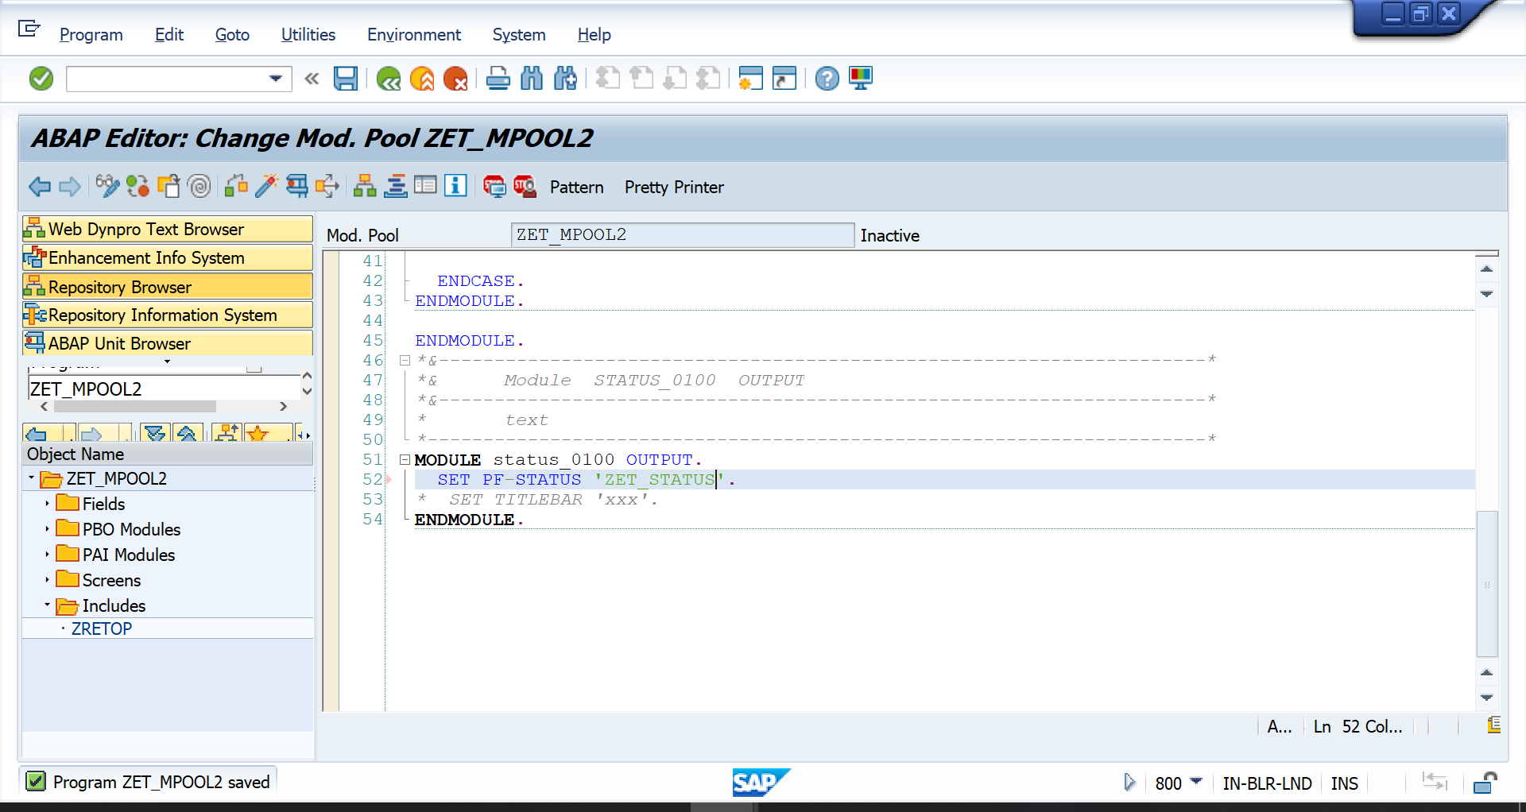

Similarly Double click on MODULE USER_COMMAND_0100.

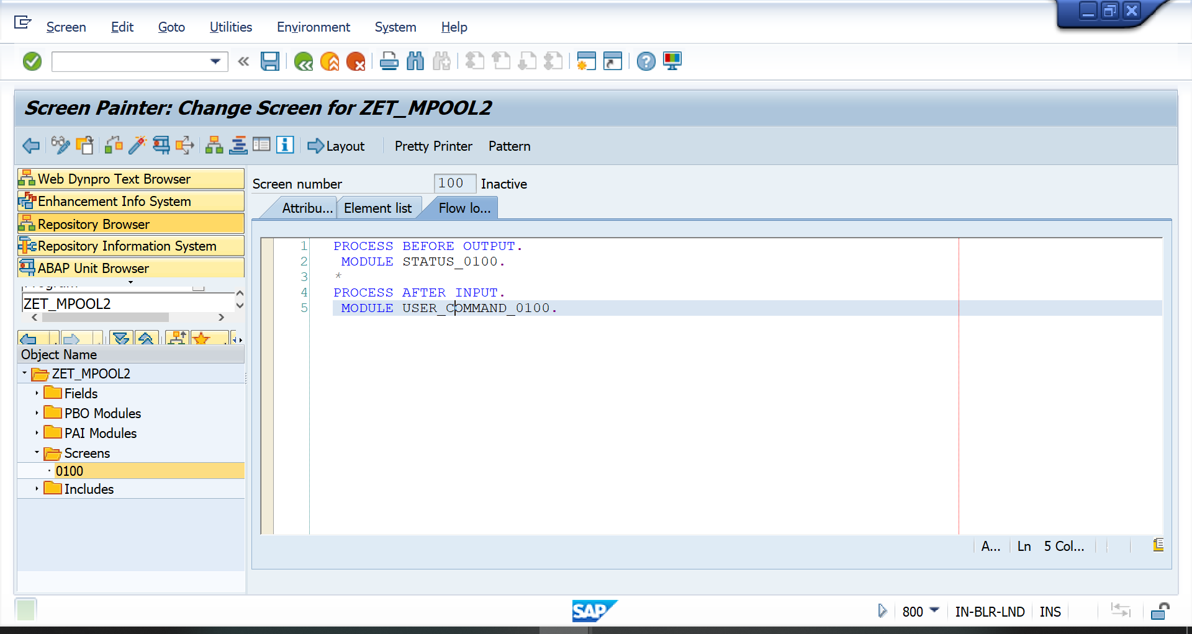

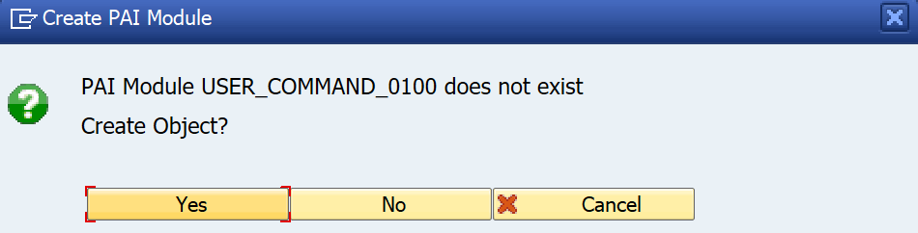

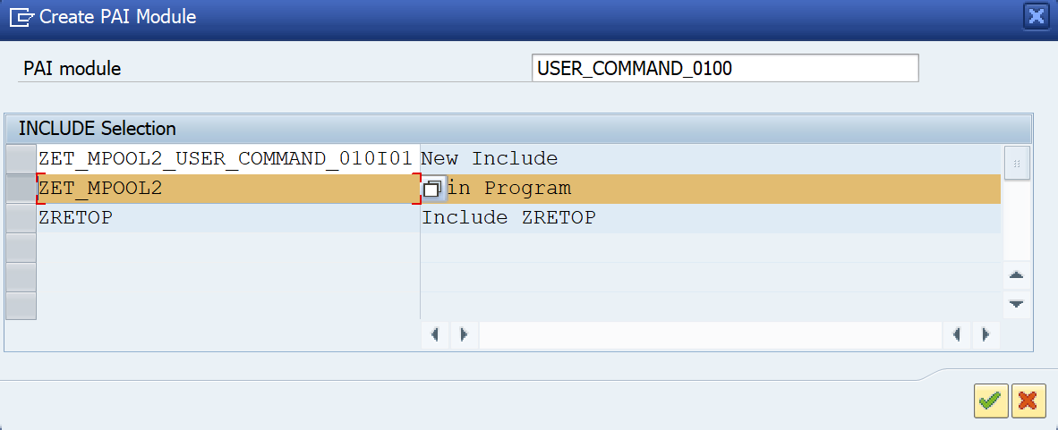

Code in PAI

MODULE user_command_0200 INPUT.  
  
  CASE sy-ucomm.  
      
    WHEN 'EXIT'.  
      LEAVE TO SCREEN 0.  
  
  ENDCASE.  
ENDMODULE.

Create Transaction Code.

