1. Go to SE80
2. Create a program
3. Create with Top Include. Give a name for Top Include.
4. Mention the Type of Program as Module Pool
5. Code in Top Include with below code

*&---------------------------------------------------------------------*  
*& Include Z104329MPTOP                                      Module Pool      Z104329MODULEPOOL1  
*&  
*&---------------------------------------------------------------------*  
PROGRAM Z104329MODULEPOOL1.  
DATA WADEPT TYPE Z104329DEPT.  
  
DATA: DEPTNO TYPE Z104329DEPT-DEPTNO,  
      DNAME TYPE Z104329DEPT-DNAME,  
      LOC TYPE  Z104329DEPT-LOC.

1. Create Screen. Give screen number 100.
2. Screen Type is Normal. Click on Layout.

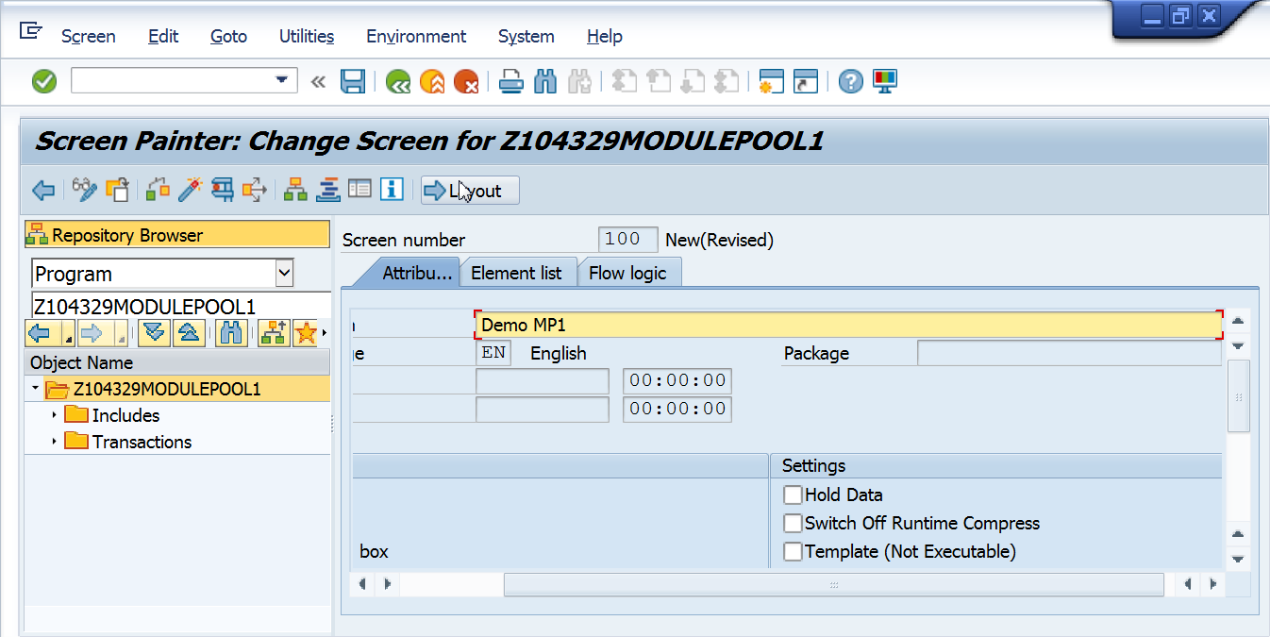

Create screen as below. Use Text Field and Input Output Field.

Give the names of I/O field as DEPTNO, DNAME, LOC.

Give datatype of DEPTNO I/O field as NUMC. DNAME and LOC are CHAR.

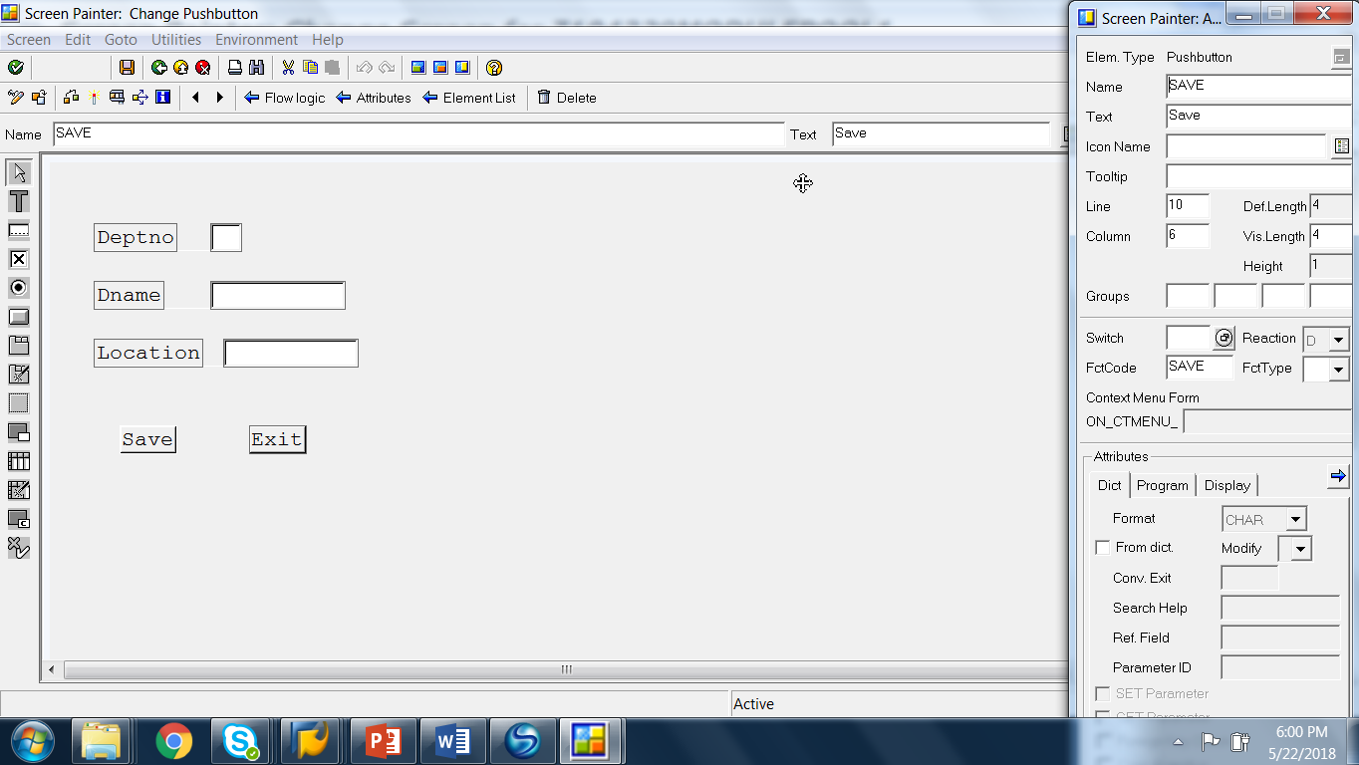

Create Pushbuttons for Save and Exit.

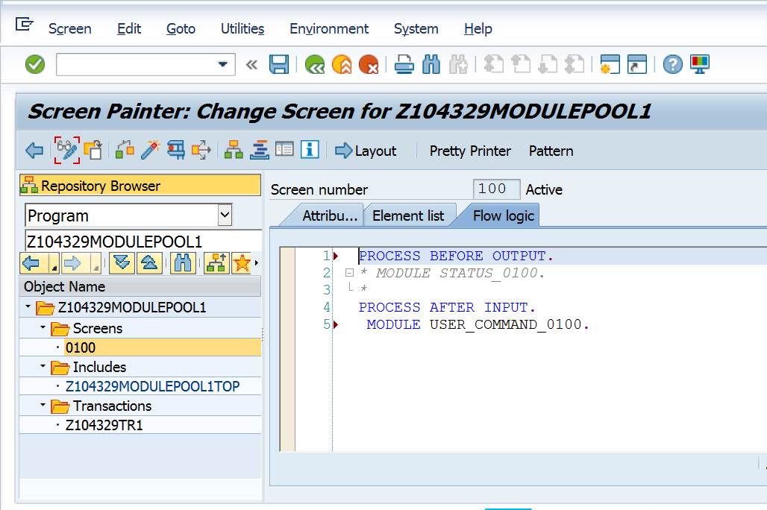

Uncomment MODULE USER_COMMAND_0100 and double click on it.

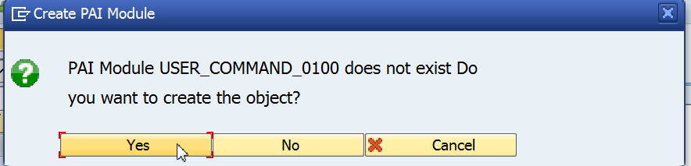

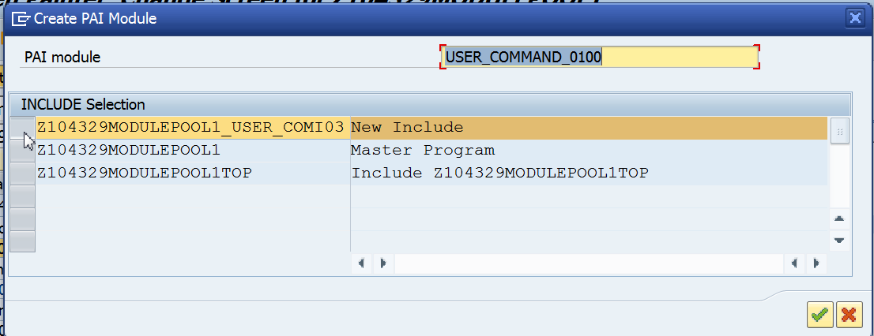

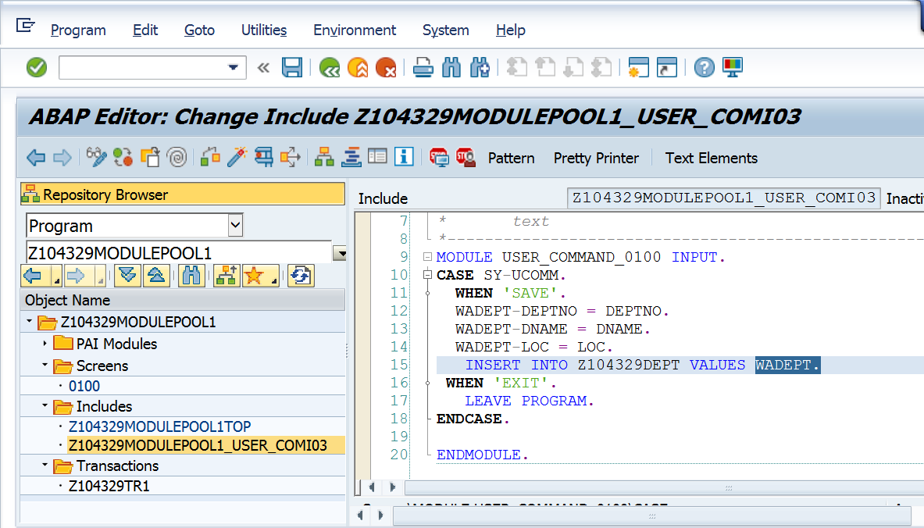

Code in PAI

MODULE user_command_0100 INPUT.  
CASE SY-UCOMM.  
  WHEN 'SAVE'.  
  WADEPT-DEPTNO = DEPTNO.  
  WADEPT-DNAME = DNAME.  
  WADEPT-LOC = LOC.  
   INSERT INTO Z104329DEPT VALUES WADEPT.  
 WHEN 'EXIT'.  
   LEAVE PROGRAM.  
ENDCASE.  
ENDMODULE.

Create Transaction Code.

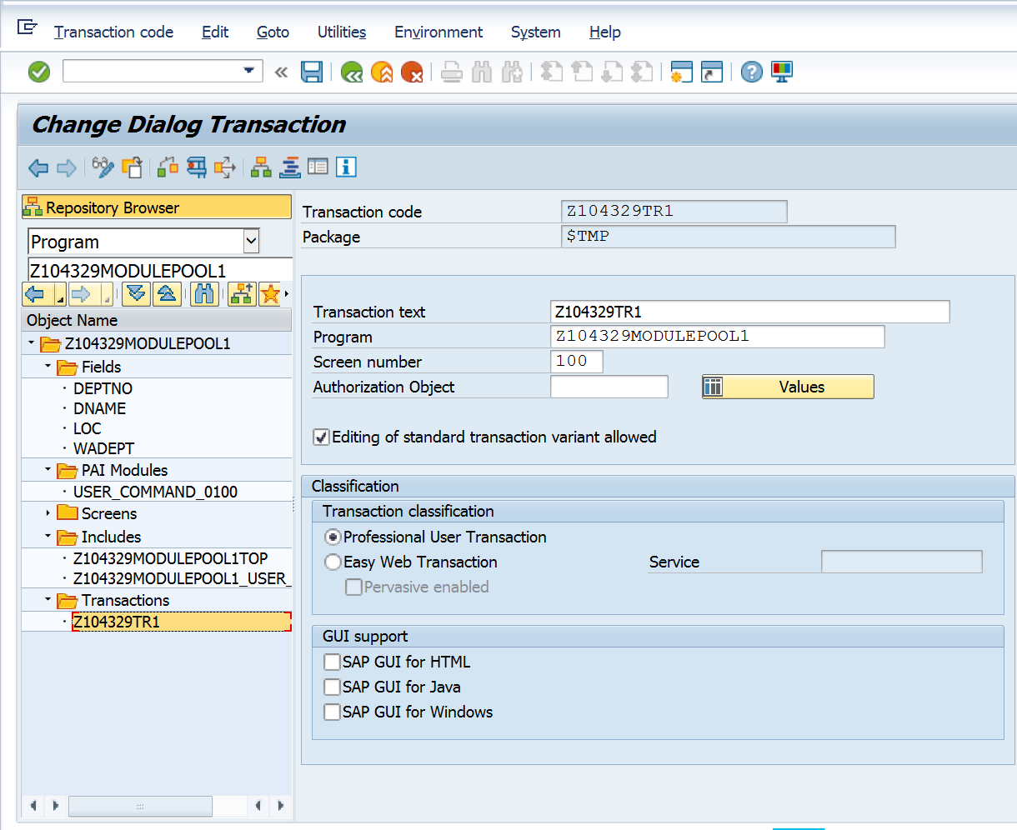

Execute the above to add a record in the dept table.

Modify the above program to add a button for Display.

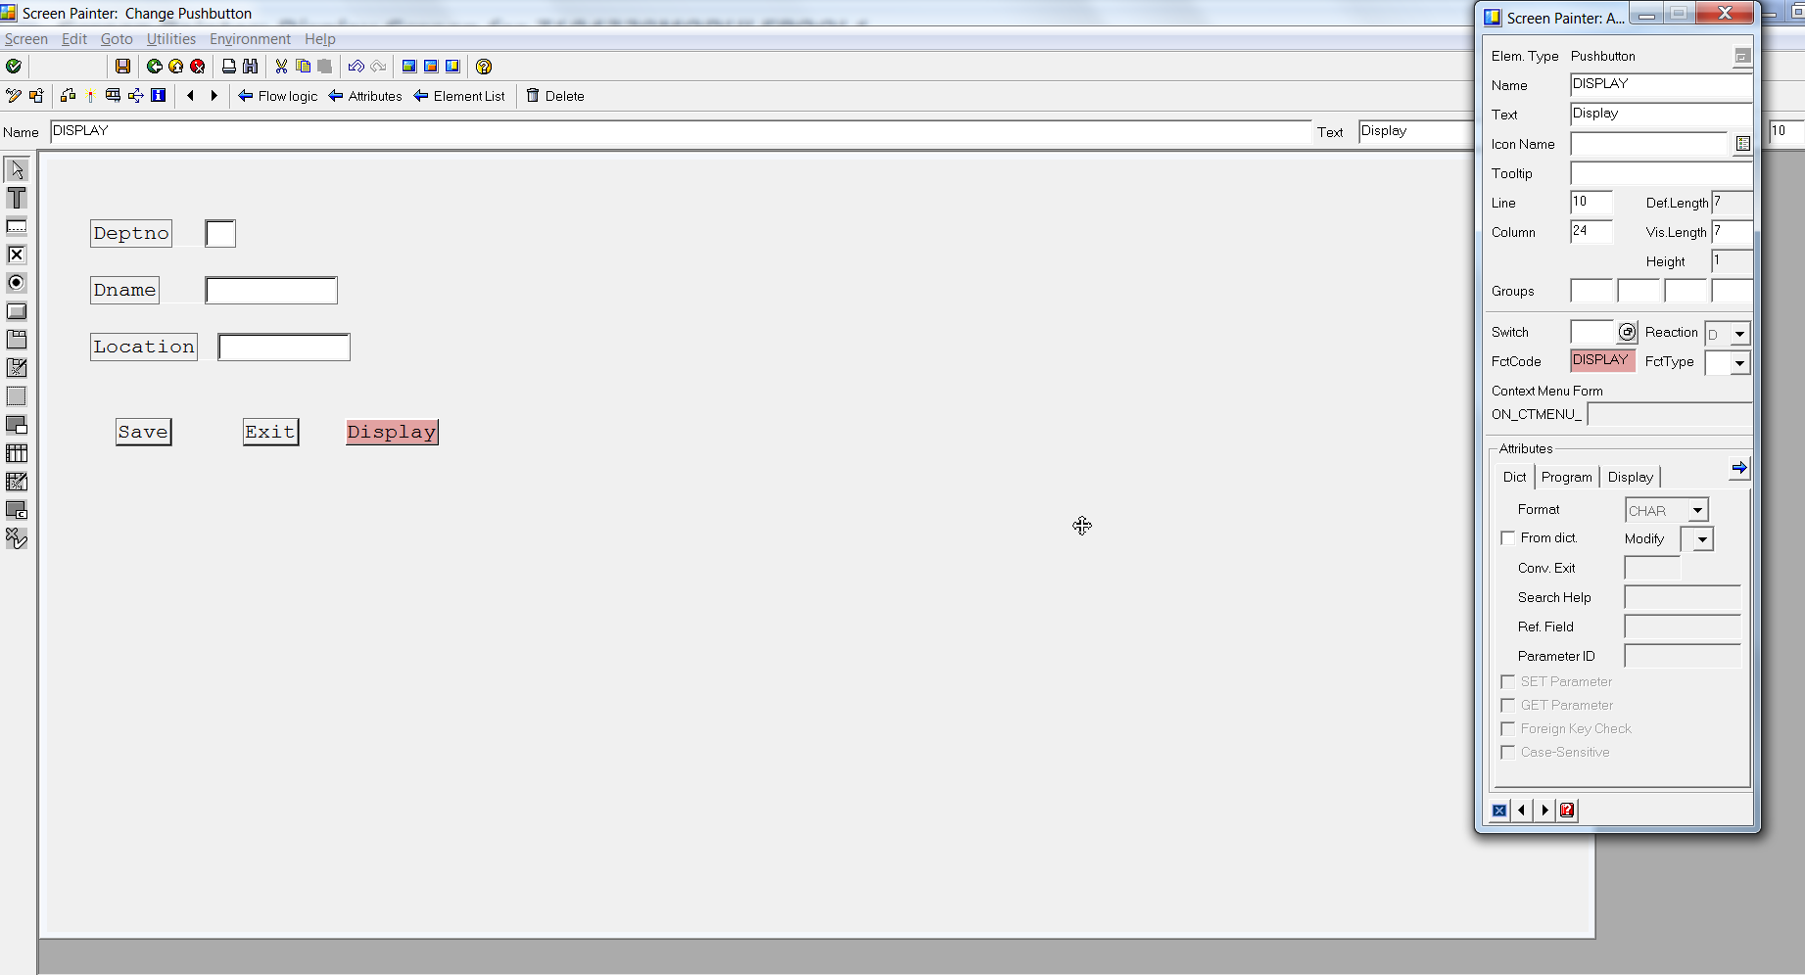

Modify the code in PAI as below. Look at the code highlighted in Yellow.

This is the code added now.

MODULE user_command_0100 INPUT.  
CASE SY-UCOMM.  
  WHEN 'SAVE'.  
    WADEPT-DEPTNO = DEPTNO.  
    WADEPT-DNAME = DNAME.  
    WADEPT-LOC = LOC.  
    INSERT INTO Z104329DEPT VALUES WADEPT.  
    MESSAGE I003(Z104329MSGCLASS) WITH SY-SUBRC.  
  WHEN 'DISPLAY'.  
    PERFORM DISP.  
  WHEN 'EXIT'.  
     LEAVE PROGRAM.  
ENDCASE.  
ENDMODULE.  
  
FORM DISP.  
  SELECT * FROM Z104329DEPT INTO WADEPT WHERE DEPTNO = DEPTNO.  
  ENDSELECT.  
   DNAME = WADEPT-DNAME.  
   LOC  = WADEPT-LOC.  
  
ENDFORM.