Make a copy of the first module pool program,.(Module_Pool_Demo1).

Make the following changes.

*&---------------------------------------------------------------------*  
*& Include Z104329MODULEPOOL1TOP                             Module Pool      Z104329MODULEPOOL1  
*&  
*&---------------------------------------------------------------------*  
PROGRAM Z104329MODULEPOOL1.  
TABLES Z104329DEPT1.  
*DATA: DEPTNO TYPE Z104329DEPT-DEPTNO,  
*      DNAME TYPE Z104329DEPT-DNAME,  
*      LOC TYPE Z104329DEPT-LOC.  
*  
*DATA WADEPT  TYPE Z104329DEPT.

Get fields from dictionary. Ensure that DB Fields have data Elements and Field Labels.

The Medium Field labels are displayed here.

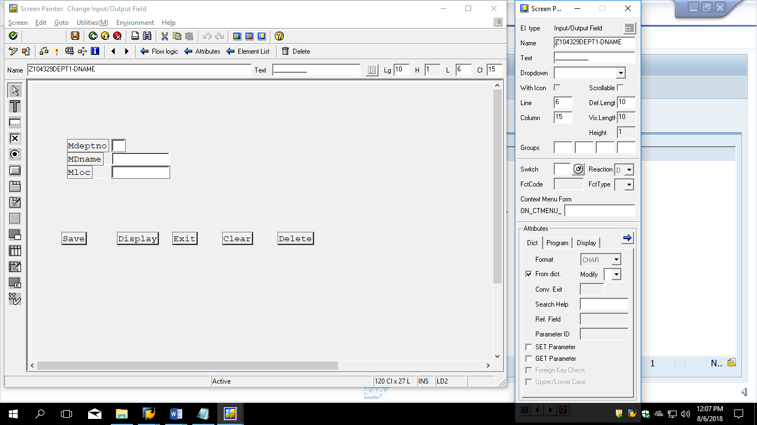

*----------------------------------------------------------------------*  
***INCLUDE Z104329MODULEPOOL1_USER_COMI01.  
*----------------------------------------------------------------------*  
*&---------------------------------------------------------------------*  
*&      Module  USER_COMMAND_0100  INPUT  
*&---------------------------------------------------------------------*  
*       text  
*----------------------------------------------------------------------*  
MODULE USER_COMMAND_0100 INPUT.  
CASE SY-UCOMM.  
   WHEN 'SAVE'.  
        PERFORM SAVEPARA.  
    WHEN 'DISP'.  
         PERFORM DISPPARA.  
    WHEN 'DELETE'.  
         PERFORM DELPARA.  
    WHEN 'CLEAR'.  
         PERFORM CLEARPARA.  
    WHEN 'EXIT'.  
         LEAVE PROGRAM.  
ENDCASE.  
ENDMODULE.  
*&---------------------------------------------------------------------*  
*&      Form  SAVEPARA  
*&---------------------------------------------------------------------*  
*       text  
*----------------------------------------------------------------------*  
*  -->  p1        text  
*  <--  p2        text  
*----------------------------------------------------------------------*  
FORM SAVEPARA .  
*WADEPT-DEPTNO = DEPTNO.  
*WADEPT-DNAME = DNAME.  
*WADEPT-LOC = LOC.  
  
INSERT Z104329DEPT1 FROM Z104329DEPT1.  
MESSAGE I001(Z104329MSGCLASS) WITH 'SY-SUBRC' SY-SUBRC.  
  
IF SY-SUBRC NE 0.  
  MESSAGE I001(Z104329MSGCLASS) WITH 'Record already present'  SY-SUBRC.  
ENDIF.  
  
ENDFORM.  
  
  
FORM DISPPARA.  
SELECT * FROM Z104329DEPT1  
       WHERE DEPTNO = Z104329DEPT1-DEPTNO.  
ENDSELECT.  
MESSAGE I001(Z104329MSGCLASS) WITH 'SY-SUBRC' SY-SUBRC.  
IF SY-SUBRC NE 0.  
  MESSAGE I001(Z104329MSGCLASS) WITH 'Record does not exists'  SY-SUBRC.  
ENDIF.  
  
ENDFORM.  
  
  
FORM DELPARA.  
   DELETE FROM Z104329DEPT1  
       WHERE DEPTNO = Z104329DEPT1-DEPTNO.  
MESSAGE I001(Z104329MSGCLASS) WITH 'SY-SUBRC' SY-SUBRC.  
IF SY-SUBRC NE 0.  
  MESSAGE I001(Z104329MSGCLASS) WITH 'Record does not exists'  SY-SUBRC.  
ENDIF.  
ENDFORM.  
  
  
FORM CLEARPARA.  
  CLEAR Z104329DEPT1.  
ENDFORM.

Make changes as below

In the Element list create ok_code as shown below.

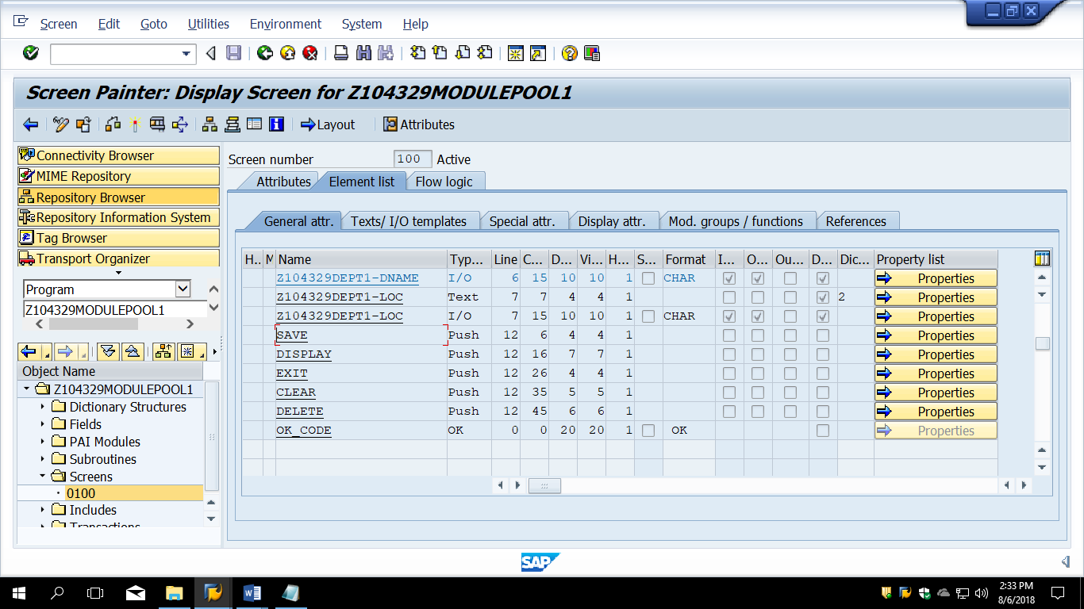

Declare ok_code in top include

DATA OK_CODE TYPE SY-UCOMM.

Make Minor change in PAI as shown below. Use ok_code instead of sy-ucomm.

Rest entire code remains ad above.

MODULE USER_COMMAND_0100 INPUT.  
CASE OK_CODE.  
"CASE SY-UCOMM.  
   WHEN 'SAVE'.  
        PERFORM SAVEPARA.  
    WHEN 'DISP'.  
         PERFORM DISPPARA.  
    WHEN 'DELETE'.  
         PERFORM DELPARA.  
    WHEN 'CLEAR'.  
         PERFORM CLEARPARA.  
    WHEN 'EXIT'.  
         LEAVE PROGRAM.  
ENDCASE.  
ENDMODULE.