**Adobe forms demo program # 1.**

***Program theme:*** *In this demo program you will get basic navigation how to create the Adobe Interface and Adobe Form.*

**Step # 1:** Go to transaction code SFP (For Adobe form and Interface creation).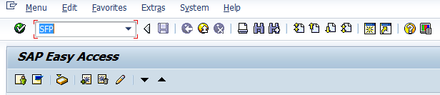

**Step # 2:** Select the interface radio button Provide the Interface name (Start with ‘Z’ or ‘Y’) and click on create.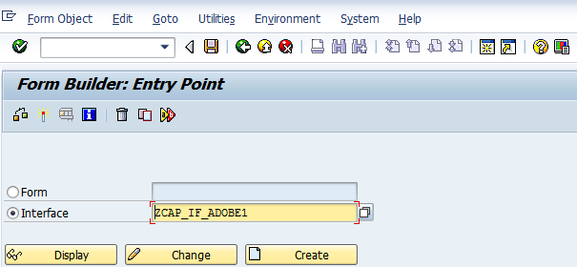

**Step # 3:** Provide the Interface description and select the Interface type as ABAP Dictionary-Based Interface from the drop down option and Click on the Save.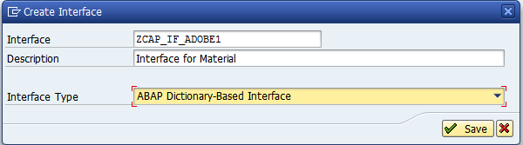

**Step # 4:** Save it in Package.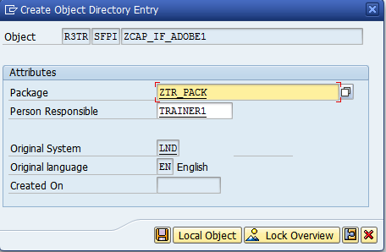

**Step # 5:** Select the Import parameter under the Form Interface. 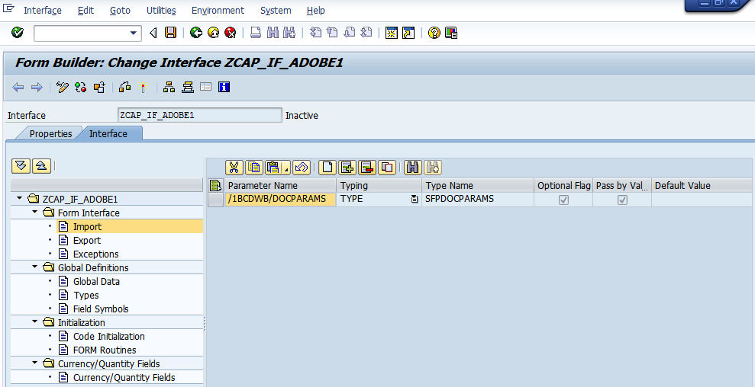

**Step # 6:** Click on Create button (5th Icon) in the tool bar of the right side window.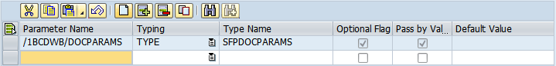

**Step # 7:** Provide the parameter name as GV_MATNR, select the TYPE under the Typing attribute and provide the data element name (MATNR) under the Type Name.

**Save and activate the Interface.**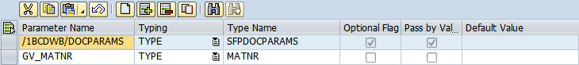

**Step # 8:** Go to transaction code SFP (For Adobe form and Interface creation). Select the Form Radio button and provide the Form Name (Start with ‘Z’ or ‘Y’) and click on create.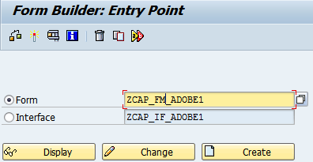

**Step # 9:** Provide the Adobe form description and click on Save.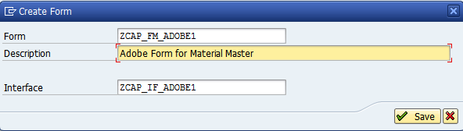

**Step # 10:** Save it in the package.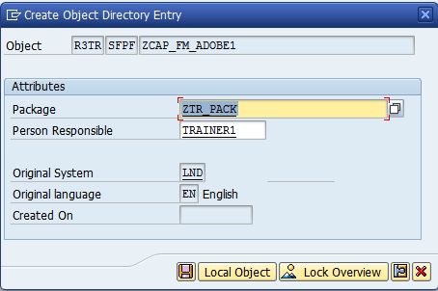

**Step # 11:** Expand the Import parameter under the interface and drag and drop the GV_MATNR to the context folder.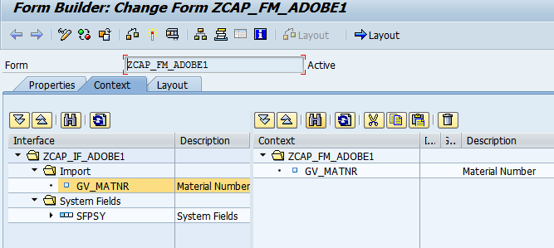

**Step # 12:** Double click on the GV_MATNR for more properties and conditions to select.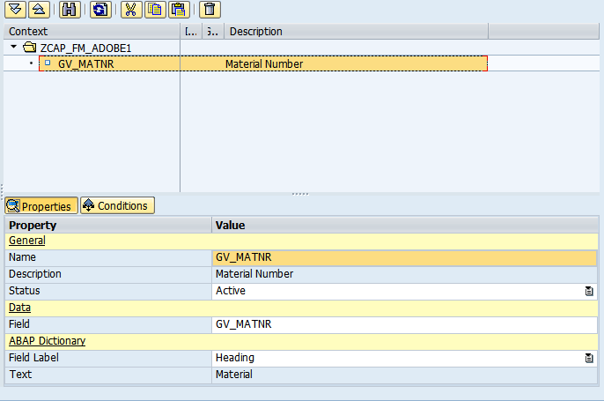

**Step # 13:** Click on the Layout tab.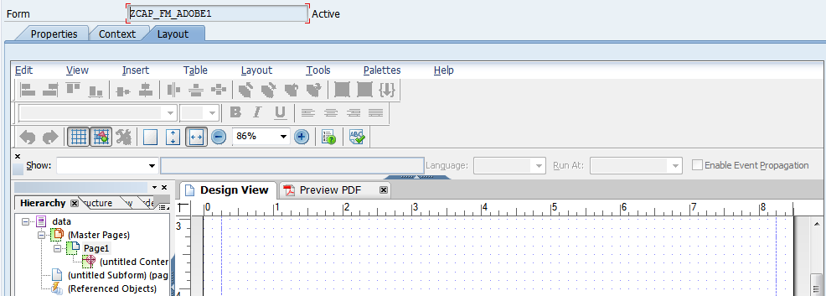

**Step # 14:** Go to palettes in the menu bar and double click on the Object Library.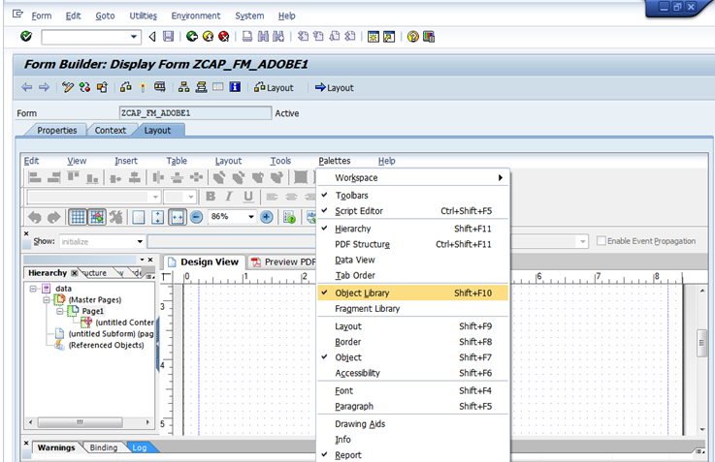

**Step # 15:** Expand the Standard properties option.

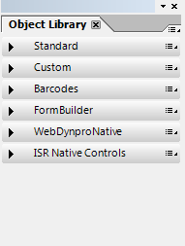

**Step # 16:** Select the **Text** option and drag and drop to the form layout.

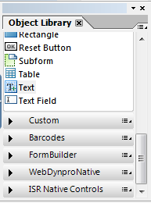

**Step # 17:** Provide the title.

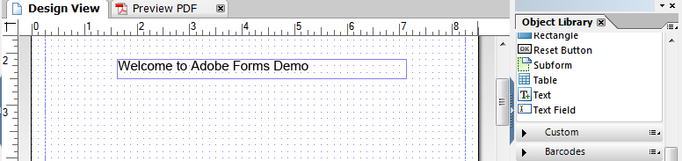

**Step # 18:** Select the **Text Field** option and drag and drop to the form layout.

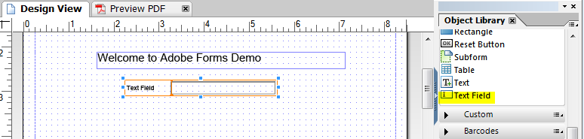

**Step # 19:** Right click on the **Text Field** (In the layout) go to Palettes and select the Object.

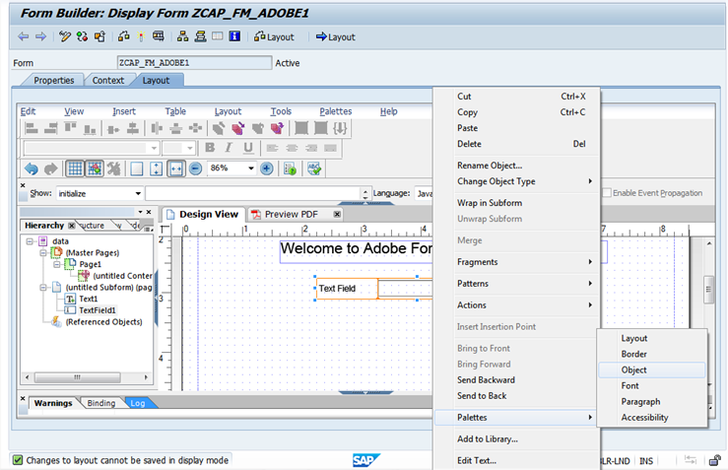

**Step # 20:** Go to **Field** tab and provide the Caption as Material Number: and select the Appearance as Sunken Box from the dropdown list.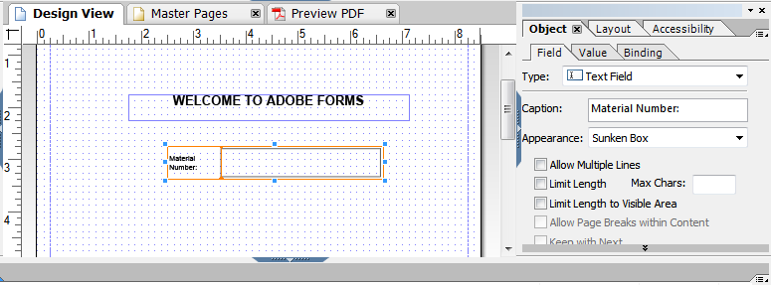

**Step # 21:** Go to **Value** tab and select the type as Read Only.

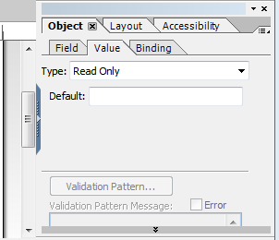

**Step # 22:** Go to **Binding** tab and select the binding arrow option under Data Binding.

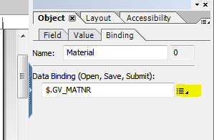

**Step # 23:** Navigate to “Use ZCAP_FM_DOBE1” and Click on GV_MATNR to bind it.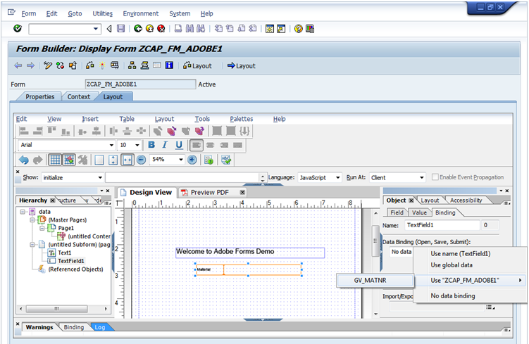

**Step # 24:** Save the form layout and click on context tab to activate the complete form. And Execute the Adobe form and provide the Material Number and execute it.

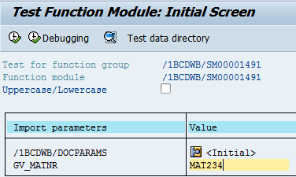

**Step # 25:** Provide the Output Device as LP01 (Default Print Purview) and click on Print Preview.

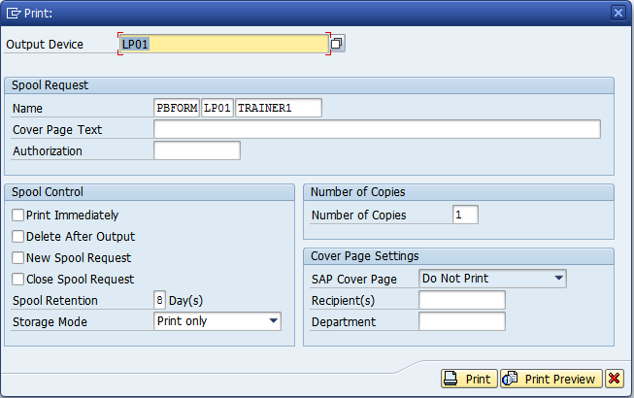

**Step # 26:** Check the below output.

