1. Create an Interface

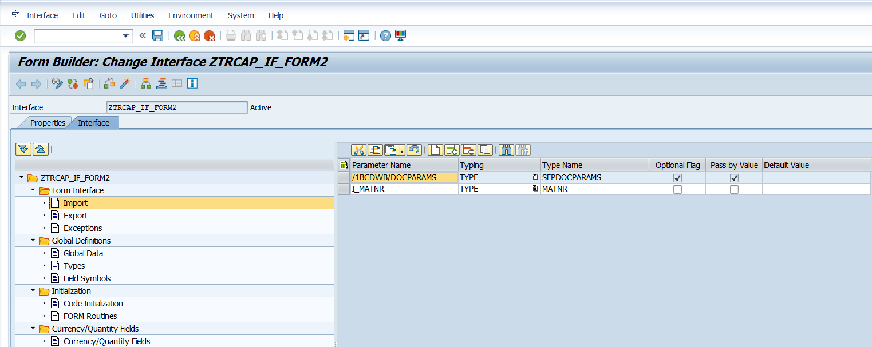

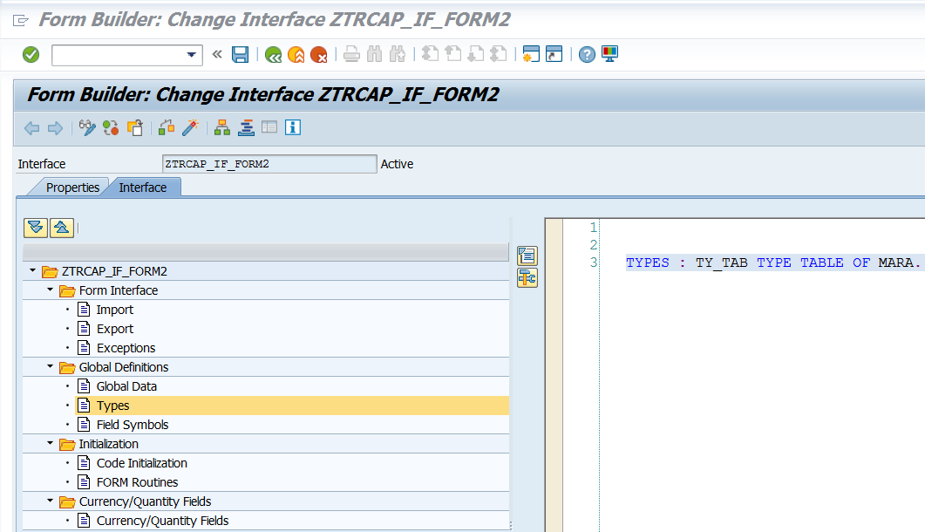

TYPES: TY_TAB TYPE TABLE OF MARA.

Note: Instead of above Type(TY_TAB), Type based on selected fields may be created.

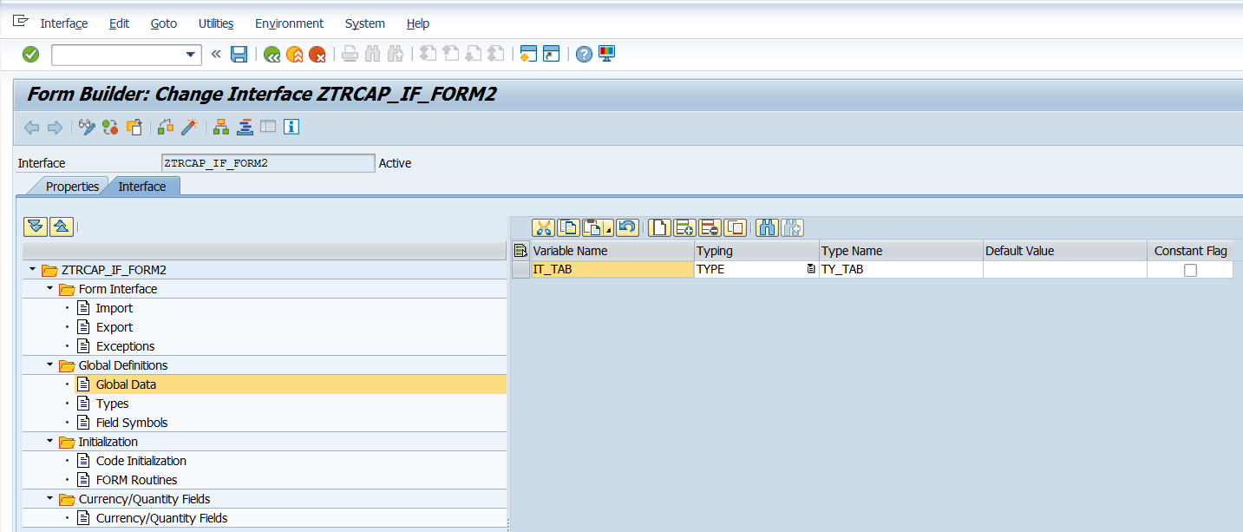

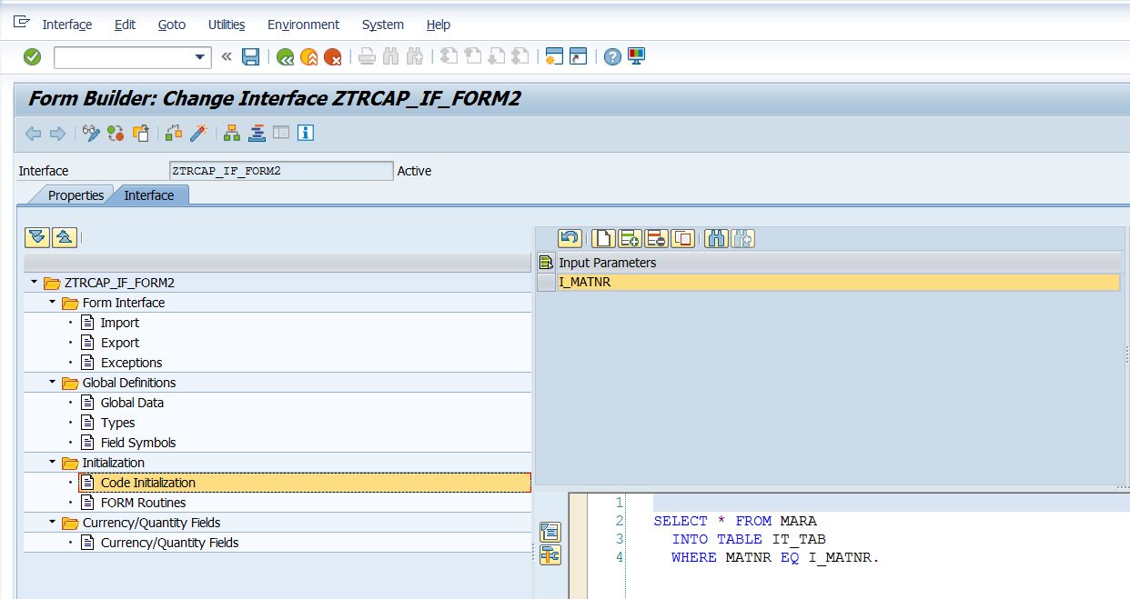

SELECT * FROM MARA   
INTO TABLE IT_TAB  
WHERE MATNR = I_MATNR.

Check, save and activate the interface.

Create a form, based on the interface created above.

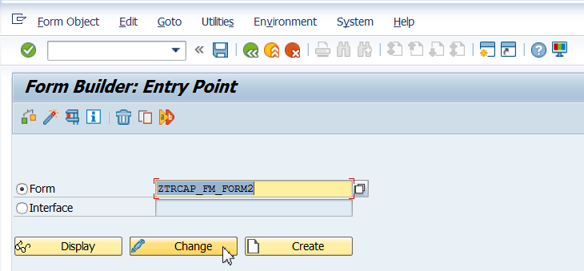

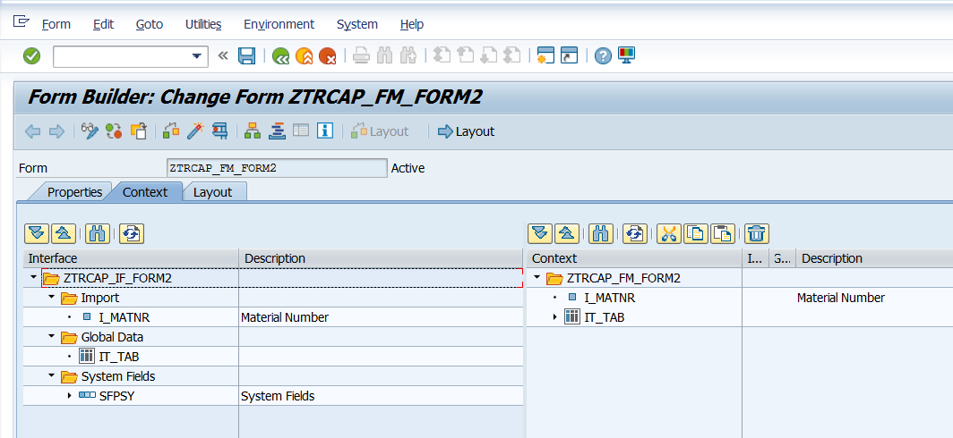

Drag and Drop I_MATNR from Interface to Context.

Drag and Drop IT_TAB from Interface to Context.

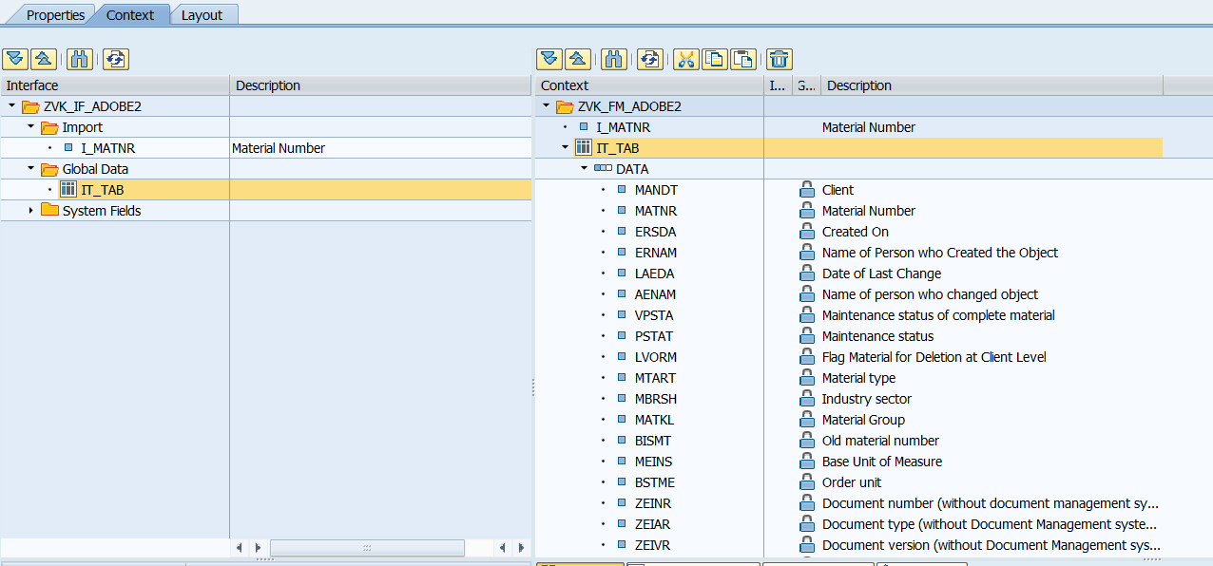

Go to the Layout. Create text fields as shown below and bind them.

Material – I_MATNR (The parameter value entered by the end user) – Header

Material : MATNR

Material Type: MTART

Base UOM: MEINS

Industry Sector: MBRSH

Material Group: MATKL

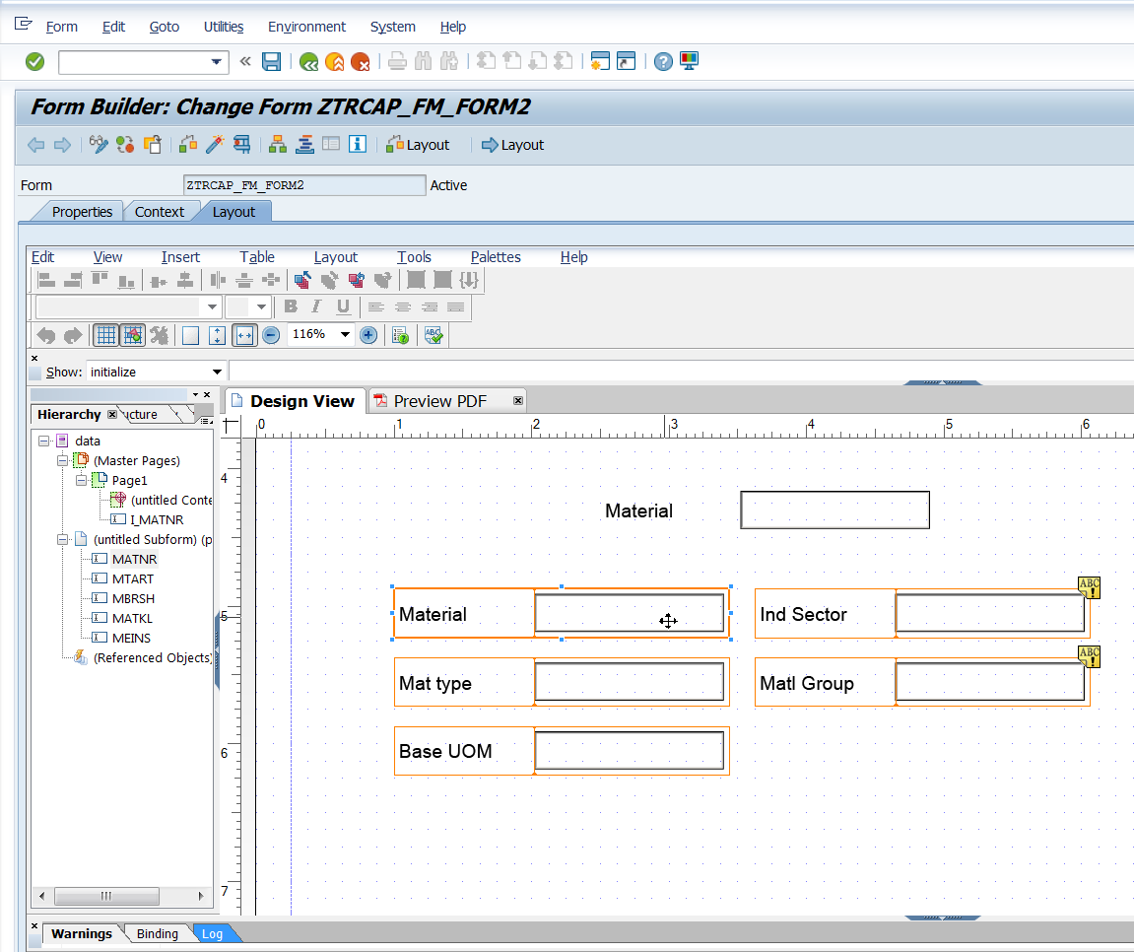

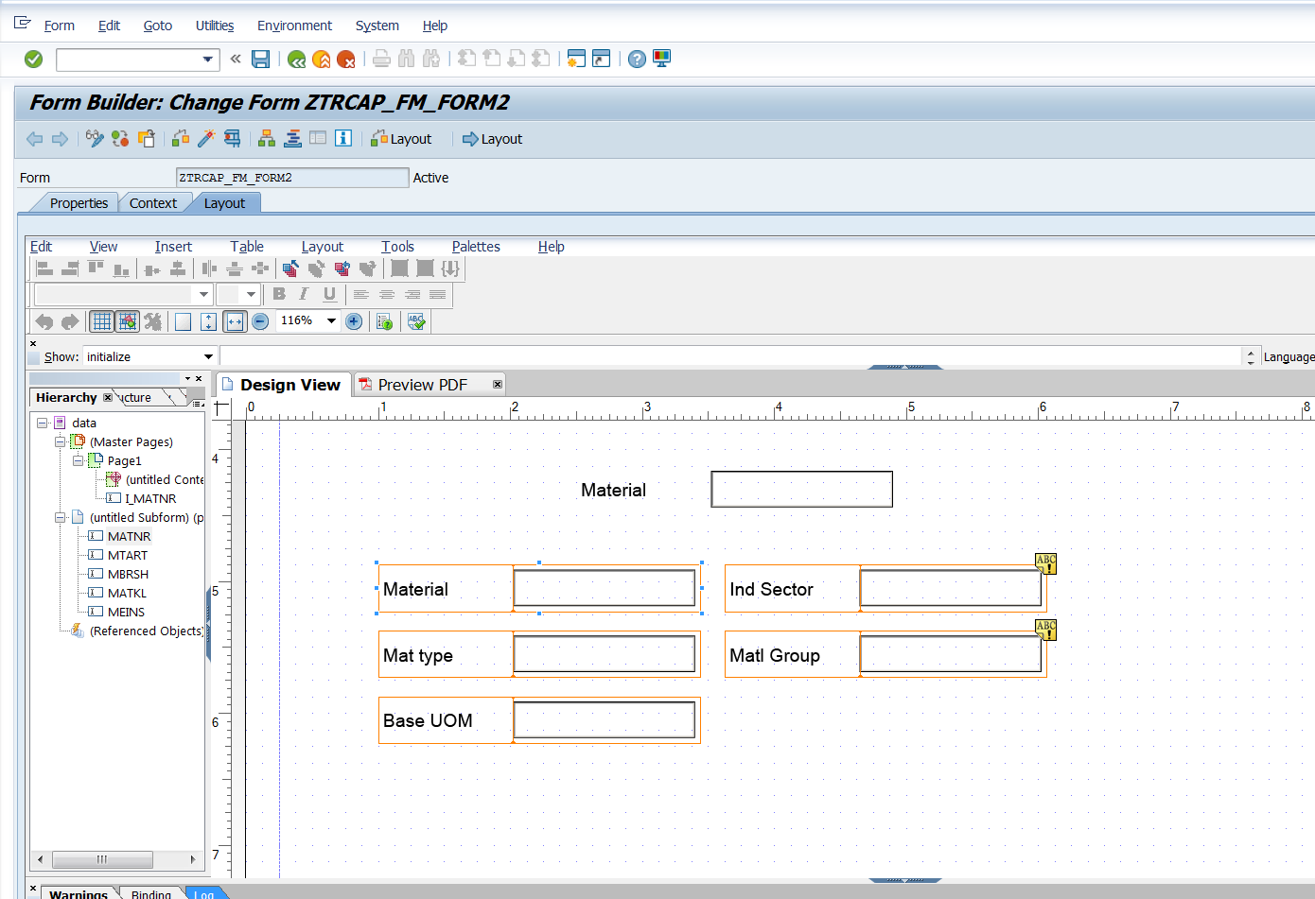

Data binding is important here.

