**Adobe forms alternative command demo program # 4.**

***Program theme:*** *In this demo program you will get how to work with alternative command in the Adobe form.*

**Step # 1:** Go to transaction code SFP (For Adobe form and Interface creation).

**Step # 2:** Select the interface radio button provide the interface name (Start with ‘Z’ or ‘Y’) and click on create.

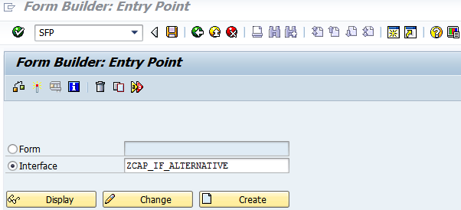

**Step # 3:** Provide the interface description and select the Interface type as ABAP Dictionary-Based Interface from the drop down option and click on the Save.

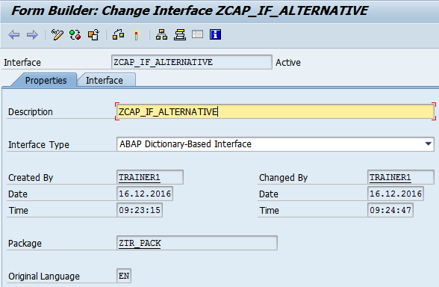

**Step # 4:** Save it in the package

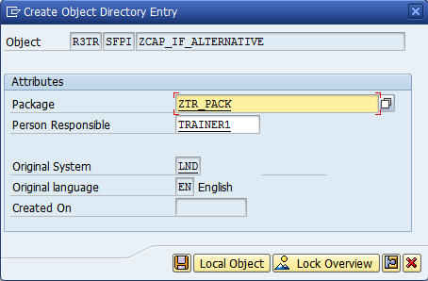

**Step # 5:** Select the Import parameter under the Form Interface and click on create button (5th Icon) in the tool bar of the right side window and provide the Import parameters.

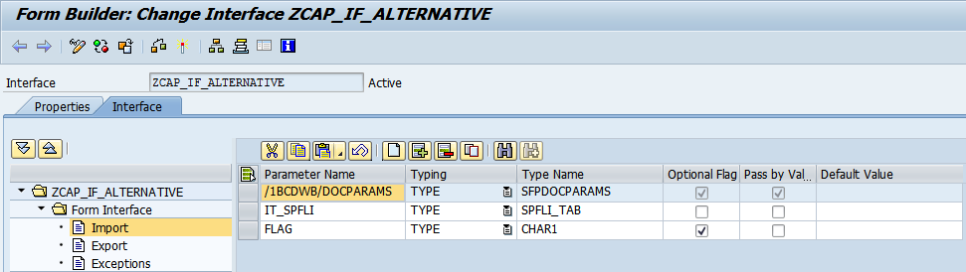

**Step # 6:** Select the Global Definitions under the Form Interface and click on create button (5th Icon) in the tool bar of the right side window and provide the Import parameters.

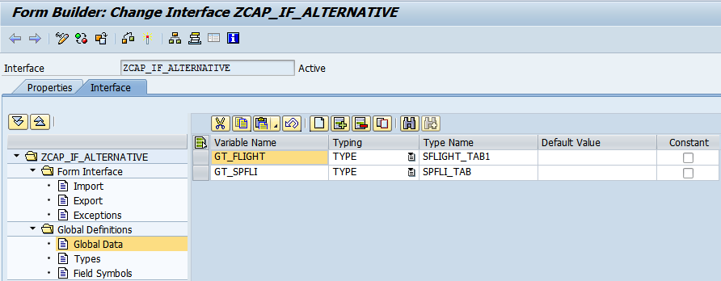

Note: SFLIGHT_TAB1 and SPFLI_TAB are predefined table types, defined in SE11.

**Step # 7:** Select the code initialization icon and provide the Input parameters, output parameters and write the code logic.

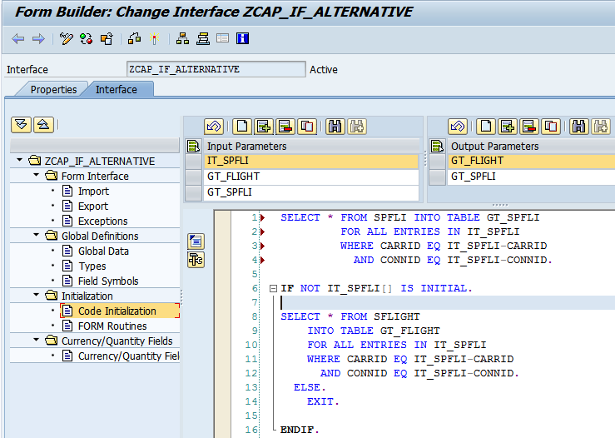

SELECT * FROM SPFLI INTO TABLE GT_SPFLI  
   FOR ALL ENTRIES IN IT_SPFLI  
   WHERE CARRID EQ IT_SPFLI-CARRID  
    AND  CONNID EQ IT_SPFLI-CONNID.  
    
  IF IT_SPFLI[] IS INITIAL.  
    SELECT * FROM SFLIGHT   
      INTO TABLE GT_FLIGHT  
   FOR ALL ENTRIES IN IT_SPFLI  
   WHERE CARRID EQ IT_SPFLI-CARRID  
    AND  CONNID EQ IT_SPFLI-CONNID.  
  ELSE.  
      EXIT.  
   ENDIF.

**Step # 8:** Go to transaction code SFP (For Adobe form and Interface creation). Select the Form Radio button and provide the Form Name (Start with ‘Z’ or ‘Y’) and click on create.

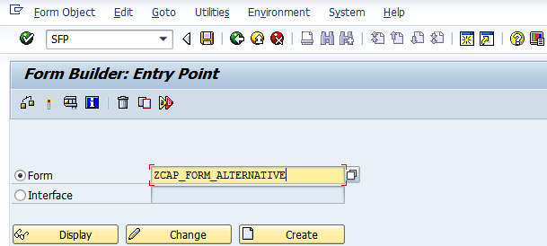

**Step # 9:** Save it in the package.

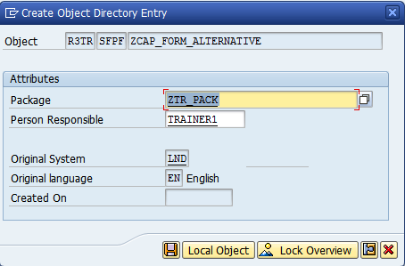

**Step # 10:** Provide the Adobe form description and interface name and click on context.

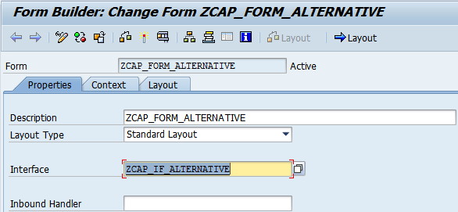

**Step # 11:** Select the FLAG from the Import tab and drag and drop to the context.

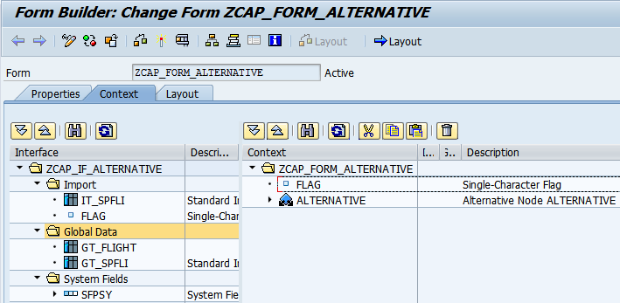

**Step # 12:** Double click on the FLAG and provide the properties.

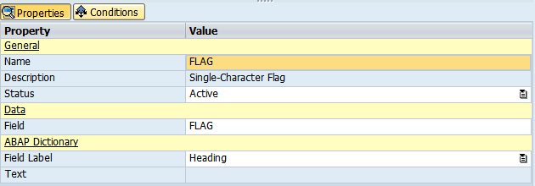

**Step # 13:** Select the FLAG and right click on it and click on create Alternative.

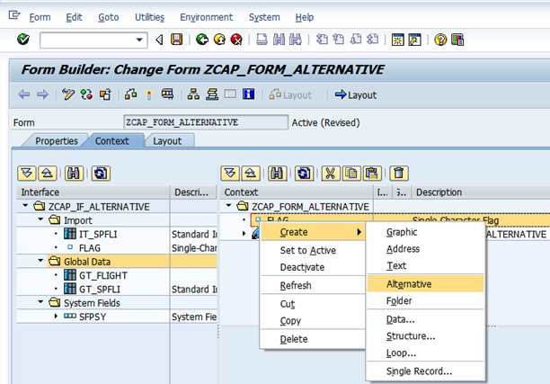

**Step # 14:** Provide the name for the Alternative command and other properties.

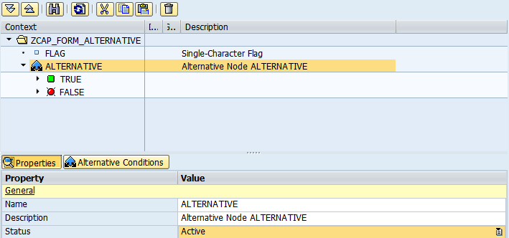

**Step # 15:** Expand the global data tab drag and drop the GT_SPFLI table from the interface to context under TRUE Node and repeat the same for GT_FLIGHT to the FALSE Node.

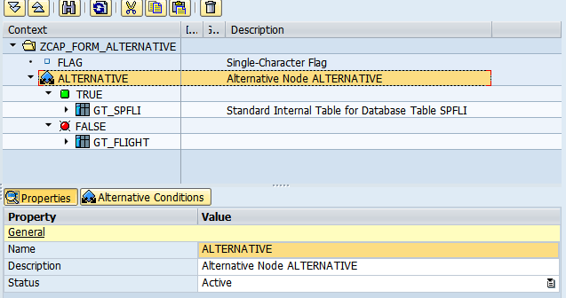

**Step # 16:** Expand the data tab under the GT_SPFLI and deactivate the fields which are not required.

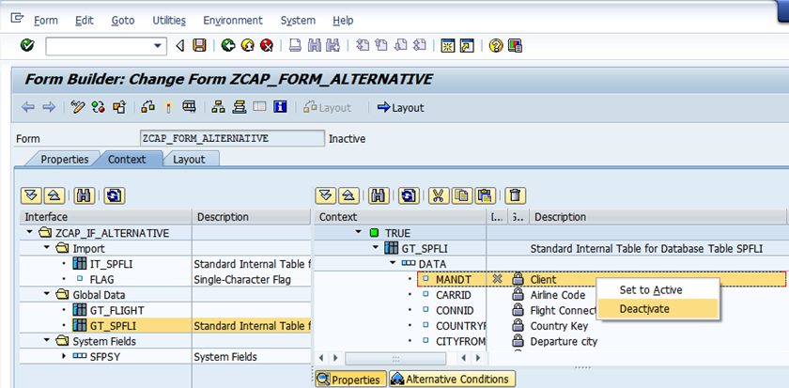

**Step # 17:** Expand the data tab under the GT_FLIGHT and deactivate the fields which are not required.

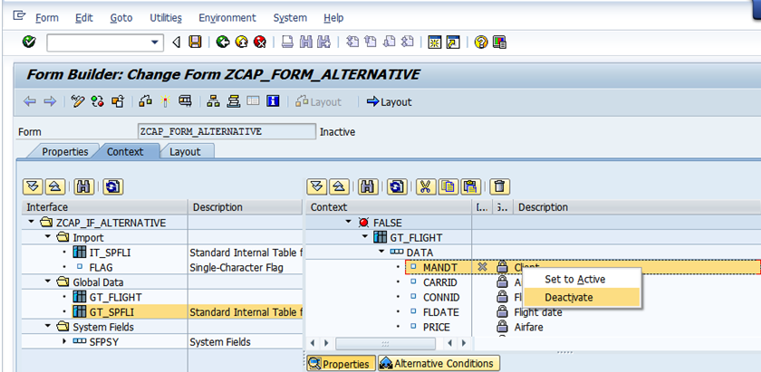

**Step # 18:** In the Layout,Go to Master Pages and go to palettes Menu 🡪 Select the Object Library from that select Text and drag and drop to the Master page design. And provide the title for the Form Heading.

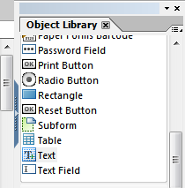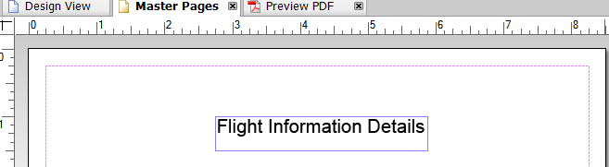

**Step # 19:** Navigate from **Hierarchy View** to **Data View** Drag all the fields to the Layout and design accordingly. **Note:** Binding will take place automatically for all the fields; not required to do manually.

Save and activate the form.

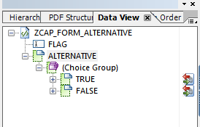

**Step # 20:** Click on the Layout tab and select the GT_SPFLI icon in the Data View, Drag and Drop it in design view as shown below.

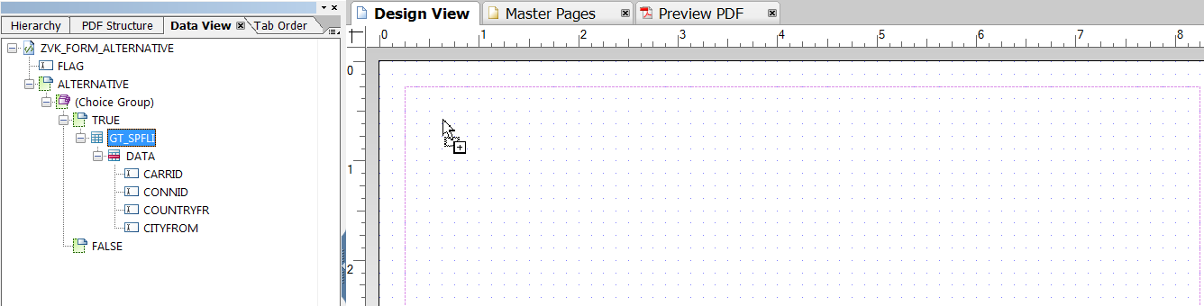

Similarly select the GT_SFLIGHT icon in the Data View, Drag and Drop it in design view as shown below.

Rename the Header columns so as to have it as shown below.

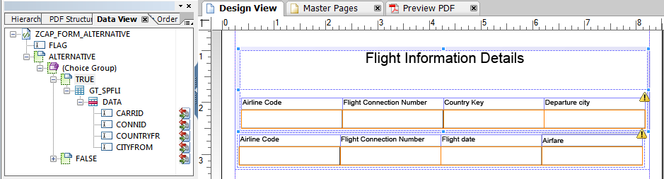

**Step # 21:** Click on the Layout Tab and select the GT_FLIGHT icon in the Data View and adjust the fields and tables properties as per the required format.

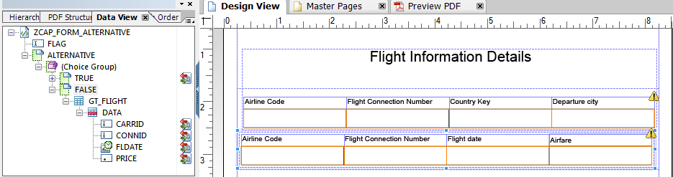

**Step # 22:** Save and activate the form and execute (F8). Provide the capital letter ‘X’ to active the True option in the alternate command and execute it.

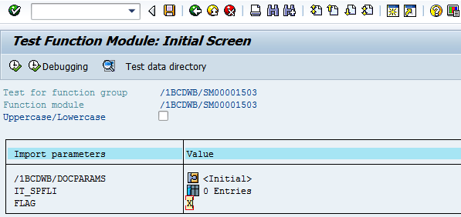

**Step # 23:** Provide the output device as LP01 (Default Print Purview) and click on Print Preview.

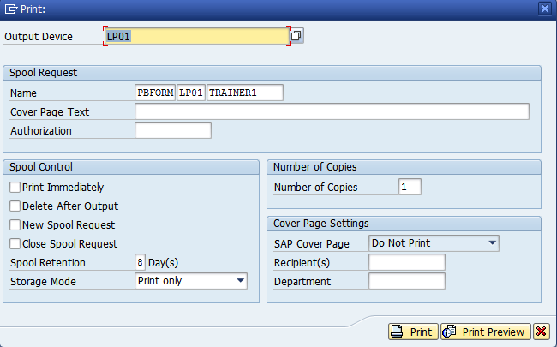

**Step # 24:** check the below Adobe Form alternative output successfully.

