**Adobe forms demo program # 5.**

***Program theme:*** *In this demo program you will get how to call Adobe form from the Driver Program/ Print Program and the basic navigation how to create the Adobe Interface and Adobe Form.*

**Step # 1:** Go to transaction code SFP (For Adobe form and Interface creation).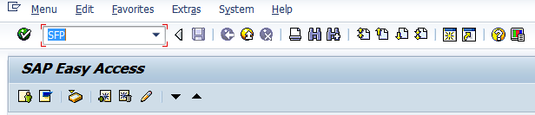

**Step # 2:** Select the interface radio button Provide the Interface name (Start with ‘Z’ or ‘Y’) and click on create.

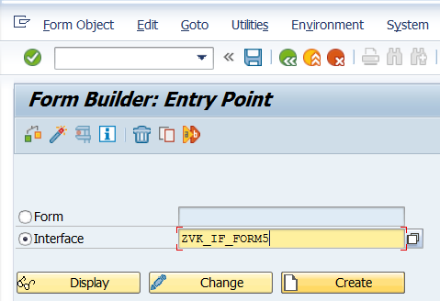

**Step # 3:** Provide the Interface description and select the Interface type as ABAP Dictionary-Based Interface from the drop down option and Click on the Save.

**Step # 4:** Save it in the package.

**Step # 5:** Select the Import parameter under the Form Interface.

**Step # 6:** Click on Append Row button (5th Icon) in the tool bar of the right side window and create parameter as shown below.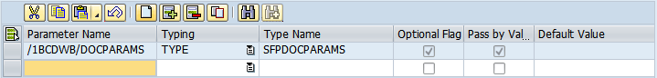

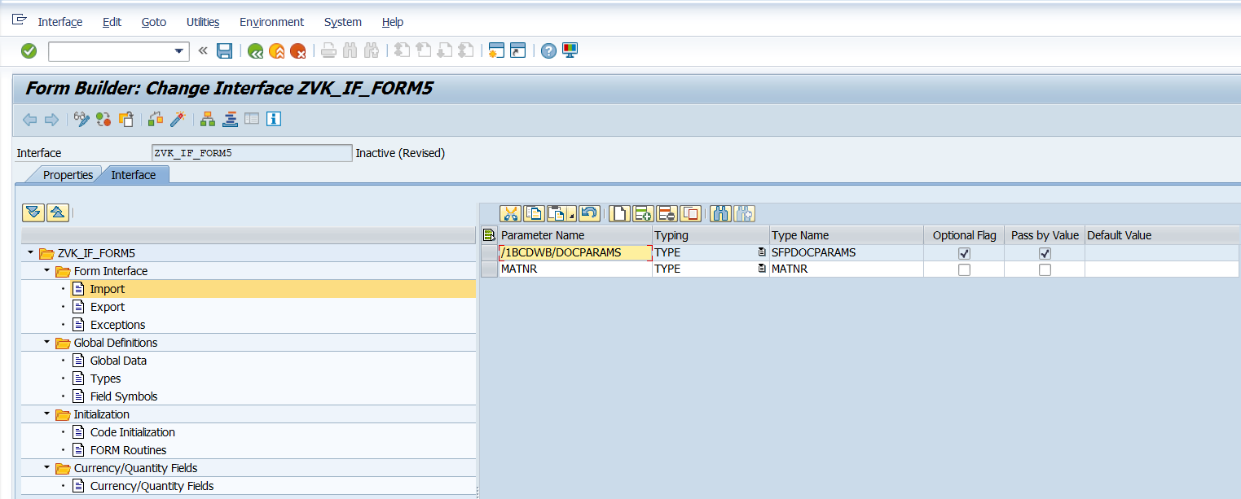

**Step # 6:** Goto Types under Global definitions and type the following code:-

* Local structure declaration  
TYPES : BEGIN OF TY_MARA,  
          MATNR TYPE MATNR,  
          MBRSH TYPE MBRSH,  
          MTART TYPE MTART,  
          MEINS TYPE MEINS,  
        END OF TY_MARA.  
  
TYPES : BEGIN OF TY_MARC,  
          MATNR TYPE MATNR,  
           WERKS TYPE WERKS_D,  
        END OF TY_MARC.  
  
TYPES : BEGIN OF TY_MARAMARC,  
          MATNR TYPE MATNR,  
          MBRSH TYPE MBRSH,  
          MTART TYPE MTART,  
          MEINS TYPE MEINS,  
          WERKS TYPE WERKS_D,  
        END OF TY_MARAMARC.  
  
TYPES : ITY_MARAMARC TYPE TABLE OF TY_MARAMARC.  
TYPES : ITY_MARA TYPE TABLE OF TY_MARA,  
        ITY_MARC TYPE TABLE OF TY_MARC.

**Step # 7:** Goto Global Data and define the following by inserting each row using Click on Insert Row.

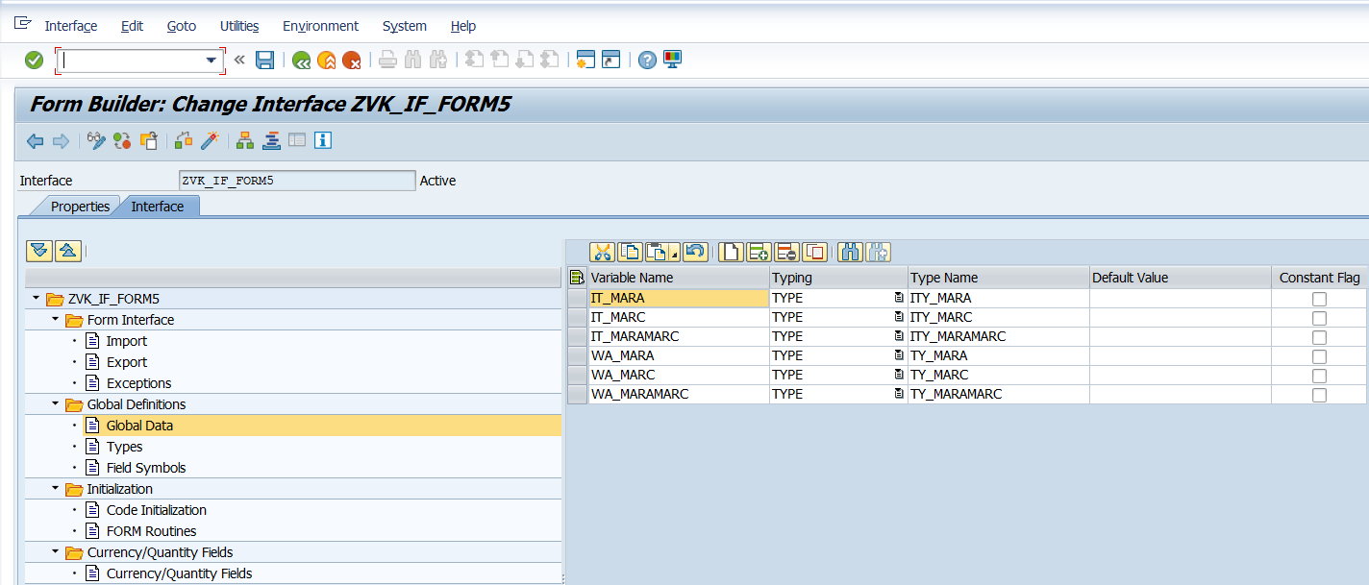

**Step # 8:** Go to Code initialization and type the code in the space provided:-

SELECT MATNR MTART MBRSH MEINS FROM MARA  
  INTO TABLE IT_MARA  
  WHERE MATNR = MATNR.  
  
SELECT MATNR WERKS FROM MARC  
  INTO TABLE IT_MARC  
  FOR ALL ENTRIES IN IT_MARA  
  WHERE MATNR = IT_MARA-MATNR.  
  
LOOP AT IT_MARA INTO WA_MARA.  
  WA_MARAMARC-MATNR = WA_MARA-MATNR.  
  WA_MARAMARC-MBRSH = WA_MARA-MBRSH.  
  WA_MARAMARC-MTART = WA_MARA-MTART.  
  WA_MARAMARC-MEINS = WA_MARA-MEINS.  
  
READ TABLE IT_MARC INTO WA_MARC WITH KEY MATNR = WA_MARA-MATNR.  
  WA_MARAMARC-WERKS = WA_MARC-WERKS.  
  
APPEND WA_MARAMARC TO IT_MARAMARC.

ENDLOOP.

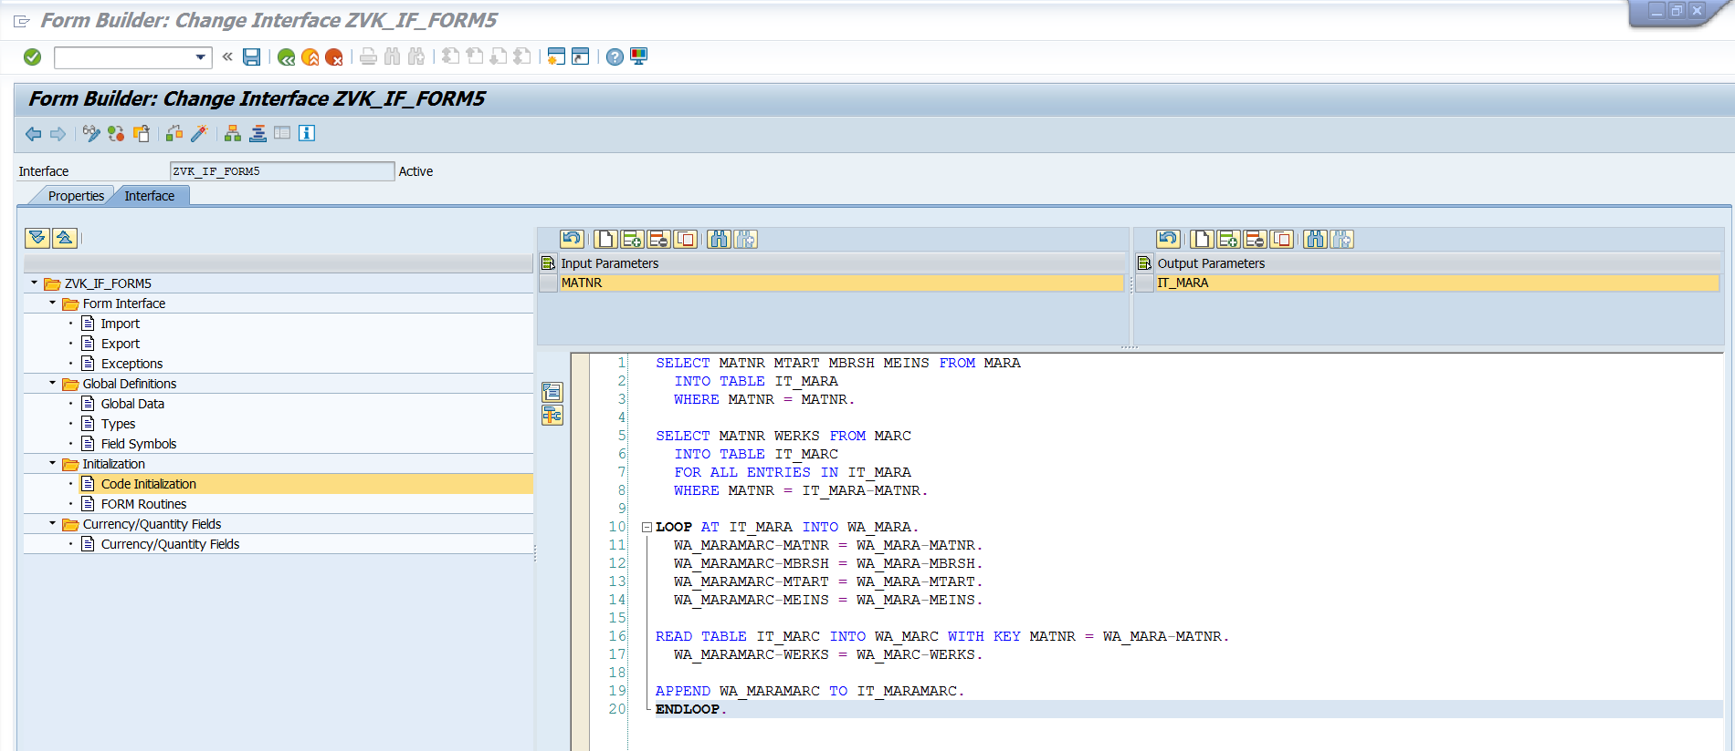

**Step # 9:** Save and Activate, Press F3.

**Step # 10:** Create new form, provide Short description and also the Interface name you want to use(e.g. the interface created in above steps).

**Step # 11:** Drag and drop individual fields (Material, Date, Time and user) from data view to design view.

Drag and drop IT_MARAMARC from data view to design view. This creates a table.

Observe the properties of the table.

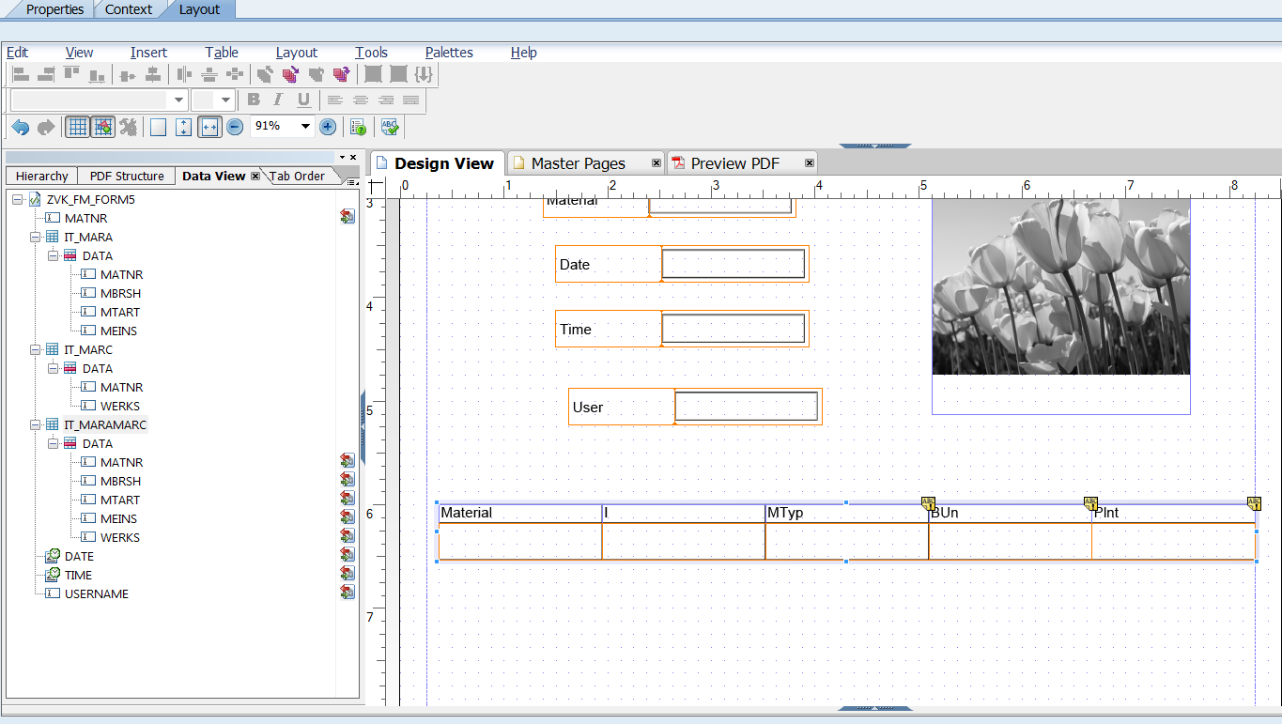

**Step # 12:** Go to Data view then Palettes->Object Library. Drag the Image in the icon area and give the path of the image as shown below.

MARK THE CHECK BOX - EMBED IMAGE DATA

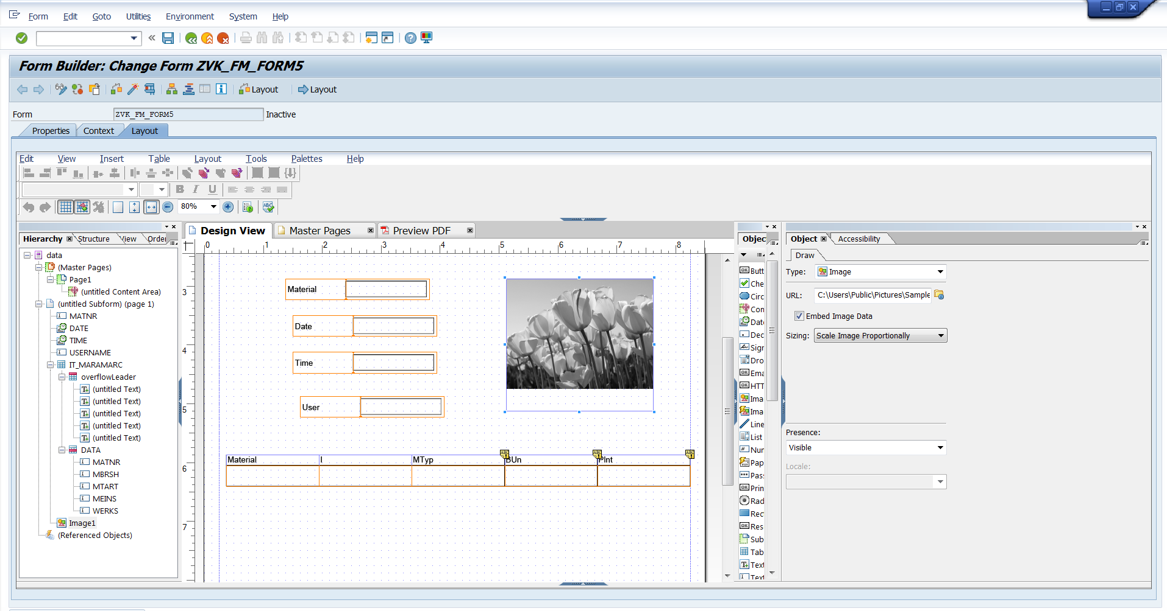

Execute.

