1. Go to Transaction SFP. Create interface as shown below.

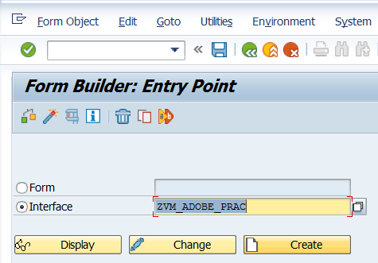

2. Create Import parameter, Types, Global Data and Code initialization as shown below.

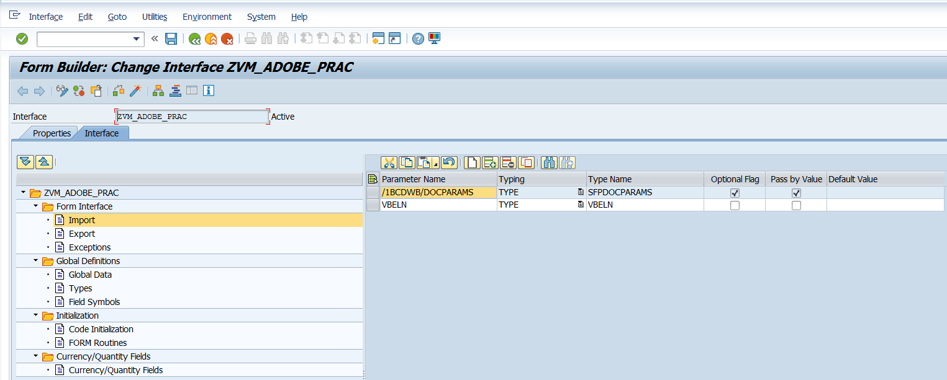

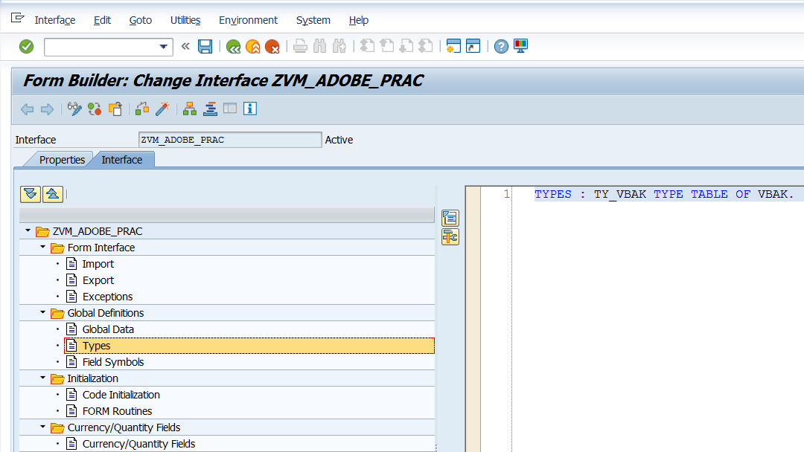

TYPES: TY_VBAK TYPE TABLE OF VBAK.

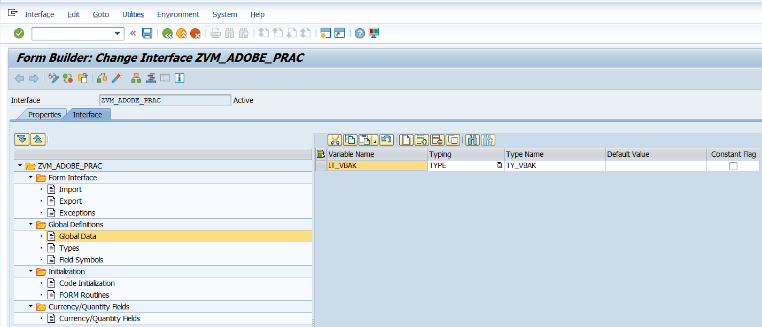

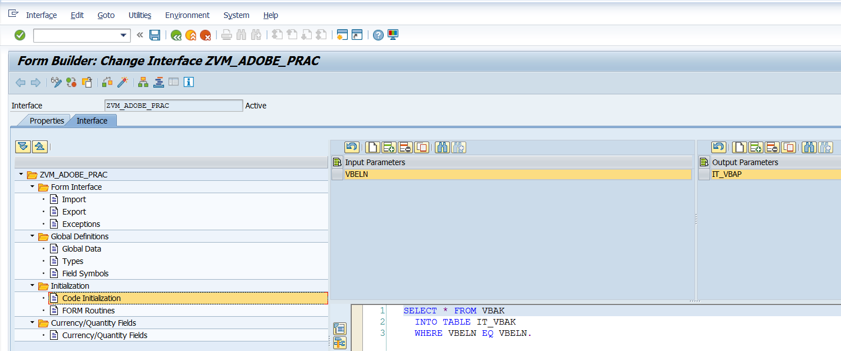

SELECT * FROM VBAK  
  INTO TABLE IT_VBAK  
  WHERE VBELN EQ VBELN.

3. Save the interface in a package.

4. Go to SFP and select Form Radio Button. Give Form Name and click create.

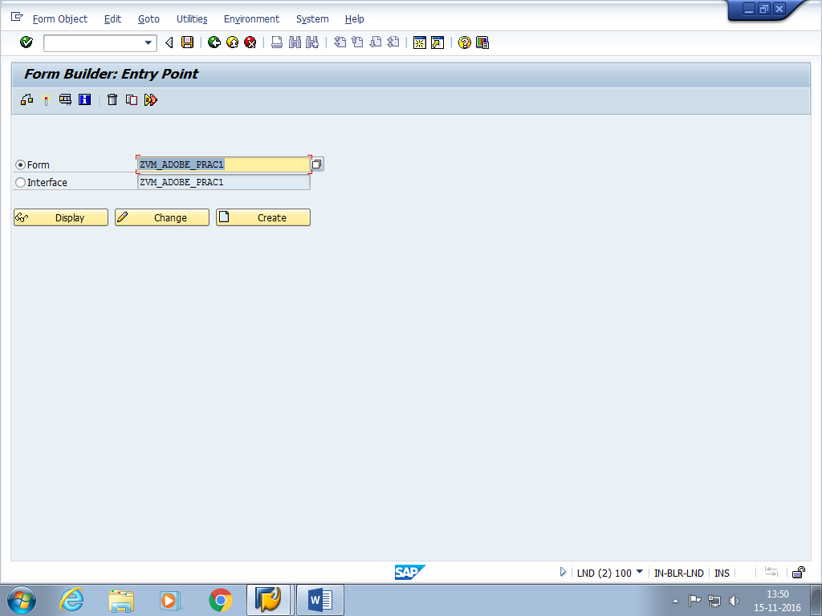

5. Give Short Description and select the Interface.

6. Drag and Drop VBELN AND IT_VBAK from interface to context.

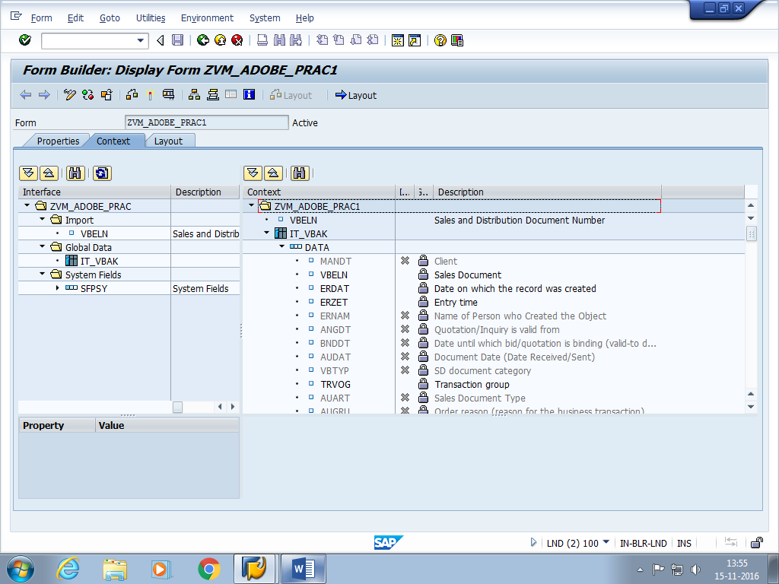

7. Activate the fields that you want and deselect rest of the fields in the Data section of IT_VBAK.

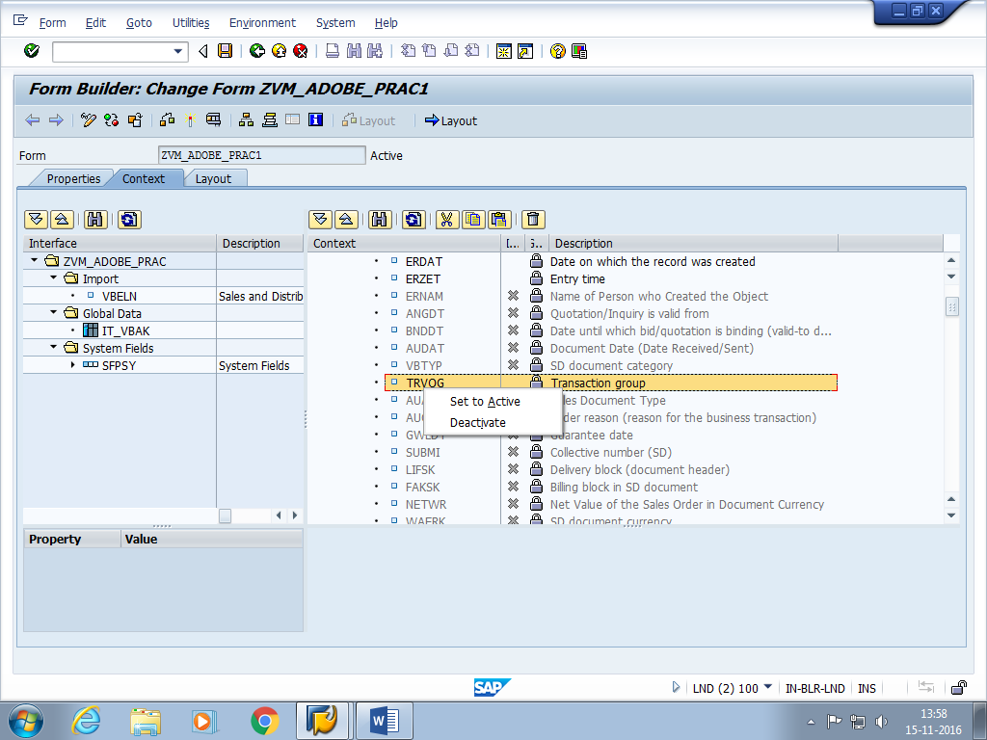

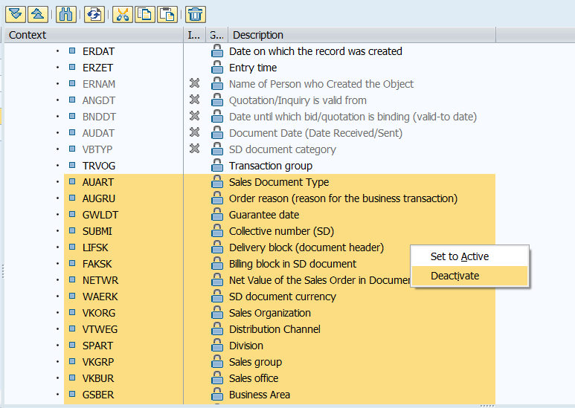

You can multiselect and deactivate as above.

8. Click on Layout tab. Select the fields that you want from Data View to Design view.

9. Go to Hierarchy and click on it_vbak, then select wrap in Subform.

13. Right Click on IT->Palettes->Object.

Click on untitled subform

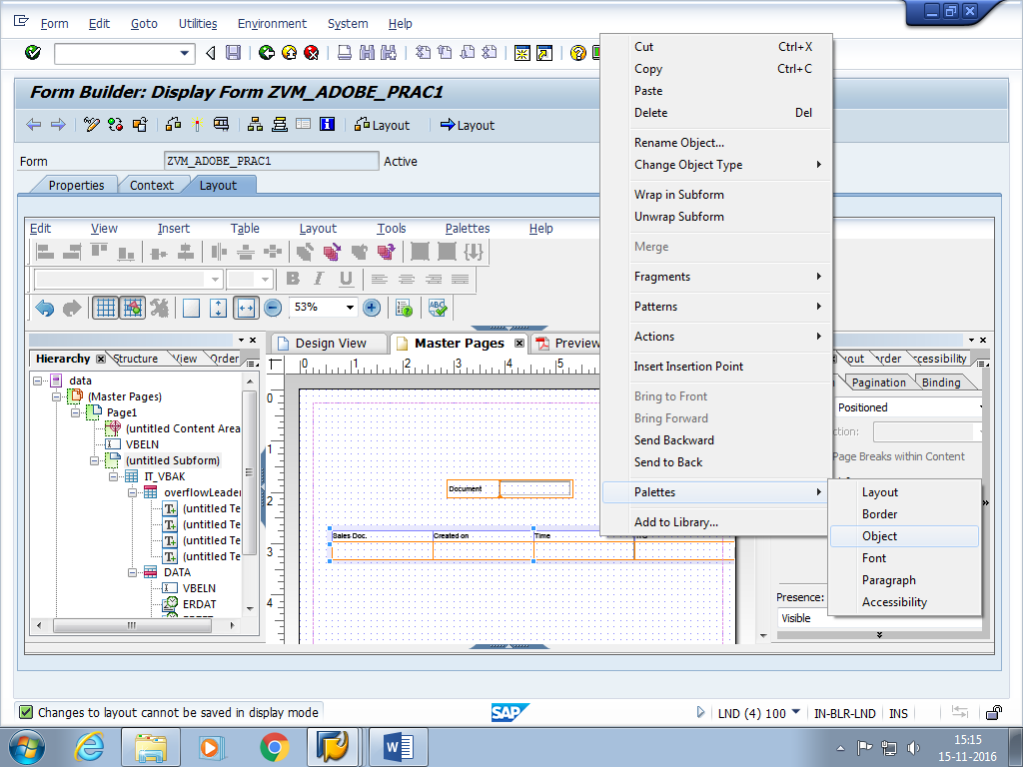

14. Under the subform tab, select content->flowed.

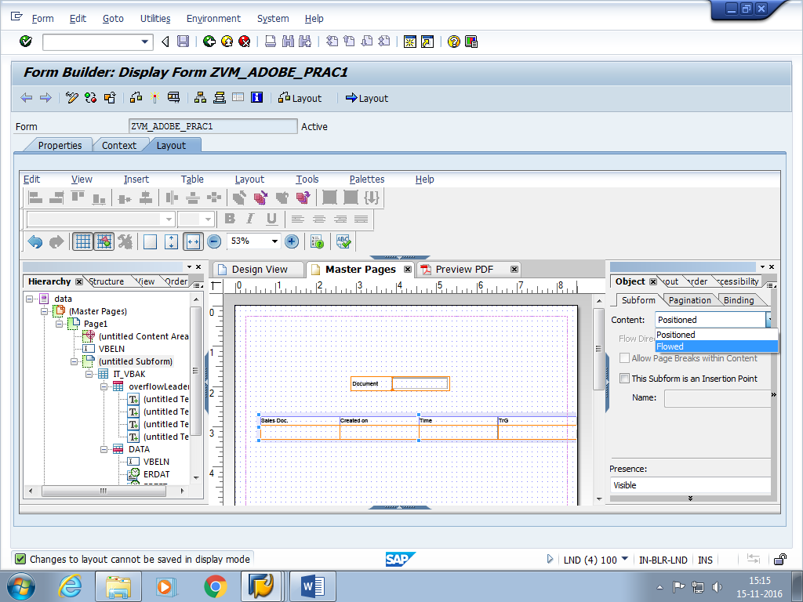

8. Save, activate and execute.

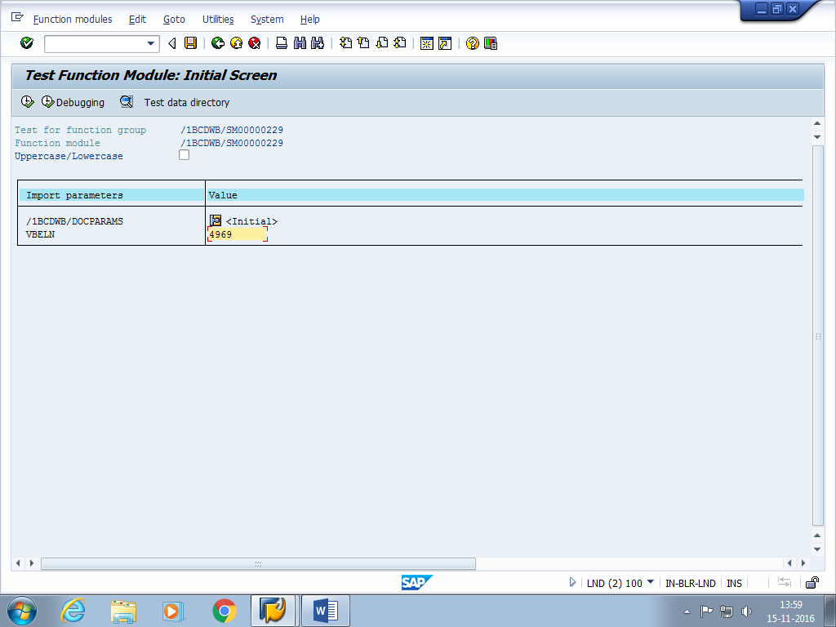

9. Give the output name as LP01 and select print preview.

