Go to tcode xd01 and enter customer name and choose account group as Customer(ext.number).

Click Continue.

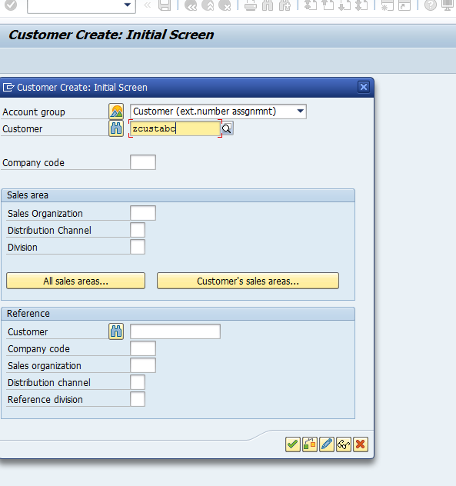

Enter the details as shown below.click on save.

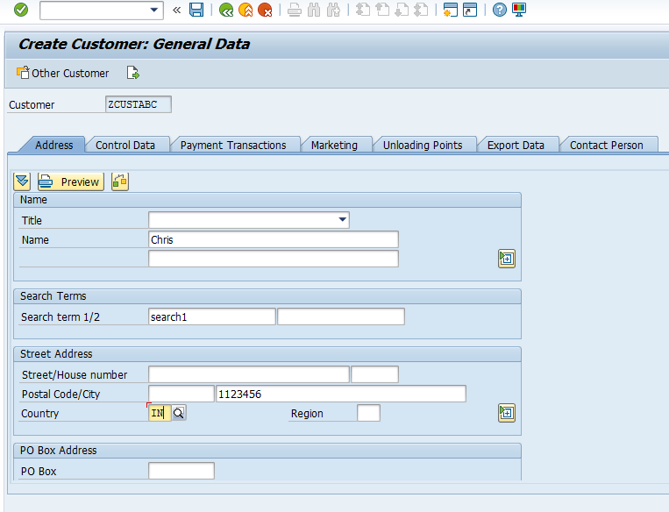

You will get a green message stating ‘The customer is created ‘.

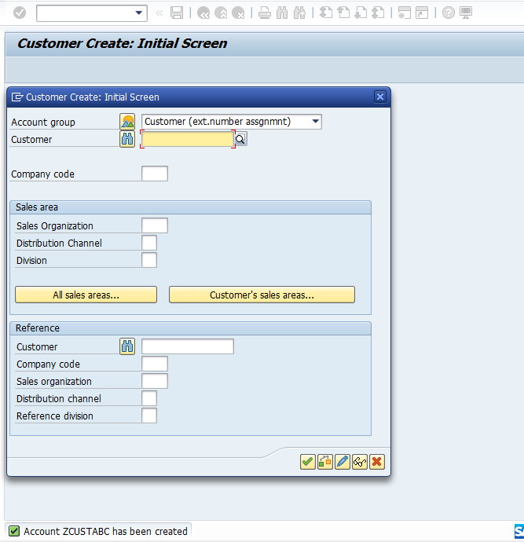

The above data can be seen in KNA1.

