**LSMW with IDoc creation steps**

1. Create a segment with the t-code WE31 and provide the Segment type with z or y.

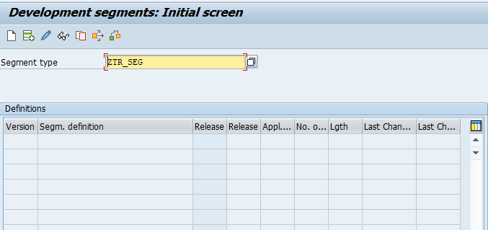

1. Click on continue and copy the data element and domain names of the tables (Based on the required table fields) under Fields Segment.

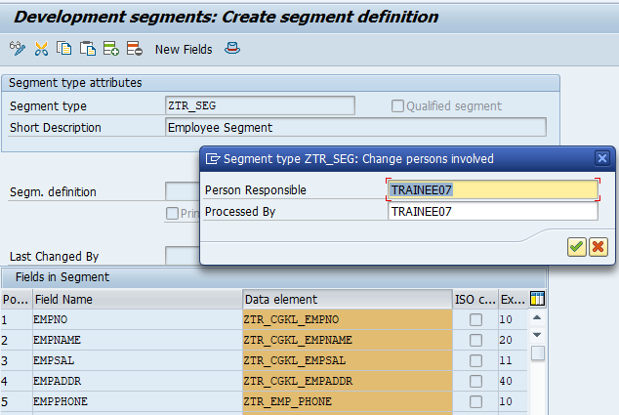

1. Save and Back to main segment initial screen to release the segment type.

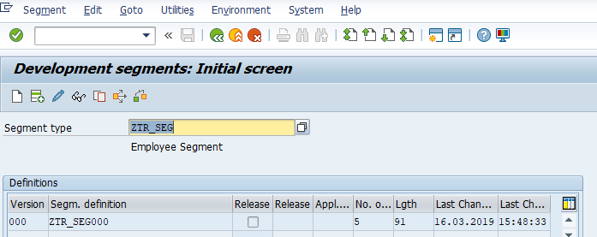

1. Go to edit and set release.

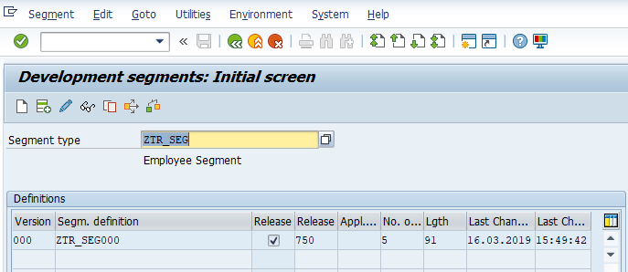

1. Create an Idoc type start with z or y t-code WE30.

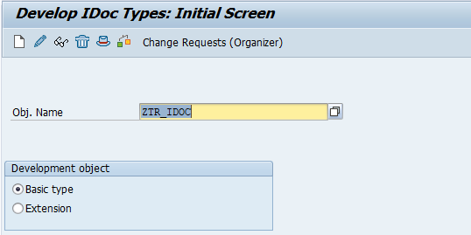

1. Click on Continue.

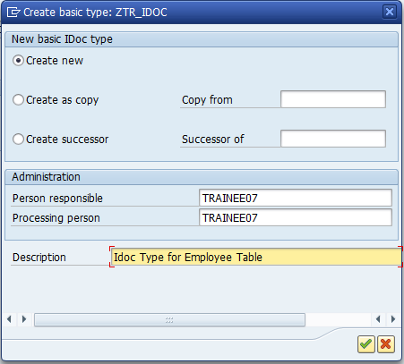

1. Place the cursor on ZTR_IDOC Idoc Type and Click on the add segment and provide the segment name.

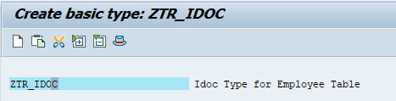

1. Provide the Minimum number and Maximum number values and continue.

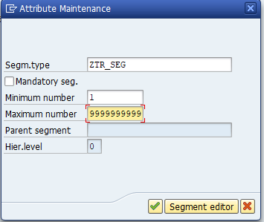

1. Save it in the package.

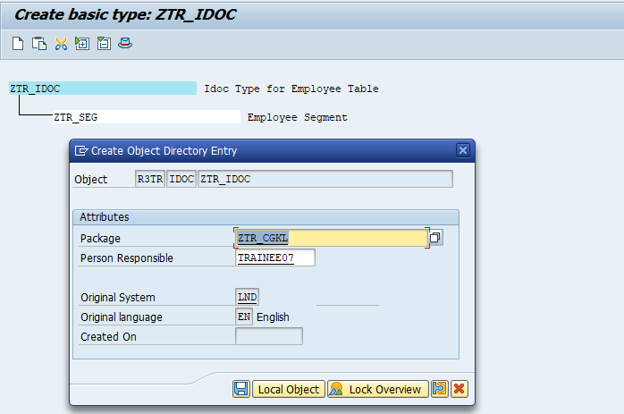

1. Create the message type t-code WE81 provide the user defined message type and save and activate it.

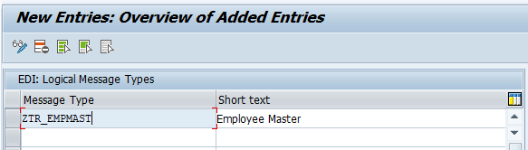

1. Assign the Idoc type to Message type t-code WE82 and enter the release no as 720.

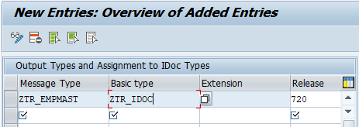

1. Create the LSMW Port select the File port and provide the Physical Directory path.

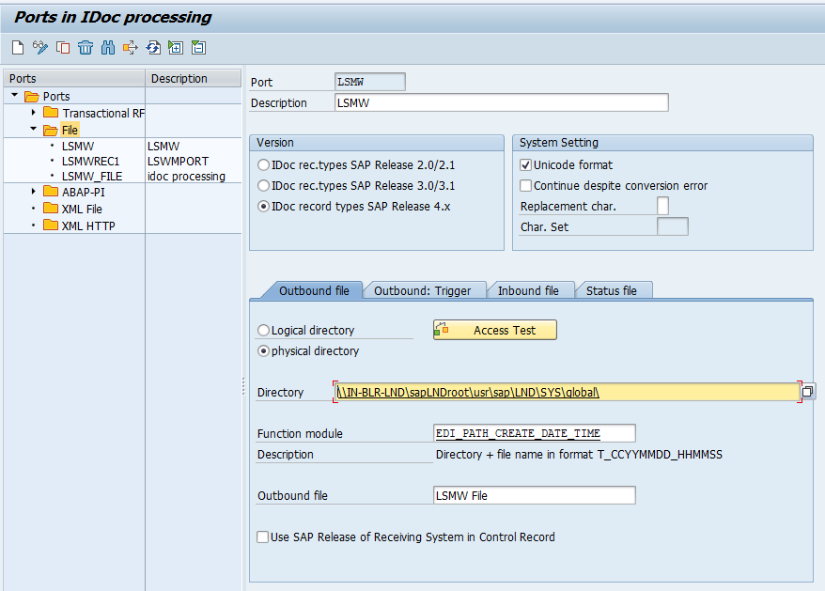

1. Create the LSMW Port select the File port and provide the local source file path.

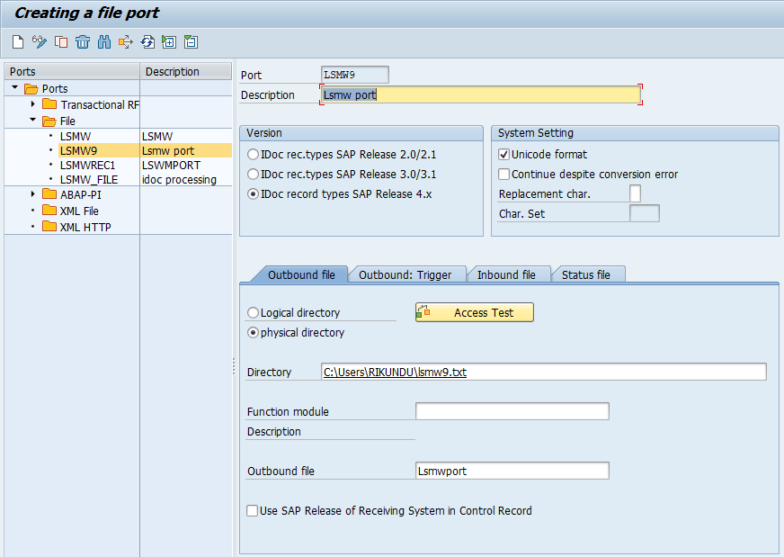

1. Create the inbound process code using the WE42-tcode.

