**Smart forms demo program # 1.**

***Program theme:*** *In this demo program you will get basic navigation how to create the Smart form and How to call the Smart form in Driver/ Print Program.*

**Step # 1:** Go to transaction code SMARTFORMS.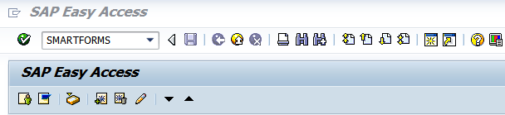

**Step # 2:** Select the Form radio button and provide the form name (Start with ‘Z’ or ‘Y’) and click on create. 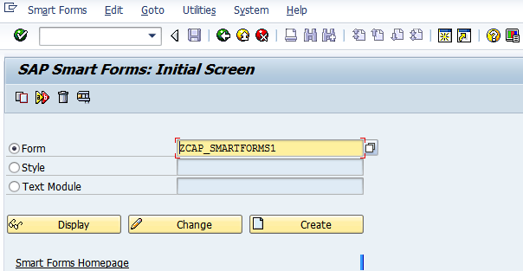

**Step # 3:** Provide the Form Description.

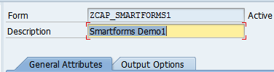

**Step # 4:** Save it in a Package. 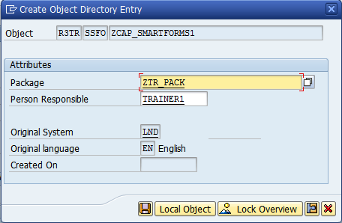

**Step # 5:** Click on the Page node and provide the page name and description.

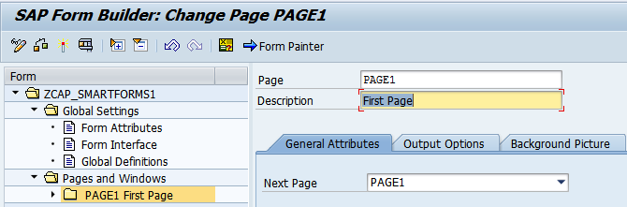

**Step # 6:** Select the Form Interface (under Global Settings) and provide the Import parameter names.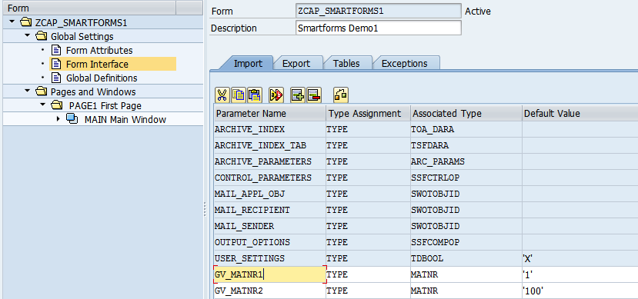

**Step # 7:** Select the Global Definitions properties and click on the **Types** tab and provide the structure and fields for the internal table.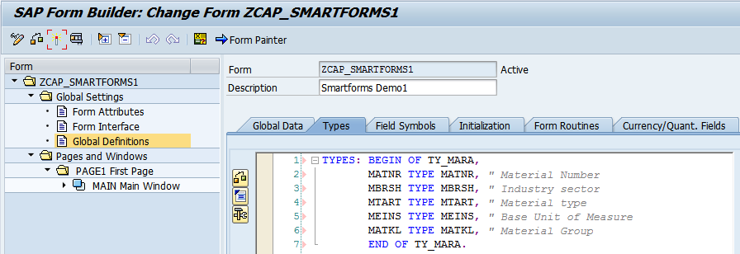

**Step # 8:** Click on the **Global Data** tab and provide the internal table and work area names.

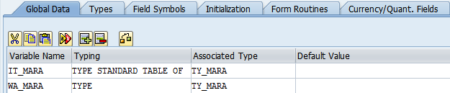

**Step # 9:** Expand the Pages and windows folder and select the PAGE1 Folder and right click on it 🡪and click on create window.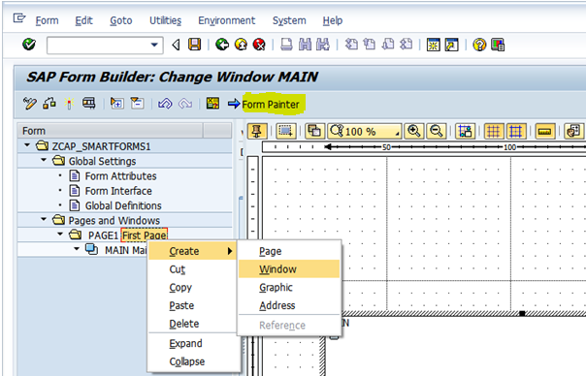

**Step # 10:** Right click on the HEADER Window and Select Create 🡪 click on Text.

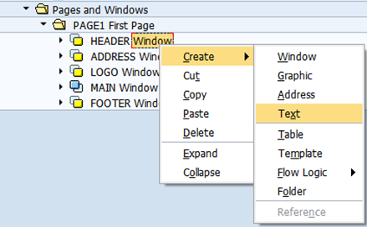

**Step # 11:** Double click on **HEADER text** Icon and provide the text for the headings (MATERIAL MASTER INFO).

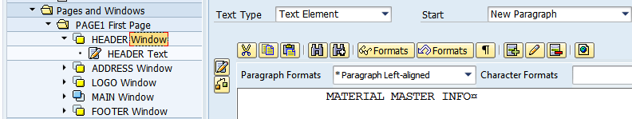

**Step # 12:** Expand the Pages and windows folder click on the MAIN Window provide the window name and description of the window.

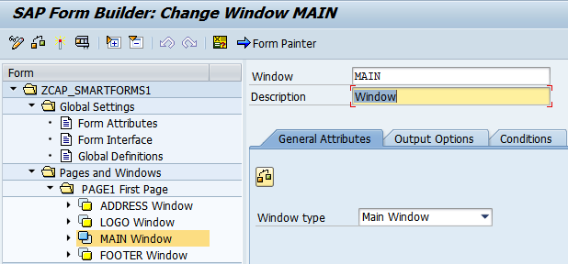

**Step # 13:** Click on the output options tab to provide the position and size (Margins). And you can select the Frame and Shading options for the window.

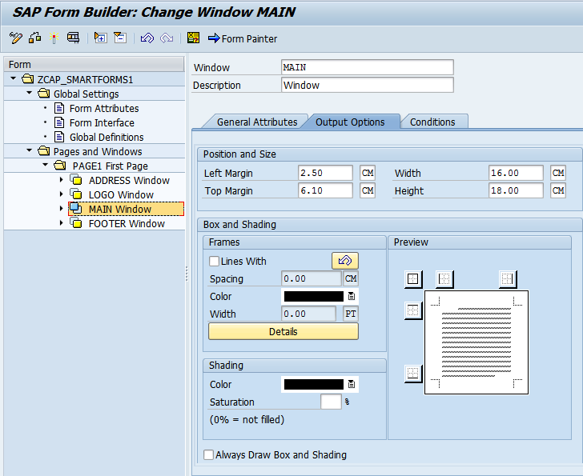

**Step # 14:** Click on the Form Painter button to adjust the windows position at design level.

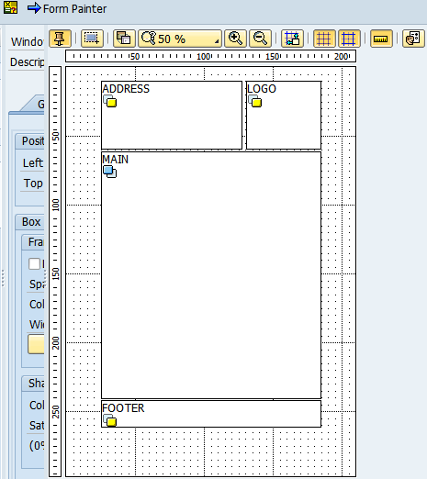

**Step # 15:** Expand the Pages and windows folder and select the PAGE1 and right click on it 🡪and click on to create window (ADDRESS Window). Provide the window name and description of the window.

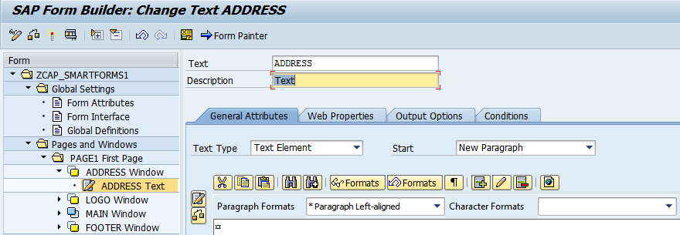

**Step # 16:** Click on the Editor Icon.

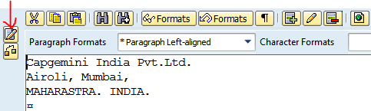

**Step # 17:** Provide the address.

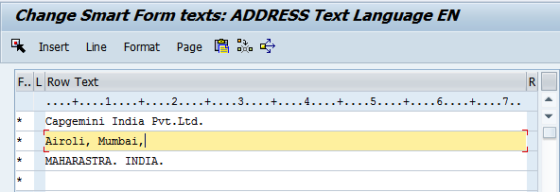

**Step # 18:** Expand the Pages and windows folder and select the PAGE1 and right click on it 🡪and click on to create window (LOGO Window). Provide the window name and description of the window.

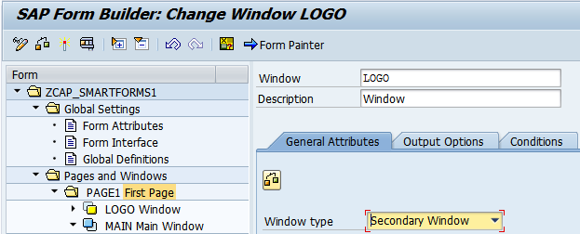

**Step # 19:** Select the LOGO Window, right click on it and select the Graphic window.

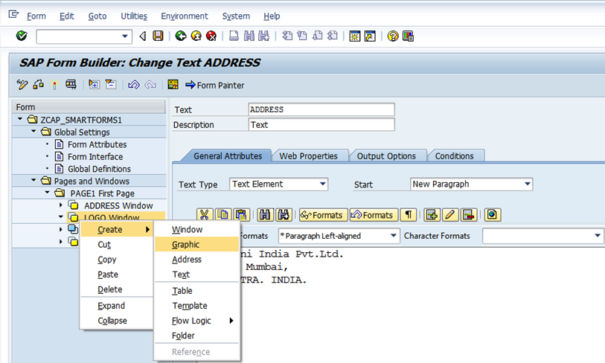

**Step # 20:** Press F4 on the Name and select the Color Bitmap Image check box and Execute (F8).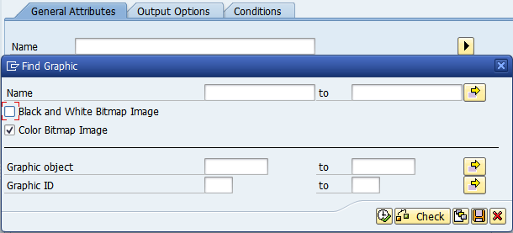

**Step # 21:** Search the Logo (Ctrl + F) and select it.

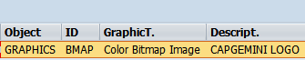

**Step # 22:** it will display the properties like the below screen and select the resolution points for the logo size.

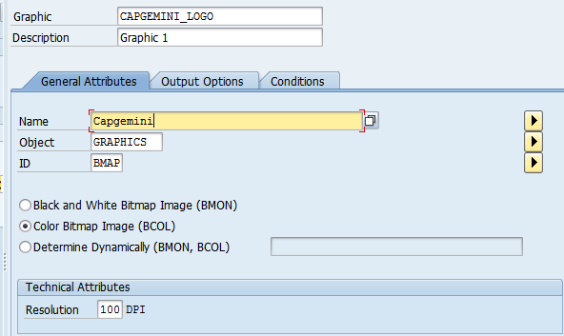

**Step # 23:** Select the main window and right click on it and click on Flow Logic 🡪 select the Program Lines.

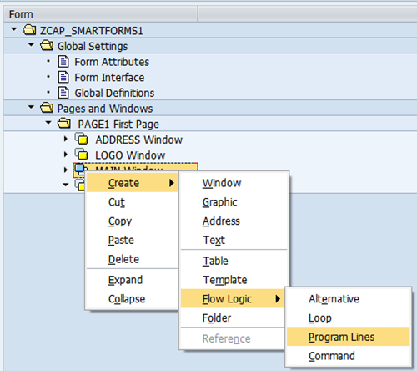

**Step # 24:** Provide the Input and output Parameters and write the main window code logic.

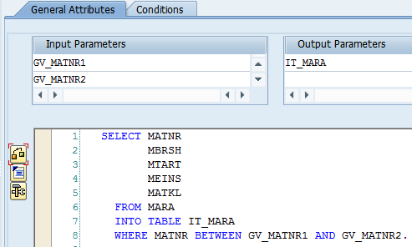

**Step # 25:** Select the Main window and right click on it and click on Flow Logic 🡪 and select the Loop.

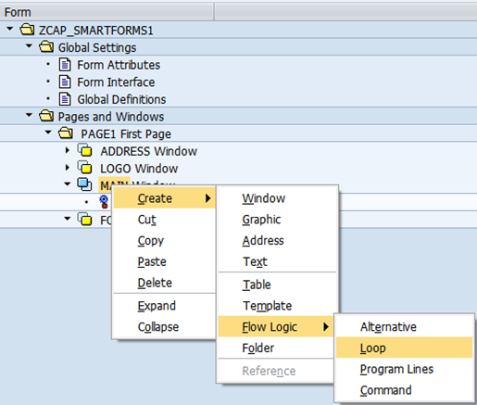

**Step # 26:** Provide the Internal table and work area name.

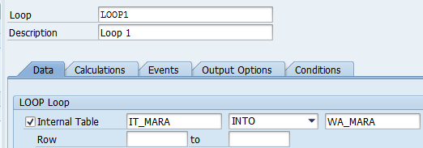

**Step # 27:** Select the Loop and right click on it and select the text.

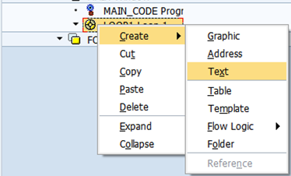

**Step # 28:** Provide the Text name and Description.

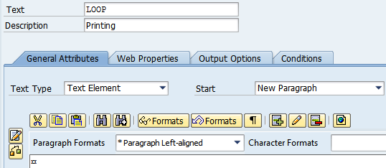

**Step # 29:** Click on the Filed List On/Off Icon.

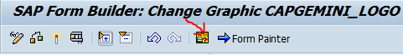

**Step # 30:** Expand the work area under the Global Data tab.

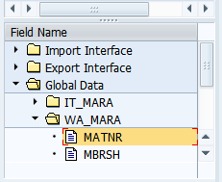

**Step # 31:** Drag and drop the required fields into Text Element area.

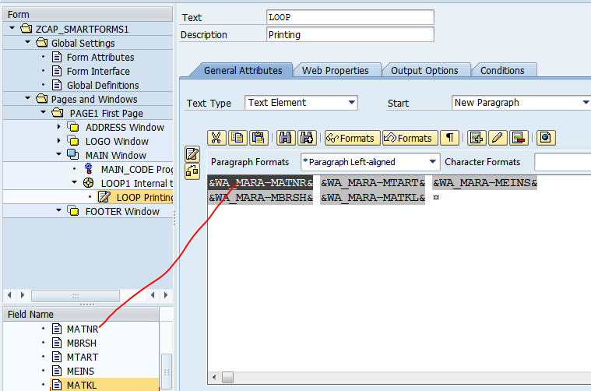

**Step # 32:** Expand the Pages and windows folder and select the PAGE1 and right click on it 🡪and click on to create window (FOOTER Window). Provide the window name and description of the window.

Right click on the FOOTER Window and Create 🡪 click on Text.

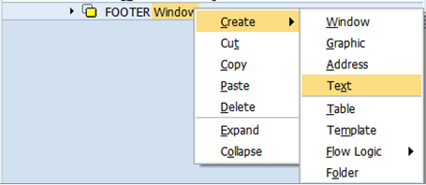

**Step # 33:** Expand the System Fields Folder (By using Field list On/OFF) and expand the SFSY Folder to select the predefined smart forms system fields.

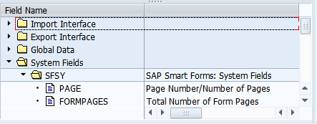

**Step # 34:** Drag and drop the required fields into Text Element area.

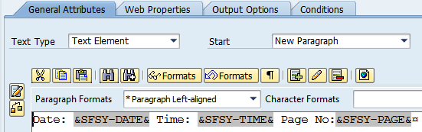

**Step # 35:** Save and activate the smart form and execute it (F8).

It provides the Function Module name automatically press (F8) to execute.

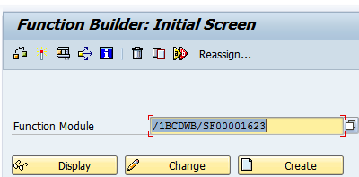

**Step # 36:** Provide the material number range (From MARA Table) and execute (f8).

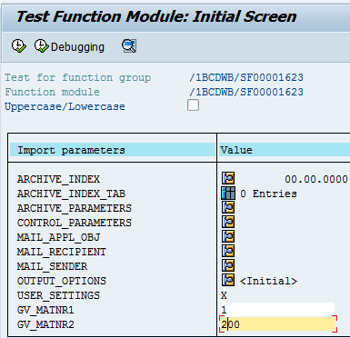

**Step # 37:** Provide the Output Device as LP01 (Default Print Purview) and click on Print Preview.

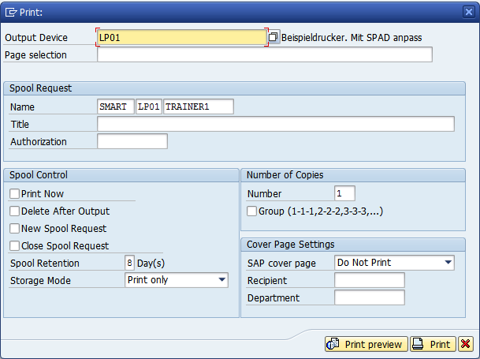

**Step # 38:** Check the below output of the Smart form.

