**Smart forms demo program # 2.**

***Program theme:*** *In this demo program you will get basic navigation how to create the Smart form with tables and templates and how to call the Smart form by using Driver/ Print program.*

**Step # 1:** Go to transaction code SMARTFORMS.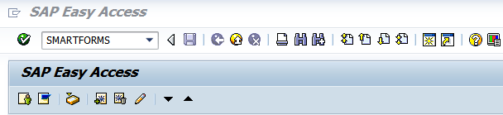

**Step # 2:** Select the Form radio button and provide the form name (Start with ‘Z’ or ‘Y’) and click on create. 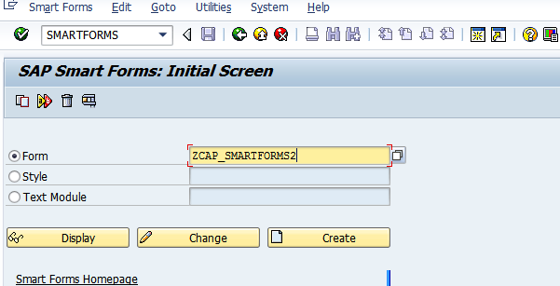

**Step # 3:** Provide the Form Description.

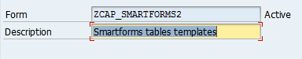

**Step # 4:** Save it in a Package. 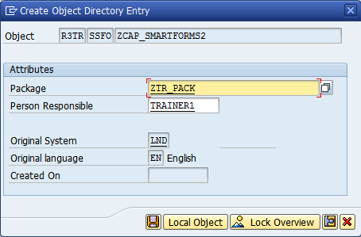

**Step # 5:** Click on the PAGE1 node and provide the page name and description.

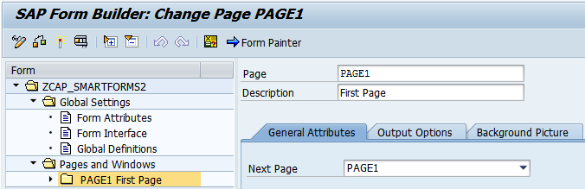

**Step # 6:** Select the **Form Interface** (under Global Settings) and provide the Import parameter name and default value. 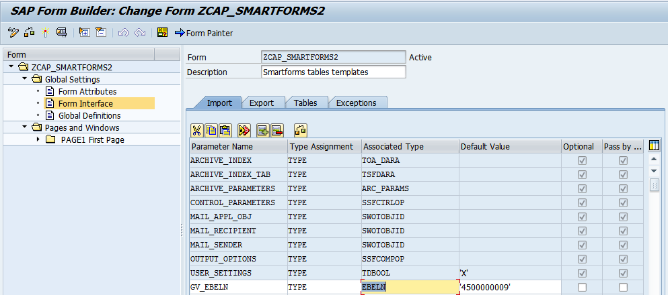

**Step # 7:** Select the **Global Definitions** properties and click on the **Types** tab and provide the structure and fields for the internal table.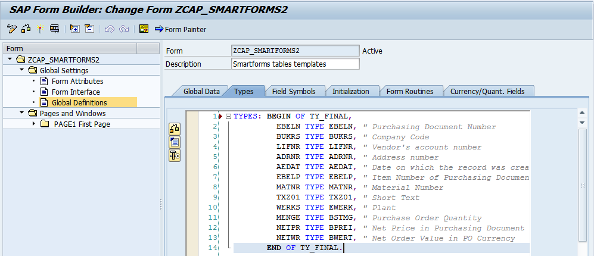

**Step # 8:** Click on the **Global Data** tab and provide the internal table and work area names.

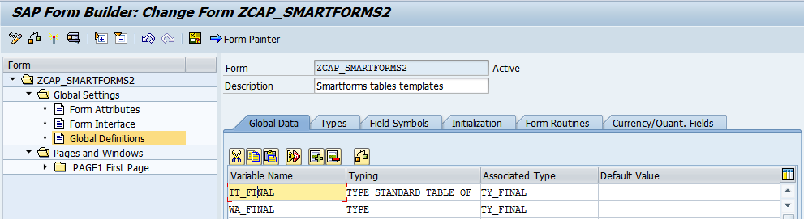

**Step # 9:** Expand the Pages and Windows folder and select the PAGE1 Folder and right click on it 🡪and click on create window. 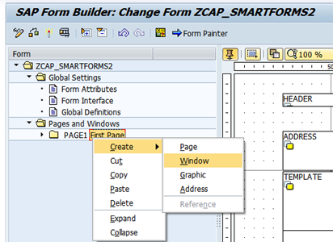

**Step # 10:** Right click on the HEADER Window and Select Create 🡪 click on Text.

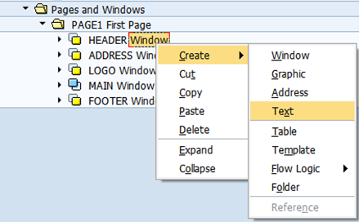

**Step # 11:** Double click on **HEADER text** Icon and provide the text for the heading of Smart form (MATERIAL MASTER INFO).

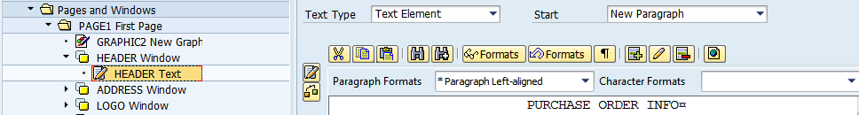

**Step # 12:** Expand the Pages and windows folder click on the MAIN Window and provide the window name and description of the window.

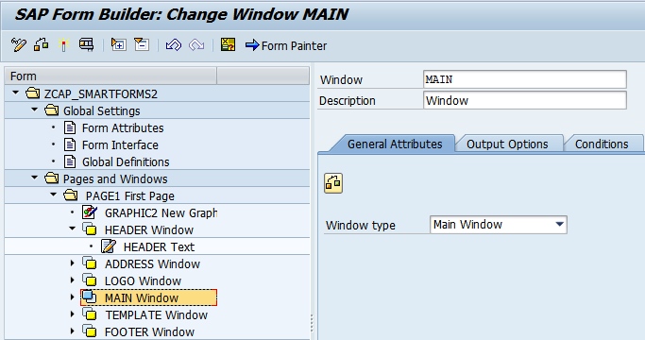

**Step # 13:** Click on the **output options** tab to provide the position and size (Margins). And you can select the Frame and Shading options for the window.

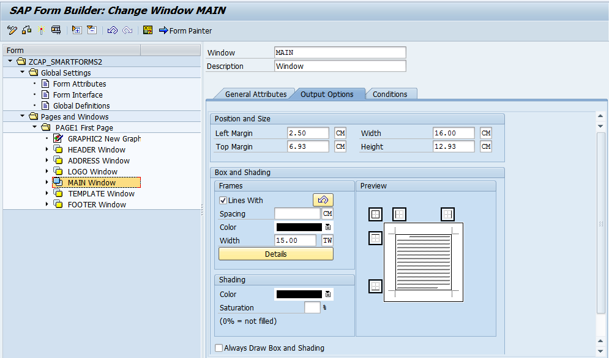

**Step # 14:** Click on the Form Painter button to adjust the windows position at design level.

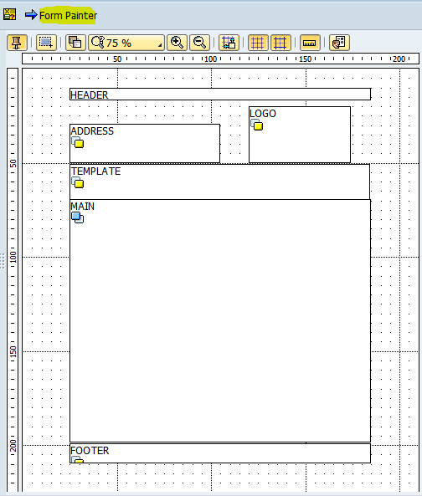

**Step # 15:** Expand the Pages and windows folder and select the PAGE1 and right click on it 🡪and click on to create window (ADDRESS Window). Provide the window name and description of the window.

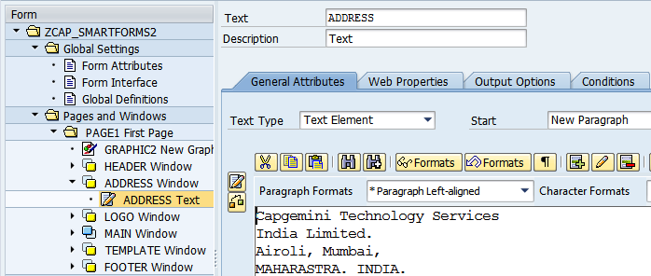

**Step # 16:** Click on the Editor Icon.

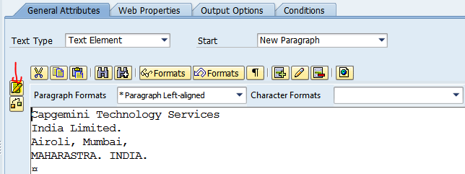

**Step # 17:** Provide the address details.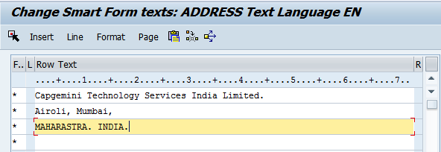

**Step # 18:** Expand the Pages and windows folder and select the PAGE1 and right click on it 🡪and click on to create window (LOGO Window). Provide the window name and description of the window.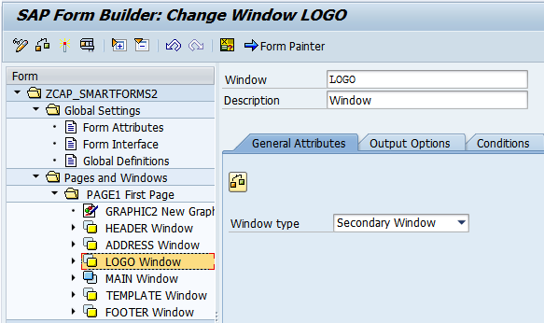

**Step # 19:** Select the LOGO Window, right click on it and select the Graphic window.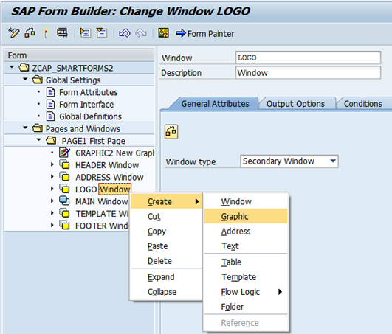

**Step # 20:** Press F4 on the **Name** input field and select the Color Bitmap Image check box and Execute (F8).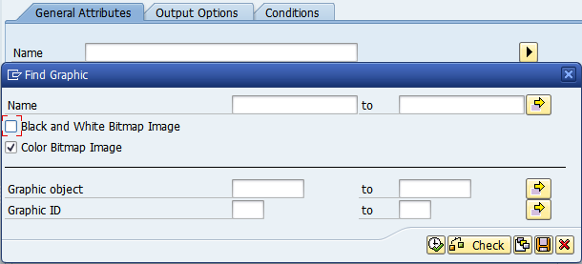

**Step # 21:** Search the Logo (Ctrl + F) and select it.

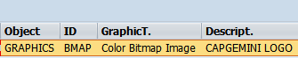

**Step # 22:** it will display the properties like the below screen and select the resolution points for the logo size.

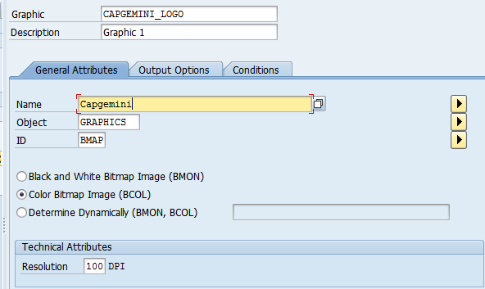

**Step # 23:** Select the main window and right click on it and click on Flow Logic 🡪 select the program lines.

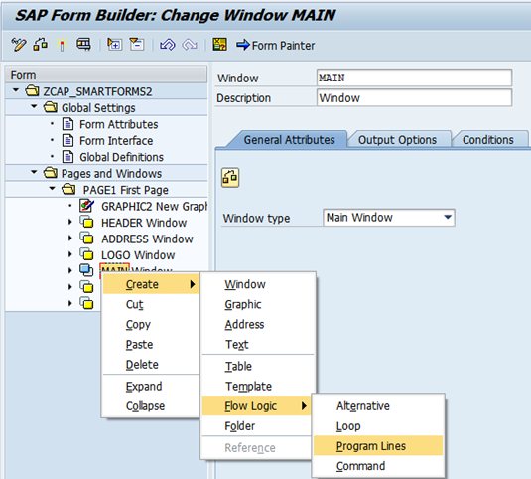

**Step # 24:** Provide the Input and output parameters and write the main window code logic.

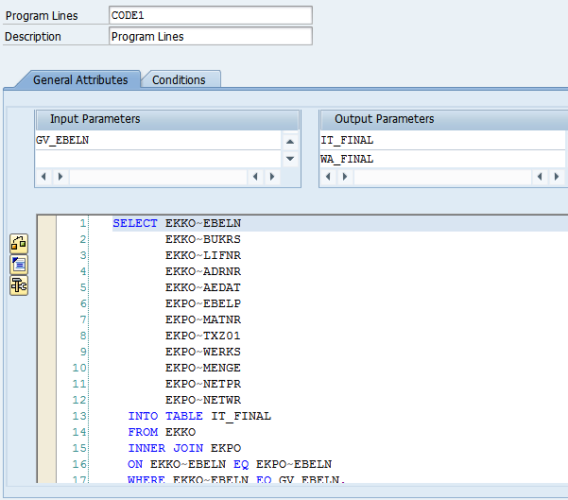

**Step # 25:** Select the main window and right click on it and click on Flow Logic 🡪 and select the Loop.

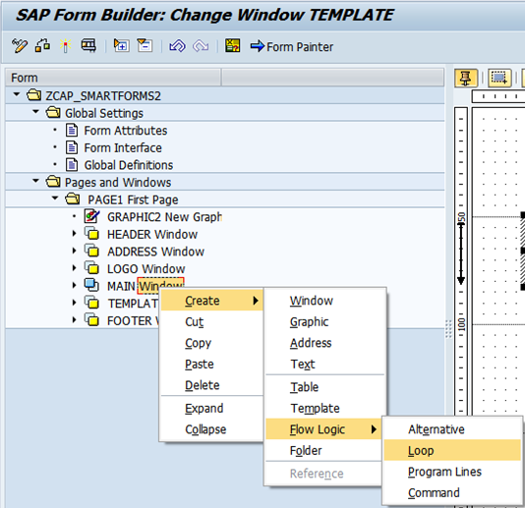

**Step # 26:** Provide the Internal table and work area name.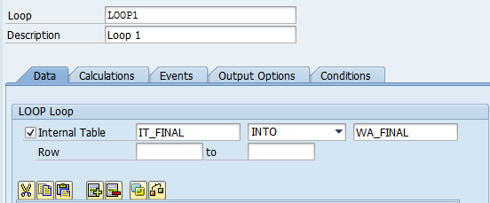

**Step # 27:** Place the cursor on main window and right click on it and click on the table.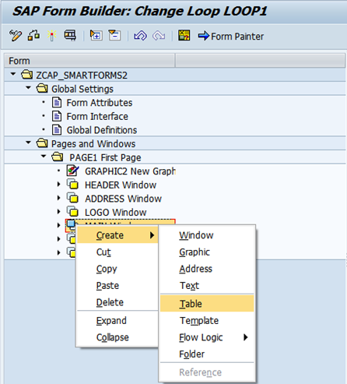

**Step # 28:** Double click on the table node and click on the details tab to provide the table properties.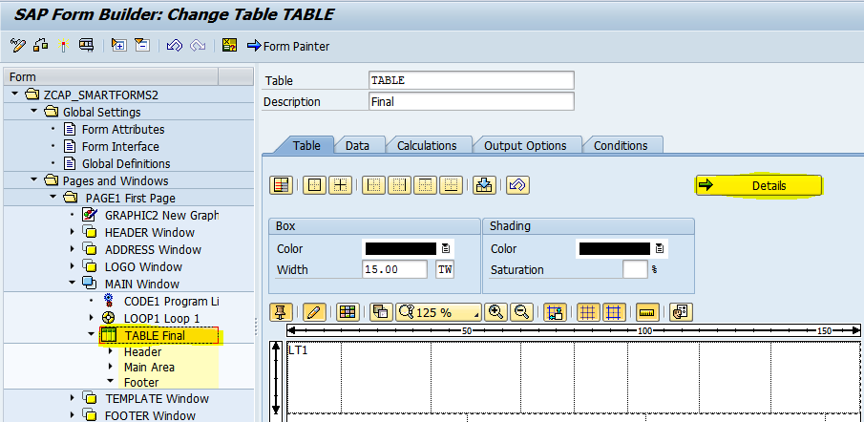

**Step # 29:** Provide the Table Width, Line Type name (LT1) and enter the each Column width.

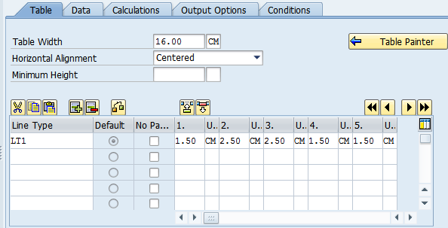

**Step # 30:** Click on the Select Pattern icon and select the required table pattern.

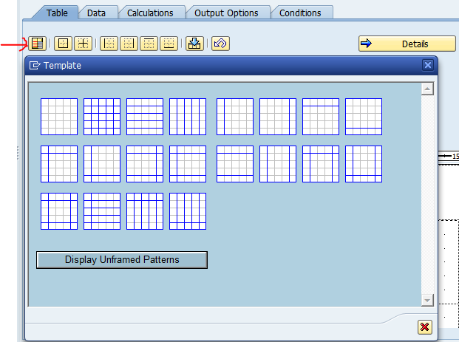

**Step # 31:** Click on the Data node and provide the Internal table and work are name .

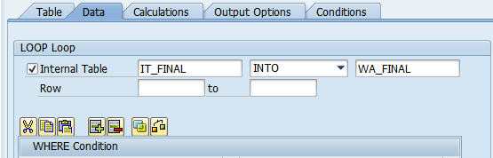

**Step # 32:** Select table header node and right click on it to select the Table Line.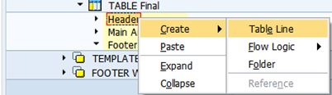

**Step # 33:** Provide the ROW name and description under the header node.

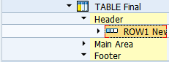

**Step # 34:** Select the Line Type name from the drop down list.

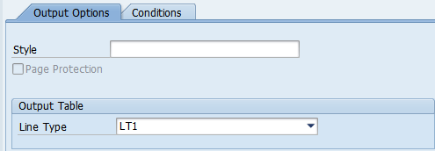

**Step # 35:** Select the First CELL and Right click on it to select the text and provide the column header name in the text element. (Repeat the same for each CELL and Each Column).

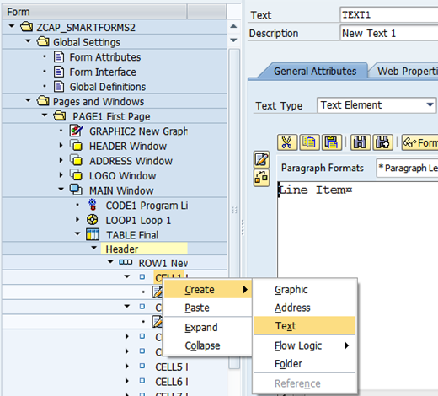

**Step # 36:** Provide the ROW name and description under Main Area.

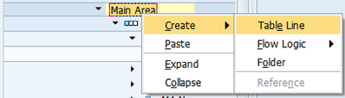

**Step # 37:** Select the Line Type name from the drop down list.

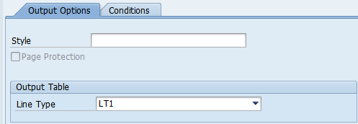

**Step # 38:** Click on the Filed List On/Off Icon.

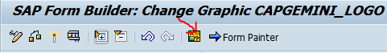

**Step # 39:** Expand the work area under the Global Data tab.

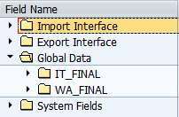

**Step # 40:** Drag and drop the required fields form the work area to text element area of each cell. Note: Repeat the same for each column under the Main Area.

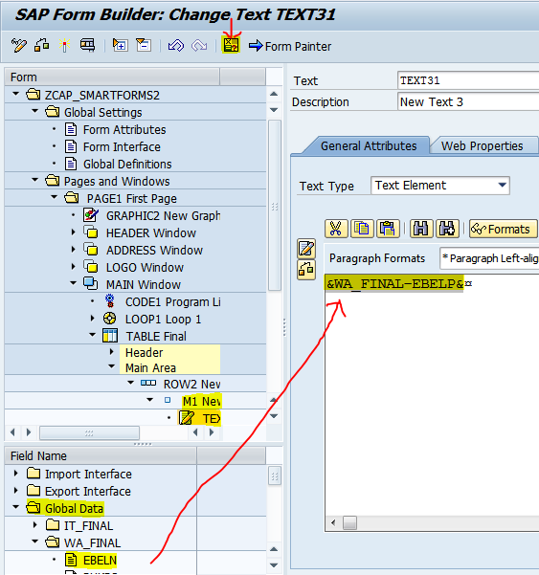

**Step # 41:** Place the cursor on template window and right click on it to create the template.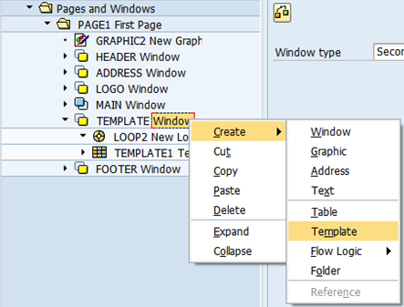

**Step # 42:** Double click on the template node. Provide the width, from and to Line numbers and column details.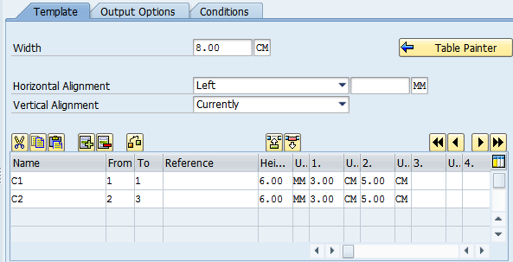

**Step # 43:** click on table painter node and select the pattern, Box and Shading for the template.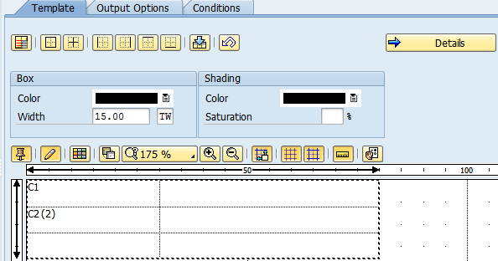

**Step # 44:** click on template node and right click on it to select the text property. Note: Repeat the same for each line(Text) in a template.

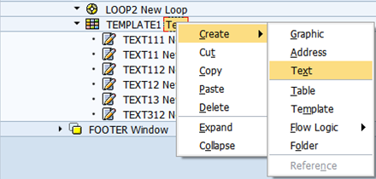

**Step # 45:** click on Output Options tab and enter the line number and column number to print the text at required position in template.

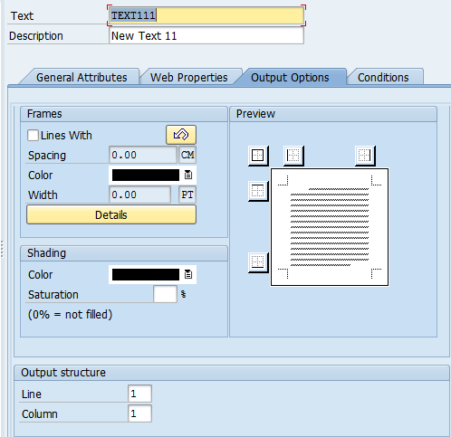

**Step # 46:** Expand the Pages and Windows folder and select the PAGE1 and right click on it 🡪and click on to create window (FOOTER Window). Provide the window name and description of the window.

Right click on the FOOTER Window and Create 🡪 click on Text.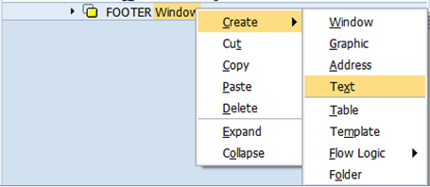

**Step # 47:** Expand the System Fields Folder (By using Field list On/OFF) and expand the SFSY Folder to select the predefined smart forms system fields.

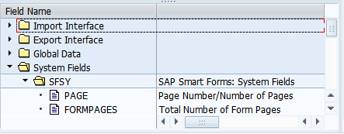

**Step # 48:** Drag and drop the required fields into Text Element area.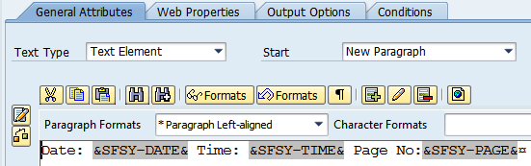

**Step # 49:** Save and activate the smart form and execute it (F8).

It provides the Function Module name automatically and (F8) to execute.

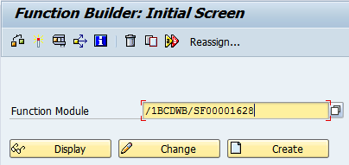

**Step # 50:** Provide the purchase order number (From EKKO Table) and execute (f8).

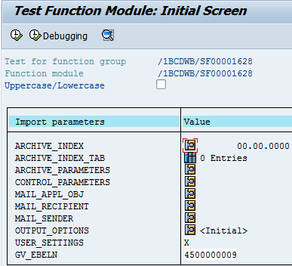

**Step # 51:** Provide the Output Device as LP01 (Default Print Purview) and click on Print Preview.

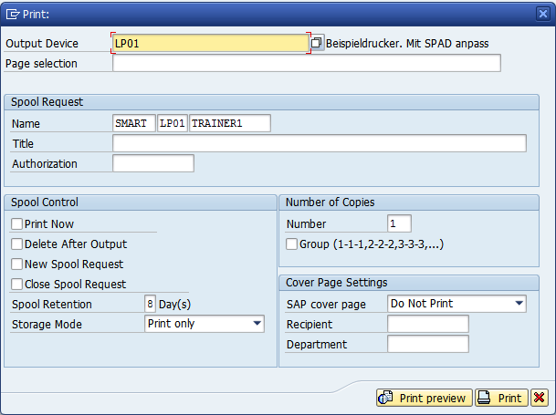

**Step # 52:** Check the below output of the Smart form.

