**Step # 1:** Go to SE38 Transaction Code (Executable Program) and Create the Smart form Driver Program/ Print Program.

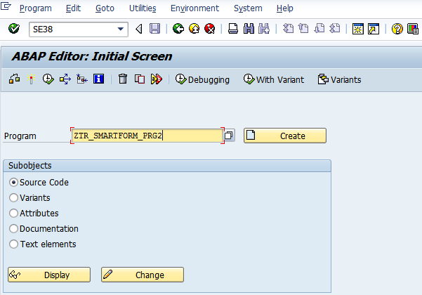

**Step # 2:** Provide the title and select the executable program and click on save.

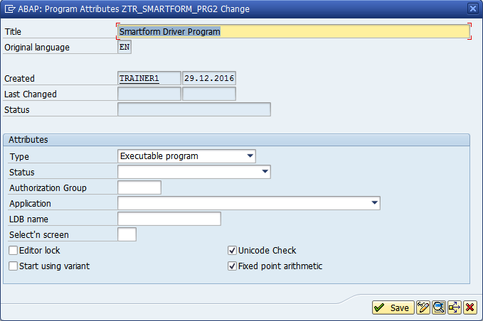

**Step # 3:** Save it in the package.

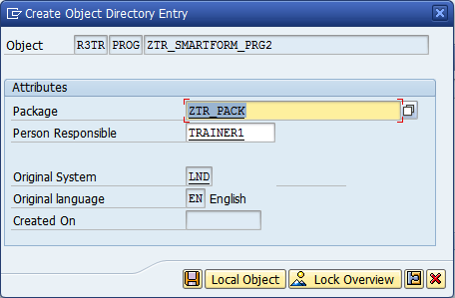

**Step # 4:** Write the code logic.

Step # 4.1 Create the include program.

*\*&---------------------------------------------------------------------\**  
*\*&  Include           ZCAP_SMARTFORMS_PROG1_TOP*  
*\*&---------------------------------------------------------------------\**  
  
TABLES : MARA. *" General Material Data*  
  
DATA FM TYPE RS38L_FNAM.  *" Name of Function Module*

Step # 4. 2 Create an executable program.

*\*&---------------------------------------------------------------------\**  
*\*& Report ZCAP_SMARTFORMS_PROG1*  
*\*&---------------------------------------------------------------------\**  
*\*&*  
*\*&---------------------------------------------------------------------\**  
REPORT ZCAP_SMARTFORMS_PROG1.  
  
INCLUDE ZCAP_SMARTFORMS_PROG1_TOP.  
  
SELECT-OPTIONS S_MATNR FOR MARA-MATNR.  
  
CALL FUNCTION 'SSF_FUNCTION_MODULE_NAME'  
  EXPORTING  
    FORMNAME                 = 'ZCAP_SMARTFORMS1'  
*\*   VARIANT                  = ' '*  
*\*   DIRECT_CALL              = ' '*  
 IMPORTING  
   FM_NAME                  = FM  
*\* EXCEPTIONS*  
*\*   NO_FORM                  = 1*  
*\*   NO_FUNCTION_MODULE       = 2*  
*\*   OTHERS                   = 3*  
          .  
IF SY-SUBRC <> 0.  
*\* Implement suitable error handling here*  
ENDIF.  
  
CALL FUNCTION FM  
 EXPORTING  
*\*   ARCHIVE_INDEX              =*  
*\*   ARCHIVE_INDEX_TAB          =*  
*\*   ARCHIVE_PARAMETERS         =*  
*\*   CONTROL_PARAMETERS         =*  
*\*   MAIL_APPL_OBJ              =*  
*\*   MAIL_RECIPIENT             =*  
*\*   MAIL_SENDER                =*  
*\*   OUTPUT_OPTIONS             =*  
*\*   USER_SETTINGS              = 'X'*  
   GV_MATNR1                  = S_MATNR-LOW  
   GV_MATNR2                  = S_MATNR-HIGH  
*\* IMPORTING*  
*\*   DOCUMENT_OUTPUT_INFO       =*  
*\*   JOB_OUTPUT_INFO            =*  
*\*   JOB_OUTPUT_OPTIONS         =*  
*\* EXCEPTIONS*  
*\*   FORMATTING_ERROR           = 1*  
*\*   INTERNAL_ERROR             = 2*  
*\*   SEND_ERROR                 = 3*  
*\*   USER_CANCELED              = 4*  
*\*   OTHERS                     = 5*  
          .  
IF SY-SUBRC <> 0.  
*\* Implement suitable error handling here*  
ENDIF.

**Step # 5:** Save and activate the program and execute it (F8).

Provide the material number range and execute it (F8).

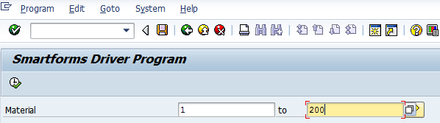

**Step # 6:** Provide the Output Device as LP01 (Default Print Purview) and click on Print Preview.

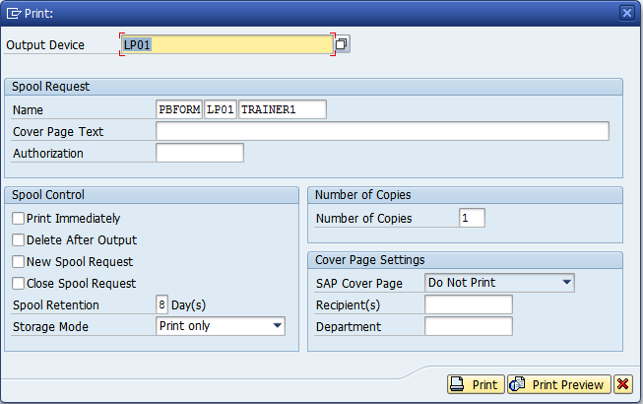

**Step # 7:** Check the below output through the print program.

