First Create a structure with desired fields from table

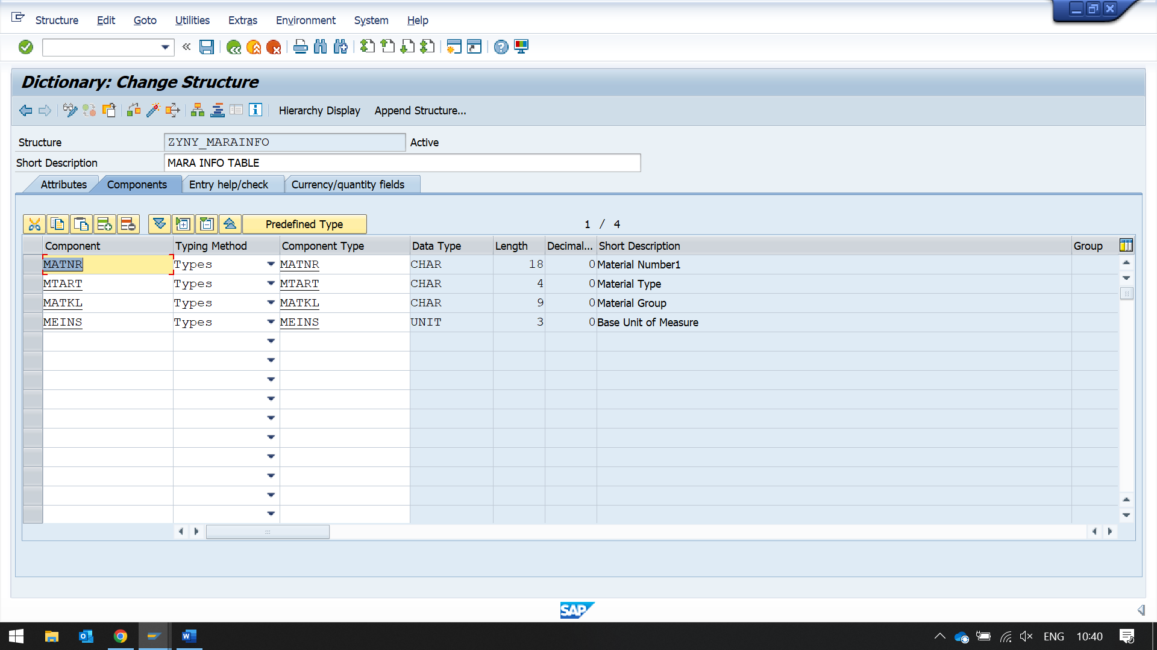

then create a table type with that structure

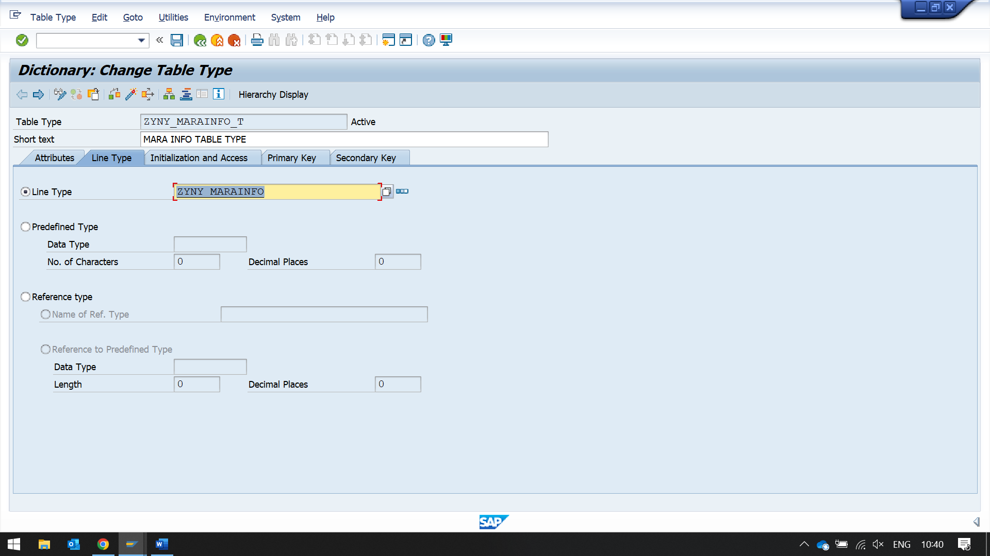

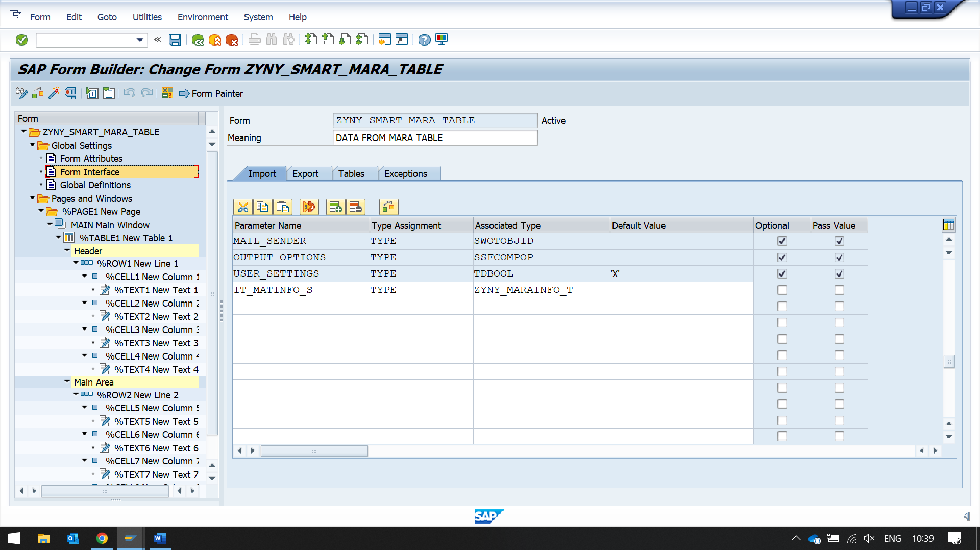

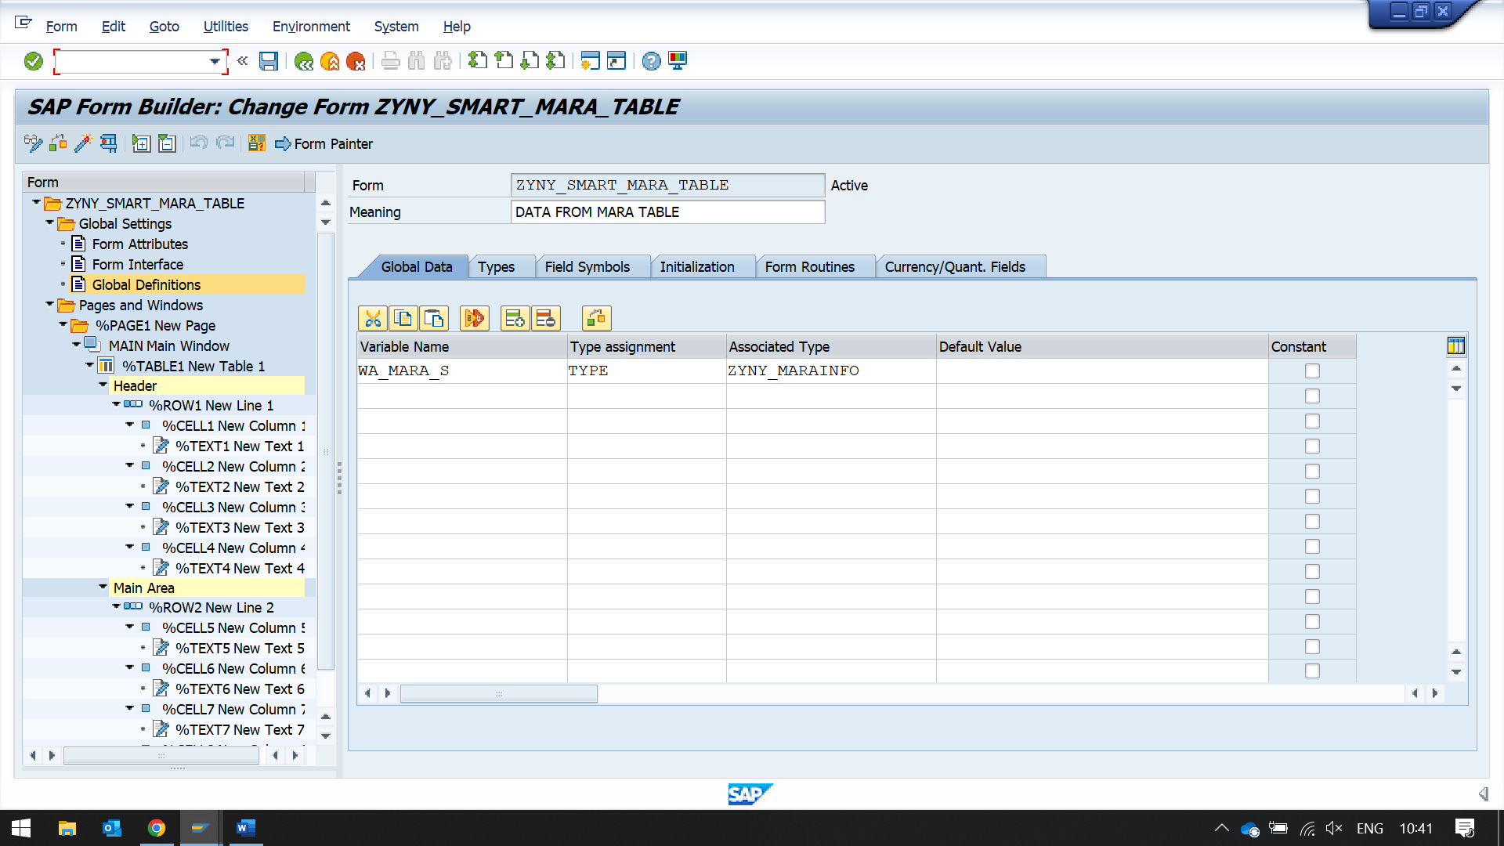

create a table in the main window

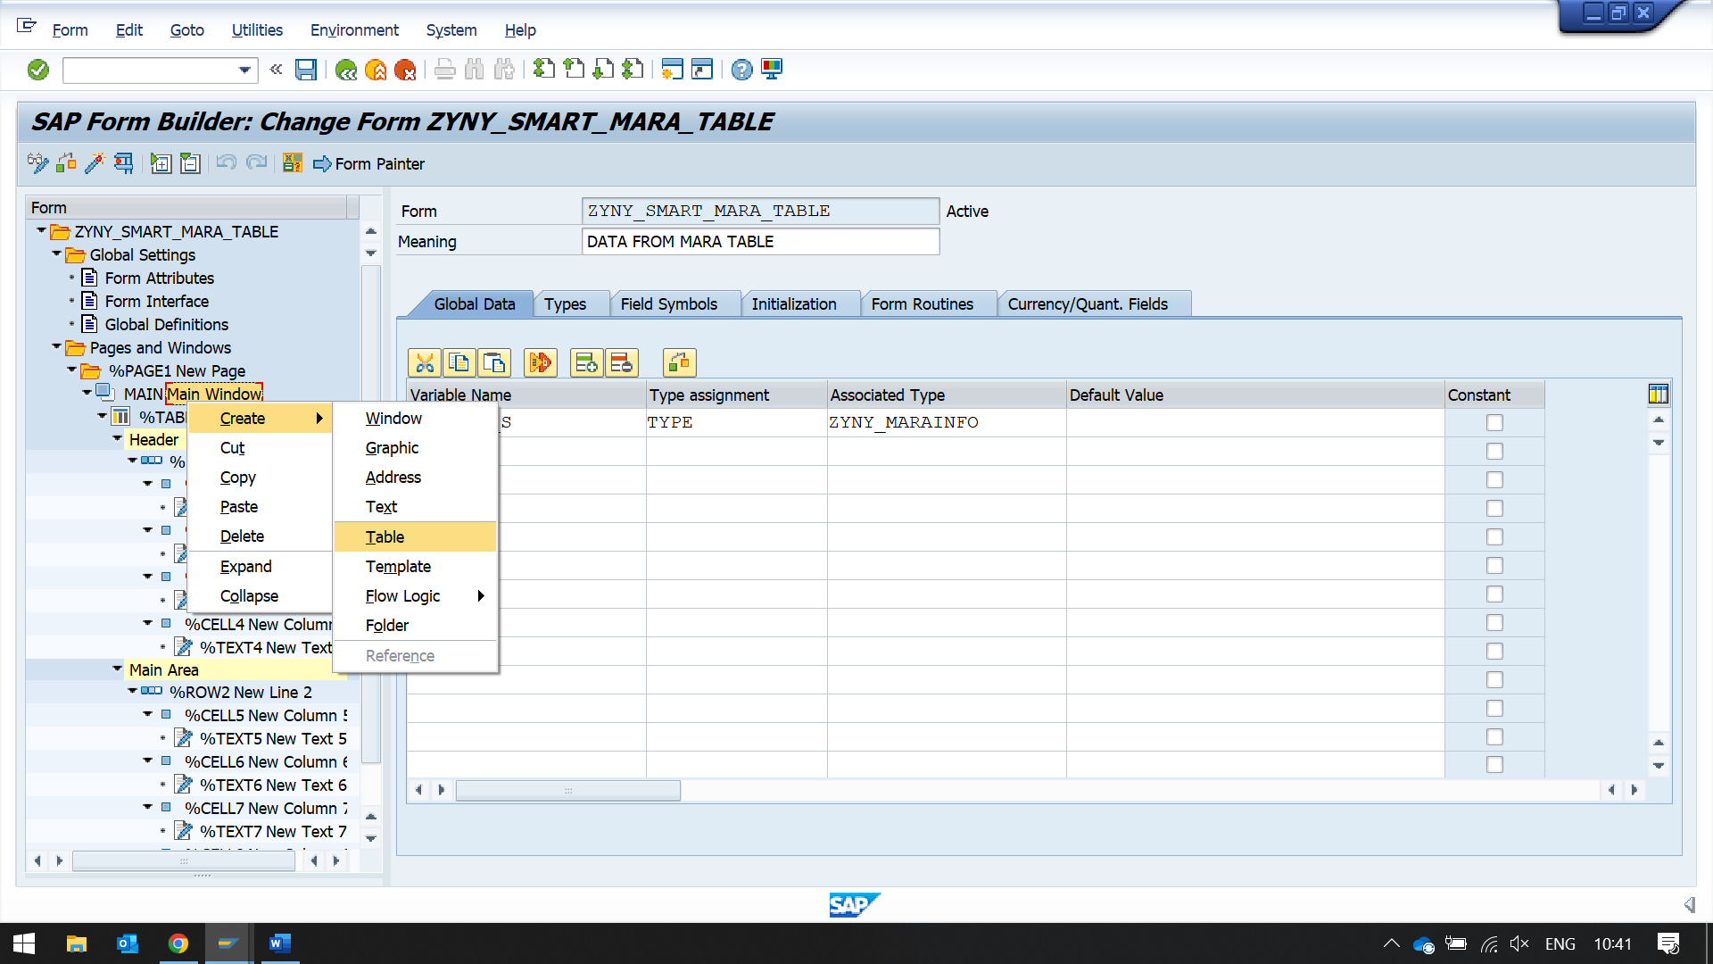

click on new created table

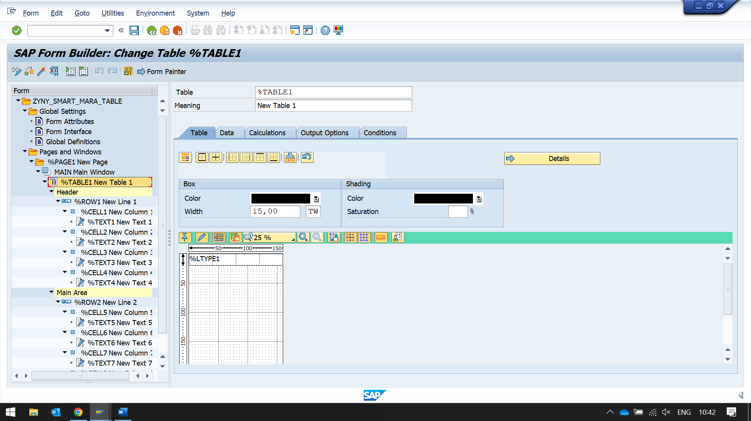then click on details button

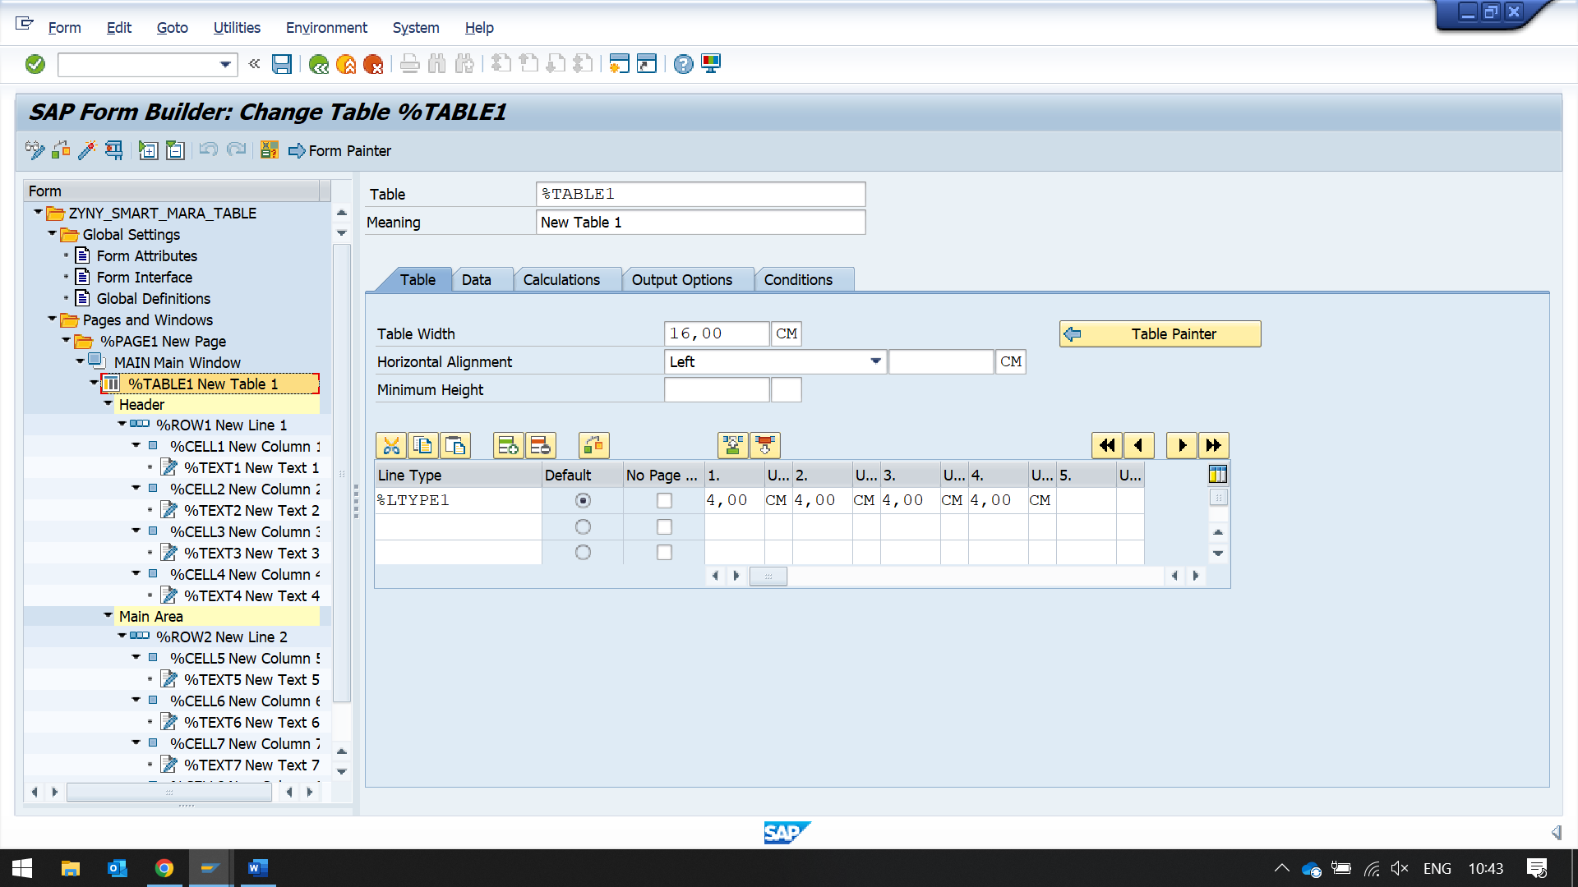

change the width of the field

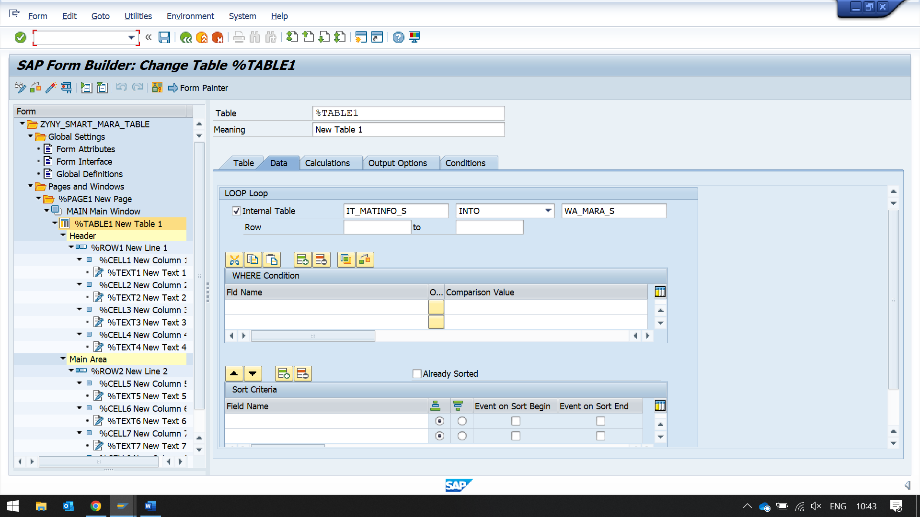

Enter internal table and work area table

create a table line in header section of table

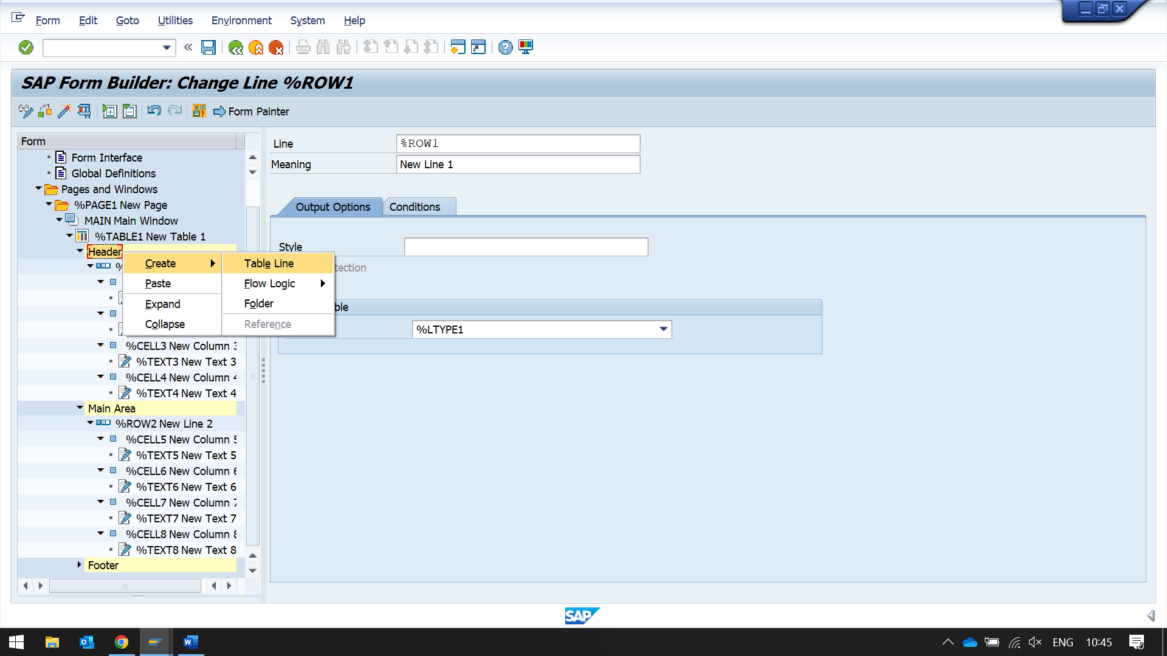

in line type select LTYPE1 WHICH YOU HAVE CREATED PREVIOUSLY

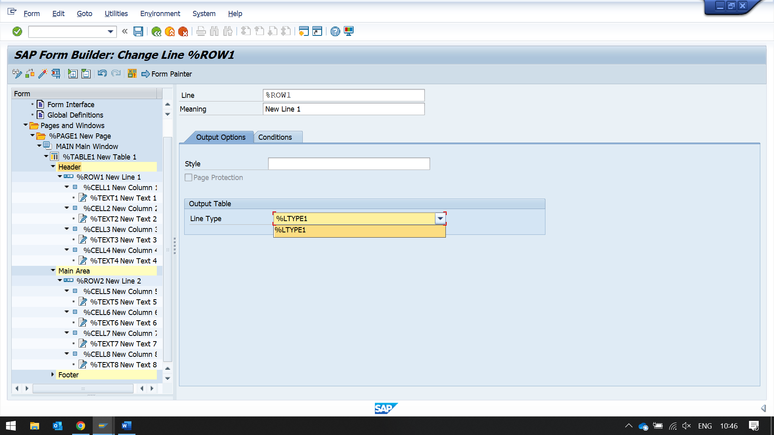

NOW CREATE TEXT IN EACH CELL COLUMN

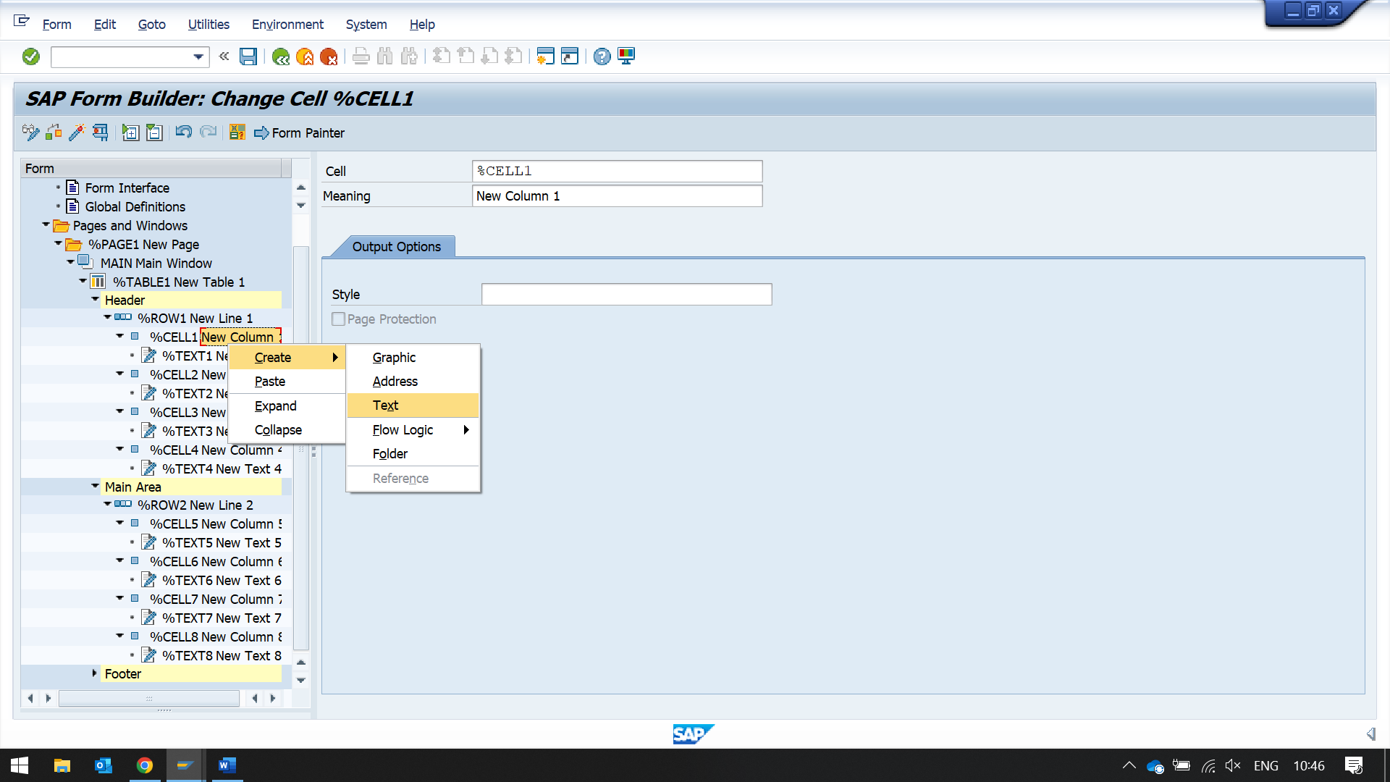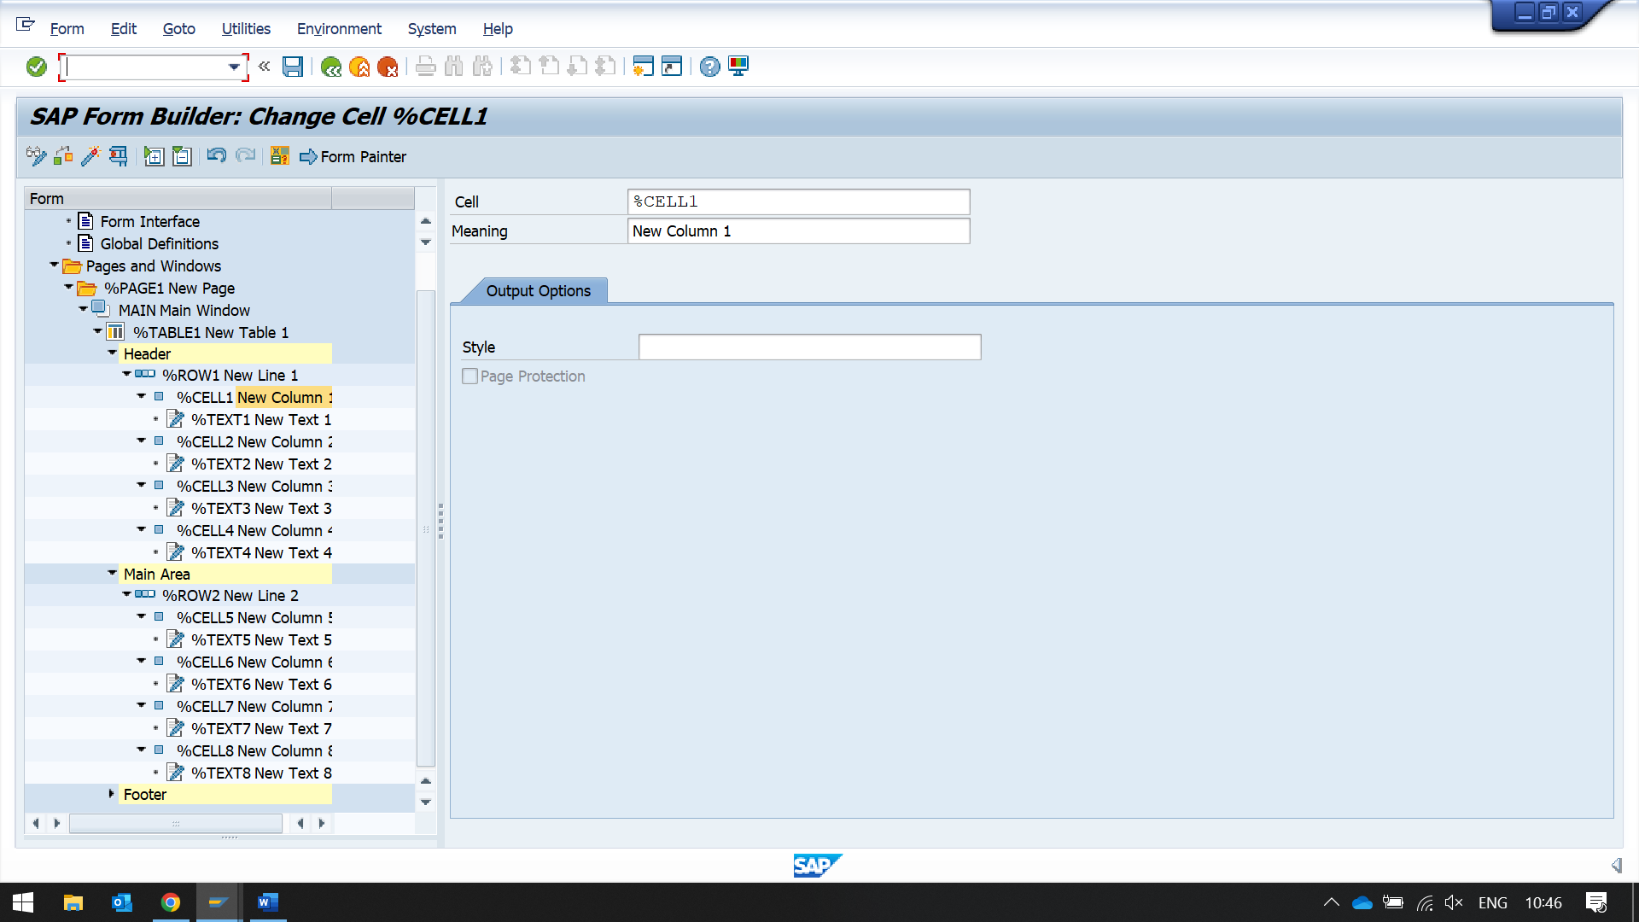

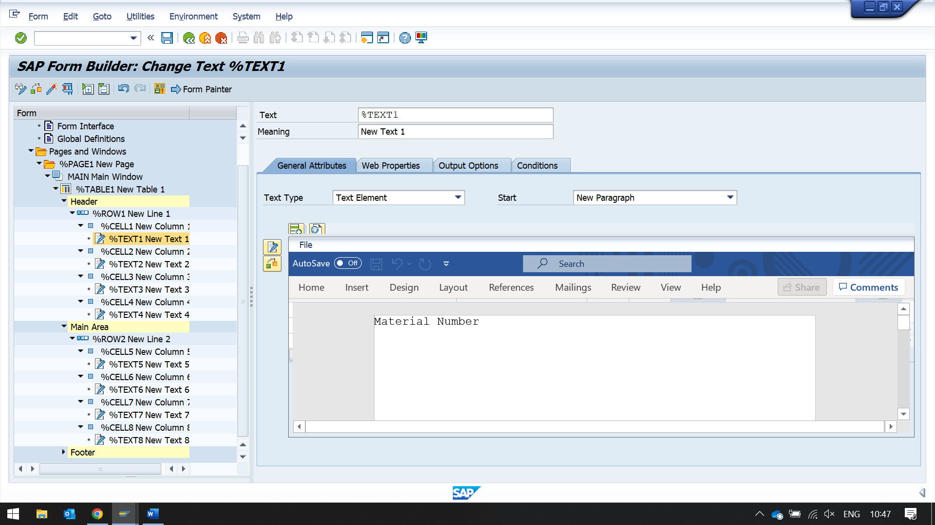

Now enter the header details in each of those text cells

like

Material Number

Material Type

Material Group

Base Unit of Measure

Now in main Area

create a new row line

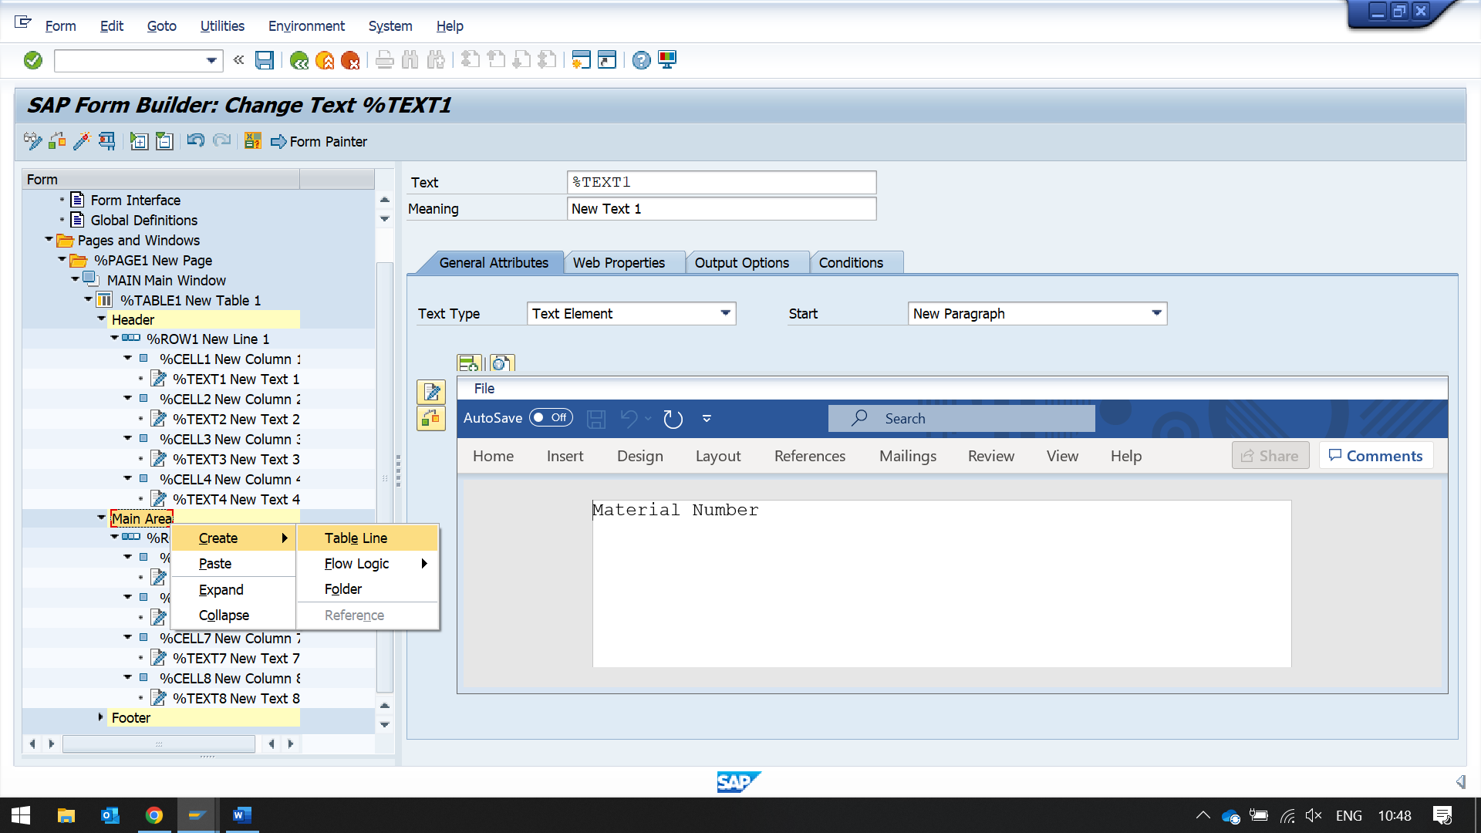

in that row line enter line type as previously choose line1

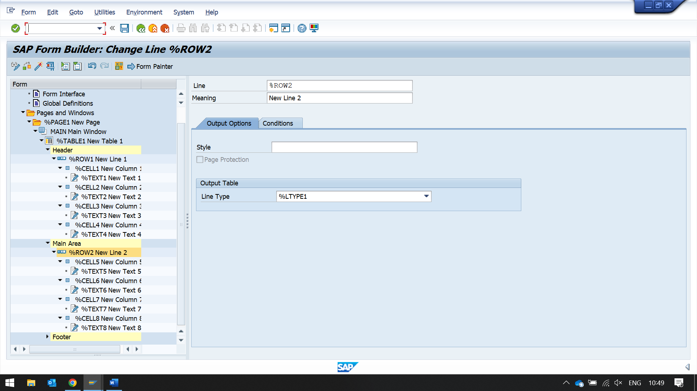

now create cell for column and text in them respectively

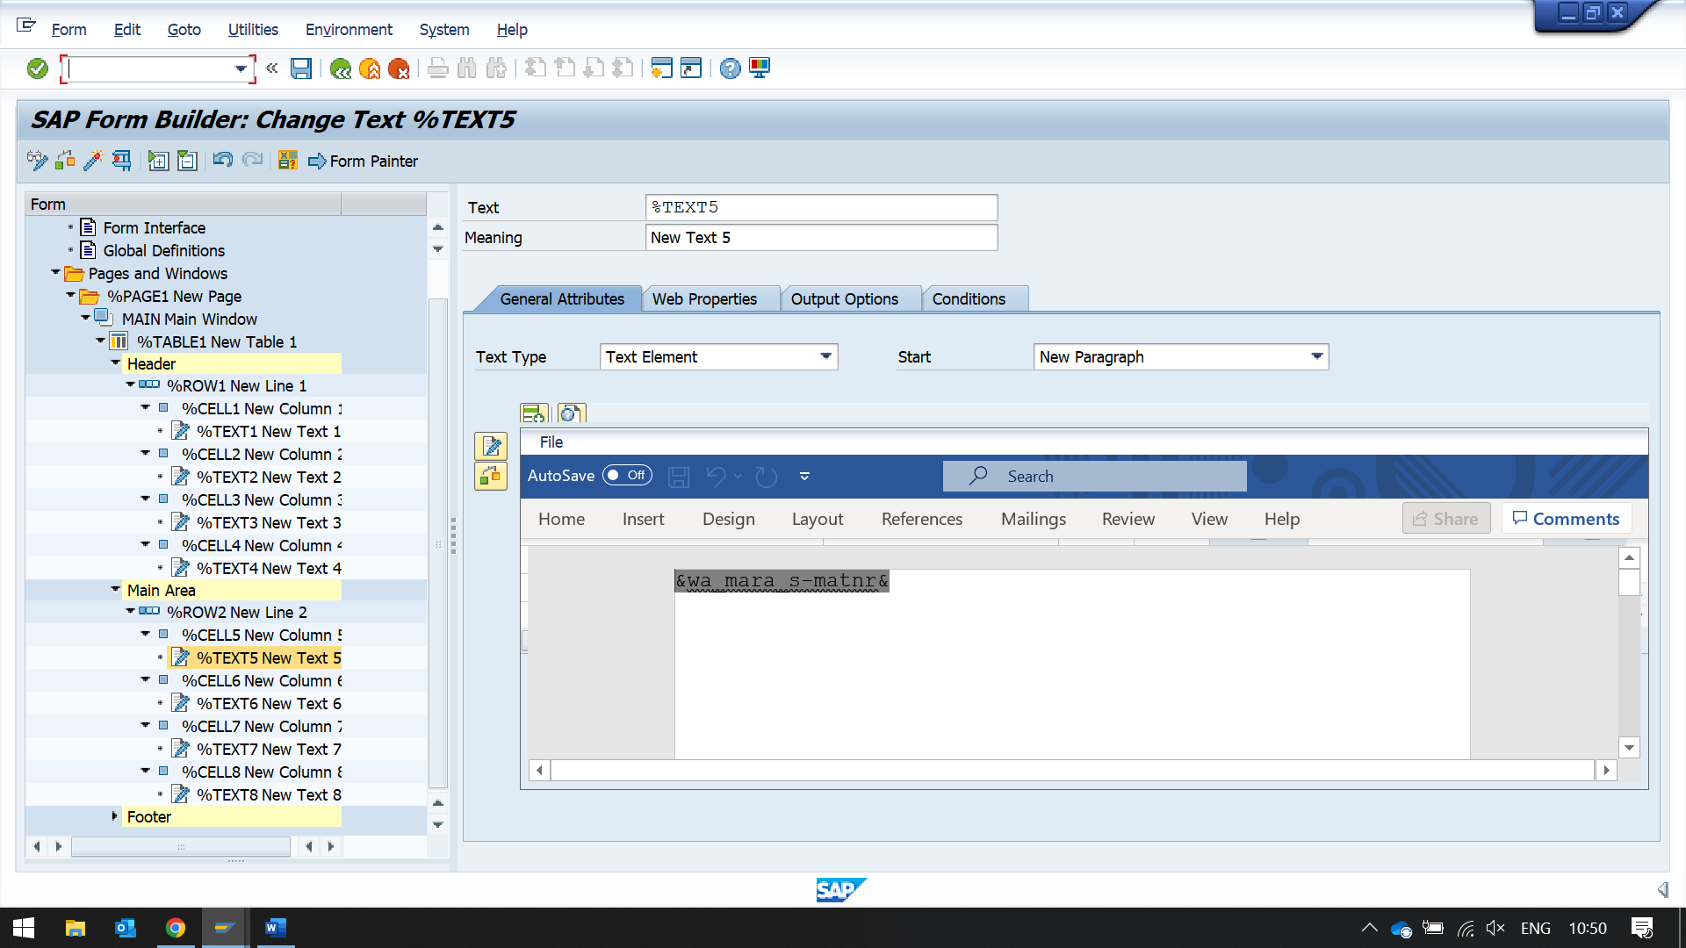

now enter the data name like &wa_mara_s-matnr&

then change them in editor to &wa_mara_s-matnr&

do this for all the 4 text elements in the row line

&wa_mara_s-matnr&

&wa_mara_s-mtart&

&wa_mara_s-matkl&

&wa_mara_s-meins&

then create a report to call the smart forms though function module call

REPORT ZNYN_SMART_FORMS_PROG_3.  
  
TABLES : MARA.  
  
DATA : IT_MATINFO TYPE TABLE OF ZYNY_MARAINFO.  
DATA : V_FMNAME TYPE RS38L_FNAM.  
DATA : V_FNAME TYPE TDSFNAME.  
  
V_FNAME = 'ZYNY_SMART_MARA_TABLE'.  
  
SELECT-OPTIONS : S_MTART FOR MARA-MTART.  
  
SELECT MATNR MTART MATKL MEINS  
  FROM MARA INTO table IT_MATINFO WHERE MTART IN S_MTART.  
  
CALL FUNCTION 'SSF_FUNCTION_MODULE_NAME'  
    EXPORTING  
      formname                 = V_FNAME   "formname  
   IMPORTING  
      FM_NAME                  = V_FMNAME.  
  
  IF sy-subrc <> 0.  
* MESSAGE ID SY-MSGID TYPE SY-MSGTY NUMBER SY-MSGNO  
*         WITH SY-MSGV1 SY-MSGV2 SY-MSGV3 SY-MSGV4.  
  ENDIF.  
  
CALL FUNCTION V_FMNAME "'/1BCDWB/SF00002849'  
  EXPORTING  
    IT_MATINFO_S               = it_matinfo  
 EXCEPTIONS  
   OTHERS                     = 5  
          .  
IF SY-SUBRC = 0.  
* Implement suitable error handling here  
*  WRITE: ' THE RESULT IS:' , RES.  
ENDIF.