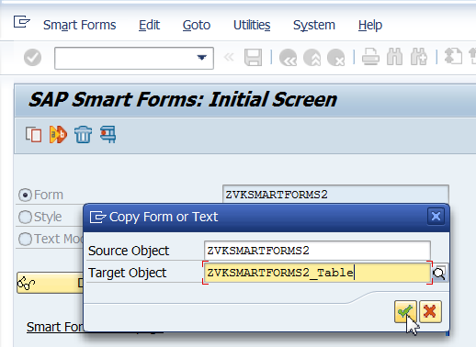

Save.

Need not have loop in Main window since a table has a loop. So this can be deleted.

Right Click on Main Window and create Table.

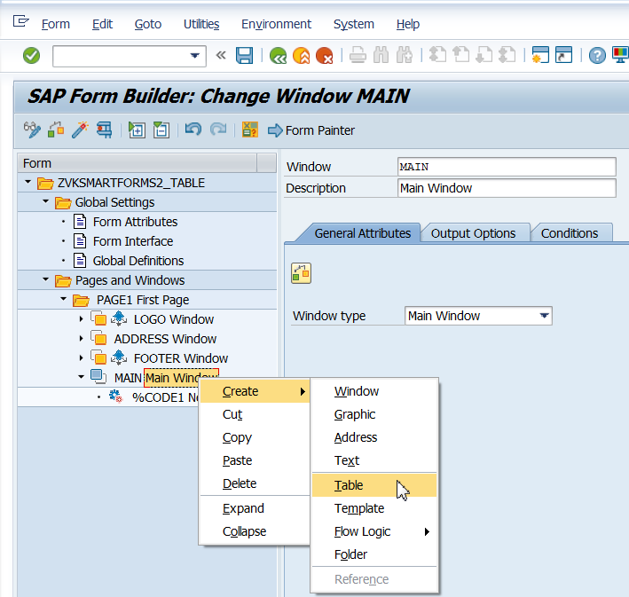

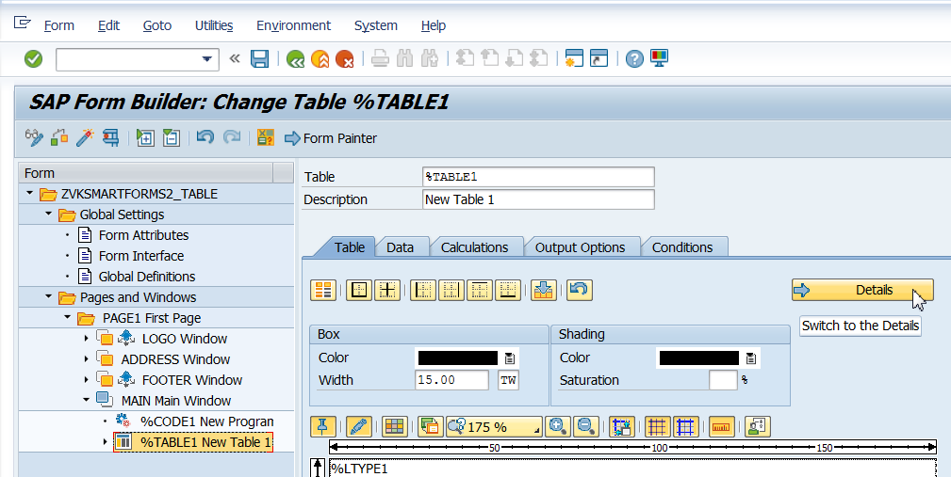

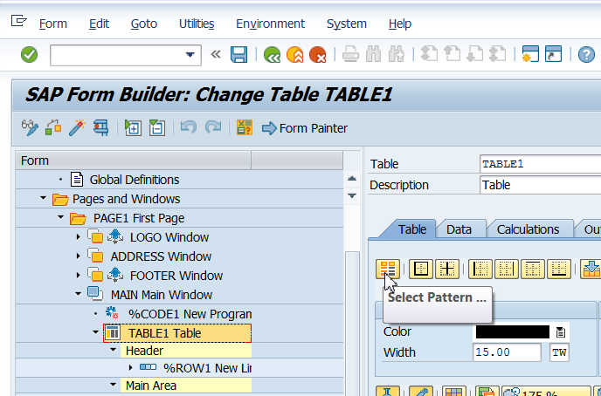

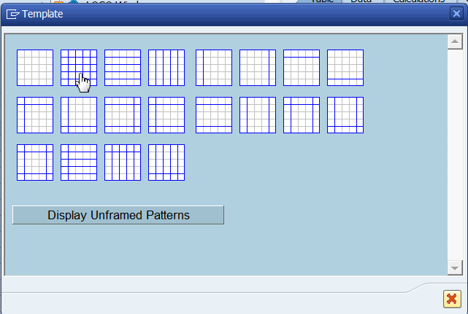

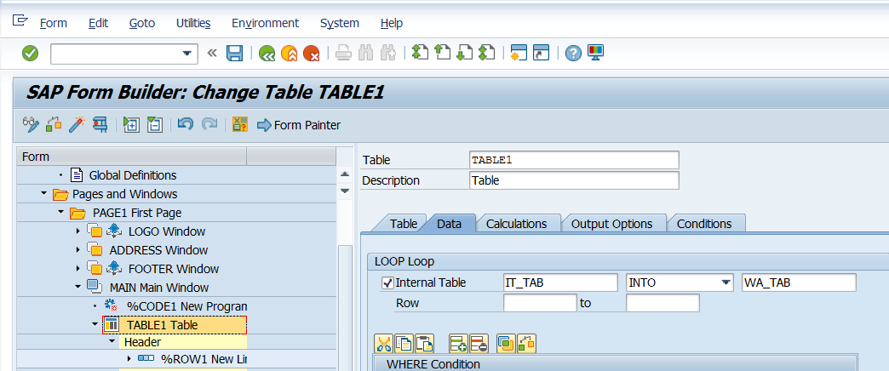

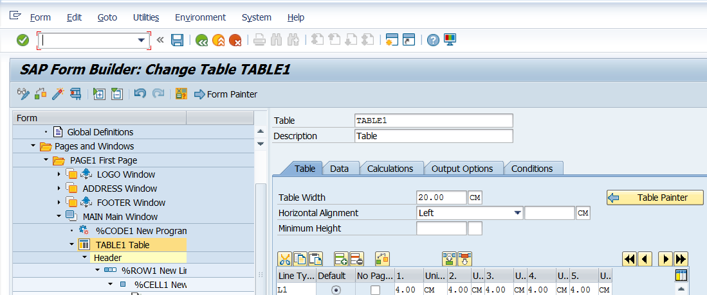

Click on details and give the table width and width of each column. Ensure that the sum of column width totals upto the table width of 20CM. Select Table width of maximum size of 22 CM since A4 paper width is 22CM.

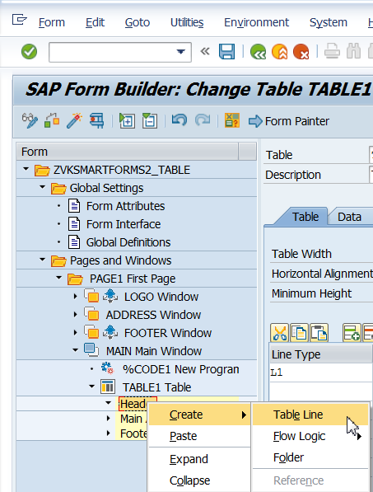

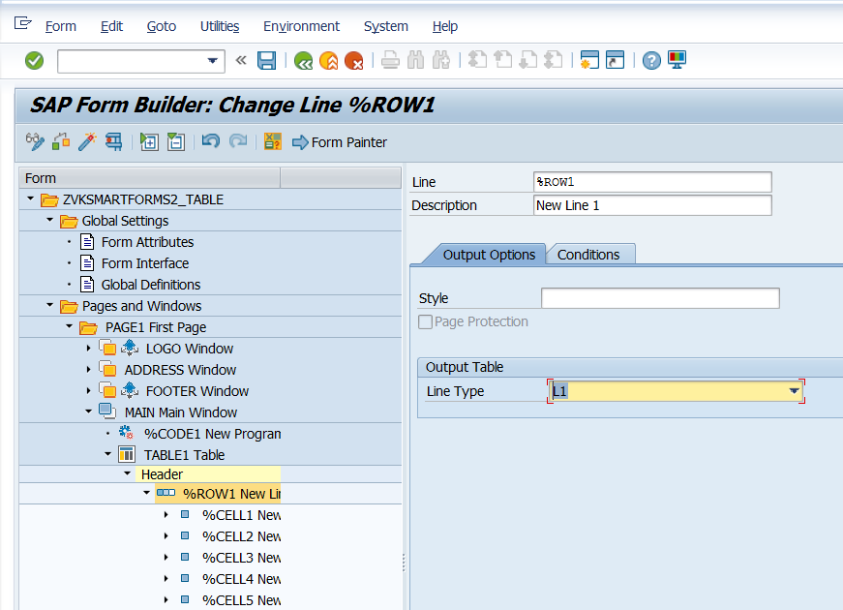

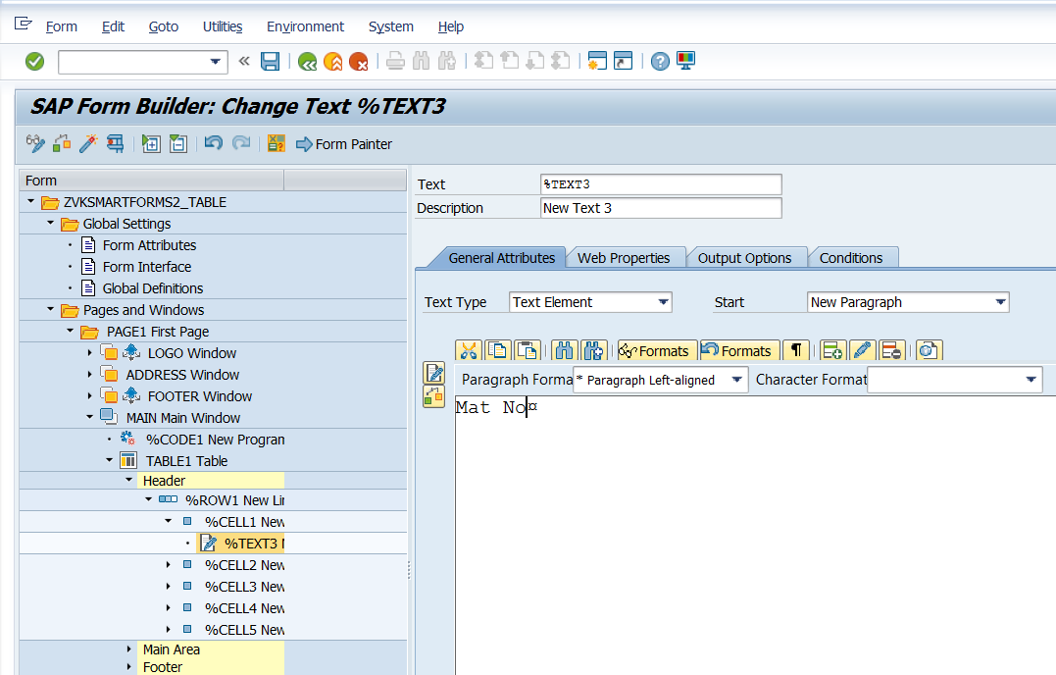

Mat Type

Base UOM

Gross Weight

Net Weight

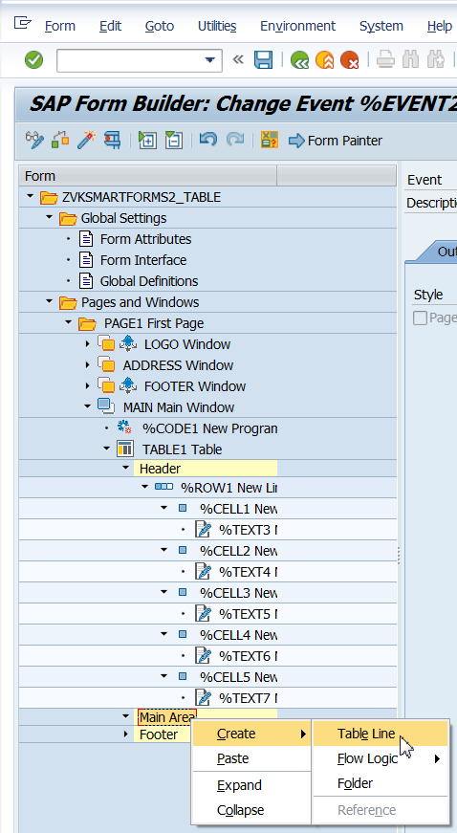

Select Line Type as L1.

Create Text under each Cells.

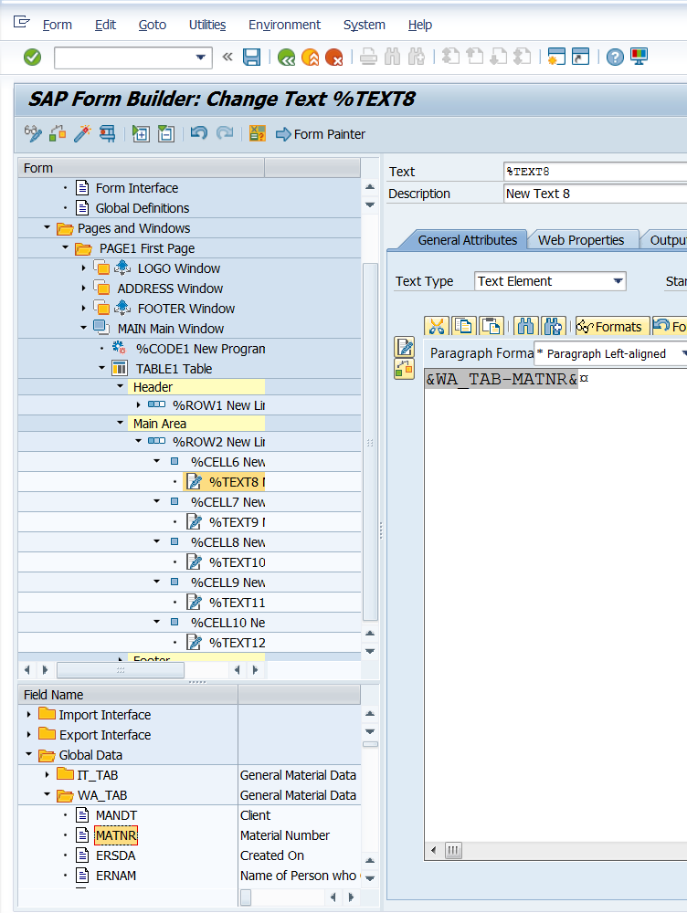

&WA_TAB-MTART&

&WA_TAB-MEINS&

&WA_TAB-BRGEW&

&WA_TAB-NTGEW&

Execute to see OP.

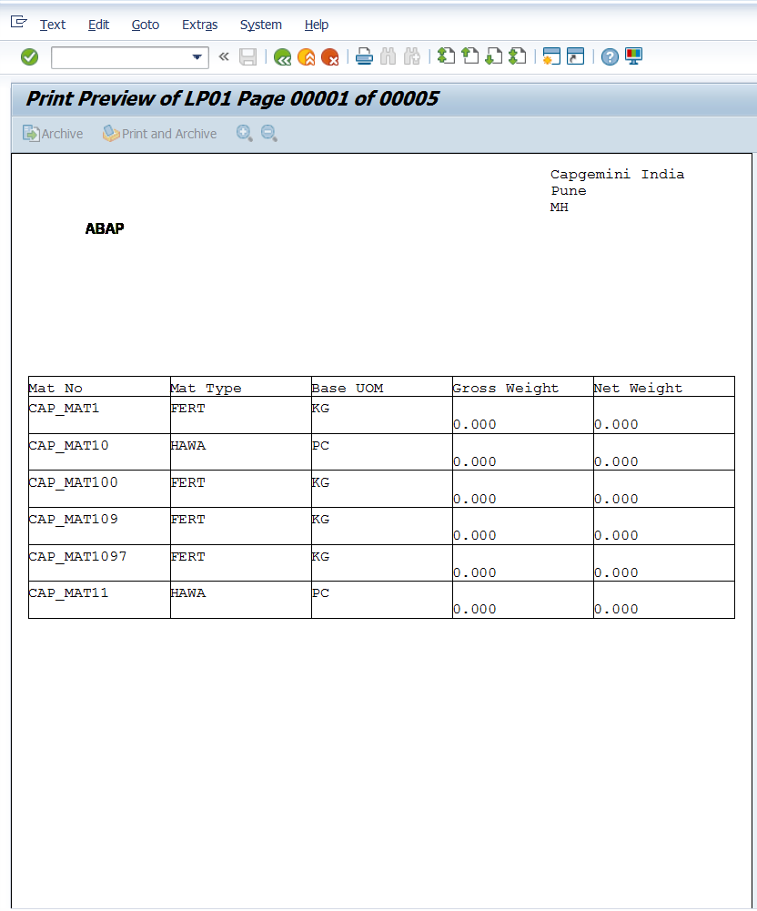

Create Graphics in Background.

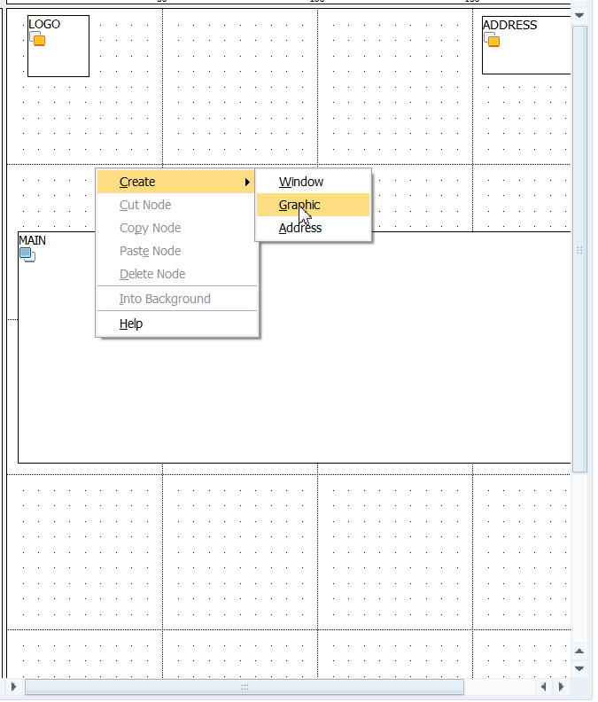

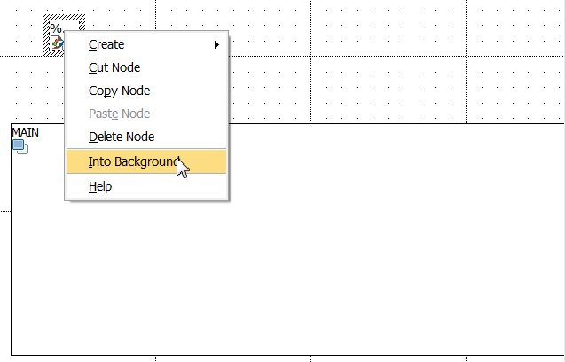

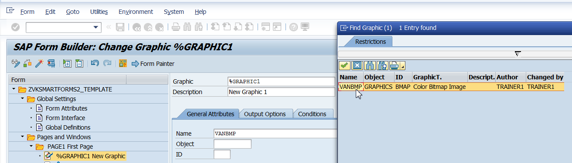

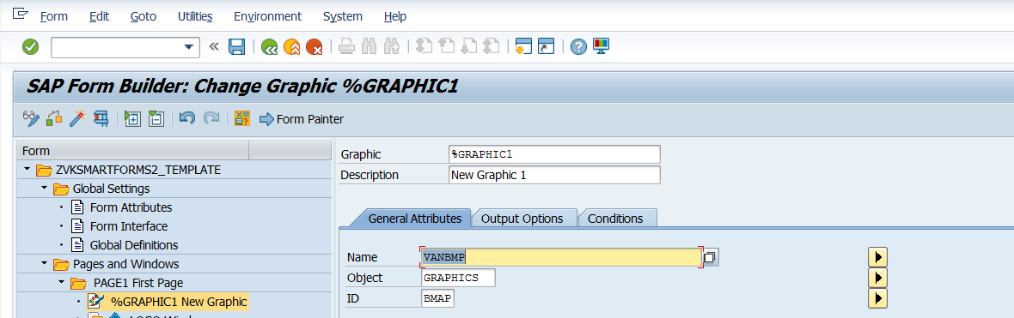

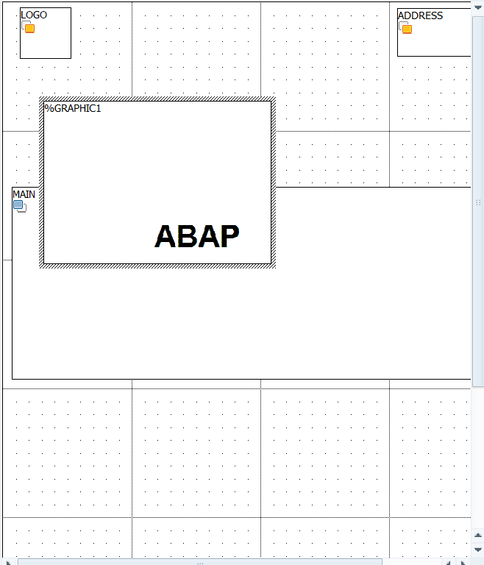

Execute it.

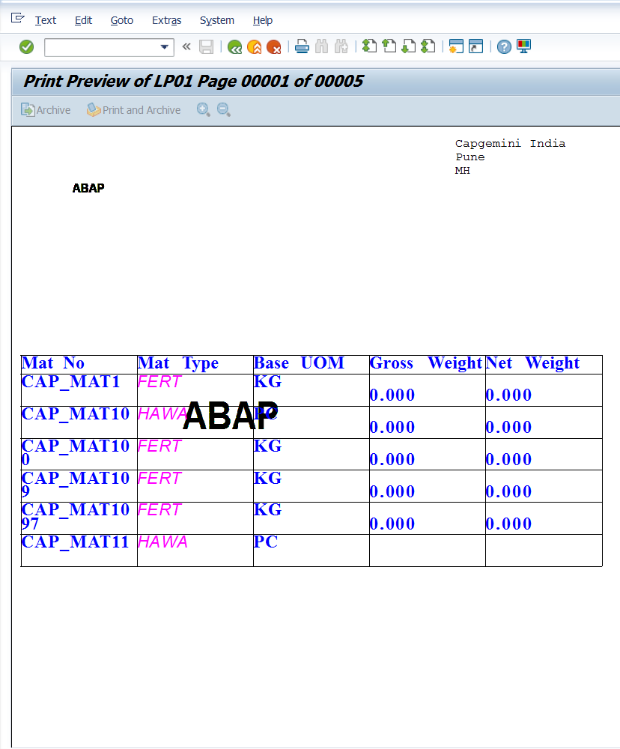&WA_TAB-MTART&&WA_TAB-MTART&