**BAPI Material Master Upload Demo Program # 2.**

***Program theme:*** *In this demo program you u can learn how to Create/Change (t-code MM01 and change MM02) the Material Master Data by sing the BAPI (Business Application Programming Interface) RFC Function Module* **BAPI_MATERIAL_SAVE_DATA.**

**Step # 1:** Go to transaction code SE38 and create the executable program.

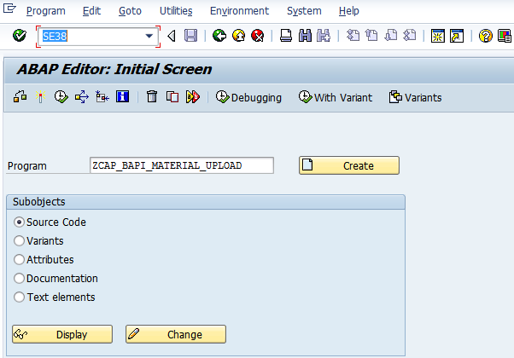

**Step # 2:** Provide the description click on save.

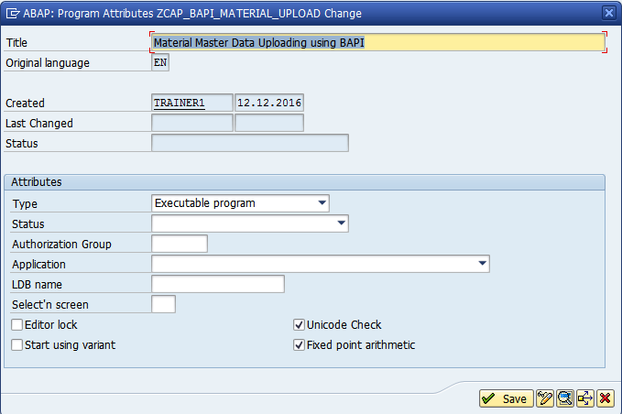

**Step # 3:** Save it in a package.

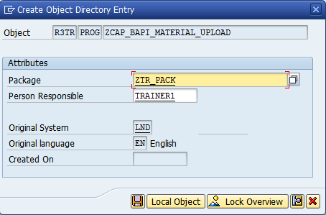

**Step # 4:** Provide the short description for change request.

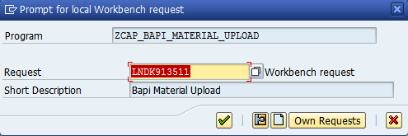

**Step # 5:** Provide the ZInclude program name in the executable program and double click on it and click on yes to create the Include program.

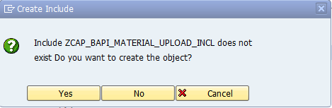

**Step # 6:** Provide the title and click on save.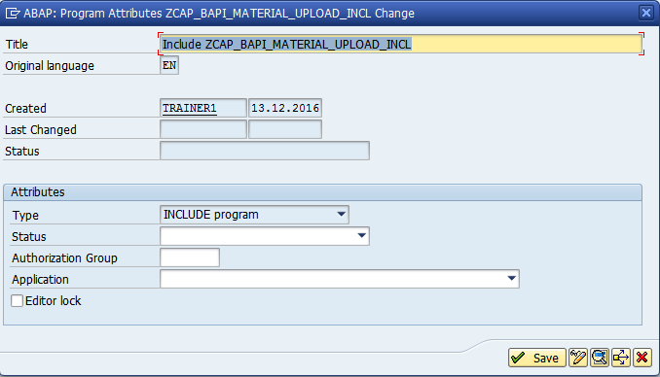

**Step # 7:** Declare all the Structures and internal tables and work areas and global variables etc.

*\*&---------------------------------------------------------------------\**  
*\*&  Include           ZCAP_BAPI_MATERIAL_UPLOAD_INCL*  
*\*&---------------------------------------------------------------------\**  
  
TABLES: BAPIMATHEAD,  *" Header Segment with Control Information*  
        BAPI_MARA,    *" Material Data at Client Level*  
        BAPI_MARAX,   *" Checkbox Structure for BAPI_MARA*  
        BAPI_MARC,    *" Material Data at Plant Level*  
        BAPI_MARCX,   *" Checkbox Structure for BAPI_MARC*  
        BAPI_MAKT,    *" Material Descriptions*  
        BAPIRET2.     *" Return Parameter*  
  
TYPES : BEGIN OF TY_TAB1,  *" Structure type*  
        MATNR(18),     *" Material Number*  
        MBRSH(1),      *" Industry sector*  
        MTART(4),      *" Material type*  
        MAKTX(40),     *" Material description*  
        MEINS(3),      *" Base Unit of Measure*  
        MATKL(9),      *" Material Group*  
        END OF TY_TAB1.  
DATA :IT_TAB1 TYPE STANDARD TABLE OF TY_TAB1,  *" Main Internal table*  
      WA_TAB1 TYPE TY_TAB1.                    *" Main Work area*  
  
TYPES : BEGIN OF TY_TAB2,  *" Structure type*  
        LANGU(1),      *" Language Key*  
        LANGU_ISO(2),  *" 2-Character SAP Language Code*  
        MATL_DESC(40), *" Material description*  
        DEL_FLAG(1),   *" Delete Data Record*  
        END OF TY_TAB2.  
  
DATA :IT_TAB2 TYPE STANDARD TABLE OF TY_TAB2, *" Material Description Internal table*  
      WA_TAB2 TYPE TY_TAB2.                   *" Work area*  
  
DATA : BEGIN OF IT_RETURN OCCURS 0.  
  
       INCLUDE STRUCTURE BAPIRET2. *" Return Parameter Structure*  
  
DATA: END OF IT_RETURN.

**Step # 8:** write the code logic in a main executable program and save it and activate both the Include and main program and execute the main BAPI program (F8).

*&---------------------------------------------------------------------*  
*& Report ZCAP_BAPI_MATERIAL_UPLOAD  
*&---------------------------------------------------------------------*  
*&  
*&---------------------------------------------------------------------*  
REPORT ZCAP_BAPI_MATERIAL_UPLOAD LINE-SIZE 800.  
  
INCLUDE ZCAP_BAPI_MATERIAL_UPLOAD_INCL.  " Include Program  
  
SELECTION-SCREEN BEGIN OF BLOCK B1 WITH FRAME TITLE TEXT-001.  
  
PARAMETERS P_FILE TYPE RLGRAP-FILENAME. "Local file for upload  
  
SELECTION-SCREEN END OF BLOCK B1.  
  
AT SELECTION-SCREEN ON VALUE-REQUEST FOR P_FILE.  " validation for Value Request  
  
  CALL FUNCTION 'F4_FILENAME'  
    EXPORTING  
      PROGRAM_NAME  = SYST-CPROG  
      DYNPRO_NUMBER = SYST-DYNNR  
    IMPORTING  
      FILE_NAME     = P_FILE.  
  
START-OF-SELECTION.  
DATA  P_FILE1 TYPE STRING.  
      P_FILE1 = P_FILE.  
  
  CALL FUNCTION 'GUI_UPLOAD'   " Upload for Data Provider  
    EXPORTING  
      FILENAME            = P_FILE1  
      FILETYPE            = 'ASC'  
      HAS_FIELD_SEPARATOR = 'X'  
    TABLES  
      DATA_TAB            = IT_TAB1.  
  
  LOOP AT IT_TAB1 INTO WA_TAB1.  
  
    BAPIMATHEAD-MATERIAL    = WA_TAB1-MATNR.  
    BAPIMATHEAD-IND_SECTOR  = WA_TAB1-MBRSH.  
    BAPIMATHEAD-MATL_TYPE   = WA_TAB1-MTART.  
    BAPIMATHEAD-BASIC_VIEW  = 'X'.  
  
    BAPI_MARA-MATL_GROUP    = WA_TAB1-MATKL.  
    BAPI_MARA-BASE_UOM      = WA_TAB1-MEINS.  
  
    BAPI_MARAX-MATL_GROUP   = 'X'.  
    BAPI_MARAX-BASE_UOM     = 'X'.  
  
    WA_TAB2-LANGU     = 'E'.  
    WA_TAB2-MATL_DESC = WA_TAB1-MAKTX.  
    APPEND WA_TAB2 TO IT_TAB2.  
  
    CALL FUNCTION 'BAPI_MATERIAL_SAVEDATA' " Calling RFC Function Module for Create and Change  
                                           " Material Master Data for MM01 and MM02 T-codes.  
      EXPORTING  
        HEADDATA            = BAPIMATHEAD  
        CLIENTDATA          = BAPI_MARA  
        CLIENTDATAX         = BAPI_MARAX  
        PLANTDATA           = BAPI_MARC  
        PLANTDATAX          = BAPI_MARCX  
      IMPORTING  
        RETURN              = IT_RETURN  
      TABLES  
        MATERIALDESCRIPTION = IT_TAB2.  
  
    WRITE : / IT_RETURN-TYPE,             " Return Parameters displayed for BAPI Status  
            3  IT_RETURN-ID,  
            23 IT_RETURN-NUMBER,  
            25 IT_RETURN-MESSAGE,  
               IT_RETURN-LOG_NO,  
               IT_RETURN-MESSAGE_V1,  
               IT_RETURN-MESSAGE_V2,  
               IT_RETURN-MESSAGE_V3,  
               IT_RETURN-MESSAGE_V4,  
               IT_RETURN-PARAMETER,  
               IT_RETURN-ROW,  
               IT_RETURN-FIELD.  
  ENDLOOP.

**Step # 9:** Prepare the flat file (.txt notepad format with tabulator space for each field) for new material master data upload.

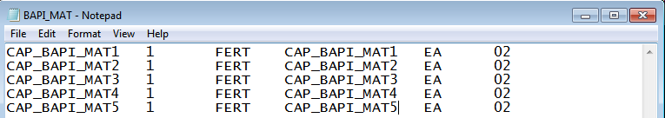

**Step # 10:** Execute the Main Program and select the flat file and press the execute button (F8) to upload the material mater data.

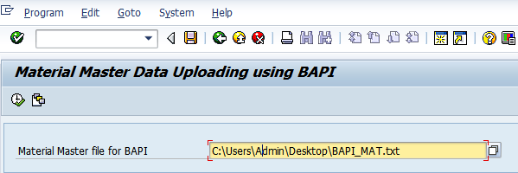

**Step # 11:** After successfully uploaded the materials you will get the below message, material has been created or extended for each record.

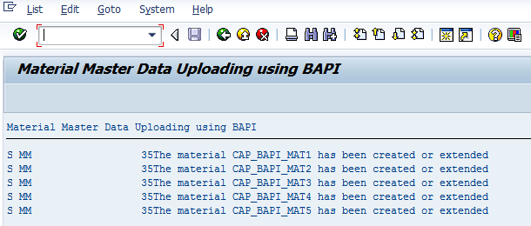

**Step # 12:** Go to SE11 and provide the MARA table name and cross check the content for materials has been posted or not?.

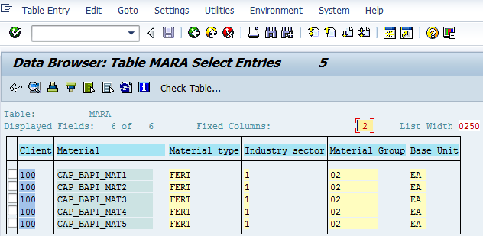

**Step # 13:** Go to SE11 provide the MAKT table and cross check the materials descriptions are posted or not.

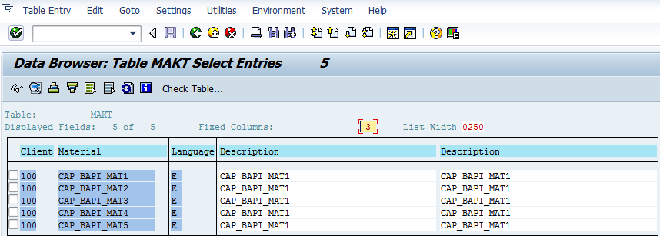

**Step # 14:** Go to t-code MM03 (Display Material) and provide the latest material number from the flat file to check the material master info at application level.

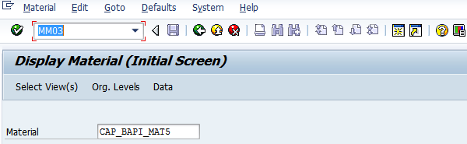

**Step # 15:** Check the complete material info in the **Basic data1**tab.

*Successfully uploaded the material master data by suing the BAPI*

