**BAPI Purchase Order Get Details Program # 3.**

***Program theme:*** *In this demo program you can learn how to get the PO details based on the PO document number (without writing SQL Code) by sing the BAPI (Business Application Programming Interface) RFC Function Module* **BAPI_PO_GETDETAIL.**

**Step # 1:** Go to transaction SE38 T-Code and create the executable program.

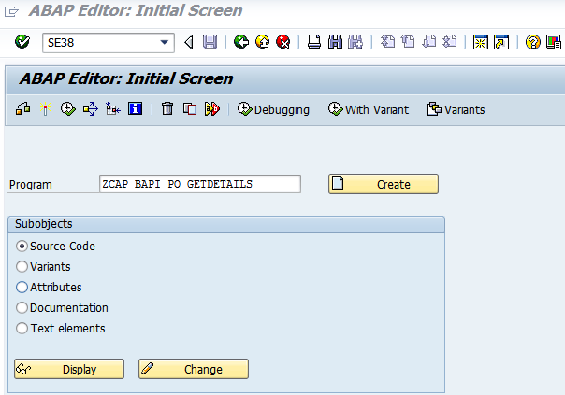

**Step # 2:** Provide the title and select the Executable program and click on save.

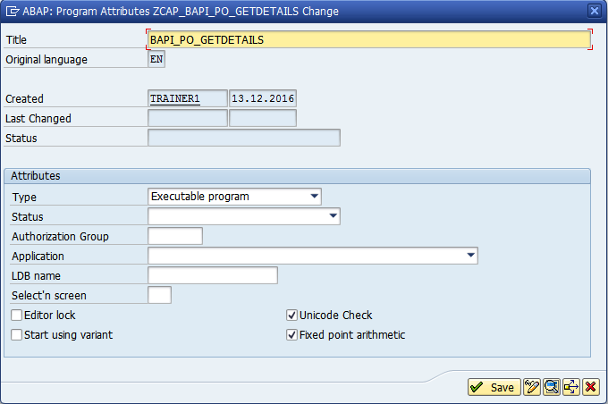

**Step # 3:** Save it in a package.

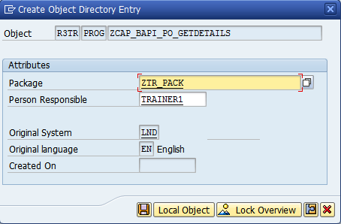

**Step # 3.1:** Write the program logic.

*&---------------------------------------------------------------------*  
*& Report ZCAP_BAPI_PO_GETDETAILS  
*&---------------------------------------------------------------------*  
*&  
*&---------------------------------------------------------------------*  
REPORT ZCAP_BAPI_PO_GETDETAILS.  
  
DATA: BEGIN OF IT_TAB OCCURS 0.  
      INCLUDE STRUCTURE BAPIEKPO. " BAPIEKPO Display/List PO Item  
DATA: END OF IT_TAB.  
  
PARAMETERS P_EBELN TYPE EKKO-EBELN.  " Purchae document Number  
  
CALL FUNCTION 'BAPI_PO_GETDETAIL'  
  EXPORTING  
    PURCHASEORDER = P_EBELN  
*   ITEMS         = 'X'  
*   ACCOUNT_ASSIGNMENT               = ' '  
*   SCHEDULES     = ' '  
*   HISTORY       = ' '  
*   ITEM_TEXTS    = ' '  
*   HEADER_TEXTS  = ' '  
*   SERVICES      = ' '  
*   CONFIRMATIONS = ' '  
*   SERVICE_TEXTS = ' '  
*   EXTENSIONS    = ' '  
* IMPORTING  
*   PO_HEADER     =  
*   PO_ADDRESS    =  
  TABLES  
*   PO_HEADER_TEXTS                  =  
    PO_ITEMS      = IT_TAB  
*   PO_ITEM_ACCOUNT_ASSIGNMENT       =  
*   PO_ITEM_SCHEDULES                =  
*   PO_ITEM_CONFIRMATIONS            =  
*   PO_ITEM_TEXTS =  
*   PO_ITEM_HISTORY                  =  
*   PO_ITEM_HISTORY_TOTALS           =  
*   PO_ITEM_LIMITS                   =  
*   PO_ITEM_CONTRACT_LIMITS          =  
*   PO_ITEM_SERVICES                 =  
*   PO_ITEM_SRV_ACCASS_VALUES        =  
*   RETURN        =  
*   PO_SERVICES_TEXTS                =  
*   EXTENSIONOUT  =  
  .  
LOOP AT IT_TAB.  
  WRITE  : /'PO Number: = ', IT_TAB-PO_NUMBER COLOR COL_HEADING,  
            'PO Item: = ', IT_TAB-PO_ITEM ,  
            'Material Number: = ', IT_TAB-MATERIAL ,  
            'Short Text: = ', IT_TAB-SHORT_TEXT ,  
            'Company Code: = ', IT_TAB-CO_CODE ,  
            'Plant: = ', IT_TAB-PLANT ,  
            'Storage location: = ', IT_TAB-STORE_LOC ,  
            'Purchase Order Quantity: = ', IT_TAB-QUANTITY ,  
            'Order unit: = ', IT_TAB-UNIT ,  
            'Net price: = ', IT_TAB-NET_PRICE COLOR COL_POSITIVE ,  
            'Net order value: = ',IT_TAB-NET_VALUE COLOR COL_TOTAL .  
ENDLOOP.

**Step # 3.2:**  Go to SE11 T-Code and enter the BAPIEKPO Structure to display the PO Line items fields.

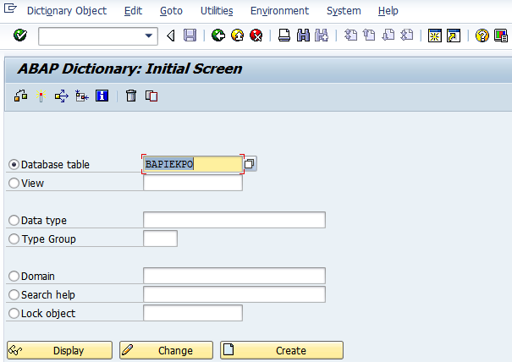

**Step # 3.3:**  Select the fields from the structure and write the code accordingly.

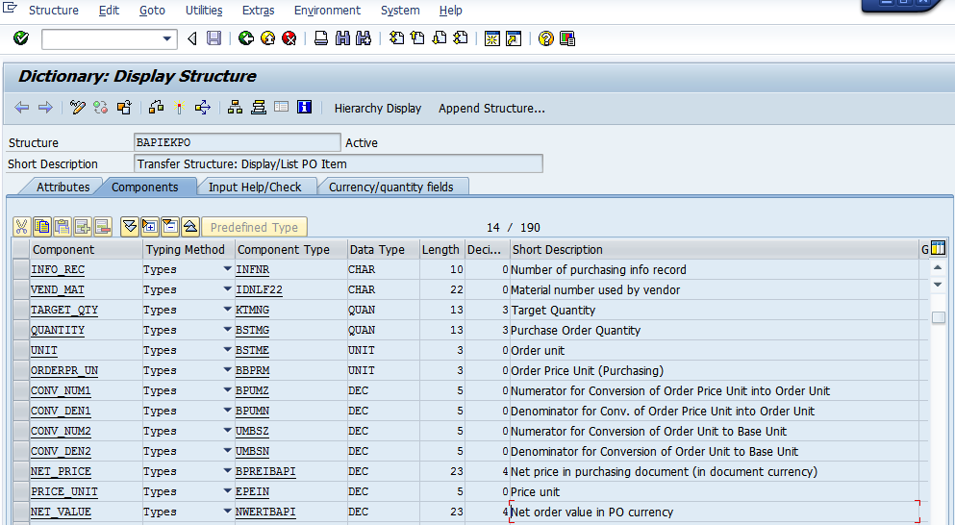

**Step # 4:** Save and activate the program. Enter the purchase document no and execute the program (F8).

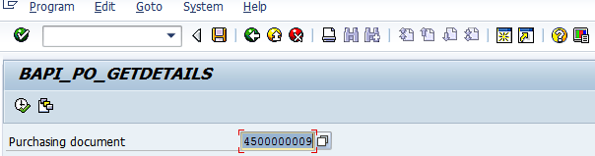

**Step # 5:** based on the PO Input it will be displayed purchased order line items details.

