Q1

Touch film{1..6}.avi

Touch snap{1..6}.jpg

Touch songs{1..6}.mp3

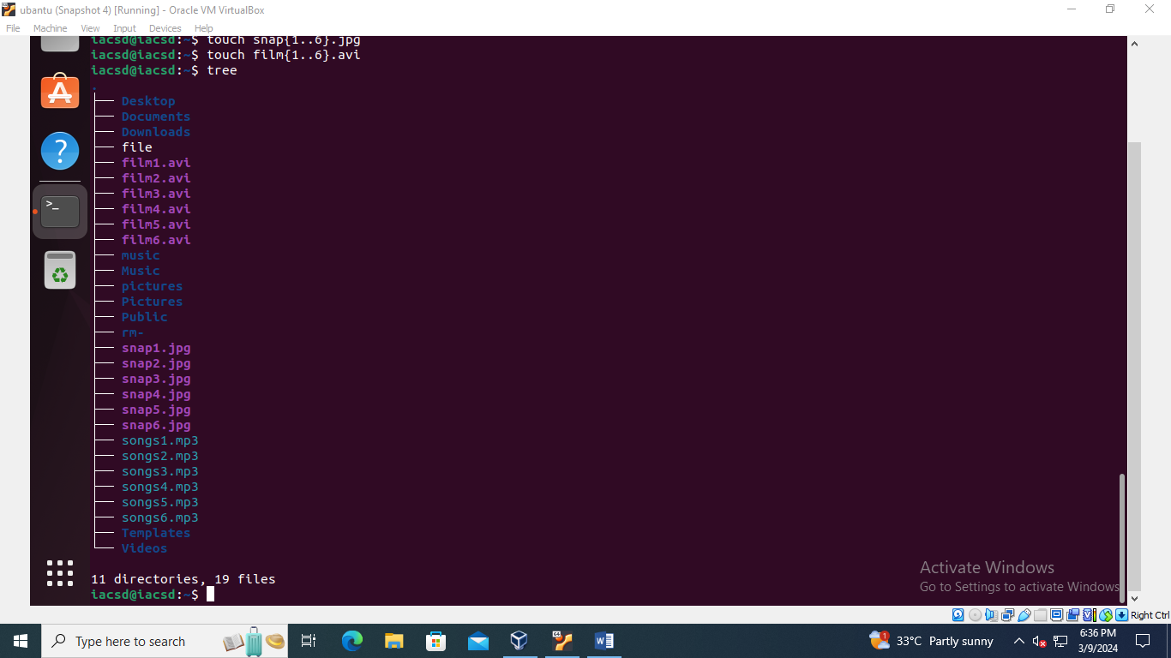

Q2

Mv film{1..6}.avi Videos

Mv Snap{1..6}.jpg picture

Mv songs{1..6}.mp3 music

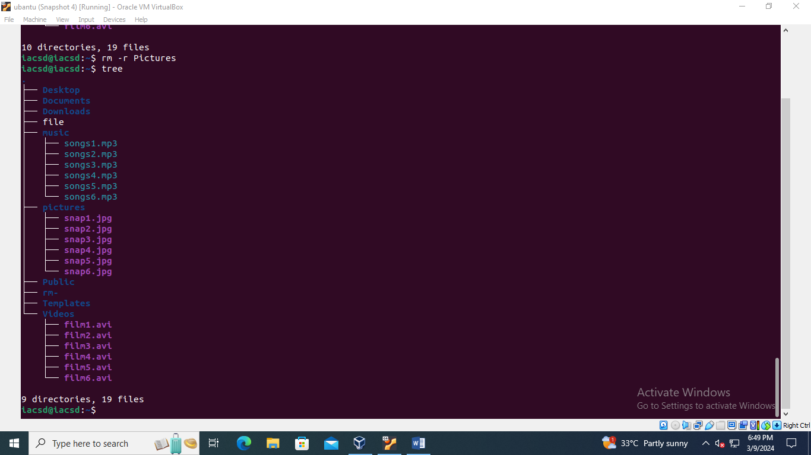

Q3,

Mkdir friends

Mkdir family

Mkdir work

Q4

cp snap{1..2}.jpg home/iacsd/friends

cp snap{3..4}.jpg home/iacsd/family

cp snap{5..6}.jpg home/iacsd/work

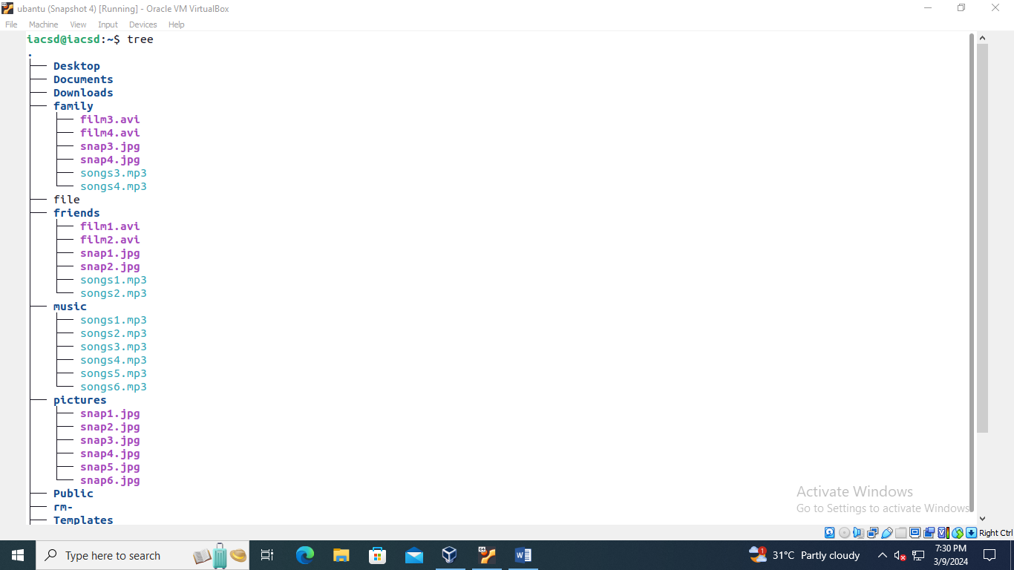

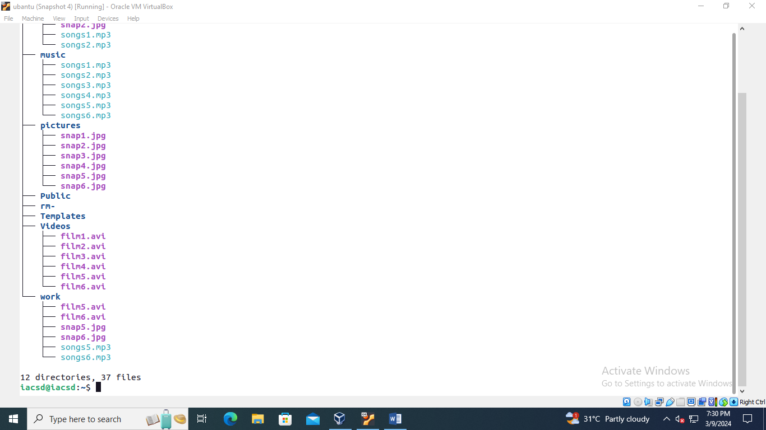

Q5

Rm –r friend

Rm –r family

Rm –r work

Q8,9

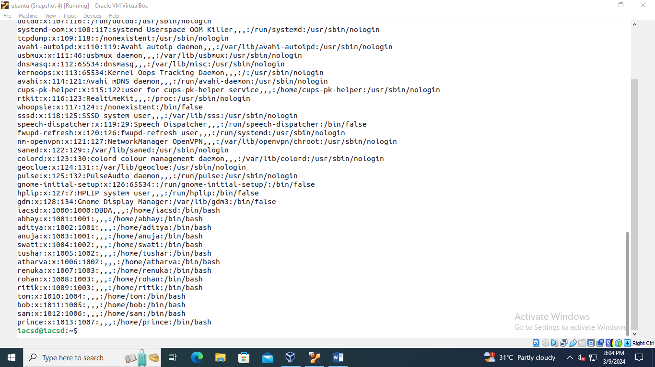

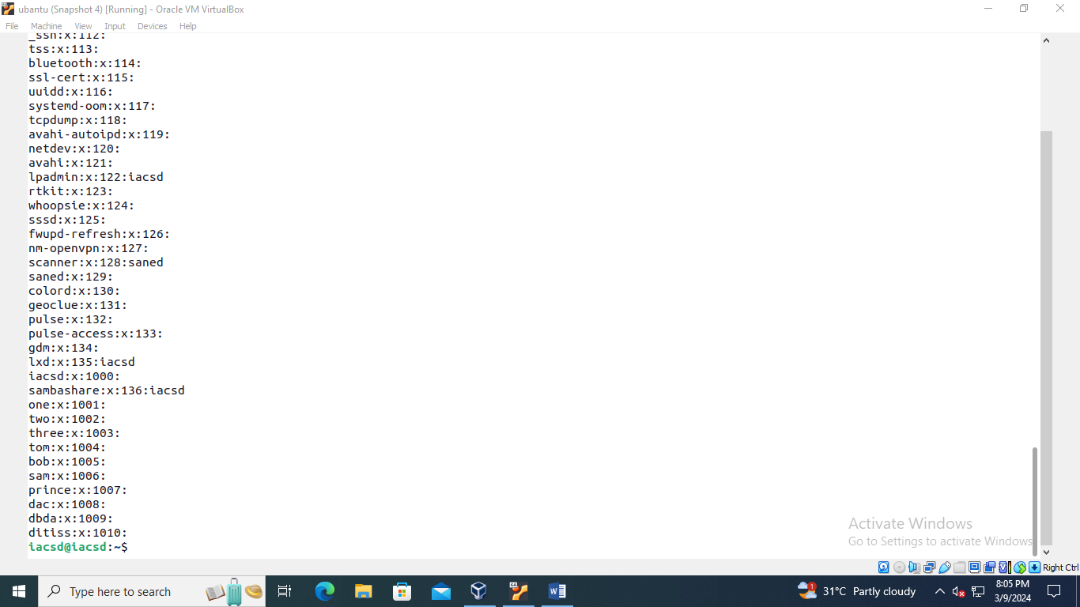

Q10

Sudo adduser sam ditiss

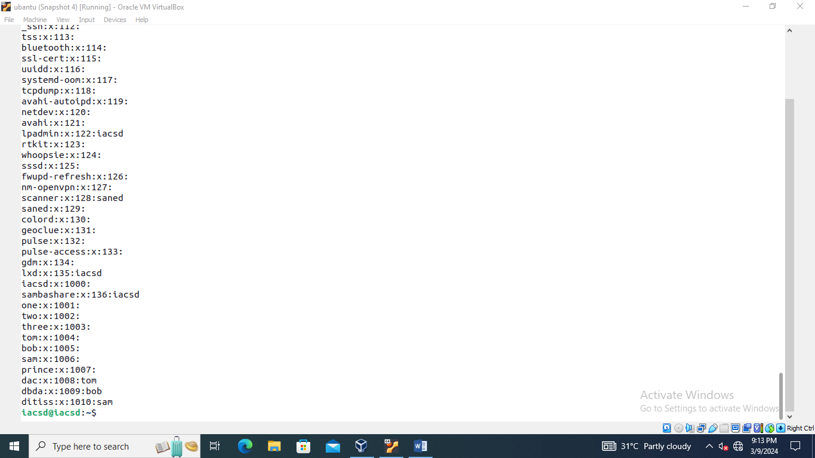

Q11

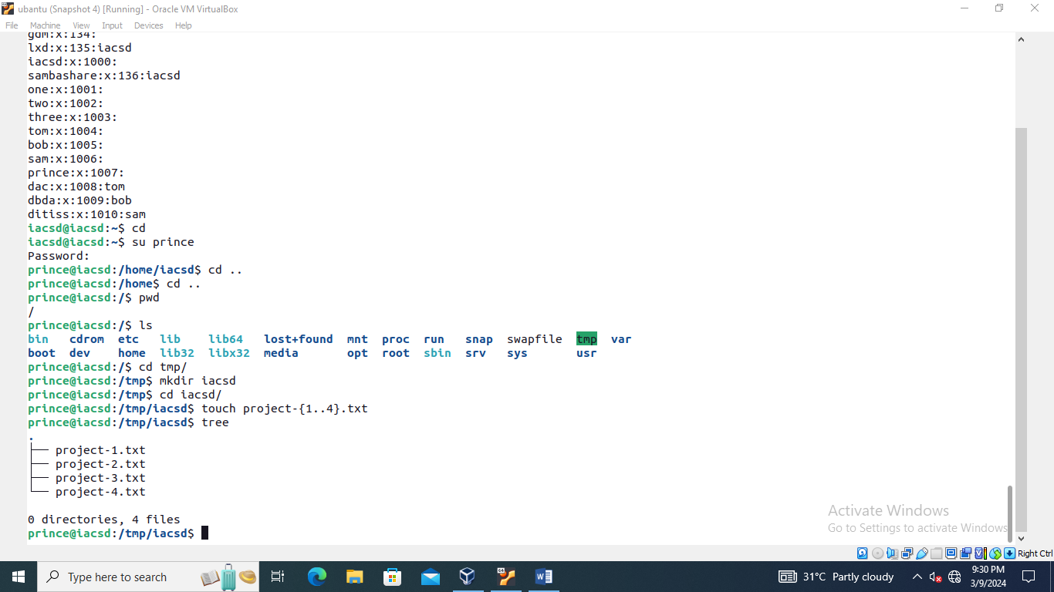

Q12

Chmod chown chgrp

