Have a Break
  - Can you help us uncover the mystery behind the KitKat heist? — TryHackMe

Background
On 26 March 2026, a refrigerated truck carrying over 400,000 units of KitKat product vanished somewhere between Central Italy and Poland. Nestlé confirmed the theft two days later. The vehicle has not been found.
The European Cargo Threat Assessment (ECTA) does not believe this was opportunistic. A shipment of this size, on a contracted route, does not disappear without someone helping it along.
An anonymous tip reached a journalist the following evening. ECTA obtained it under judicial authority. That is where your investigation begins.
You are a CZ Node investigator on Project HAVEABREAK. Your goal is to identify the culprit behind the heist by using the following files:
There is a ZIP given as a task file, containing multiple files.
File Description
ecta_memo.pdf Your briefing. Start here.
exhibit_a.eml Exhibit A — referenced in the memo
exhibit_b.jpg Exhibit B — referenced in the memo
transeuro_data/employees.csv Subpoenaed from TransEuro Logistics IT
transeuro_data/access_log.csv Subpoenaed from TransEuro Logistics IT
transeuro_data/comms_export.txt Subpoenaed from TransEuro Logistics IT
Question: Which VPN service was used to send the anonymous email from the .eml file?
Answer Character Count: 7
Analysis
- Dead End: I opened the “exhibit_a.eml” file to see if there was any mention of any VPN service, but nothing relevant was found.
- I opened the .eml using Notepad to see its headers and gain any intel that was hidden. By reviewing the headers closely, I discovered the origin IP of this message, which is 193.32.249.132.
- Now that I had this IP, I went to IP-API to gather additional intel on this IP. I discovered a connection with “31173 Services AB Netherlands,” which is a specialised data centre and infrastructure provider based in Sweden. Digging a bit more, I’ve found that they partner with “Mullavad” VPN, which perfectly fits our criteria.
Answer: M*****ad
Question: What is the full street address of the petrol station where the missing vehicle was last seen?
Analysis
- I started by looking at the Exif data for the image, but found nothing interesting.
- In the picture, there are multiple signals such as “Olomouc 27 KM”, “Brno 45 KM”, “Orlen” Petrol Station, D1 ?? Road name or some terminal. From these signals, there is one thing clear: “This is an Orlen petrol station somewhere in the middle of Olomouc and Brno”
- I have a route in my mind, but there may be multiple ways to reach Olomouc from Brno. To confirm which route the vehicle has taken, I started reviewing the other provided documents. When reviewing the “ecta_memo” PDF file under Exhibit B, I discovered that “a dashcam SD card was recovered from a vehicle stopped for an unrelated traffic matter near Hulín.”
- Now we have a proper route, “Orlen petrol station somewhere in the middle of the Olomouc and Brno route that goes through Hulín.”
- I used Google Maps to create a Route for this and added locations for all Orlen petrol stations along the way.
Press enter or click to view image in full size
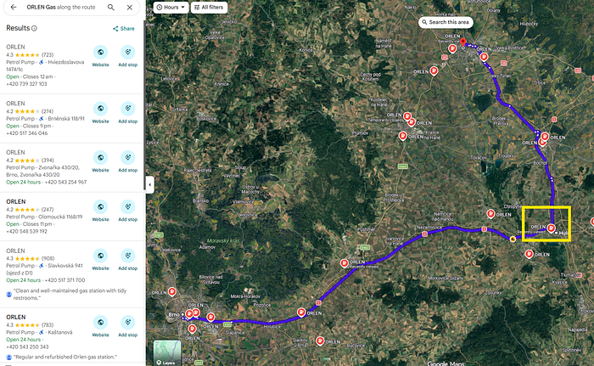
There is only one petrol station that is on the highway D1 near Hulín.
Answer: K********hia
Question: At what time did the suspicious action take place in the route planning system on March 25th, 2026?
Format: HH:MM:SS
Analysis
To find the timing of the suspicious action, I went to the “access_log.csv” file and filtered all the entries to March 25th 2026. There was only one entry, which was exporting data.
Press enter or click to view image in full size
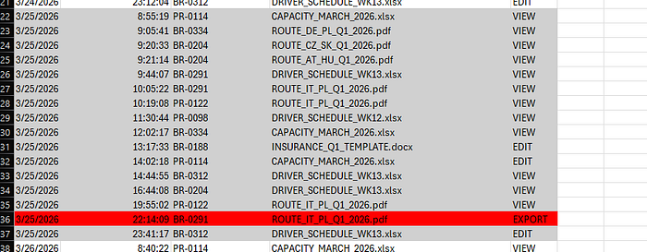
Answer: 2****9
Question: What is the employee ID of the person who sent the anonymous email?
- I went back to the “ecta_memo” PDF file, under Exhibit A, there was information about the timeframe this communication was received: “27 March 2026 at 23:14 CET, an anonymous electronic communication was received”.
- I’ve used this time to find exact communication inside the “comms_export.txt” file, which was sent from “br0312[@]transeuro-log[.]cz”.
- Now that I have the email, I used it to find the Employee Code by going through “employees.csv”.
Answer: b****2
Question: What is the employee ID of the employee responsible for leaking the shipment details?
I have already found the time of suspicious action; the entry also contains the ID of the employee responsible for leaking the shipment details.
Answer: B*****1
Question: What is the leaker’s full name?
I searched the comms_export route planning internal messages and found a message where a request was received from an external address (kraliknovak09@gmail.com) to access files in the route planning shared folder.
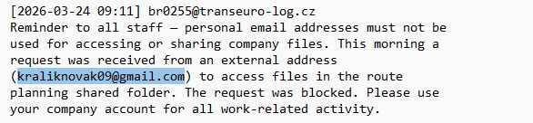
Since it is a Gmail address, the first instinct would be to look at Google Maps, Calendar or Plus history using Epieos.
Press enter or click to view image in full size
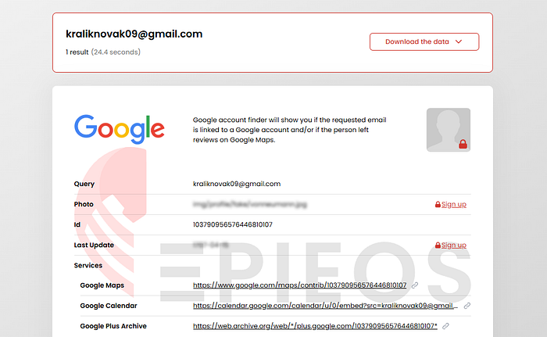
By visiting the Google Maps link, I’ve discovered the name attached to this email address.
Press enter or click to view image in full size
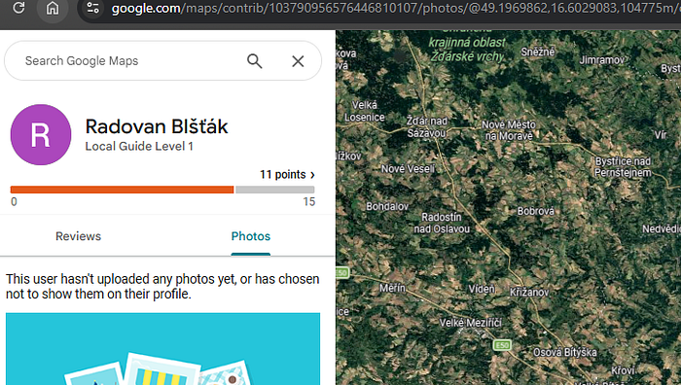
Answer: R******k
“The struggle you’re in today is developing the strength you need tomorrow.” — Robert Tew
___________

