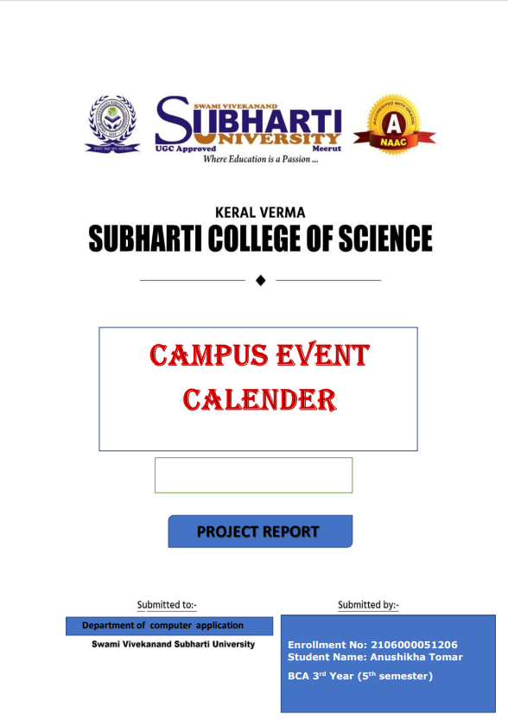

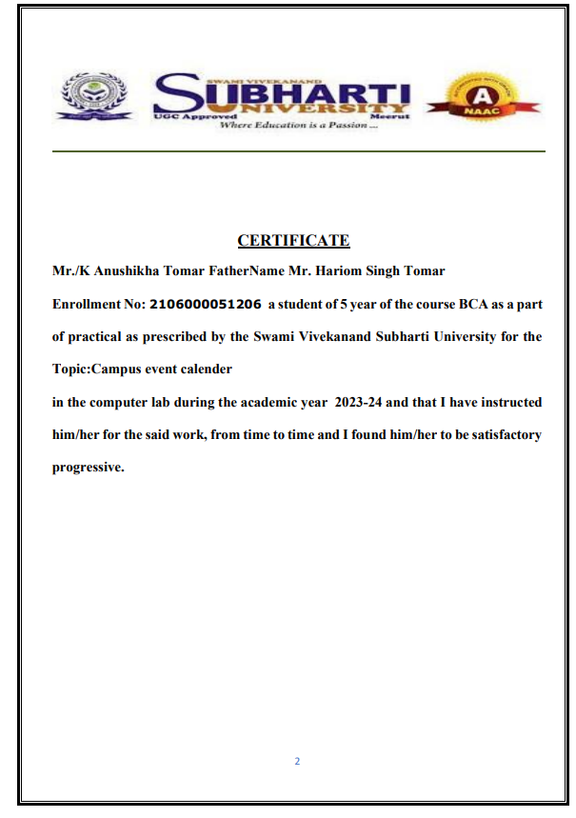**TABLE OF CONTENT**

|  |  |  |
| --- | --- | --- |
| **S.NO** | **Content** | **Page NO** |
| **1.** | **Introduction** | **1-2** |
| **2.** | **Key Features** | **2-3** |
| **3.** | **Techonology Used** | **3-4** |
| **4.** | **Module** | **5-19** |

## INTRODUCTION

**The provided HTML, CSS, and JavaScript code constitutes a Campus Event Calendar web-page for an educational institution. The page offers information about various campus events, including workshops, competitive events, and writing sessions. Here's an introductory description for this web-page:**

**----------------------------------------------------------------------------------------------------**

**\*\*Title: Campus Event Calendar\*\***

**The Campus Event Calendar web-page presents an extensive array of upcoming events within the educational landscape. Embracing a user-friendly interface, it invites students, faculty, and visitors to explore and engage with a diverse range of activities aimed at fostering holistic development and academic enrichment.**

**The campus event calendar web-page is the vibrant heartbeat of our university community, offering a dynamic and centralized platform to explore the rich tapestry of activities, gatherings, and engagements pulsating throughout our campus. Seamlessly curated and meticulously organized, this digital hub serves as a one-stop destination for students, faculty, staff, and visitors to discover a diverse array of events that enrich our academic, cultural, and social landscapes.**

**From captivating guest lectures by esteemed scholars to spirited sporting events that ignite our competitive fervor, this calendar encapsulates the essence of our campus life. It's a living mosaic, showcasing a plethora of opportunities—from artistic performances and club meetings to academic symposiums and volunteer initiatives—that collectively define the vibrant rhythm of our university experience.**

**Each listing within this comprehensive calendar unveils a treasure trove of information, offering details on event timings, locations, descriptions, and sometimes the chance to RSVP or synchronize events with personal schedules. Beyond its functionality, this platform embodies our commitment to fostering a thriving community, nurturing connections, and encouraging active participation in the multifaceted tapestry of campus life.**

**Welcome to our digital agora—a virtual gateway to explore, engage, and be inspired by the kaleidoscope of events that shape our collective journey within this esteemed academic landscape.**

----------------------------------------------------------------------------------------------------

**\*\*Key Features:\*\***

- **Visual Identity:**

**- A vibrant logo at the top, symbolizing the institution's identity and linking to the official website for additional information.**

- **Event Listings:**

**- A well-organized layout showcasing a series of events, each encapsulating essential details like dates, titles, descriptions, and other relevant information.**

- **User Interaction:**

**- Opportunities for engagement and participation through clickable links providing further event details and external resources for an enriched experience.**

- **Accessibility:**

**- A footer section offering convenient navigation to the homepage, comprehensive event details, and direct contact with the institution.**

**Functionality:**

**The web-page dynamically populates event details fetched from a JavaScript array. It employs scripting to generate an intuitive display format, enabling visitors to explore events scheduled within a specific timeframe. The use of event-specific icons and formatting aids in easy comprehension and enhances user engagement.**

**Objective:**

**The primary aim of this Campus Event Calendar is to serve as a centralized hub for disseminating information about upcoming events, workshops, and competitions. By providing comprehensive details and convenient access, it encourages active participation, fosters a sense of community, and enriches the academic journey for all stakeholders associated with the institution.**

-**------------------------------------------------------------------------------------------------------------------------------------**

**This introductory overview aims to highlight the functionality, purpose, and user - centric design aspects of the Campus Event Calendar web-page, emphasizing its role in facilitating engagement and communication regarding campus activities.**

**----------------------------------------------------------------------------------------------------**

**\*\*Techonology used in creating the websites\*\***

**Website development is a dynamic field that relies on a combination of**

**technologies to create engaging, functional, and visually appealing online**

**experiences. Two fundamental languages that play a crucial role in this process are HTML (Hypertext Markup Language) and CSS (Cascading Style Sheets).Together, these technologies form the backbone of the modern web, enabling developers to structure content and enhance its presentation.**

**Explanation of HTML (Hypertext Markup Language) for Structure:**

**HTML, or Hypertext Markup Language, is the foundational language of the World Wide Web. It serves as the backbone for creating the structural framework of a webpage. HTML uses a markup system, utilizing tags to define various elements on a web page such as headings, paragraphs, images, links, and more. Each HTML tag encapsulates content, providing browsers with instructions on how to display and organize information.**

**Overview of CSS (Cascading Style Sheets) for Styling and Design:**

**While HTML defines the structure of a webpage, CSS (Cascading Style Sheets) takes center stage in the realm of styling and design. CSS allows developers to control the visual presentation of HTML elements, ensuring a consistent and visually appealing user experience. CSS achieves this through a style rule mechanism. Selectors identify HTML elements, and declarations within the rule specify how those elements should be styled. Properties like color, font size, margin, padding, and more are used to define the appearance.**

Overview of JAVASCRIPT for creating webpage:  
**JavaScript, as a crucial part of web development, complements HTML and CSS by adding interactivity, functionality, and dynamism to websites. It enables me to create engaging user experiences and perform various tasks on the client-side.**

**----------------------------------------------------------------------------------------**

**Codes of:- LOGIN PAGE**

**File Name:-login.html**

|  |
| --- |
| <!DOCTYPE html>  <html lang="en">  <head>      <meta charset="UTF-8">      <title>Login Page</title>      <link rel="stylesheet" href="login.css">  </head>  <body>      </div>      <div class="login-container">          <form>              <div class="input-group">                  <h2>Login</h2>                  <label for="username">Enrollment no./Student Id:</label>                  <input type="number" id="username" name="username" required>              </div>              <div class="input-group">                  <label for="password">Password:</label>                  <input type="password" id="password" name="password" required>              </div>              <a href="html.html">LOG IN</a>          </form>      </div>  </body>  </html> |

**Decoding of code of login.html**

**This is an HTML document that creates a basic login page. Let me break down what each section does:**

**1. <!DOCTYPE html>: Declares the document type and version of HTML being used.**

**2. <html lang="en">: Defines the document as an HTML5 document and sets the language to English.**

**3. <head>: Contains meta-information about the document, like character encoding, title, and linked resources.**

**- <meta charset="UTF-8">: Sets the character encoding to UTF-8, allowing proper rendering of text.**

**- <title>Login Page</title>: Sets the title of the webpage to "Login Page".**

**- <link rel="stylesheet" href="login.css">: Links an external CSS file named "login.css" for styling the HTML elements.**

**4. <body>: Contains the visible content of the webpage.**

**- <div class="login-container">: Creates a container for the login form.**

**- <form>: Defines a form to collect user input.**

**- <div class="input-group">: Contains form elements for the username.**

**- <h2>Login</h2>: Displays the heading "Login".**

**- <label for="username">Enrollment no./Student Id:</label>: Provides a label for the username input field.**

**- <input type="number" id="username" name="username" required>: Creates a numeric input field for the username, marked as required.**

**- Another <div class="input-group"> contains form elements for the password similar to the username.**

**- <a href="html.html">LOG IN</a>: Presents a link or button styled as "LOG IN" that navigates to a page named "html.html" when clicked**

**------------------------------------------------------------------------------------------------**

**File Name:-login.css**

|  |
| --- |
| body {    font-family: Arial, sans-serif;    margin: 0;    padding: 0;    display: flex;    justify-content: center;    align-items: center;    height: 100vh;    background-color: #c96e55;    background-image: url('https://media-exp1.licdn.com/dms/image/C561BAQEaEHUBNHRsfw/company-background_10000/0/1601620086436?e=2159024400&v=beta&t=UlAU2u73JkbRPwW-W6HLrPufl9kOJojpmiPFl3aHEjU');    background-repeat: no-repeat;    background-size: 100%;  }  .login-container {    background-color: #907d7d;    padding: 10px;    border-radius: 5px;    box-shadow: 0 0 10px rgba(0, 0, 0, 0.1);  }  .logo {    color: rgb(255, 0, 0);    font-family: serif;    border: solid 2px blue;    padding: 20px;  }  form {    display: flex;    flex-direction: column;    align-items: baseline;  }  .input-group {    padding: 1px;    margin-bottom: 15px;  }  label {    margin-bottom: 5px;    display: block;    font-weight: bold;  }  input[type="number"],  input[type="password"] {    padding: 8px;    font-size: 16px;    border: 4px solid #ccc;  }  a {    display: inline-block;    padding: 10px 20px;    background-color: #007bff;    color: white;    text-decoration: none;    border-radius: 4px;  } |

**Decoding of code of login.css**

**This CSS code contains styles for the layout, appearance, and interactions of elements in a web-page login.html, the same login page described above. Let me break down the sections:**

**1. body: Defines styles for the entire webpage.**

**- font-family: Sets the font family for the entire document to Arial or sans-serif if Arial is not available.**

**- margin and padding: Removes any default margin and padding on the body element.**

**- display: flex: Turns the body into a flex container.**

**- justify-content: center: Horizontally centers the flex items (children) within the body.**

**- align-items: center: Vertically centers the flex items within the body.**

**- height: 100vh: Sets the height of the body to occupy the full viewport height.**

**- background-color: Sets the background color of the body to #c96e55.**

**- background-image: Sets a background image from a specific URL.**

**- background-repeat: Specifies that the background image should not be repeated.**

**- background-size: Sets the size of the background image to cover the entire body.**

**2. .login-container: Styles a container for the login form.**

**- background-color: Sets the background color to #907d7d.**

**- padding: Adds 10px of padding inside the container.**

**- border-radius: Rounds the corners of the container by 5px.**

**- box-shadow: Applies a subtle shadow effect to the container.**

**3. .logo: Defines styles for a logo within the form.**

**- color: Sets the text color to red.**

**- font-family: Specifies a serif font family for the logo text.**

**- border: Creates a solid blue border around the logo.**

**- padding: Adds 20px of padding inside the logo.**

**4. form: Styles the login form itself.**

**- display: flex: Turns the form into a flex container.**

**- flex-direction: column: Aligns flex items vertically in a column.**

**- align-items: baseline: Aligns flex items along their baselines.**

**5. .input-group and label: Styles for form labels and their corresponding input groups.**

**6. input[type="number"] and input[type="password"]: Styles for number and password input fields.**

**- padding, font-size, and border: Defines consistent styles for these input types.**

**7. a: Styles for links within the form.**

**- display, padding, background-color, color, text-decoration, border-radius: Styles the link as a button**

**\*\*\*-------------------------------------------------------------------------\*\*\***

**Overall, these styles aim to create a centered login form with specific formatting for input fields and custom link styles for visual interaction cues. The CSS code aims to provide a cohesive and styled appearance to the login page elements.**

**----------------------------------------------------------------------------------------------------**

**Codes of:- MAIN PAGE**

**File Name:-html.html**

|  |
| --- |
| <!DOCTYPE html>  <html lang="en">  <head>      <meta charset="UTF-8">      <title>Campus Event Calendar</title>      <link rel="stylesheet" href="style.css">  </head>  <body>      <div class="logo">          <a target="_blank" href="https://subharti.org/"><img             src='https://1.bp.blogspot.com/-Q8hZJshjlrs/YBP2E_D_kgI/AAAAAAAADQg/x0QLcgFqlYoc4TbOpxutKXi1F6IeD_iYQCLcBGAsYHQ/s701/subharti.png'                  width="800" height="180" alter="campus logo"></a>      </div>      <div class="calendar">          <div class="head">              <h1>Campus Event Calendar</h1>          </div>          <div class="events" id="events">          </div>      </div>      <hr width="70%" color="black" size="3">      <footer class="footer">          <div class="container">              <p>&copy; 2023 Campus Event Calendar</p>              <ul class="footer-links">                  <li><a href="login.html">Home</a></li>                  <li><a target="_blank" href="https://erp.subharti.org/">For More About Events</a></li>                  <li><a target="_blank" href="https://subharti.org/">Contact</a></li>              </ul>          </div>      </footer>      <script src="script.js"></script>  </body>  </html> |

**Decoding of code of html.html**

**This HTML code constructs a webpage, likely a Campus Event Calendar, with various sections and links. Here's a breakdown of its structure:**

**### Document Structure**

**- <!DOCTYPE html>: Declaration specifying the HTML version as HTML5.**

**- <html lang="en">: The opening tag for the HTML document with the language set to English.**

**### Head Section**

**- <head>: Contains meta-information about the document and links to external resources.**

**- <meta charset="UTF-8">: Sets the character encoding to UTF-8 for handling various characters.**

**- <title>Campus Event Calendar</title>: Sets the title of the webpage.**

**- <link rel="stylesheet" href="style.css">: Links an external CSS file named "style.css" for styling the webpage.**

**### Body Section**

**- <body>: Contains the visible content of the webpage.**

**- <div class="logo">: Section for the logo with a link wrapped around an image.**

**- <a target="_blank" href=”**https://subharti.org **">: Opens the link in a new tab.**

**- <img src='URL' width="800" height="200" alter="campus logo">: Image with specific URL, width, height, and alternative text.**

**- <div class="calendar">: Container for the calendar section.**

**- <div class="head">: Subdivision for the calendar header.**

**- <h1>Campus Event Calendar</h1>: Heading for the calendar.**

**- <div class="events" id="events">: Placeholder for events, possibly to be populated dynamically.**

**- <hr width="70%" color="white" size="3">: Horizontal line with specific width, color, and size.**

**- <footer class="footer">: Footer section.**

**- <div class="container">: Container for footer content.**

**- <p>&copy; 2023 Campus Event Calendar</p>: Copyright notice.**

**- <ul class="footer-links">: Unordered list for footer links.**

**- List items with anchor tags linking to various pages/resources.**

**### Scripts**

**- <script src="script.js"></script>: Links an external JavaScript file named "script.js" for scripting functionalities or interactions on the webpage.**

**\*\*\*---------------------------------------------------------------------\*\*\***

**This HTML structure seems to create a complete webpage layout with a header, calendar section, footer, and references to external styles and scripts for additional functionality and styling.**

**---------------------------------------------------------------------------------------------------**

**File Name:-style.css**

|  |
| --- |
| body {    font-family: Arial, sans-serif;    margin: auto;    padding: auto;    background-image: url('https://www.ranklogos.com/wp-content/uploads/2014/10/Subharti-University.png');    background-repeat: no-repeat;    background-attachment: fixed;    background-size: 80%;  }  .logo {    border: solid 3px green;    padding: 10px 0 10px 350px;    display: flex;  }  .cname {    color: rgb(255, 166, 0);    font-size: 50px;    text-align: center;  }  .calendar {    max-width: 800px;    margin: 20px auto;    padding: 20px;    border-radius: 5px;  }  .head {    color: rgb(255, 0, 225);    font-family: serif, monospace;    text-decoration: solid;    text-decoration: underline;    padding-left: 10px;  }  .events {    margin-top: 20px;  }  .event {    border: 1px solid #ddd;    padding: 10px;    margin-bottom: 10px;    border-radius: 5px;    background-color: #fff;  }  .date {    border: solid 2px red;  }  .title {    color: rgb(0, 150, 0);    font-size: 30px;    font-weight: bold;    font-display: solid;    font-family: serif  }  .description {    color: rgb(10, 52, 222);    border: dotted 2px black;    padding: 5px;  }  .dl {    text-decoration: underline;    font-weight: 600;  }  .time {    color: rgb(255, 0, 0);    font-weight: bold;  }  .e1 {    background-image: url('https://th.bing.com/th/id/R.6effa7b5c9b41d759a527c3fc4ca8a4f?rik=RxTDqmB%2bnKuafA&riu=http%3a%2f%2fgetwallpapers.com%2fwallpaper%2ffull%2f1%2f2%2f4%2f1261529-cool-birthday-celebration-wallpaper-1920x1080-lockscreen.jpg&ehk=OObeYLYWj%2fkKP08D6EmeLaHltMGdOf9cTXTD2IOSV%2bY%3d&risl=&pid=ImgRaw&r=0');  }    a {    color: #001eff;    font-weight: bold;    font: size 25px;  }  a:visited {    color: #0033ff;  }  a:hover {    color: #00ff2f;  }  a:active {    color: #FFFF00;  }  .footer {    color: #000000;    padding: 20px 0;    text-align: center;  }  .footer p {    margin: 0;  }  .footer-links {    list-style: none;    padding: 0;  }  .footer-links li {    display: inline;    margin: 0 10px;  }  .footer-links li a {    color: #ff0404;    text-decoration: none;  } |

**Decoding of code of style.css**

**This CSS code contains various styles applied to elements within a webpage. Let's break it down:**

**### Body Styles:**

**- body: Styles the body of the webpage, setting the font-family, margin, padding, and a background image. It ensures the background image doesn't repeat and covers the entire background.**

**### Logo Section:**

**- .logo: Styles a logo section, setting a green border, padding, and using flex for layout purposes.**

**### Calendar Section:**

**- .cname: Styles the calendar name with specific color, font size, and center alignment.**

**- .calendar: Styles the calendar container, defining maximum width, margin, padding, and border radius.**

**### Calendar Head:**

**- .head: Styles the calendar header text, setting color, font-family, text decoration, and padding.**

**### Events:**

**- .events: Styles the container for events, setting margin-top.**

**### Event Details:**

**- .event: Styles each event box, setting border, padding, margin, border radius, and background color.**

**- .date: Styles the date section within an event box, setting a red border.**

**- .title: Styles the event title with color, font size, weight, and font family.**

**- .description: Styles the event description with color, border, and padding.**

**- .dl: Styles a downloadable link within an event.**

**- .time: Styles the time section within an event with color and font weight.**

**### Individual Event Classes:**

**- .e1: Styles a specific event class with a background image.**

**### Link Styles:**

**- a:-webkit-any-link: Styles applied to all links, setting cursor, text decoration, font size, and weight.**

**- a, a:visited, a:hover, a:active: Styles for different states of links—normal, visited, hover, and active. It defines colors and text decorations for each state.**

**### Footer Styles:**

**- .footer: Styles the footer section with color, padding, and text alignment.**

**- .footer p: Styles the paragraphs within the footer, removing margin.**

**- .footer-links: Styles the list within the footer, removing list-style and padding.**

**- .footer-links li: Styles list items within the footer, displaying inline and setting margins.**

**- .footer-links li a: Styles links within the footer, setting color and removing text decoration.**

**\*\*\*-----------------------------------------------------------------\*\*\***

**Overall, this CSS code seems to style various sections of a webpage, including the logo, calendar, events, links, and footer, to create a visually appealing and organized layout for displaying event details.**

**----------------------------------------------------------------------------------------------------**

**File Name:-script.js**

|  |
| --- |
| alert("welcome to Swami Vivekanand Subharti University Event Calender");  document.addEventListener('DOMContentLoaded', function () {    const eventsContainer = document.getElementById('events');  *// Sample event data (you can replace this with real data)*    const events = [      { date: '2023-11-25', title: 'Swami Vivekanand Chhatra Sansad 2023', description: 'AGENDAS:<br>1. A healthy working environment.<br>2. Strengthening animal welfare law.<br>3. Prohibition of religous propagation by Elected Political Leaders.', dutyleave: 'YES', timing: '09:00 Am Onwards', location: 'https://www.google.co.in/maps/dir//Subharti+Law+College,+Subhartpuram,+Meerut,+Uttar+Pradesh+250002/@28.9559035,77.6360283,18.28z/data=!4m8!4m7!1m0!1m5!1m1!1s0x390c66bc226199f9:0x6464b59b73ccd7c0!2m2!1d77.6370066!2d28.9565575?entry=ttu', venue: 'Subharti LAW College' },      { date: '2023-12-04', title: 'Intercollegiate Sport events', description: 'University is Organizing the Intercollegiate Sport events. The Faculty of Management and Commerce, FOMC (AVGSCMC) is Hosting the "Kabaddi Tournament"<br>Rules for Participation:<br>1. Registration Starts: 24-Nov-2023 onwards.<br>2. Entry fees for each team is Rs.600.<br>3. Only One team will be considered from each college.<br>4. Maximum members in each team should be not more than 12 players.(Only 7 players per team are allowed on the field of play at one time.)<br>5. Last date of Entry is 01-12-2023.', dutyleave: 'Yes', timing: '09:00 AM Onwards ', location: 'https://www.google.co.in/maps/dir//General+Mohan+Singh+Play+Ground,+Subharti+university,+NH-58,+Delhi-Haridwar,+NH58,+Meerut,+Uttar+Pradesh+250005/@28.9560192,77.6331906,17z/data=!4m8!4m7!1m0!1m5!1m1!1s0x390c677b6876847b:0x7b6df41207fca90b!2m2!1d77.6357655!2d28.9560192?entry=ttu', venue: 'General Mohan Singh Subharti Play Ground.' },      { date: '2023-12-07', title: 'Badminton Tournament', description: 'The Faculty of Engineering and Technology,  is Hosting the "Badminton Tournament.<br>Rules for Participation:<br>1. Registration Starts: 01-Dec-2023  onwards.<br>2. Entry fees for each team are Rs.400. (Boys and Girls separately).<br>3. Only One  team of boys and Girls will be considered from each college.<br>4. Maximum members in each team should be not more than 3 to 5 players<br>5. Matches will be singles, Doubles. (No Mix doubles)<br>6. Games will be on Knock out basis.<br>7. Last date of Entry is 05-12-2023.', dutyleave: 'YES', timing: '08:00 AM Onwards ', location: 'https://www.google.co.in/maps/dir//Subharti+Institute+of+Technology+and+Engineering,+Subhartipuram,+NH-58+Delhi-Haridwar,+NH58,+Meerut,+Uttar+Pradesh+250005/@28.9575639,77.6312775,17z/data=!4m8!4m7!1m0!1m5!1m1!1s0x390c668f40000001:0x9ea5e359307f4608!2m2!1d77.6338524!2d28.9575639?entry=ttu', venue: 'Faculty of Engineering and Technology  (Badminton court)' },      { date: '2023-12-28', title: 'Subharti Diwas', description: 'Dept. of Public Health Dentistry is organizing activities on the occasion of Veer Bal Diwas (Subharti Diwas) onVEER BAL DIWAS About the Event: We are organizing few Events are as follows:<br>1.Guest Lecture<br> 2. Quiz competition<br> 3. Script Writing competition', dutyleave: 'YES', timing: '9:00 AM Onwards', location: 'https://www.google.co.in/maps/dir//Subharti+Dental+College,+Swami+Vivekanand+Subharti+University+Subharti+Puram,+NH-58,+Delhi+Haridwar,+NH58,+Meerut,+Uttar+Pradesh+250005/@28.9592512,77.6377686,20.36z/data=!4m8!4m7!1m0!1m5!1m1!1s0x390c66bdb931d307:0x3a5198841d7ac87e!2m2!1d77.6378738!2d28.9592695?entry=ttu', venue: 'LT4(SDC&H)' },        {        date: '2023-12-30', title: 'Essay Competition', description: 'As per the guidelines of the government and the letter received from the U.P. Higher Education Commission to organize Road Safety Pakhwara by the Educational Institutions. In this regard the Keral Verma Subharti College of Science is organizing “Essay Competition" on the topic "Sadak Suraksa”.'        , dutyleave: 'YES', timing: '12:00 PM onwards', location: 'https://www.google.co.in/maps/dir//XJ4M%2BVQ5+Keral+Verma+Subharti+College+of+Science,+Meerut,+Uttar+Pradesh+250002/@28.957254,77.6340215,19.39z/data=!4m8!4m7!1m0!1m5!1m1!1s0x390c67a5f26aa431:0x6d73ee4d5ea465c6!2m2!1d77.6344846!2d28.9571312?entry=ttu', venue: 'Conference Hall, KVSCOD'      },  *// Add more events here by format given below*  *// { date: '', title: '', description: '', dutyleave: '', timing: '', location: '', venue: '' },*    ];  *// Function to display events*    function displayEvents() {      eventsContainer.innerHTML = '';      events.forEach(event => {        const eventElement = document.createElement('div');        eventElement.classList.add('event');        const eventDate = new Date(event.date);        const formattedDate = eventDate.toLocaleDateString('en-US', { month: 'long', day: 'numeric', year: 'numeric' });        eventElement.innerHTML = `          <div class='e1'>         <p class='date'><h2> ${formattedDate}</h2></p>            <p class='title'> ${event.title}</p>             <p class='description'>${event.description}</p>             <p class="dl">Duty Leave:${event.dutyleave}</p>             <p class="time"><img src='https://th.bing.com/th/id/OIP.z1QT7_XPt3d0ympQwdTrZgHaHa?rs=1&pid=ImgDetMain' width='25' height='25' alter='Timing|'>${event.timing}</p>             <p class='location'><a target='_blank' href="${event.location}"><img src='https://1.bp.blogspot.com/-nO3qPOtQJ-A/Xwo_LZEYCBI/AAAAAAAABAU/KDoOKCEW7UYWLsdqqKYwk6D8of93VapgACLcBGAsYHQ/s2048/location%2Bicon.png' width='25' height='25' alter='Venue|'>${event.venue}</a></p>             <p class='details'><a target="_blank" href="https://erp.subharti.org/">click here for more details</a></p></div>             `;        eventsContainer.appendChild(eventElement);      });    }    displayEvents();  }); |

**Decoding of code of script.js**

**This JavaScript code contains functionality to display a series of events dynamically on a webpage. Let's break it down:**

**### Alert:**

**- alert("welcome to Swami Vivekanand University Event Calendar");: Displays an alert with the message "welcome to Swami Event Calendar" when the script runs.**

**### Event Data:**

**- A JavaScript object array named events contains event details like date, title, description, duty leave availability, timing, location URL, and venue.**

**### Event Display Function:**

**- displayEvents(): A function that displays events dynamically on the webpage.**

**- document.addEventListener('DOMContentLoaded', function () {...});: Listens for the DOM content to be fully loaded before executing the JavaScript code inside it.**

**### Displaying Events:**

**- Iterates through the events array and creates HTML elements dynamically for each event.**

**- Formats event data into HTML structure and populates it into the eventsContainer element fetched using document.getElementById('events').**

**- Uses Date object to format dates and creates elements accordingly for date, title, description, duty leave, timing, location, and venue.**

**- Appends each event element to the eventsContainer to display on the webpage.**

**### Event Structure:**

**The event HTML structure includes:**

**- Date with formatting.**

**- Event title.**

**- Event description.**

**- Duty leave availability.**

**- Event timing.**

**- Event location with a link to Google Maps.**

**- A link for more details leading to a specific URL.**

**\*\*\*--------------------------------------------------------------\*\*\***

**This code is structured to dynamically generate event elements based on the data provided in the events array and then display them on the webpages when the document is fully loaded.**