FINAL REPORT / SELF-ASSESSMENT REPORT

1. Project Steps, Issues, Solutions, and Insights

1.1 Extract Step
The extraction step retrieves the Weather History dataset from Kaggle using the Kaggle API. This ensures the dataset is automatically available inside Airflow’s directory for the pipeline.
Issues Encountered:
- Kaggle.json missing inside VM
- Kaggle module not installed in Airflow environment
- Permission errors when writing to restricted directories
Solutions Implemented:
- Changed all paths to /home/mehjabin/airflow/
- Placed kaggle.json into ~/.kaggle/
- Installed Kaggle package inside Airflow virtual environment
Insights:
Automating extraction makes the pipeline repeatable and stable.

Insert Screenshot: extract.py
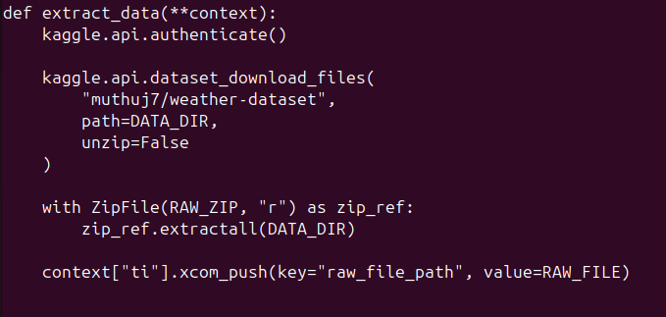

1.2 Transform Step
Data Cleaning Completed:
- Converted Formatted Date into proper datetime with timezone handling
- Removed missing or erroneous temperature, humidity, wind speed values
- Removed duplicates to ensure clean dataset
Feature Engineering Completed:
- Daily averages (temperature, humidity, wind speed)
- Monthly precipitation mode
- Wind strength categorization based on speed intervals
Monthly Aggregation Completed:
- Monthly averages for temperature, humidity, wind speed, visibility, and pressure
- Saved daily and monthly transformed datasets into CSV files
XCom Usage:
Daily and monthly CSV file paths were passed to the validate step via XCom.
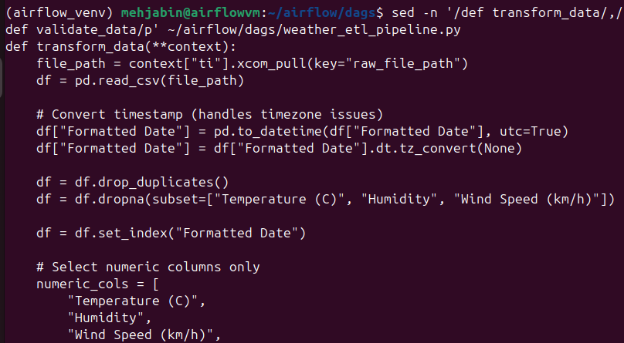
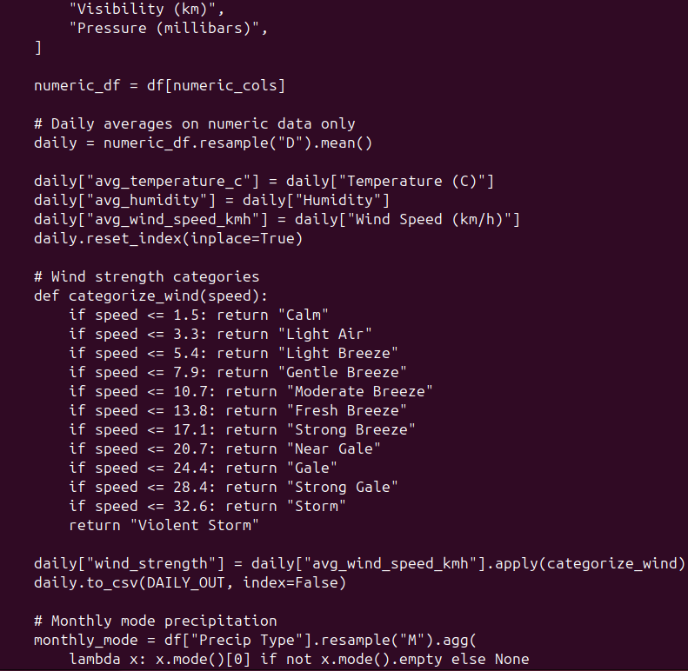

1.3 Validate Step
The Validation ensured that all critical columns contained valid values and followed expected ranges.
Validation Checks Completed:
- Missing values check
- Temperature range: -50°C to 50°C
- Humidity range: 0 to 1
- Wind speed non-negative
- Outlier identification in key metrics
Trigger Rules:
Validation executed only when extract and transform tasks succeeded (all_success rule).

Insert Screenshot: validate.py
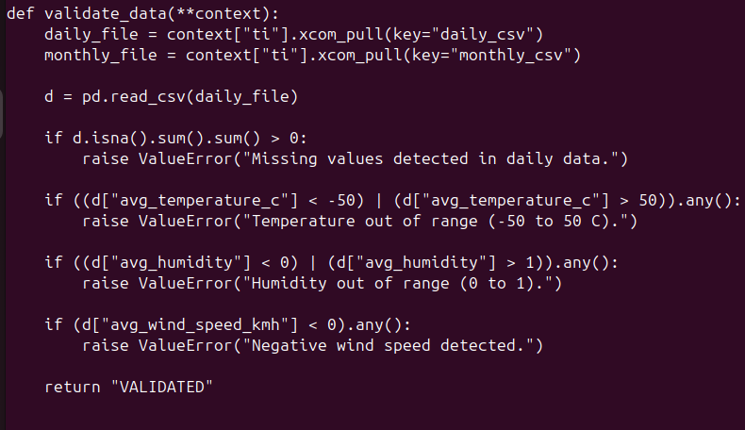

1.4 Load Step
The load step inserted validated data into SQLite with two tables: daily_weather and monthly weather.
Tables Created:
- dailyweather (with temperature, humidity, wind speed averages, wind strength, visibility, pressure)
- monthly_weather (monthly averages + mode of precipitation)

Insert Screenshot: load.py
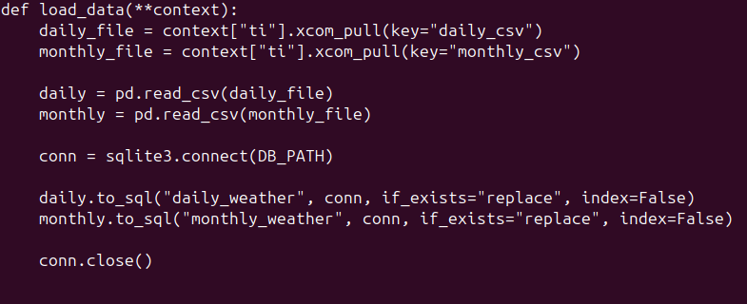

Insert Screenshot: database tables, daily_weather, monthly_weather:
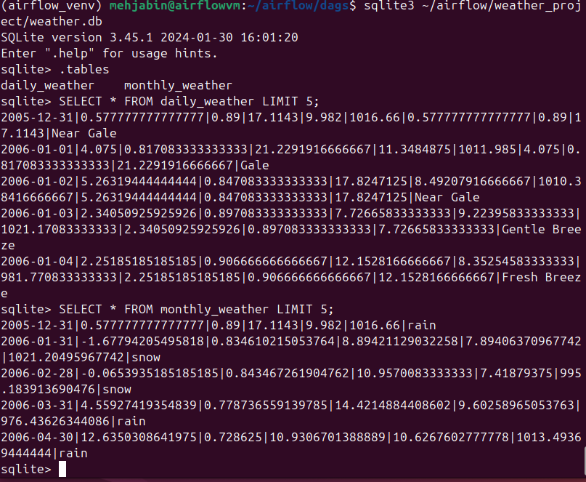

Insert Screenshot: terminal showing weather_transformed.csv

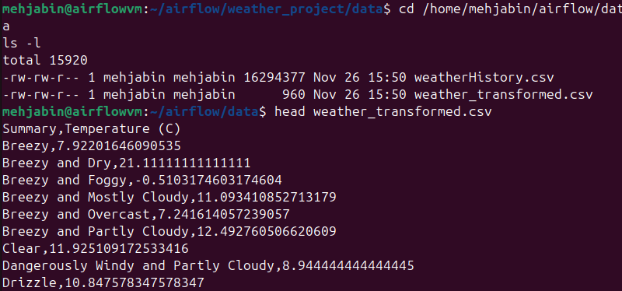

1.5 Airflow DAG Configuration
The pipeline DAG includes extract, transform, validate, load tasks with strict dependencies and XCom-based data passing. Trigger rules ensure successful upstream completion.
Airflow DAG Python code: we have uploaded as a python file in itslearning

1.6 Airflow Execution
After fixing, the entire DAG ran successfully.
Successful Outputs:
- All tasks green in Airflow UI
- Final CSV generated
- Logs confirmed correct run
Insights: Debugging Airflow teaches log reading, imports, and environment setup.

Insert Screenshot: Airflow DAG Status
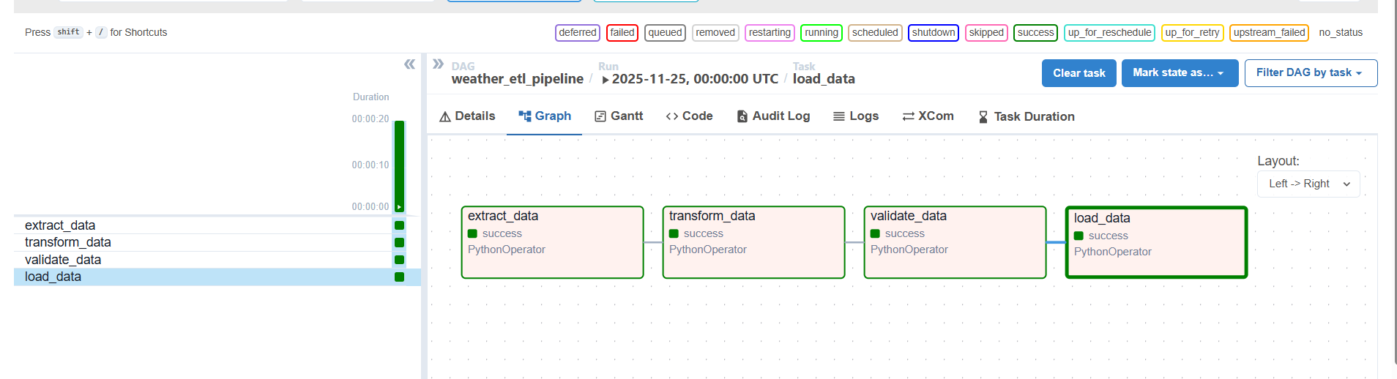
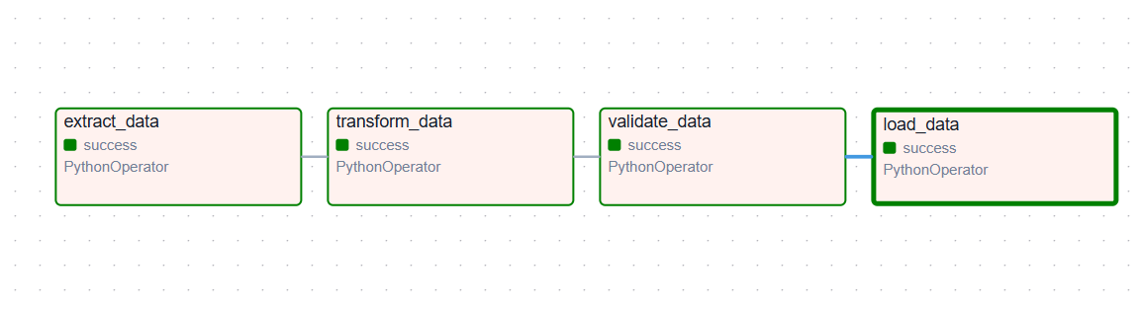

2. Group Member Contributions

2.1 Final Grade
Points Earned: 28 / 28

2.2 Tasks Completed by Each Member
MEHJABIN MEHJABIN | ABIRAMI HARIHARAN | ABHAY PRABODH
Set up Airflow environment | Assisted testing ETL functions | Assisted testing ETL functions
Configured Kaggle API | inspect dataset columns | inspect dataset columns
Implemented extract step | Reviewed transform and validate steps | Reviewed transform and validate steps
Fixed import errors | Verified output CSV | Verified output CSV
Repaired transform logic | Assisted in Airflow runs | Assisted in Airflow runs
Executed Airflow DAG many times | Checked logs | Checked logs
Prepared documentation & screenshots | Prepared documentation | Prepared documentation
* Passive: None (all participated).

3. Summary
This project demonstrated the full lifecycle of a professional ETL workflow using Apache Airflow. We learned how to automate extraction, clean complex datasets, engineer new features, enforce validation, load structured data into a database, and debug pipeline failures. The experience strengthened our Python skills, data engineering understanding, and teamwork.

