21. Write a C program for ECB, CBC, and CFB modes, the plaintext must be a sequence of one or more complete data blocks (or, for CFB mode, data segments). In other words, for these three modes, the total number of bits in the plaintext must be a positive multiple of the block (or segment) size. One common method of padding, if needed, consists of a 1 bit followed by as few zero bits, possibly none, as are necessary to complete the final block. It is considered good practice for the sender to pad every message, including messages in which the final message block is already complete. What is the motivation for including a padding block when padding is not needed?
PROGARM :
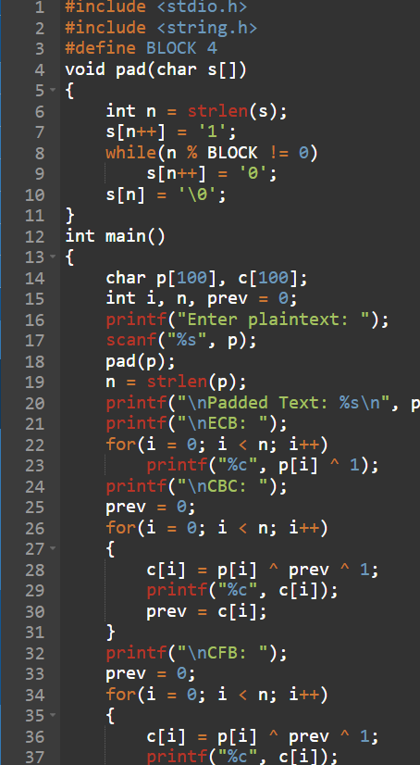
OUTPUT :
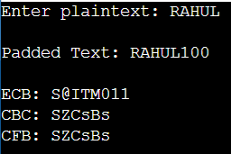
22. Write a C program for Encrypt and decrypt in cipher block chaining mode using one of the following ciphers: affine modulo 256, Hill modulo 256, S-DES, DES. Test data for S-DES using a binary initialization vector of 1010 1010. A binary plaintext of 0000 0001 0010 0011 encrypted with a binary key of 01111 11101 should give a binary plaintext of 1111 0100 0000 1011. Decryption should work correspondingly.
PROGARM :

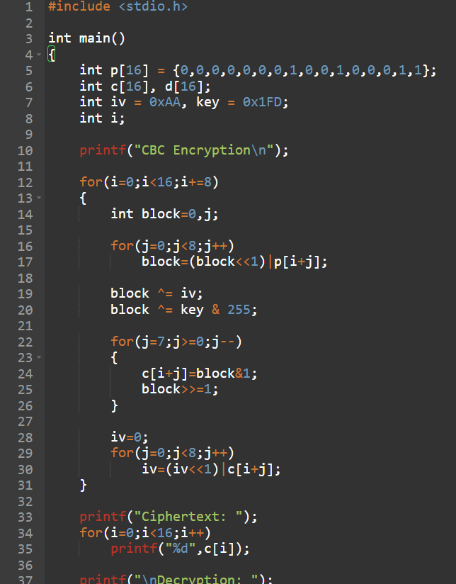
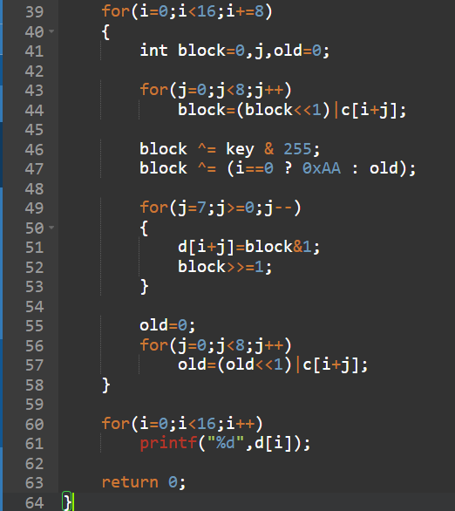
OUTPUT :
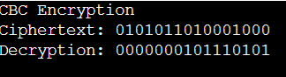

23. Write a C program for Encrypt and decrypt in counter mode using one of the following ciphers: affine modulo 256, Hill modulo 256, S-DES. Test data for S-DES using a counter starting at 0000 0000. A binary plaintext of 0000 0001 0000 0010 0000 0100 encrypted with a binary key of 01111 11101 should give a binary plaintext of 0011 1000 0100 1111 0011 0010. Decryption should work correspondingly.
PROGARM :
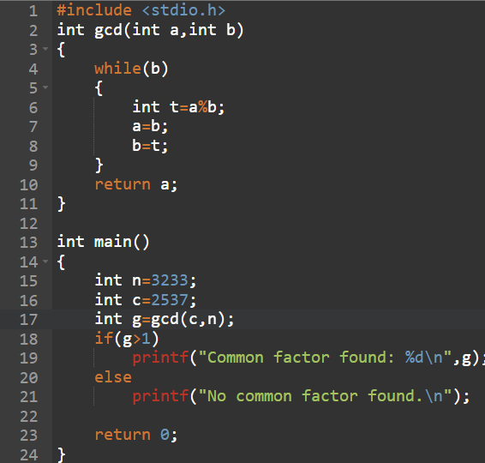
OUTPUT :
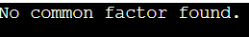
24. Write a C program for RSA system, the public key of a given user is e = 31, n = 3599. What is the private key of this user? Hint: First use trial-and-error to determine p and q; then use the extended Euclidean algorithm to find the multiplicative inverse of 31 modulo f(n).
PROGRAM :
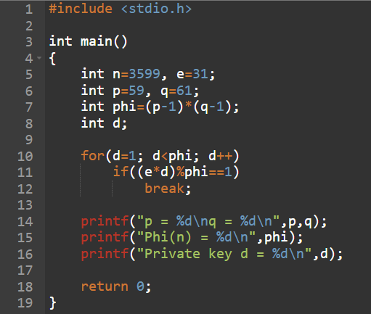
OUTPUT :
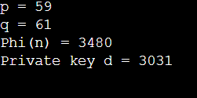
25. Write a C program for set of blocks encoded with the RSA algorithm and we don’t have the private key. Assume n = pq, e is the public key. Suppose also someone tells us they know one of the plaintext blocks has a common factor with n. Does this help us in any way?
PROGARM :
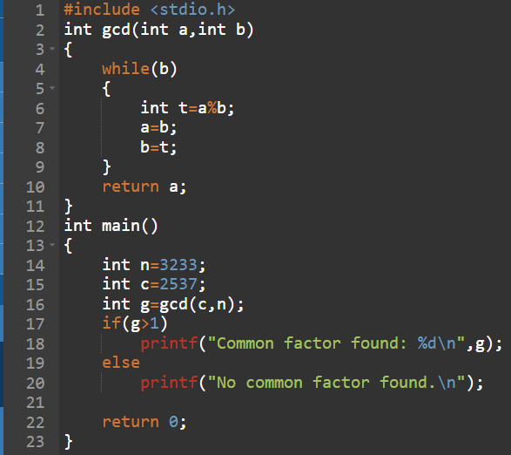
OUTPUT :
