26. Write a C program for RSA public-key encryption scheme, each user has a public key, e, and a private key, d. Suppose Bob leaks his private key. Rather than generating a new modulus, he decides to generate a new public and a new private key. Is this safe?
PROGRAM :
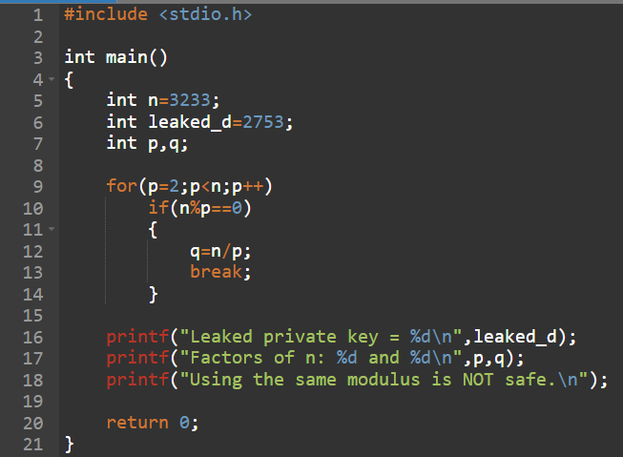
OUTPUT :
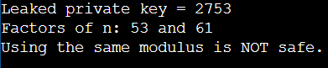
27. Write a C program for Bob uses the RSA cryptosystem with a very large modulus n for which the factorization cannot be found in a reasonable amount of time. Suppose Alice sends a message to Bob by representing each alphabetic character as an integer between 0 and 25 (A S 0, c, Z S 25) and then encrypting each number separately using RSA with large e and large n. Is this method secure? If not, describe the most efficient attack against this encryption method.
PROGRAM :
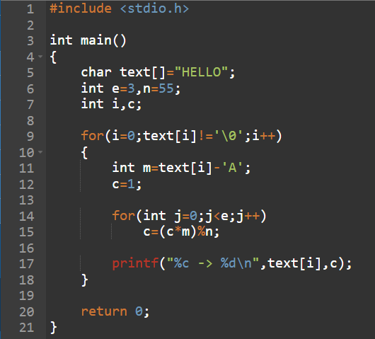
OUTPUT :
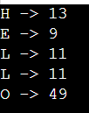
28. Write a C program for Diffie-Hellman protocol, each participant selects a secret number x and sends the other participant ax mod q for some public number a. What would happen if the participants sent each other xa for some public number a instead? Give at least one method Alice and Bob could use to agree on a key. Can Eve break your system without finding the secret numbers? Can Eve find the secret numbers?
PROGARM :
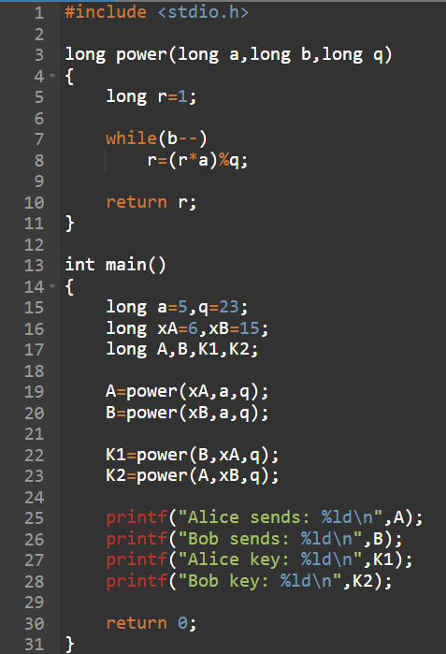
OUTPUT :
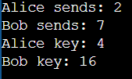
29. Write a C program for SHA-3 option with a block size of 1024 bits and assume that each of the lanes in the first message block (P0) has at least one nonzero bit. To start, all of the lanes in the internal state matrix that correspond to the capacity portion of the initial state are all zeros. Show how long it will take before all of these lanes have at least one nonzero bit. Note: Ignore the permutation. That is, keep track of the original zero lanes even after they have changed position in the matrix.
PROGRAM :
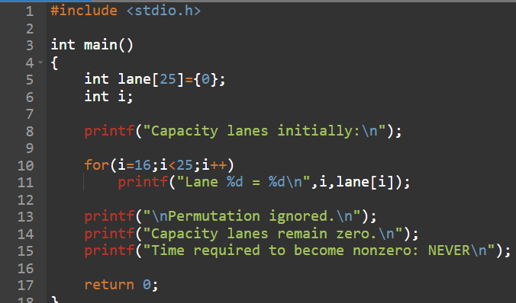
OUTPUT :
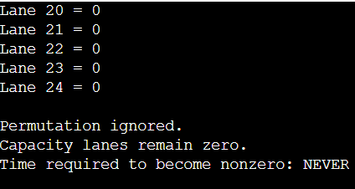
30. Write a C program for CBC MAC of a oneblock message X, say T = MAC(K, X), the adversary immediately knows the CBC MAC for the two-block message X || (X ⊕ T) since this is once again.
PROGARM :
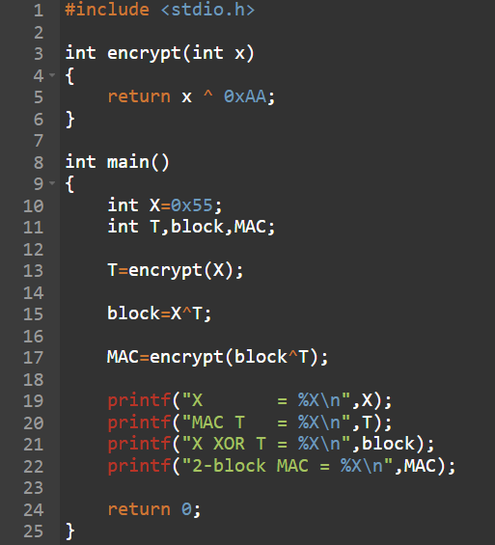

OUTPUT :
