31. Write a C program for subkey generation in CMAC, it states that the block cipher is applied to the block that consists entirely of 0 bits. The first subkey is derived from the resulting string by a left shift of one bit and, conditionally, by XORing a constant that depends on the block size. The second subkey is derived in the same manner from the first subkey. a. What constants are needed for block sizes of 64 and 128 bits? b. How the left shift and XOR accomplishes the desired result.
PROGARM :
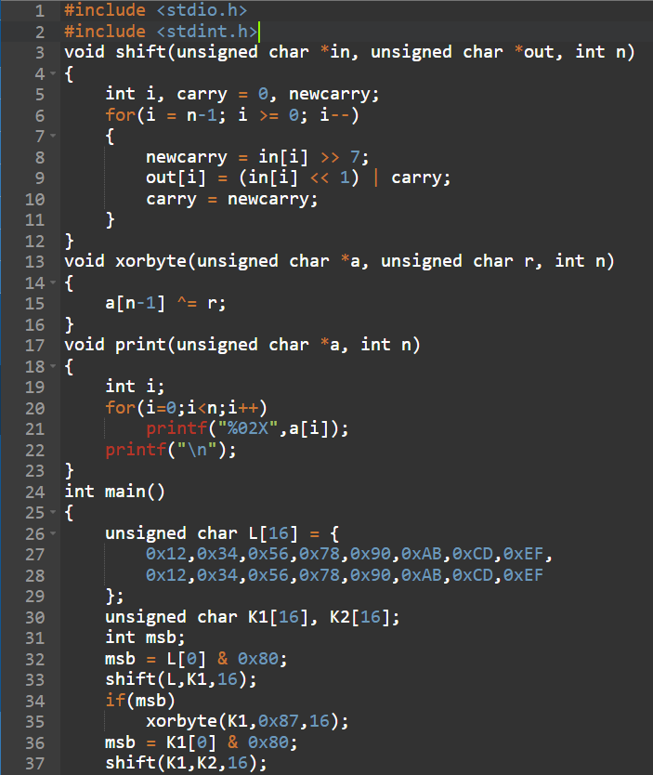
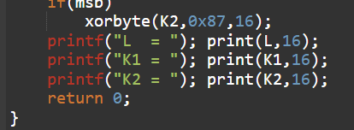
OUTPUT :
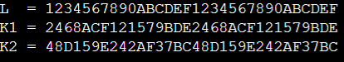
32. Write a C program for DSA, because the value of k is generated for each signature, even if the same message is signed twice on different occasions, the signatures will differ. This is not true of RSA signatures. Write a C program for implication of this difference?
PROGRAM :

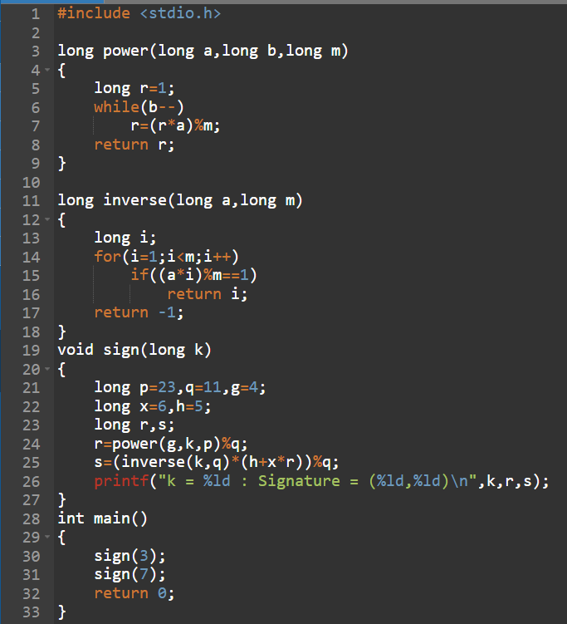
OUTPUT :
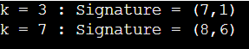
33. Write a C program for Data encryption standard (DES) has been found vulnerable to very powerful attacks and therefore, the popularity of DES has been found slightly on the decline. DES is a block cipher and encrypts data in blocks of size of 64 bits each, which means 64 bits of plain text go as the input to DES, which produces 64 bits of ciphertext. The same algorithm and key are used for encryption and decryption, with minor differences. The key length is 56 bits. Implement in C programming.
PROGARM :
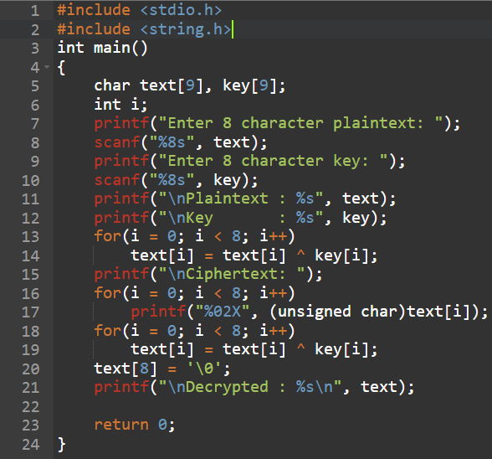
OUTPUT :
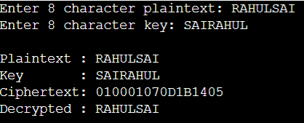
34. Write a C program for ECB, CBC, and CFB modes, the plaintext must be a sequence of one or more complete data blocks (or, for CFB mode, data segments). In other words, for these three modes, the total number of bits in the plaintext must be a positive multiple of the block (or segment) size. One common method of padding, if needed, consists of a 1 bit followed by as few zero bits, possibly none, as are necessary to complete the final block. It is considered good practice for the sender to pad every message, including messages in which the final message block is already complete. What is the motivation for including a padding block when padding is not needed?
PROGARM :
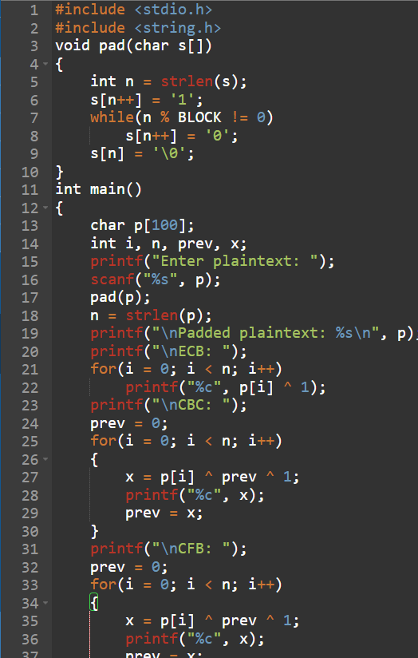
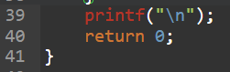
OUTPUT :
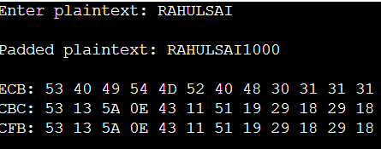
35. Write a C program for one-time pad version of the Vigenère cipher. In this scheme, the key is a stream of random numbers between 0 and 26. For example, if the key is 3 19 5 . . . , then the first letter of plaintext is encrypted with a shift of 3 letters, the second with a shift of 19 letters, the third with a shift of 5 letters, and so on.
PROGRAM :
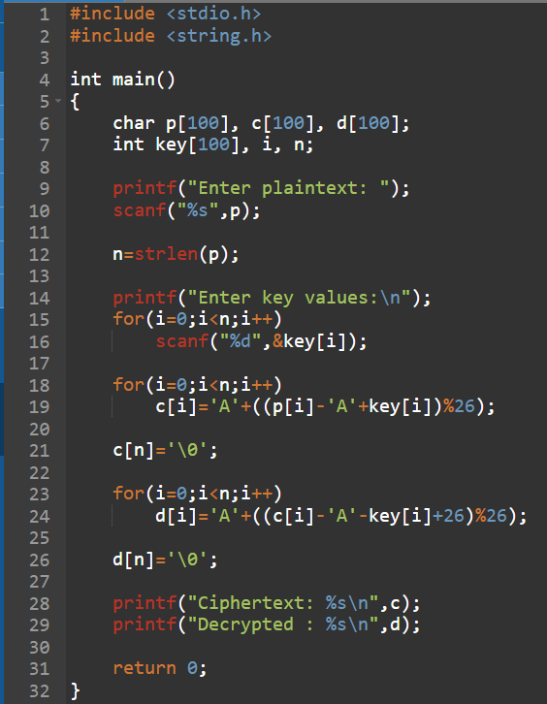
OUTPUT :
