36. Write a C program for Caesar cipher, known as the affine Caesar cipher, has the following form: For each plaintext letter p, substitute the ciphertext letter C: C = E([a, b], p) = (ap + b) mod 26 A basic requirement of any encryption algorithm is that it be one-to-one. That is, if p q, then E(k, p) E(k, q). Otherwise, decryption is impossible, because more than one plaintext character maps into the same ciphertext character. The affine Caesar cipher is not one-to-one for all values of a. For example, for a = 2 and b = 3, then E([a, b], 0) = E([a, b], 13) = 3.
PROGRAM :
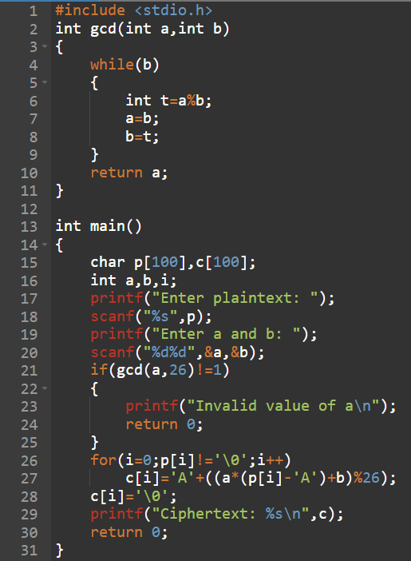
OUTPUT :
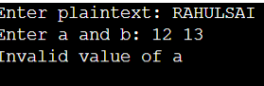
37. Write a C program that can perform a letter frequency attack on any monoalphabetic substitution cipher without human intervention. Your software should produce possible plaintexts in rough order of likelihood. It would be good if your user interface allowed the user to specify “give me the top 10 possible plaintexts.”
PROGRAM :

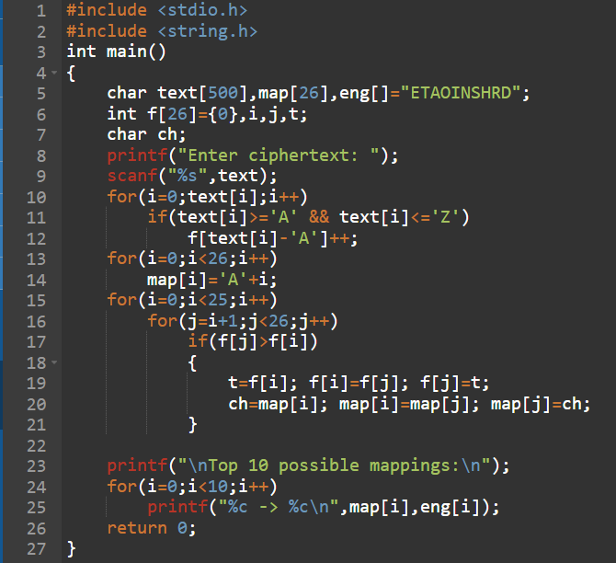
OUTPUT :
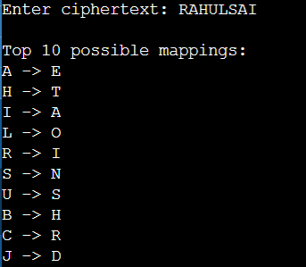
38. Write a C program for Hill cipher succumbs to a known plaintext attack if sufficient plaintextciphertext pairs are provided. It is even easier to solve the Hill cipher if a chosen plaintext attack can be mounted. Implement in C programming.
PROGRAM :
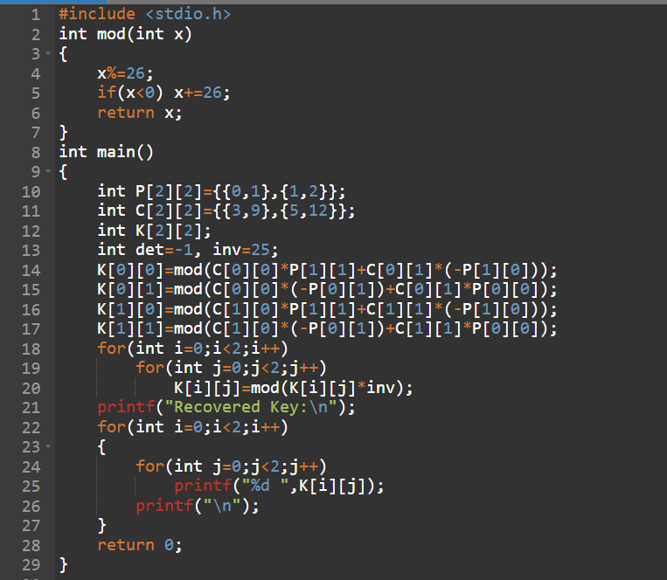
OUTPUT :
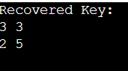
39. Write a C program that can perform a letter frequency attack on an additive cipher without human intervention. Your software should produce possible plaintexts in rough order of likelihood. It would be good if your user interface allowed the user to specify “give me the top 10 possible plaintexts.”
PROGRAM :
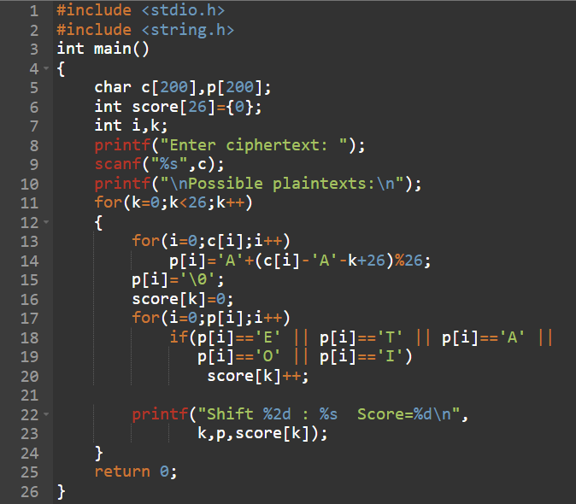
OUTPUT :
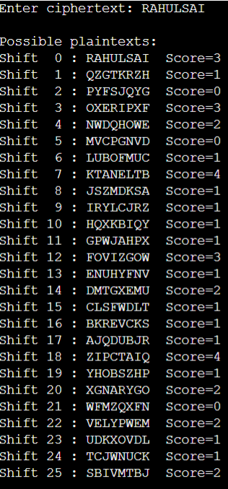
40. Write a C program that can perform a letter frequency attack on any monoalphabetic substitution cipher without human intervention. Your software should produce possible plaintexts in rough order of likelihood. It would be good if your user interface allowed the user to specify “give me the top 10 possible plaintexts.”
PROGRAM :
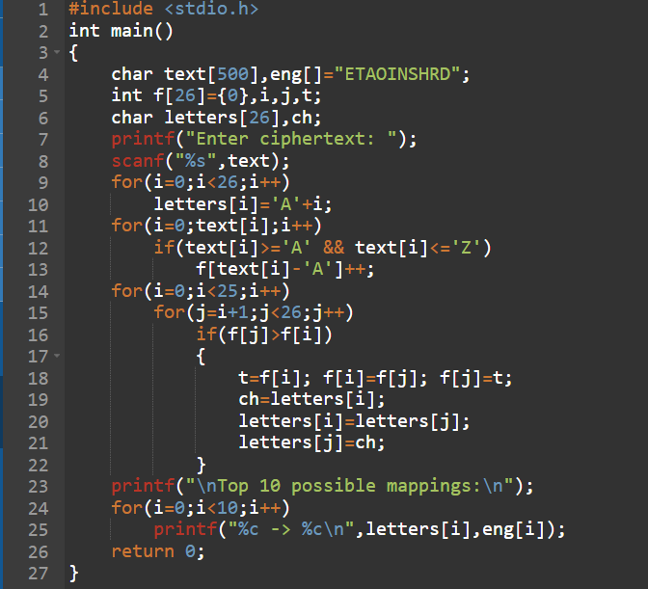
OUTPUT :
