MA 322: Scientific Computing
LAB 7 Report
Abheek Ghosh - 140123047

NOTE: The right angled triangle for comparison is of same length on both perpendicular and base. So, the hypotenuse has a slope of -1. The distortion in graph is due to change in scale of graph. The comparison of slope of the method should be compared with relative to unit slope of the triangle.

Question 1
(A)
Explicit-Euler method

N Error Order
10 8.728002e-02 1.026022
20 4.285993e-02 1.015965
40 2.119413e-02 1.007824
80 1.053975e-02 1.003868
160 5.255765e-03 1.001947
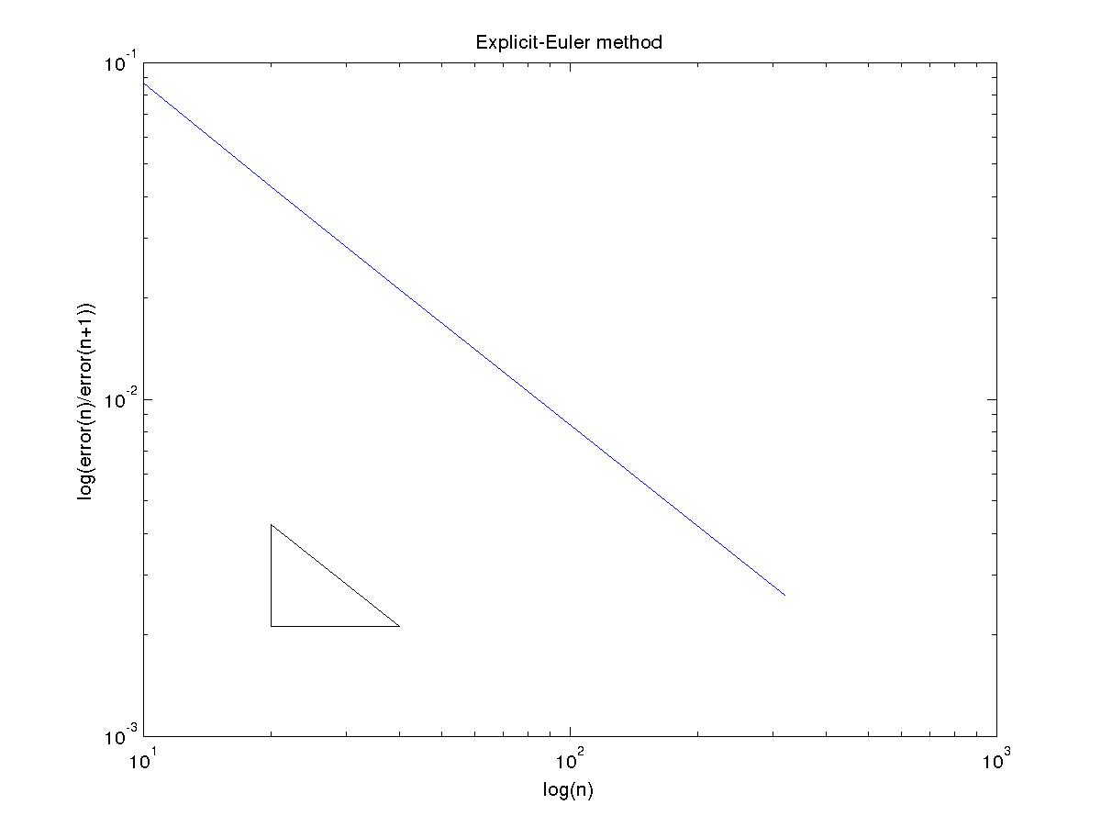

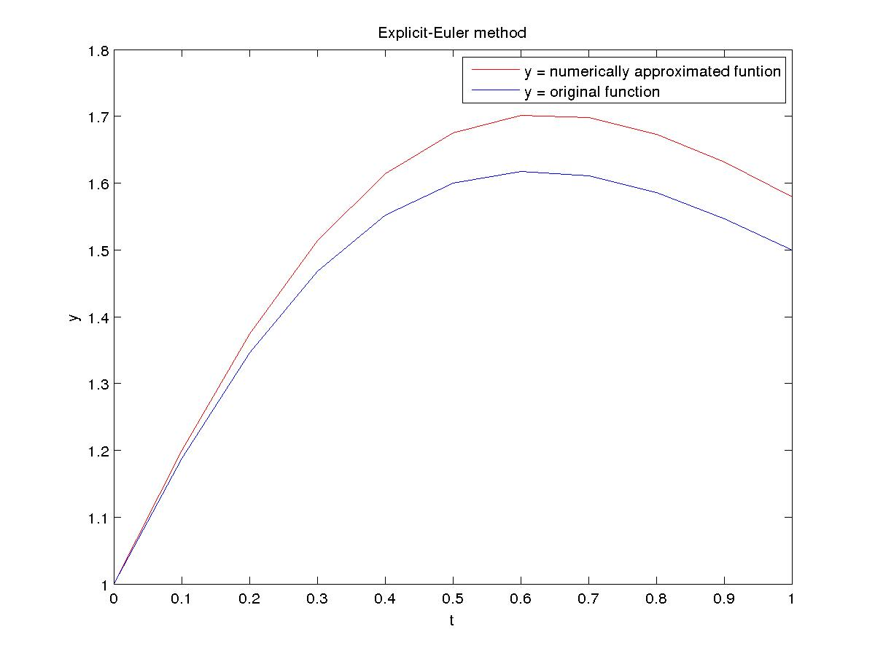
Implicit-Euler method

N Error Order
10 8.022849e-02 0.967347
20 4.103251e-02 0.984525
40 2.073751e-02 0.991968
80 1.042664e-02 0.996121
160 5.227355e-03 0.998028
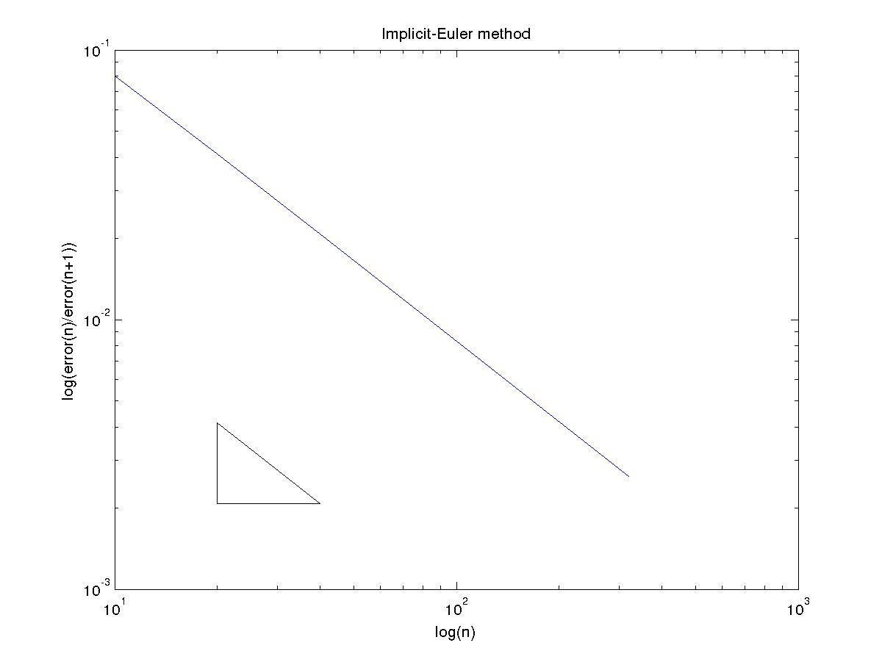
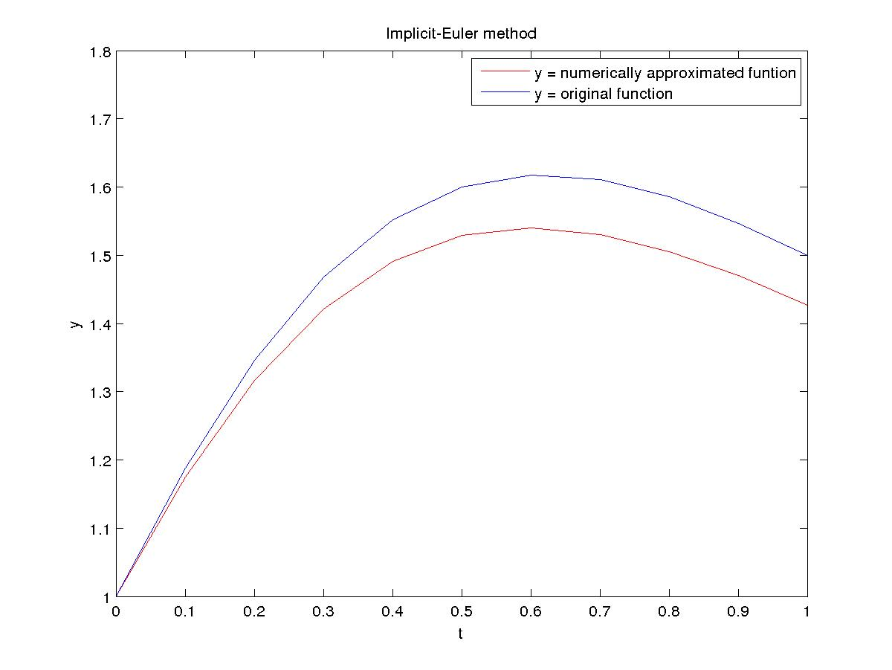

Modified-Euler (trapezoid) method

N Error Order
10 1.414167e-03 1.980782
20 3.582828e-04 1.998082
40 8.968986e-05 1.997962
80 2.245416e-05 2.000010
160 5.613502e-06 1.999948

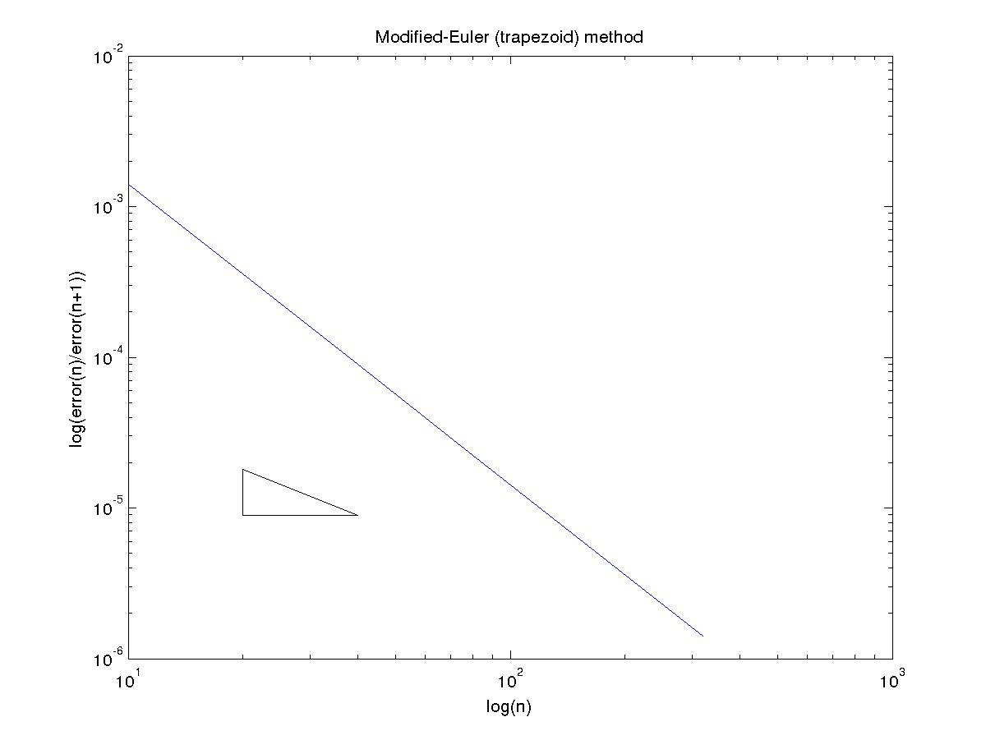

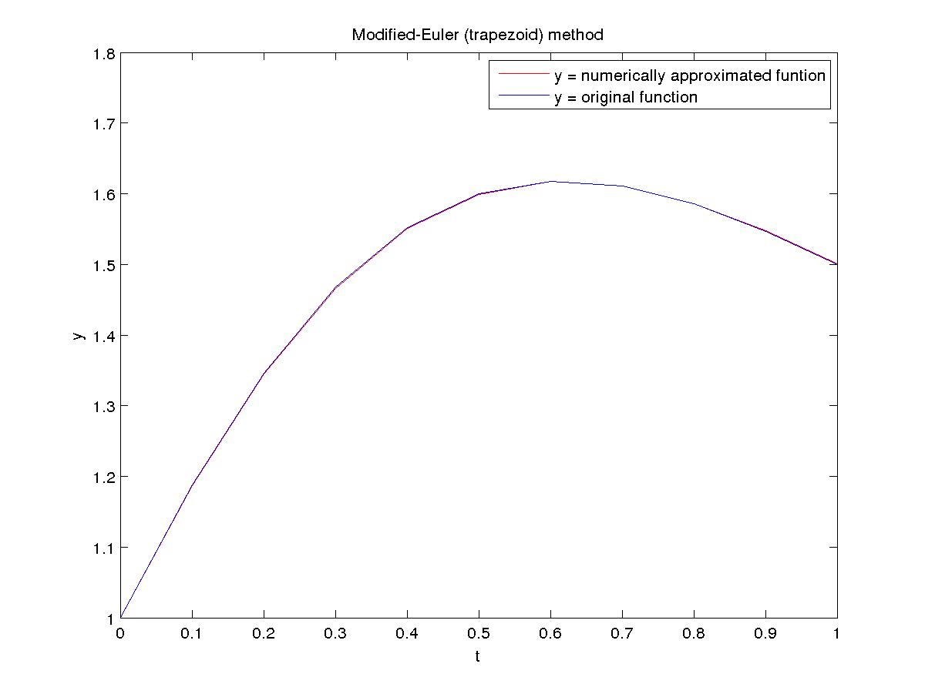
Midpoint method

N Error Order
10 1.202405e-03 1.995053
20 3.016337e-04 2.000562
40 7.537903e-05 1.999535
80 1.885083e-05 2.000036
160 4.712592e-06 2.000004

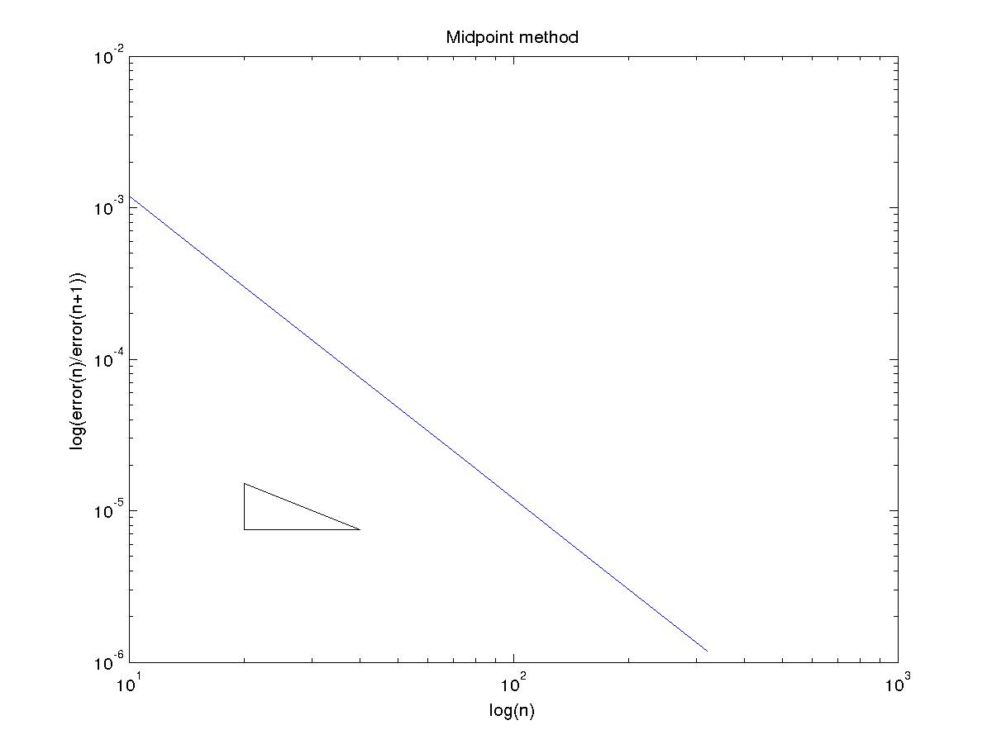
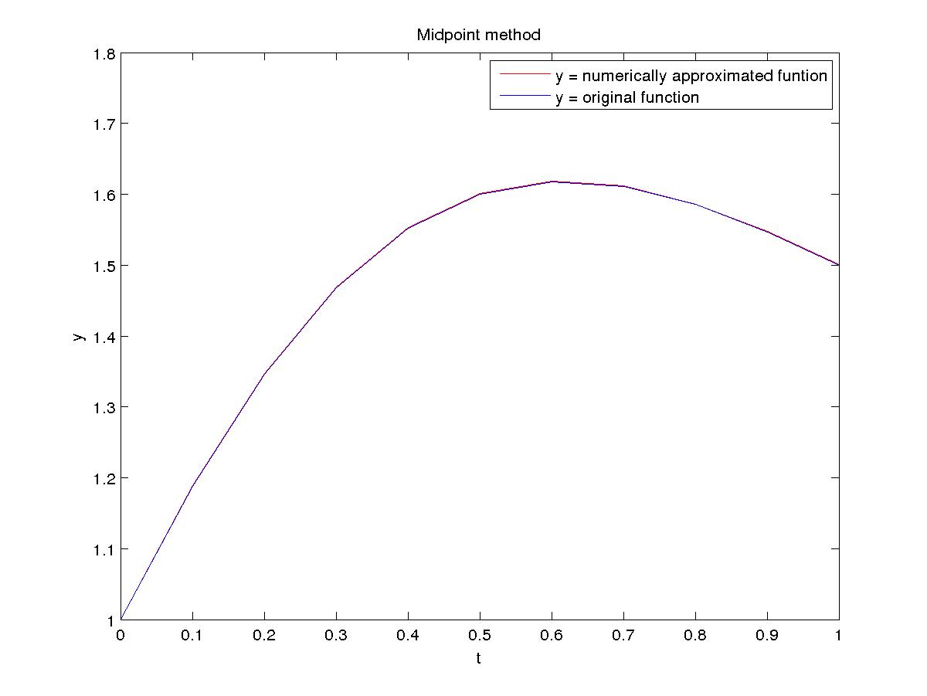

Runge Kutta 2th Order (Optimal) method

N Error Order
10 1.980428e-03 2.092101
20 4.644874e-04 2.049850
40 1.121780e-04 2.025210
80 2.755871e-05 2.012637
160 6.829590e-06 2.006348

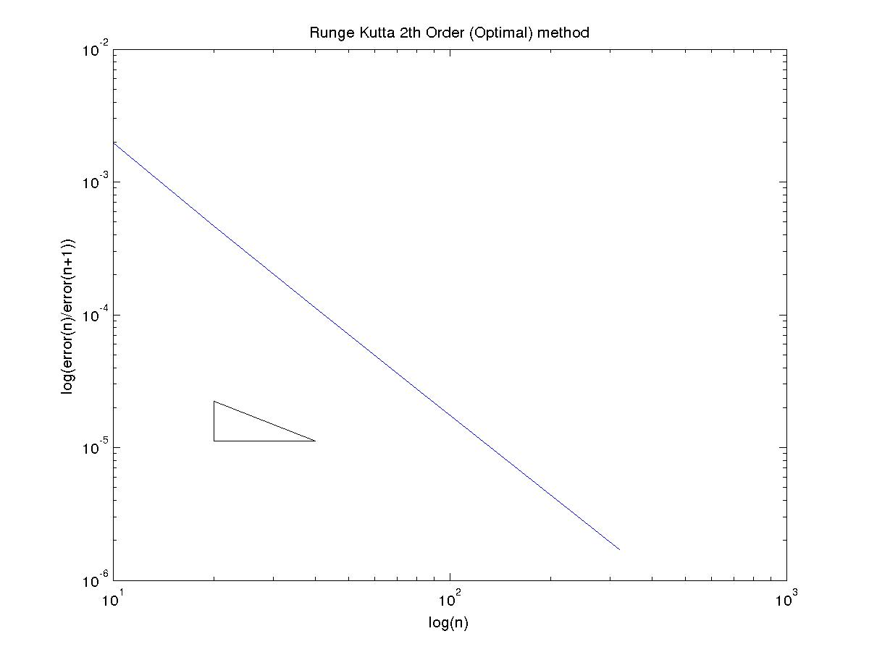

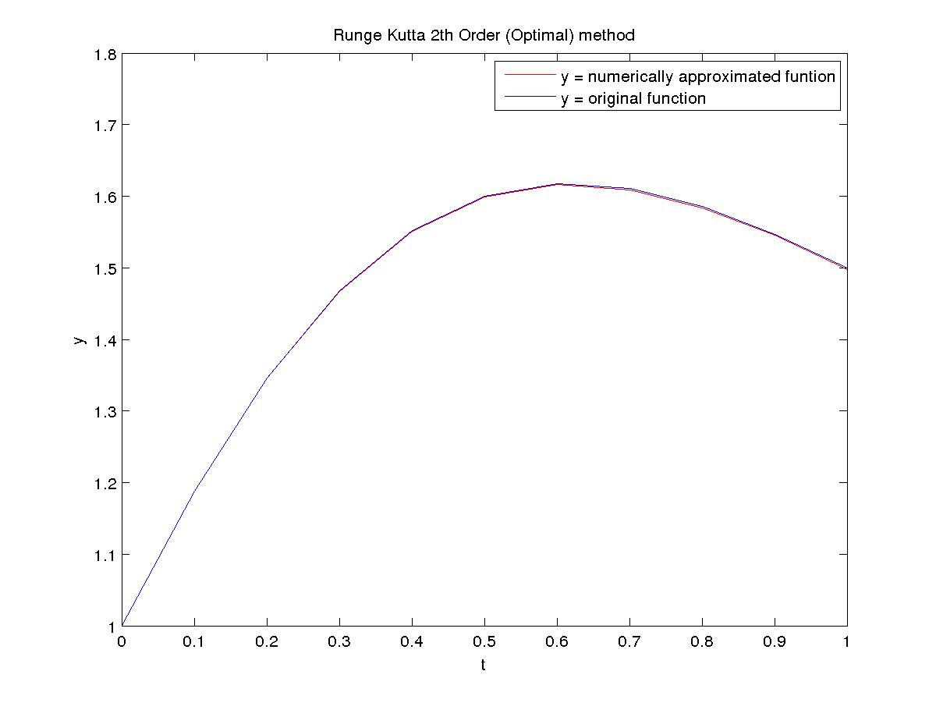

Runge Kutta 4th Order method

N Error Order
10 1.823453e-06 4.036679
20 1.111049e-07 4.018364
40 6.856224e-09 4.008934
80 4.258685e-10 4.004488
160 2.653411e-11 4.002259

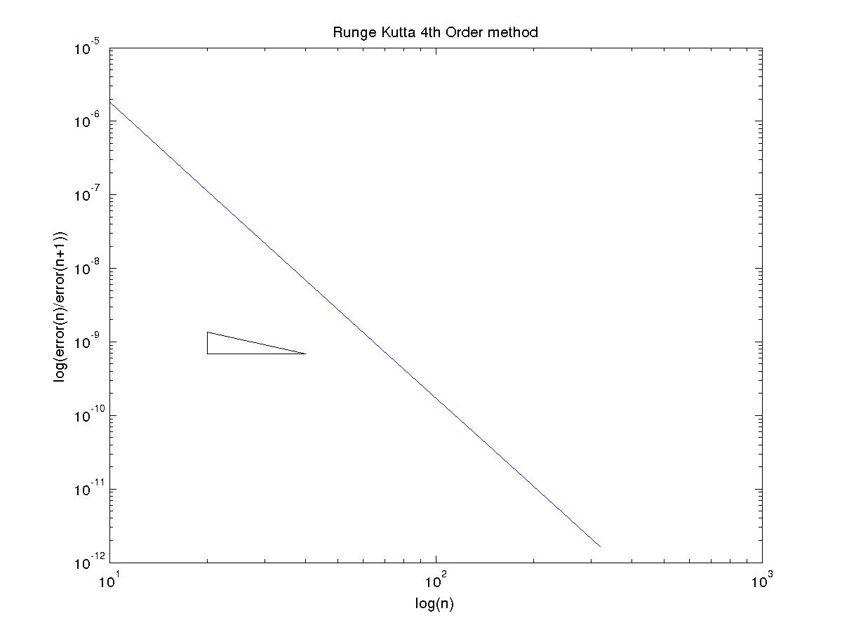
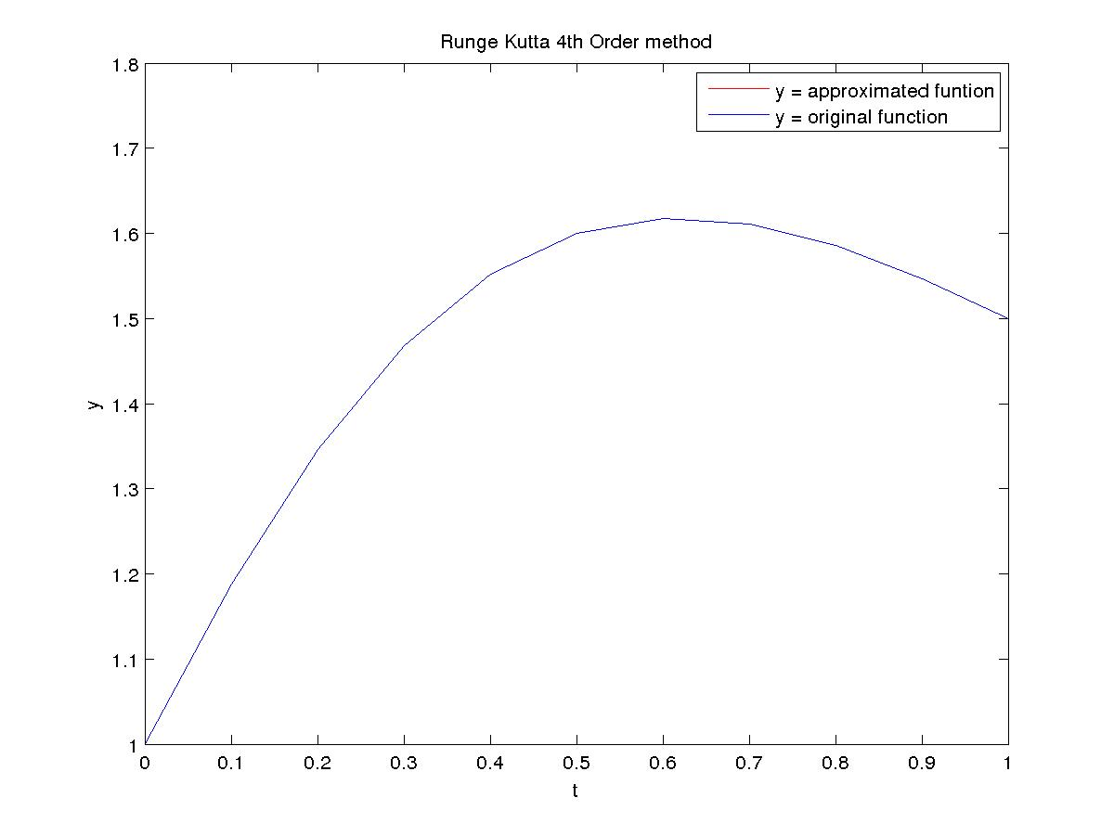

(B)
Explicit-Euler method

N Error Order
10 1.155556e-01 1.227102
20 4.936241e-02 1.096493
40 2.308443e-02 1.044949
80 1.118814e-02 1.021197
160 5.512480e-03 1.010424

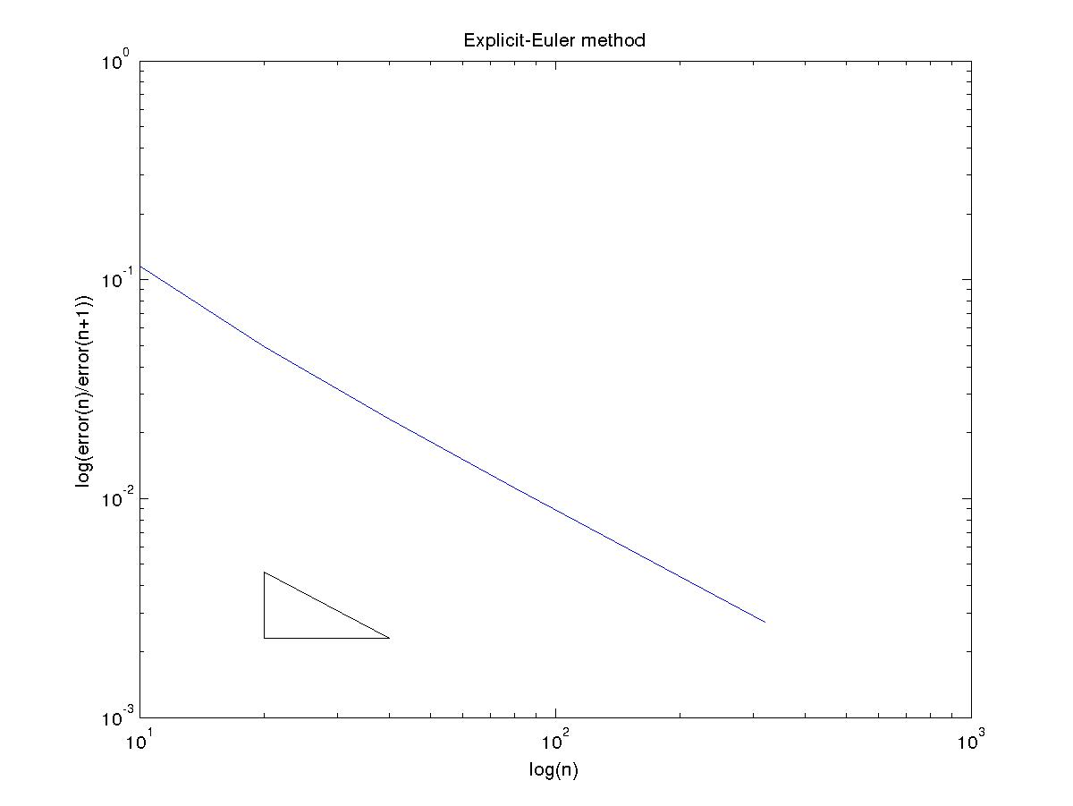

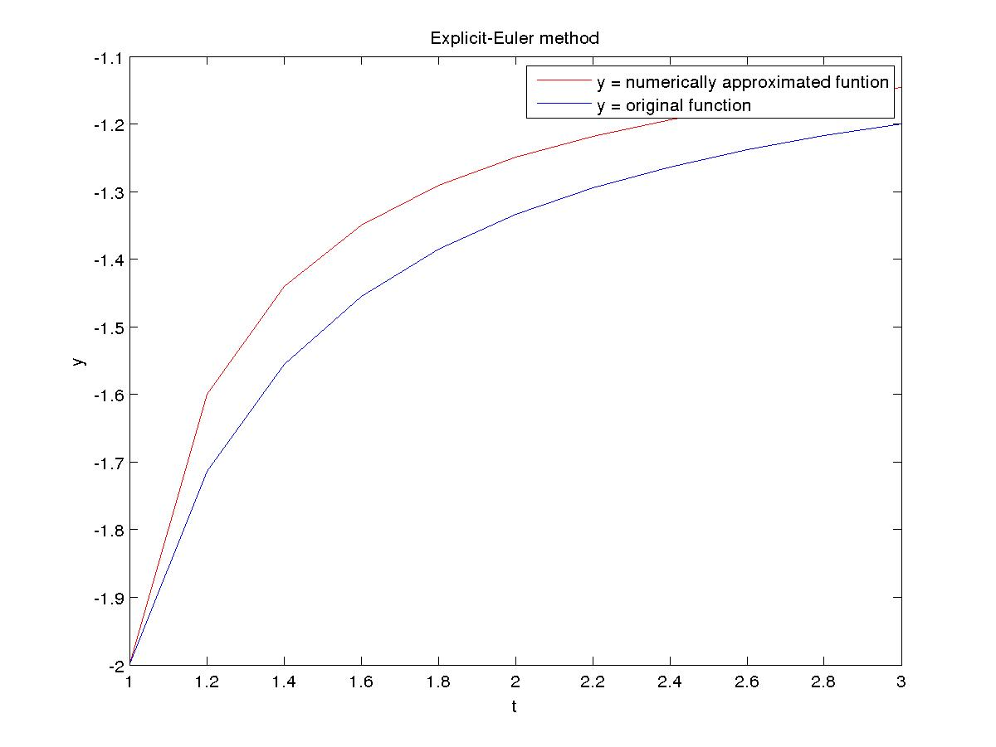

Implicit-Euler method

N Error Order
10 7.154419e-02 0.867985
20 3.919990e-02 0.928349
40 2.059795e-02 0.962450
80 1.057056e-02 0.980201
160 5.358312e-03 0.989956

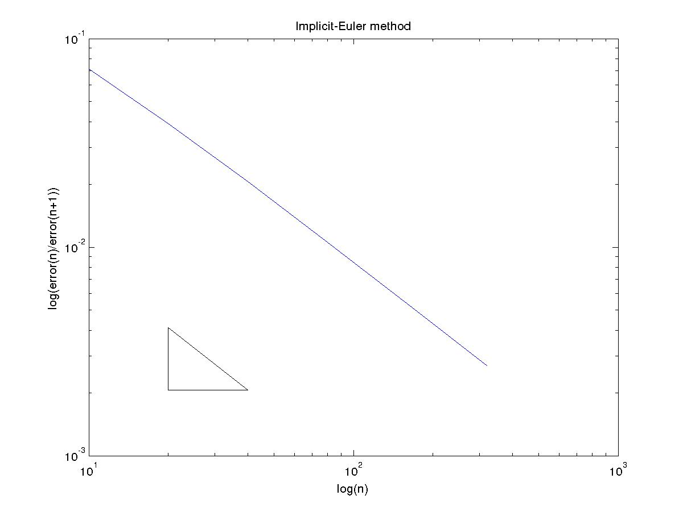
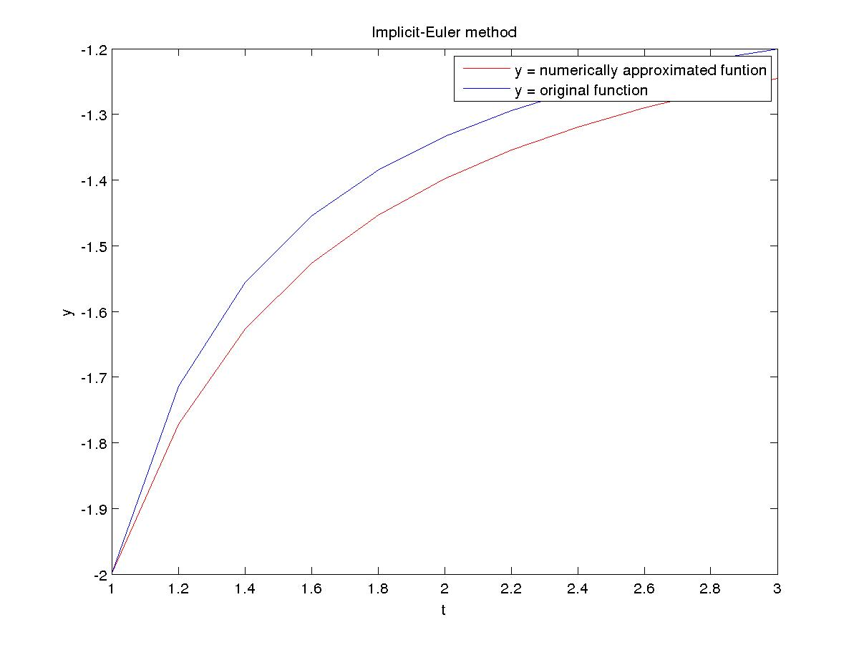

Modified-Euler (trapezoid) method

N Error Order
10 1.382418e-02 2.008651
20 3.435384e-03 2.011356
40 8.521125e-04 2.002841
80 2.126091e-04 2.000262
160 5.314263e-05 2.000172

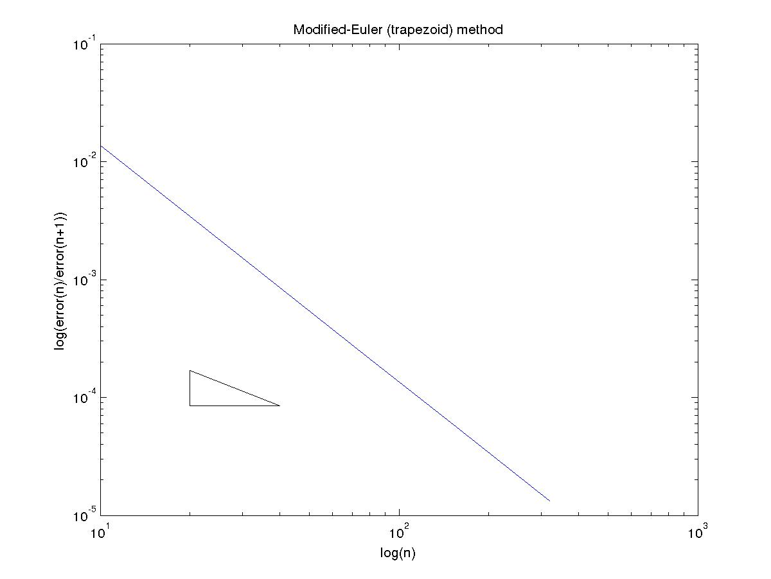

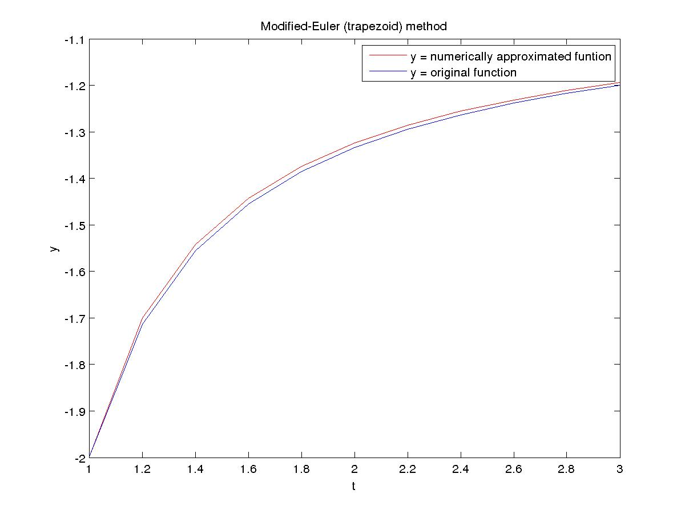
Midpoint method

N Error Order
10 2.976513e-03 1.964880
20 7.624653e-04 1.998627
40 1.907979e-04 1.996826
80 4.780453e-05 1.999980
160 1.195130e-05 1.999991

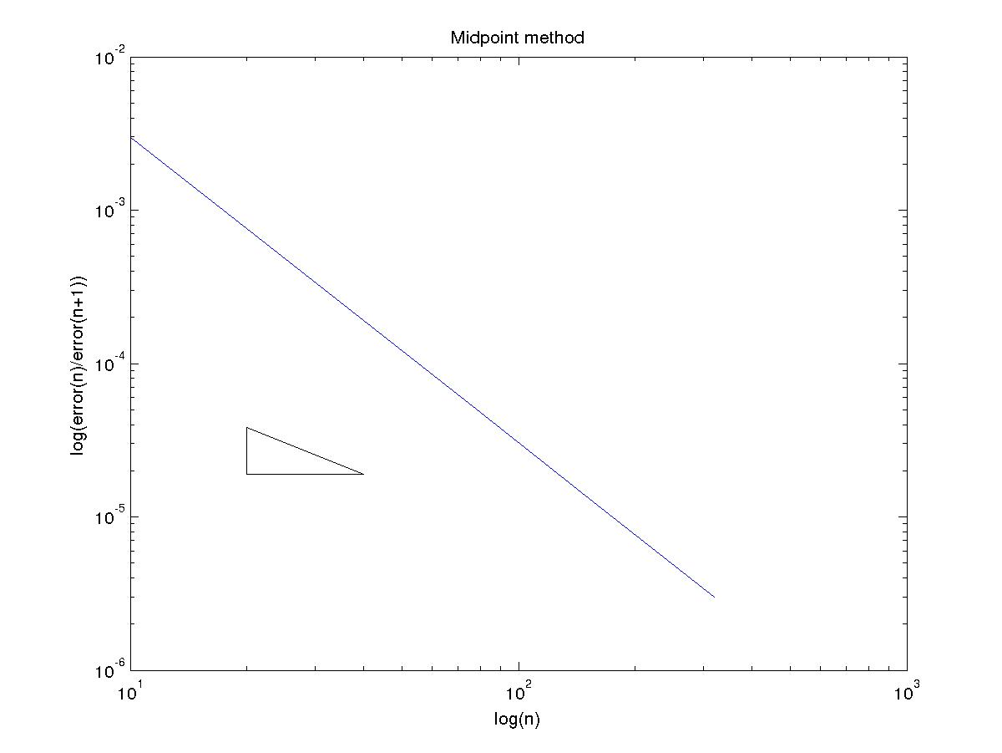
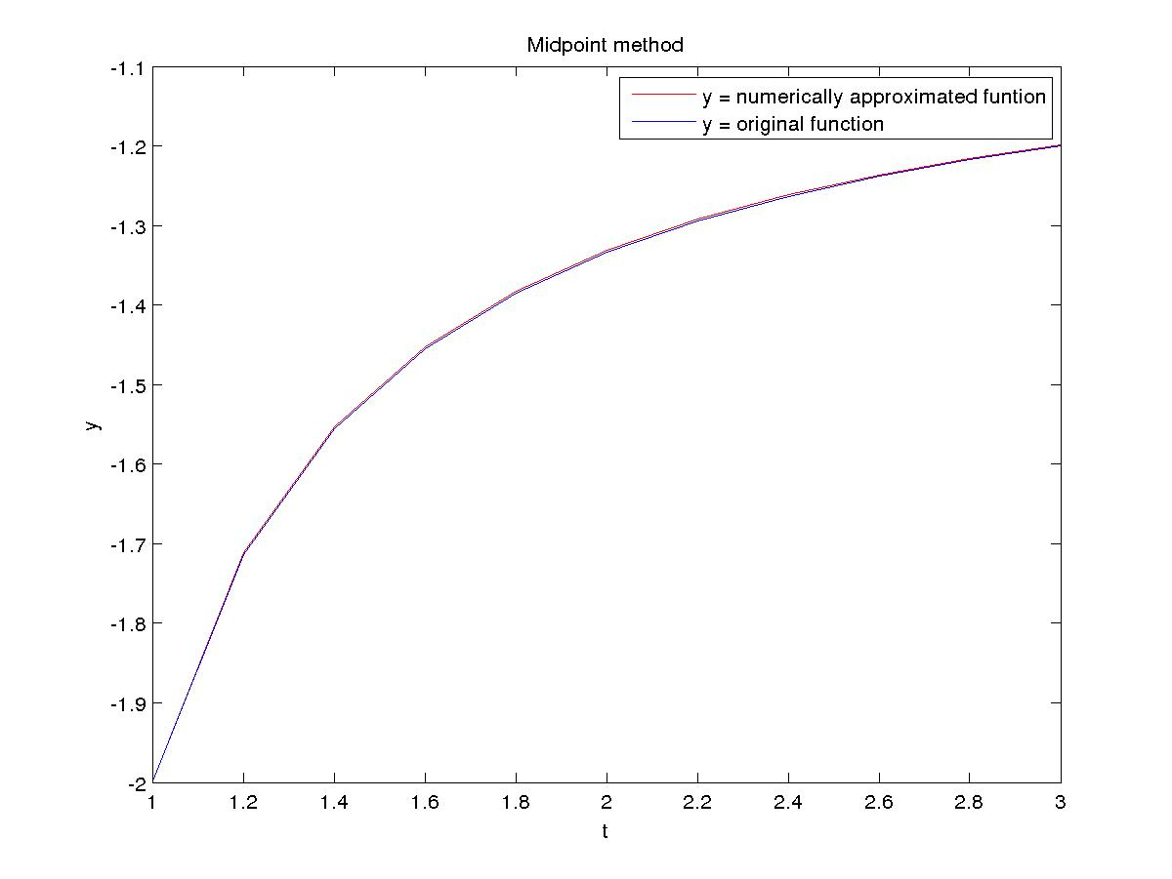

Runge Kutta 2th Order (Optimal) method

N Error Order
10 1.763556e-02 2.167027
20 3.926893e-03 2.125475
40 8.999482e-04 2.065738
80 2.149653e-04 2.033370
160 5.251254e-05 2.016781

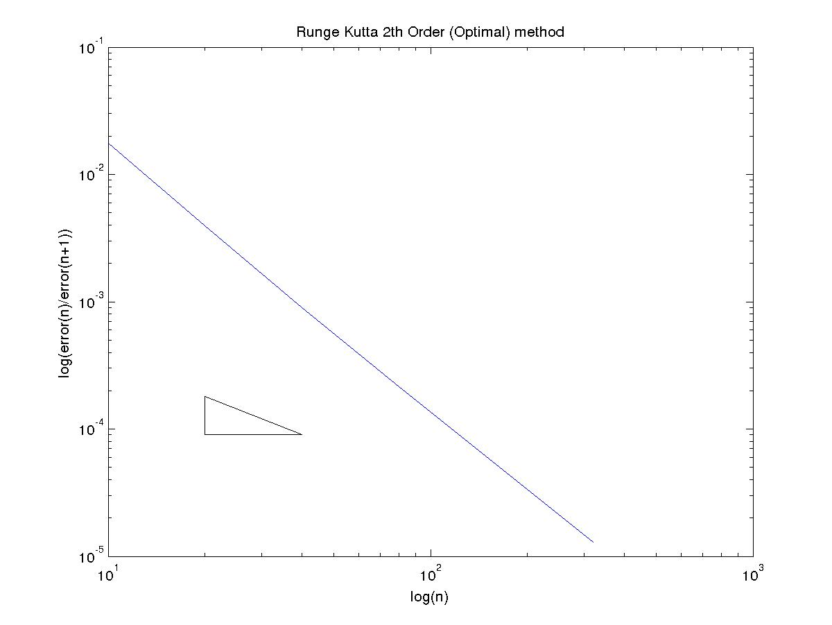

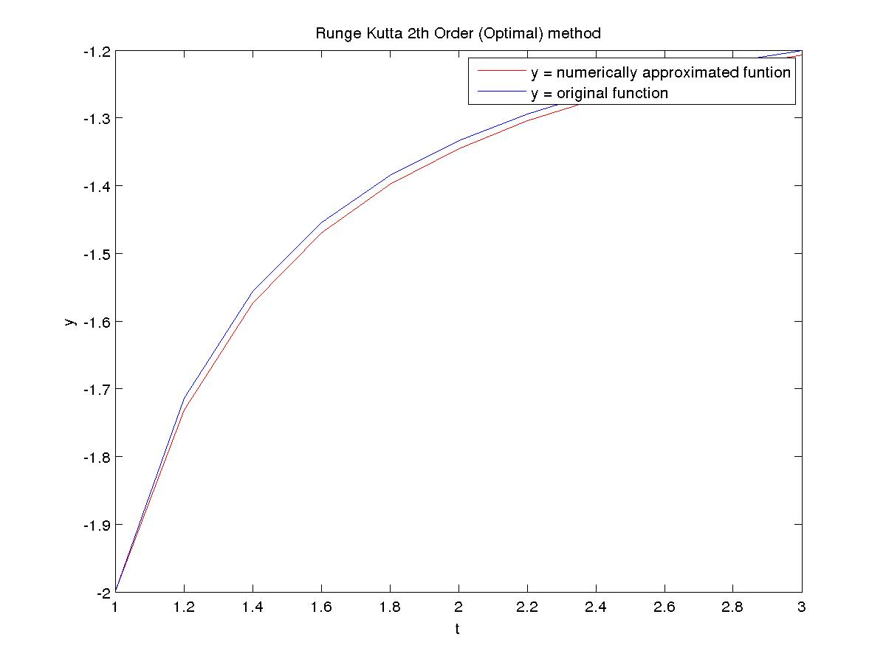

Runge Kutta 4th Order method

N Error Order
10 4.053383e-05 6.218198
20 5.444444e-07 5.271688
40 1.409345e-08 2.718562
80 2.141158e-09 3.661933
160 1.691598e-10 3.864334

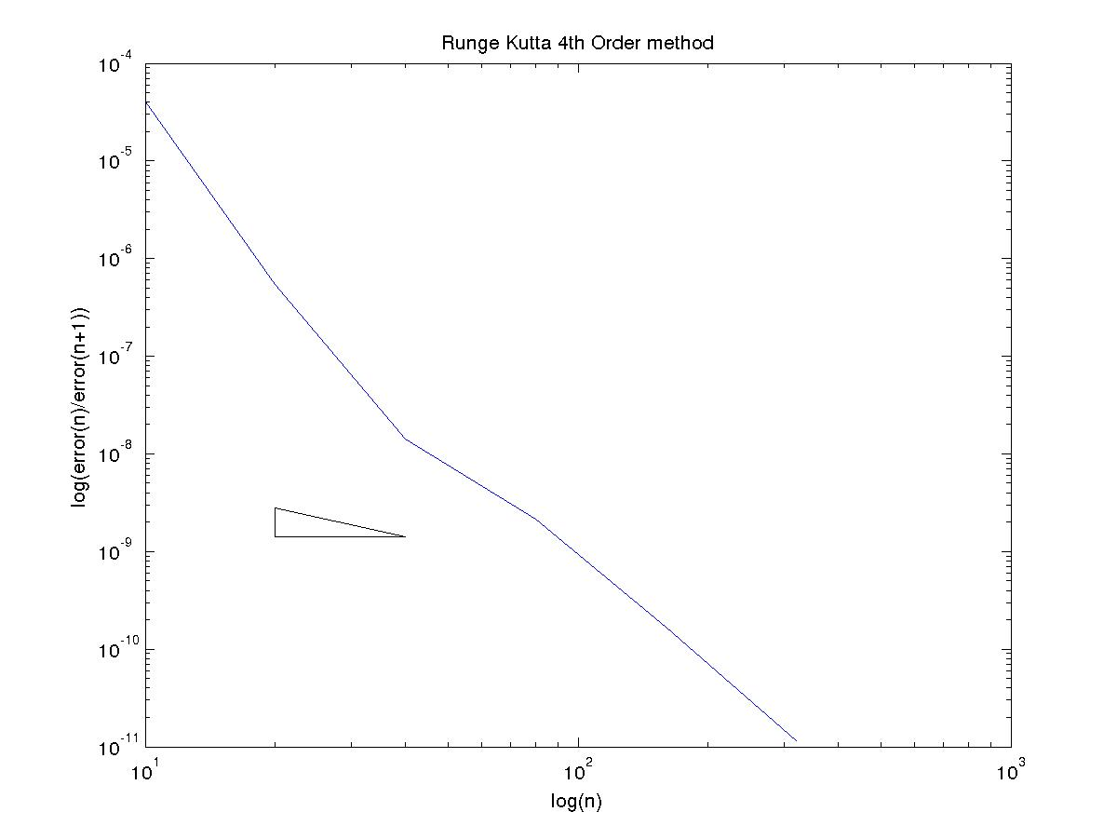
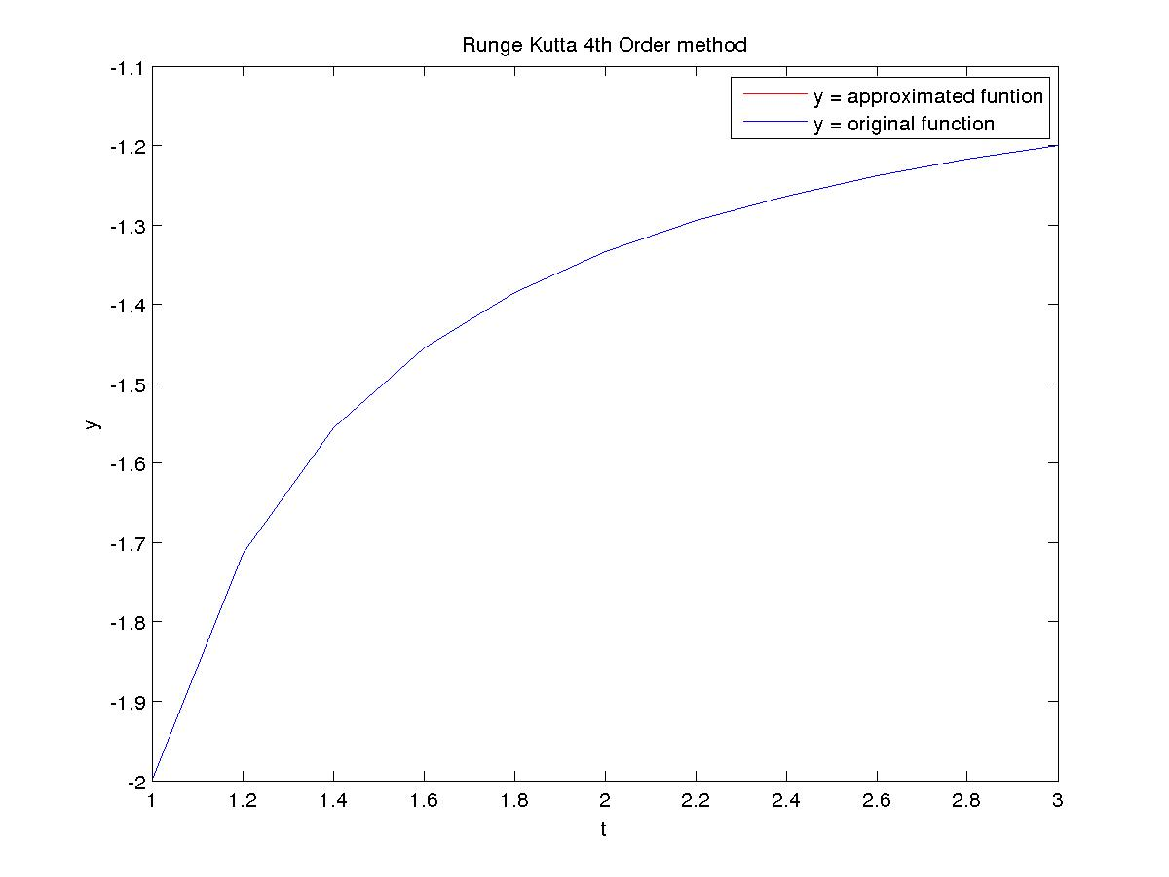

(C)
Explicit-Euler method

N Error Order
10 1.359823e+00 0.739928
20 8.142197e-01 0.843863
40 4.536422e-01 0.913033
80 2.409145e-01 0.953853
160 1.243726e-01 0.976192

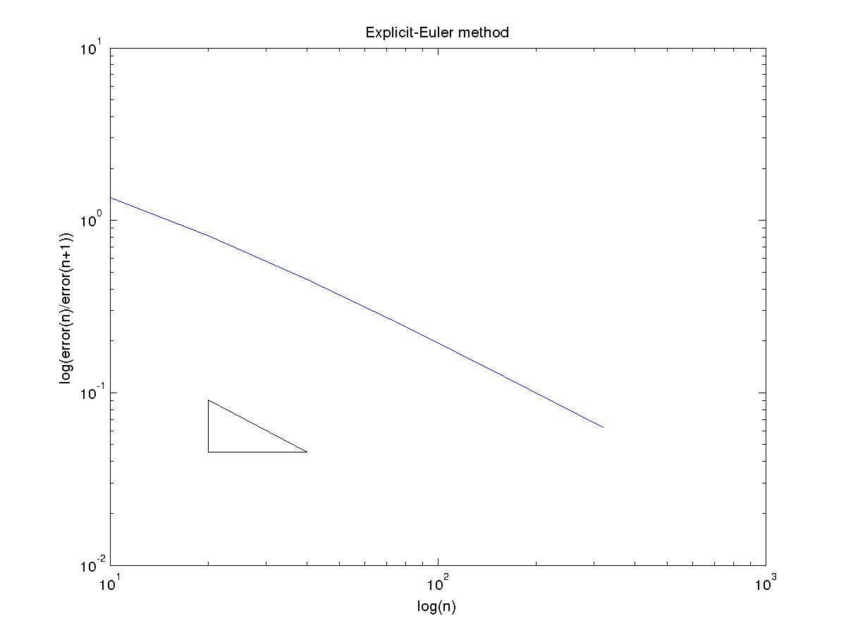

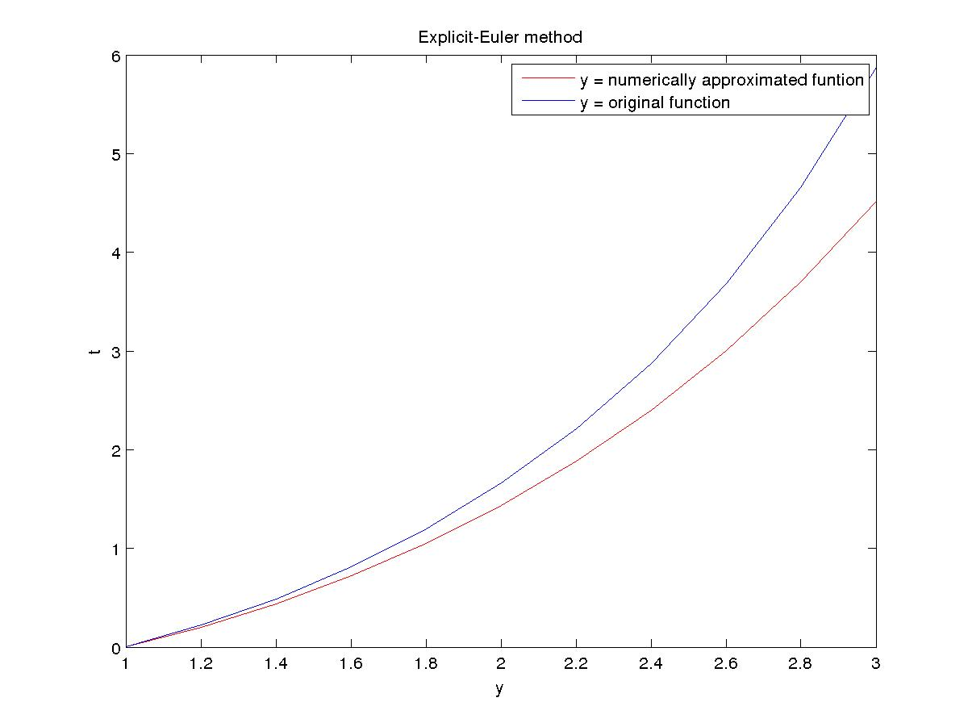
Implicit-Euler method

N Error Order
10 5.674011e+00 1.975610
20 1.442687e+00 1.271163
40 5.977421e-01 1.113688
80 2.762233e-01 1.052714
160 1.331563e-01 1.025443

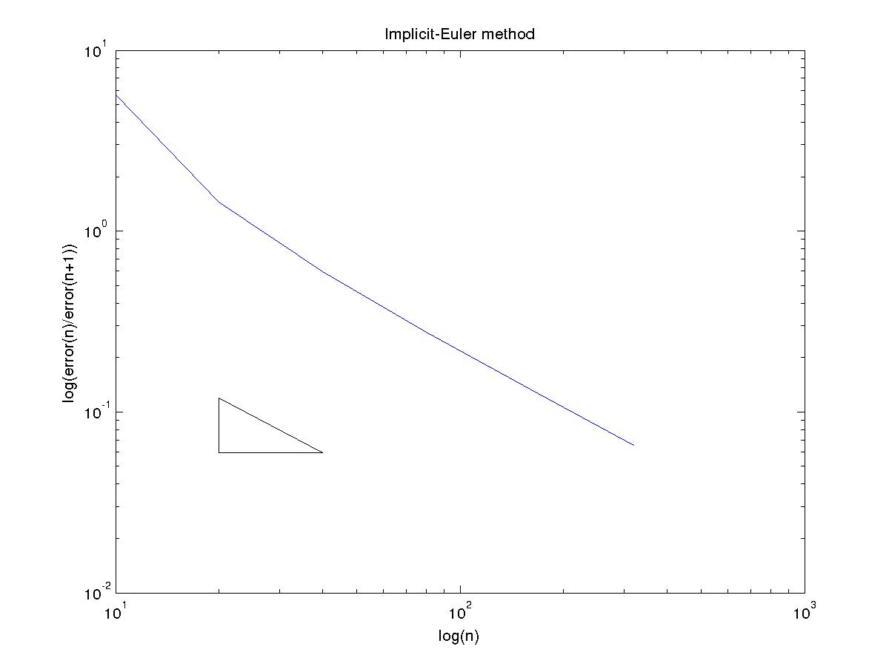
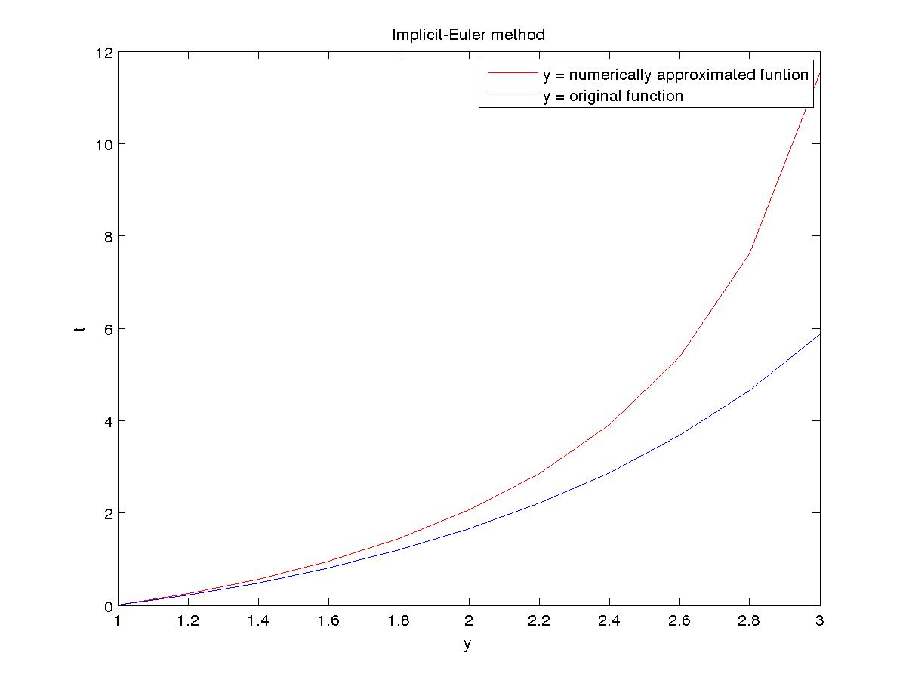

Modified-Euler (trapezoid) method

N Error Order
10 6.985429e-02 2.032640
20 1.707290e-02 2.007953
40 4.244762e-03 2.001976
80 1.059738e-03 2.000494
160 2.648439e-04 2.000123

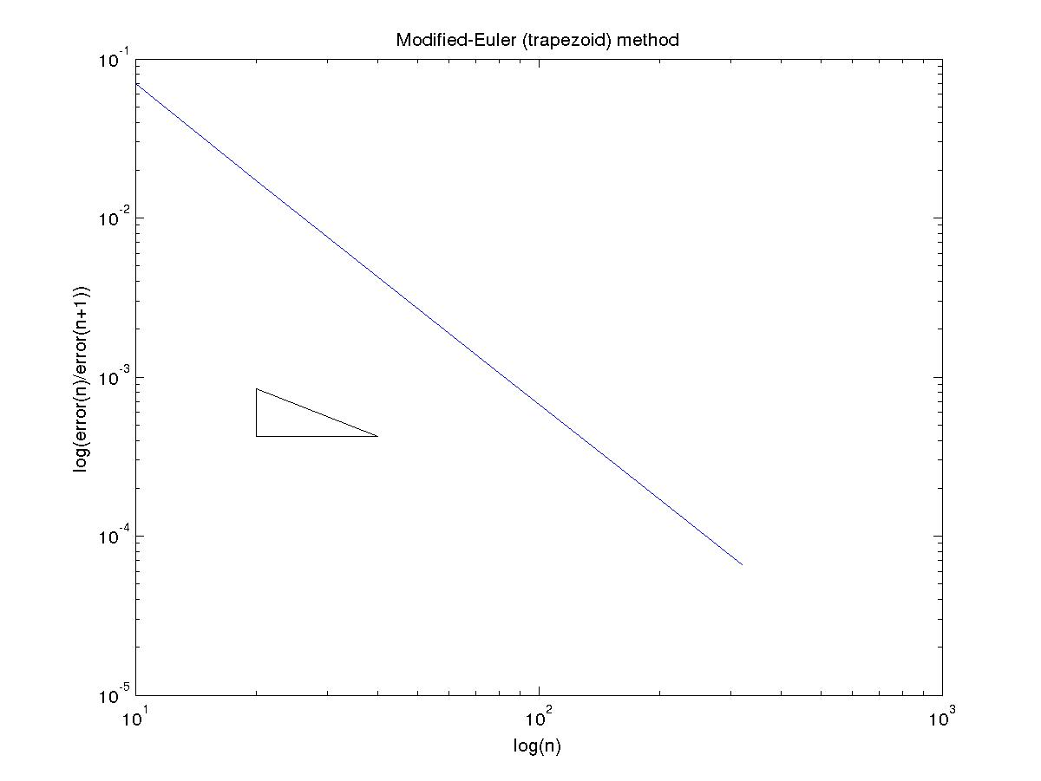

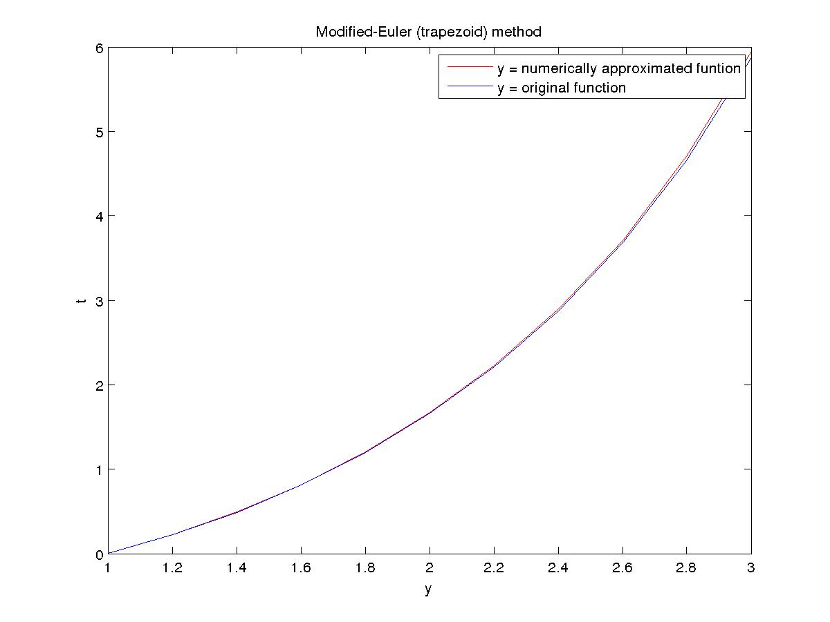

Midpoint method

N Error Order
10 1.045453e-01 2.040836
20 2.540690e-02 2.009994
40 6.307877e-03 2.002486
80 1.574255e-03 2.000621
160 3.933942e-04 2.000155

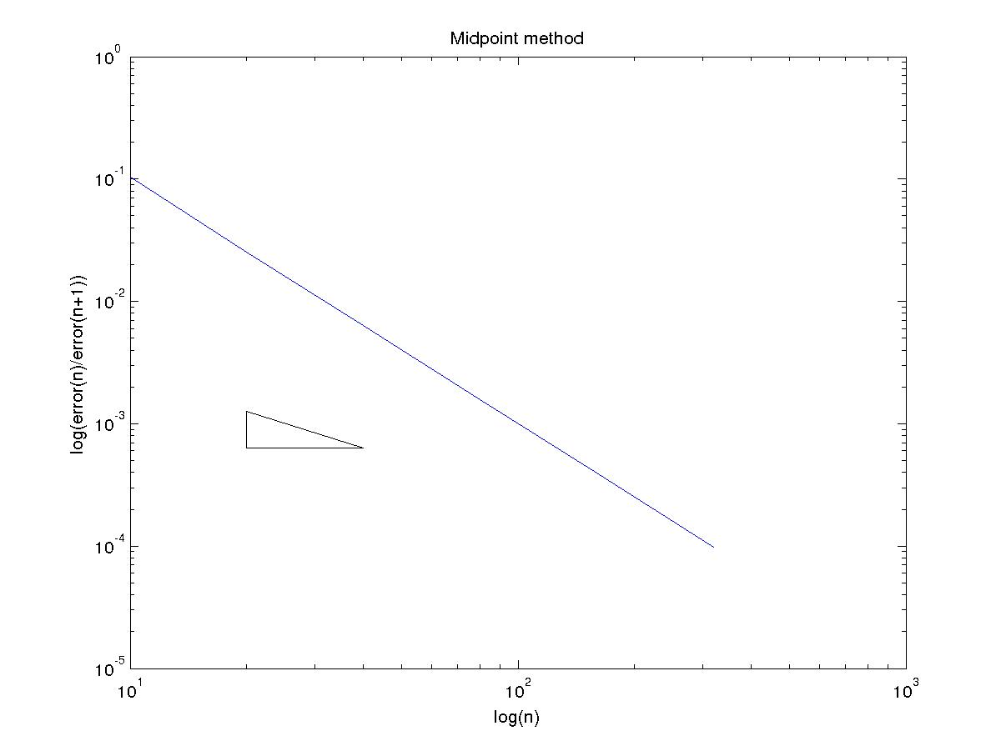
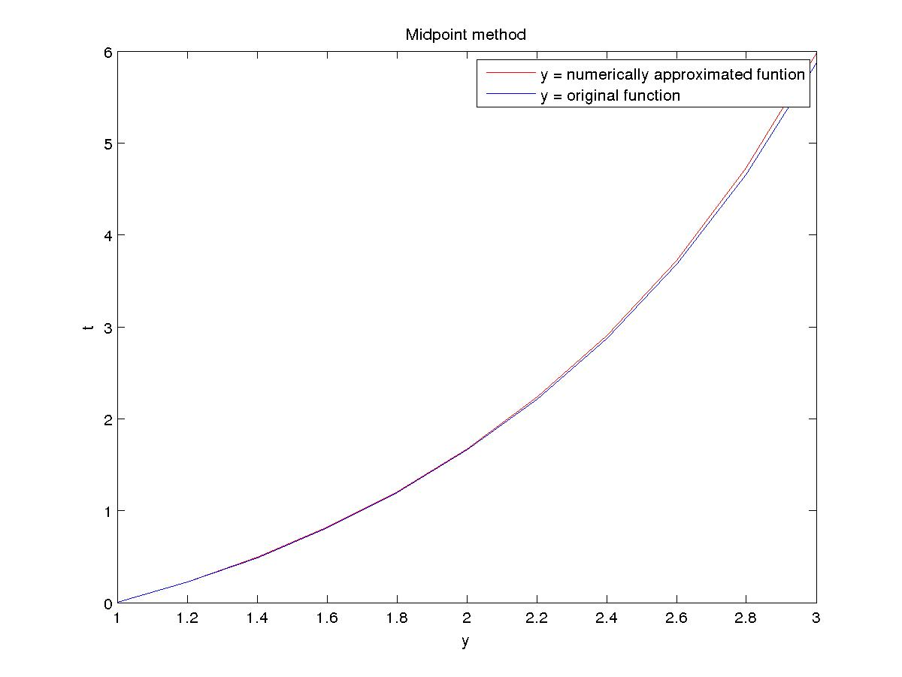

Runge Kutta 2th Order (Optimal) method

N Error Order
10 1.454753e-01 1.838099
20 4.068799e-02 1.926147
40 1.070627e-02 1.965506
80 2.741333e-03 1.983452
160 6.932395e-04 1.991912

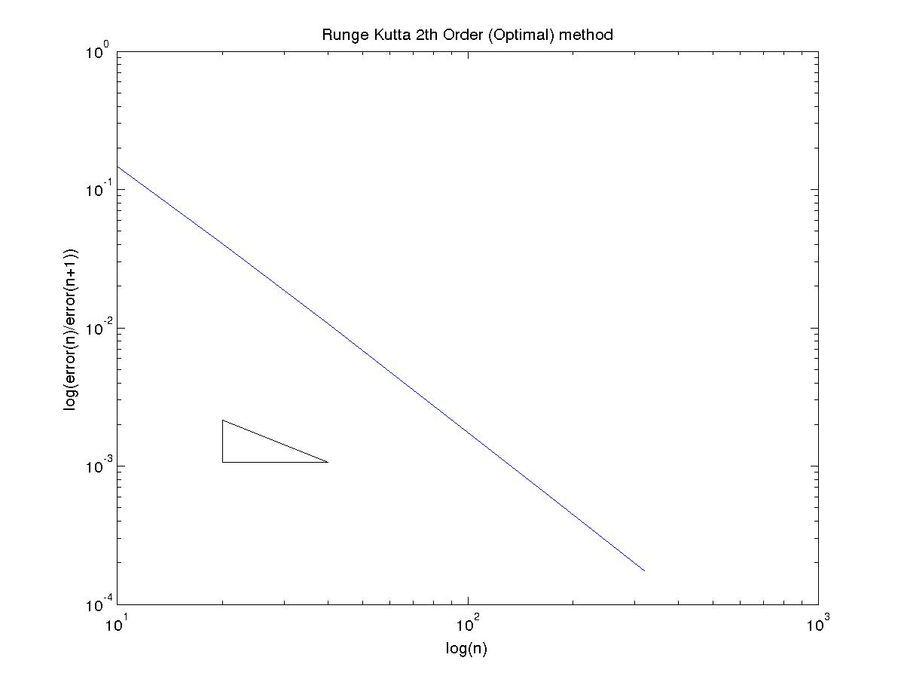

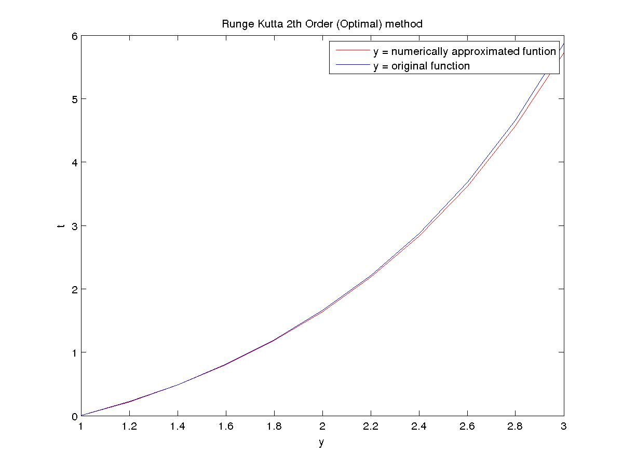

Runge Kutta 4th Order method

N Error Order
10 2.614084e-04 3.904348
20 1.745797e-05 3.951604
40 1.128346e-06 3.975832
80 7.171296e-08 3.987953
160 4.519643e-09 3.993964

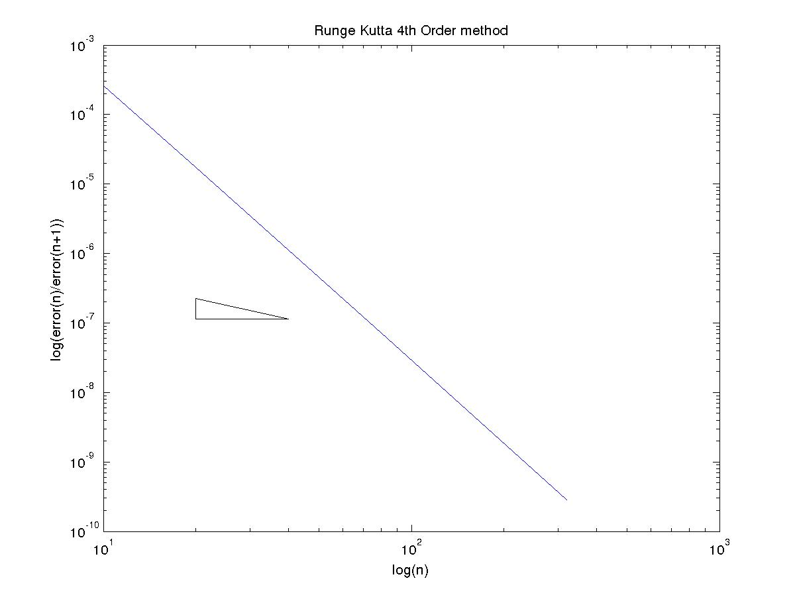
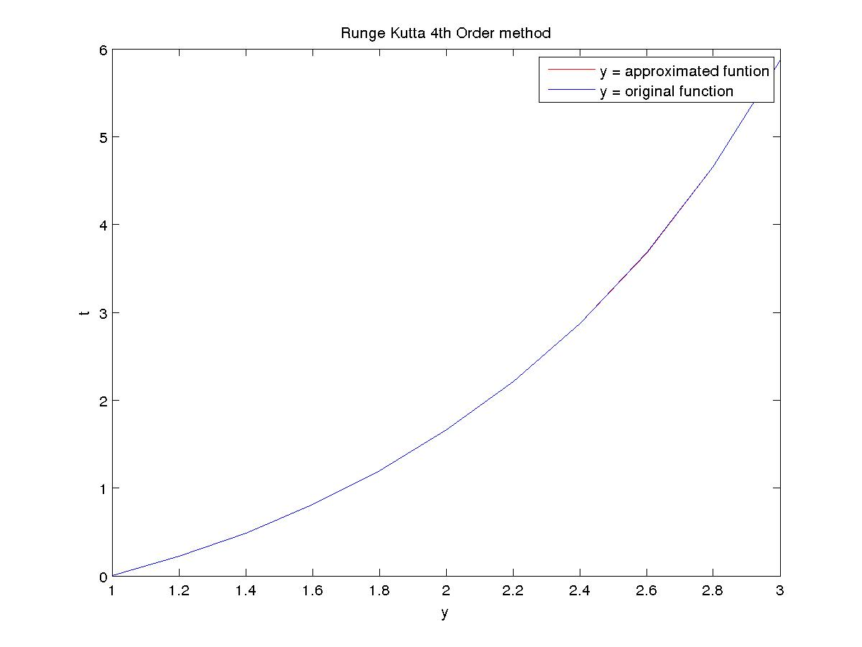
(D)
Explicit-Euler method

N Error Order
10 9.711427e-03 1.017006
20 4.798811e-03 1.008424
40 2.385436e-03 1.004193
80 1.189257e-03 1.002091
160 5.937671e-04 1.001044

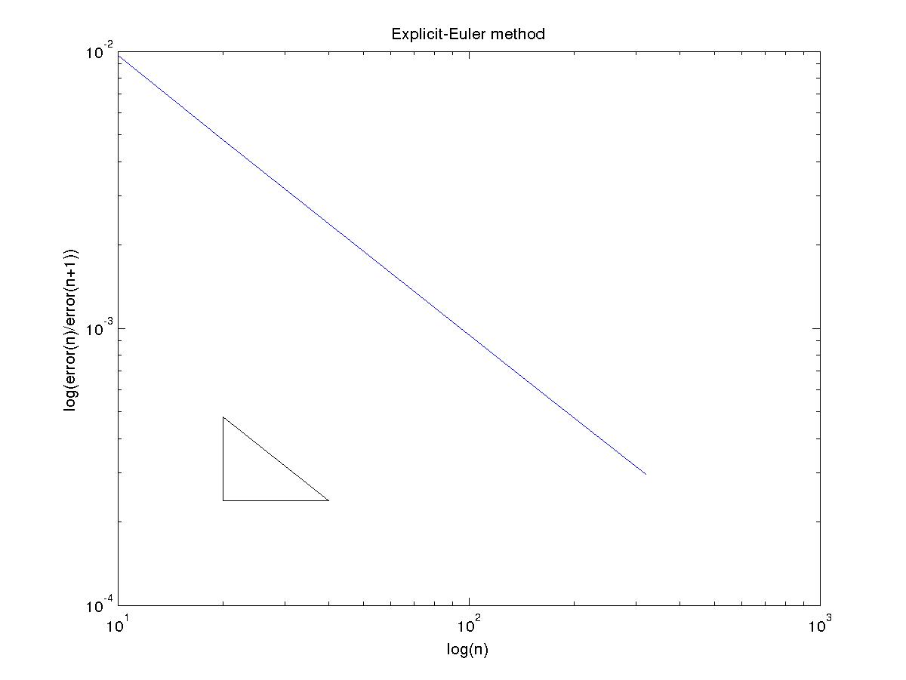

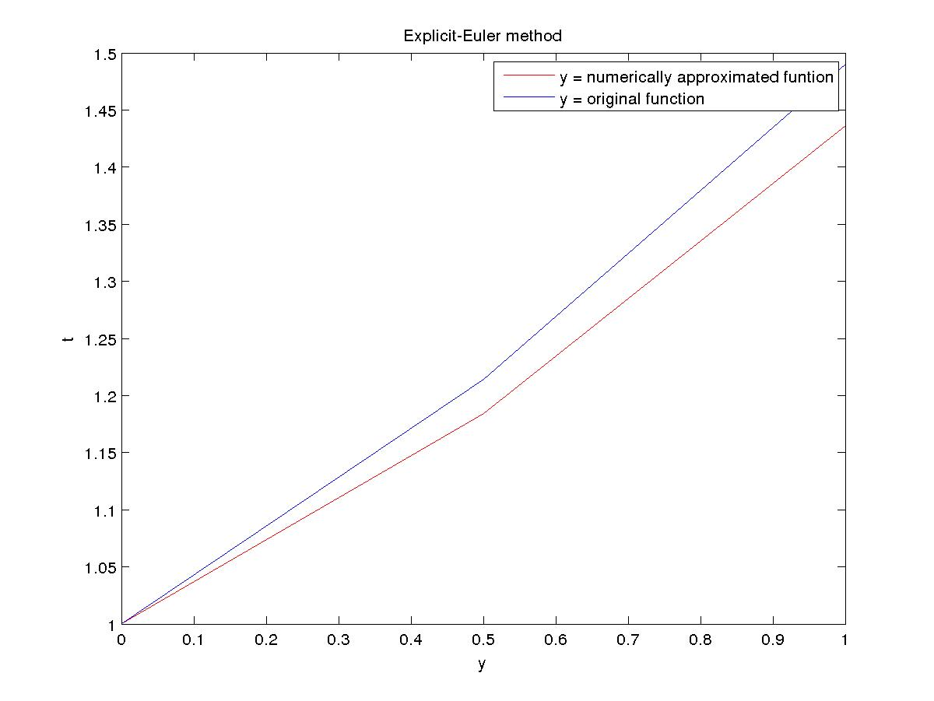

Implicit-Euler method

N Error Order
10 9.272210e-03 0.983620
20 4.689043e-03 0.991732
40 2.357996e-03 0.995847
80 1.182397e-03 0.997918
160 5.920521e-04 0.998958

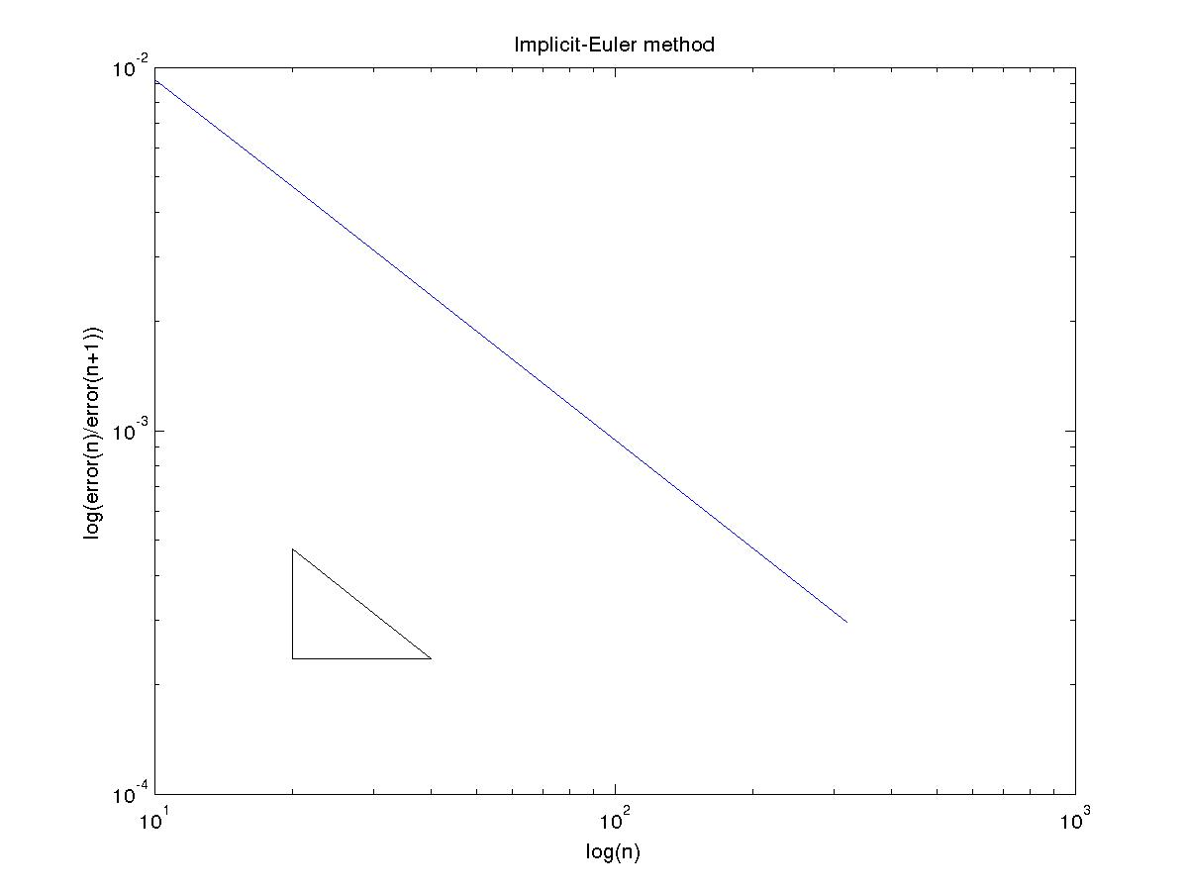
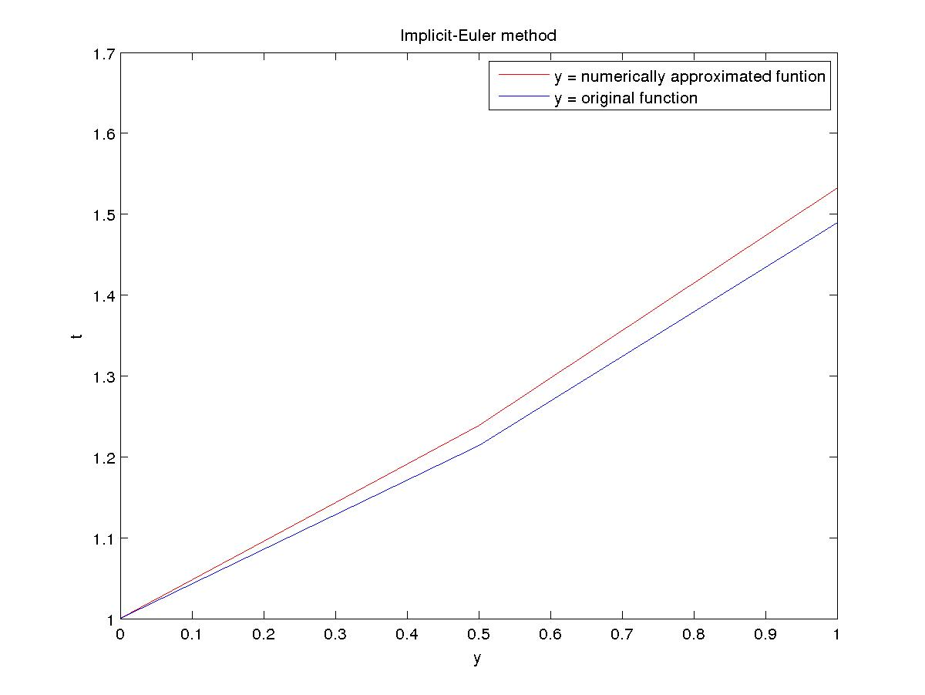

Modified-Euler (trapezoid) method

N Error Order
10 1.258717e-05 2.001433
20 3.143670e-06 1.998869
40 7.865335e-07 1.999899
80 1.966472e-07 1.999883
160 4.916579e-08 1.999991

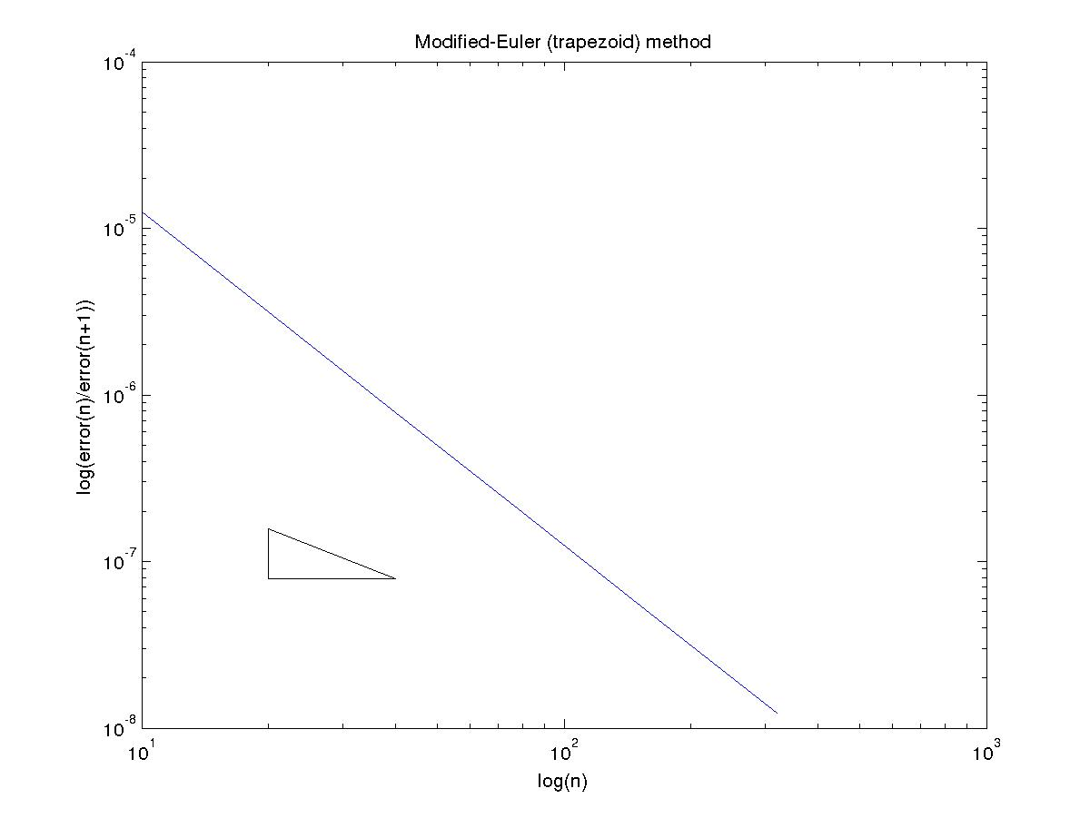

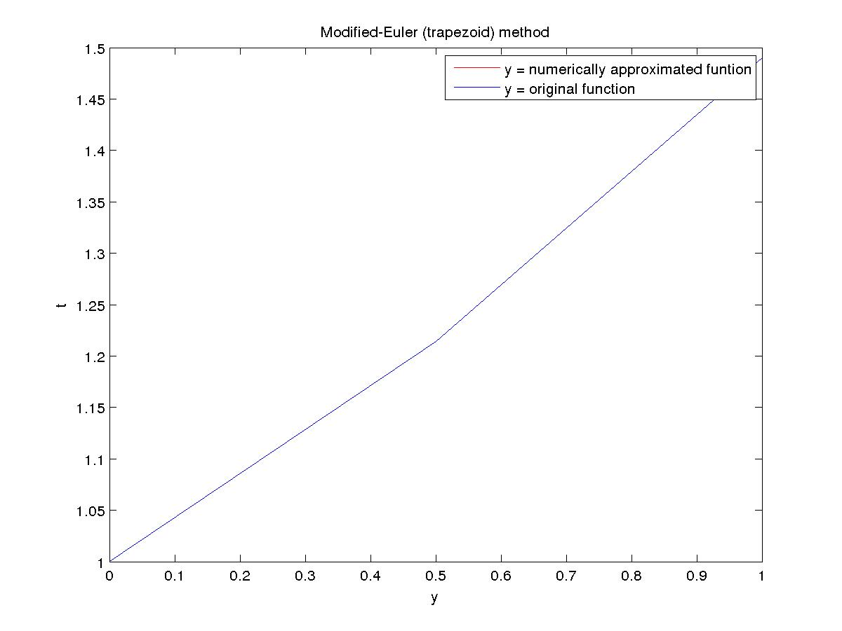

Midpoint method

N Error Order
10 1.186375e-04 2.000333
20 2.965253e-05 2.000084
40 7.412698e-06 2.000018
80 1.853151e-06 1.999998
160 4.632884e-07 2.000008

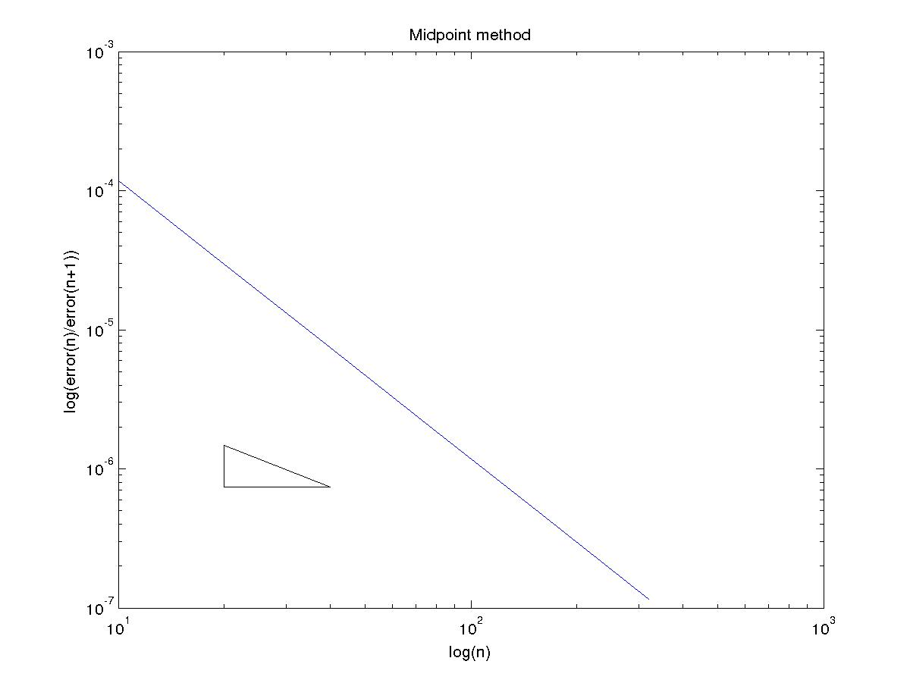
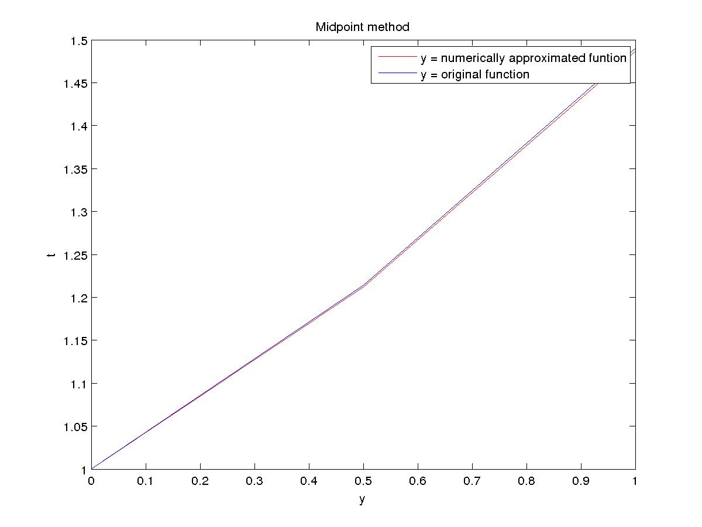

Runge Kutta 2th Order (Optimal) method

N Error Order
10 1.641263e-04 2.026594
20 4.028213e-05 2.013296
40 9.978148e-06 2.006647
80 2.483070e-06 2.003323
160 6.193394e-07 2.001661

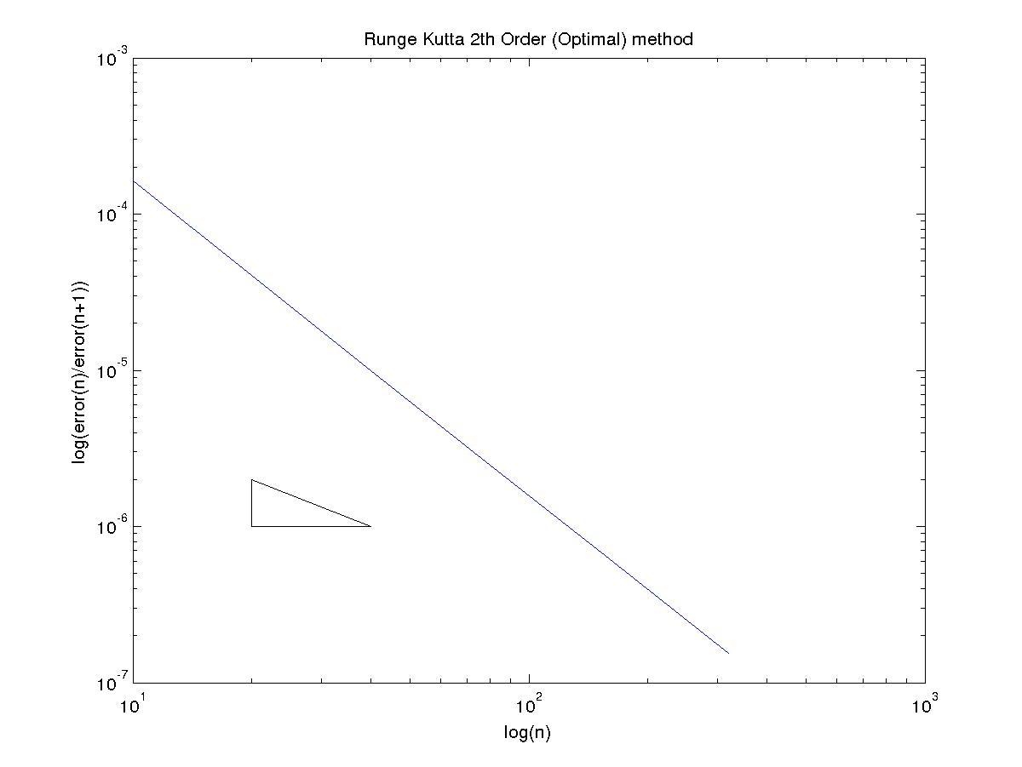

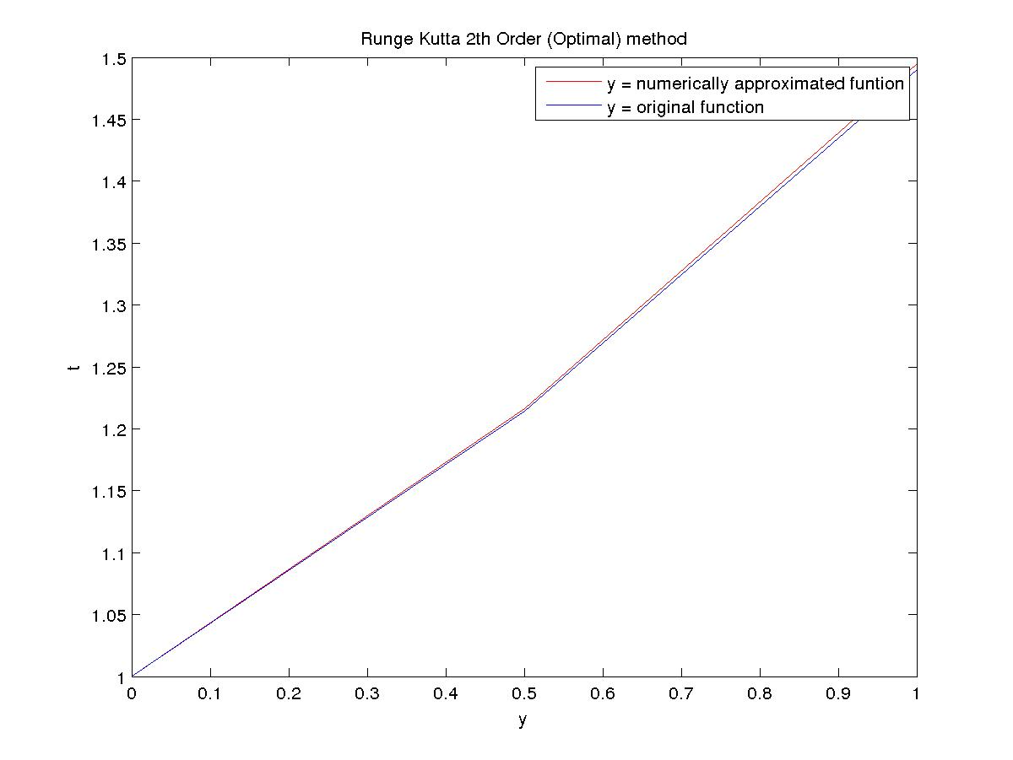

Runge Kutta 4th Order method

N Error Order
10 5.643600e-08 4.029736
20 3.455292e-09 4.014998
40 2.137224e-10 4.007514
80 1.328826e-11 4.005918
160 8.271162e-13 3.986508

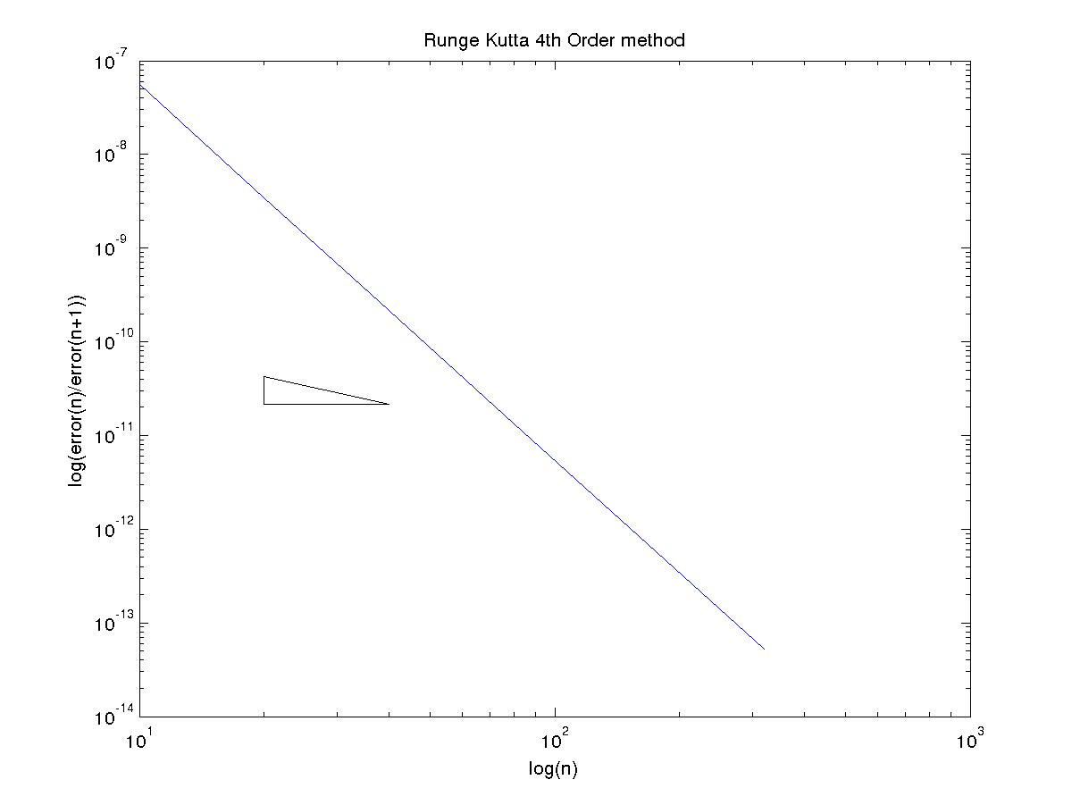
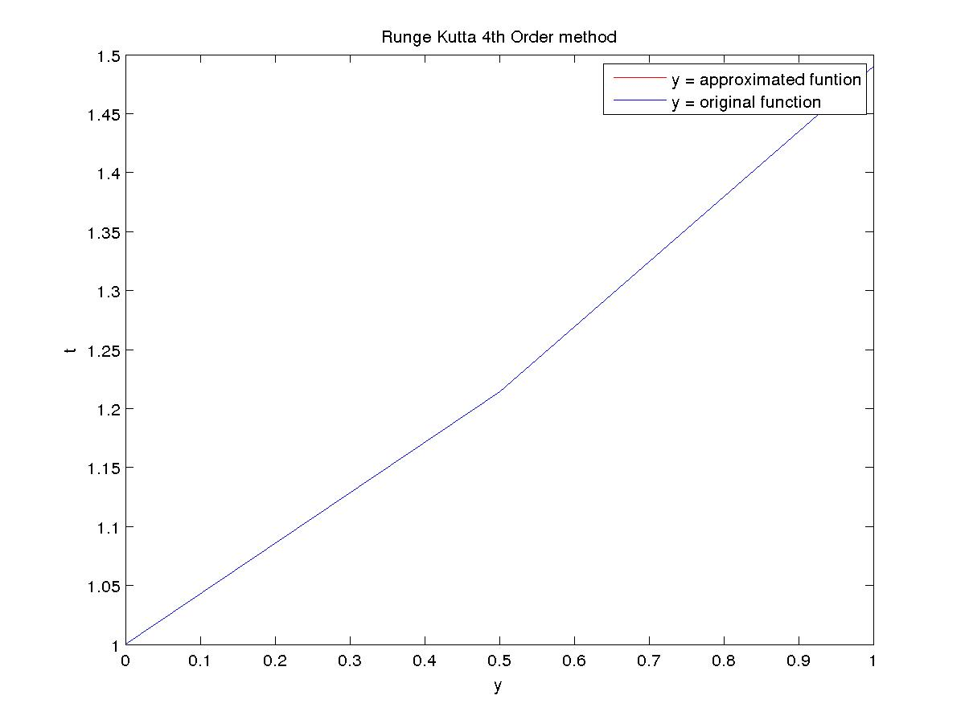

Question 2
Runge Kutta 4th Order method
Max-error = 5.167121e-02

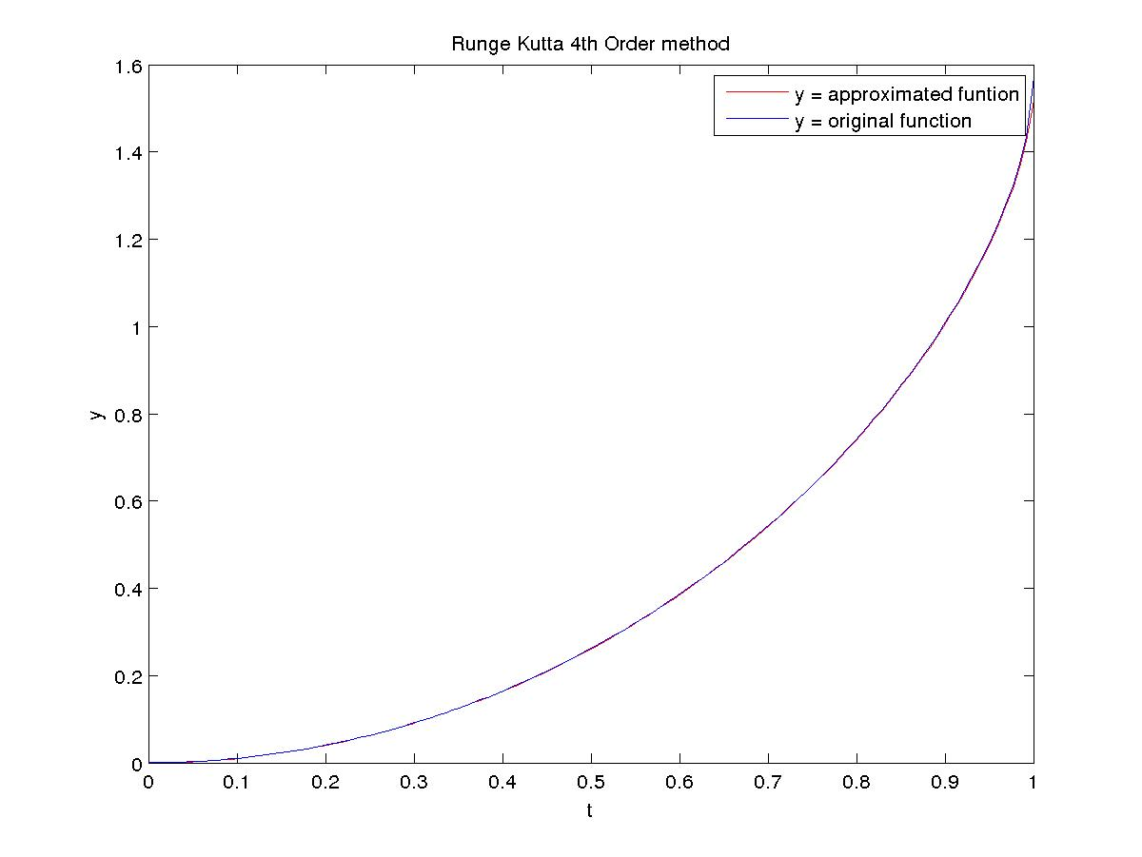

Question 3
Runge Kutta 4th Order method
After 0.200000 seconds amount of KOH formed = 2.079409e+03

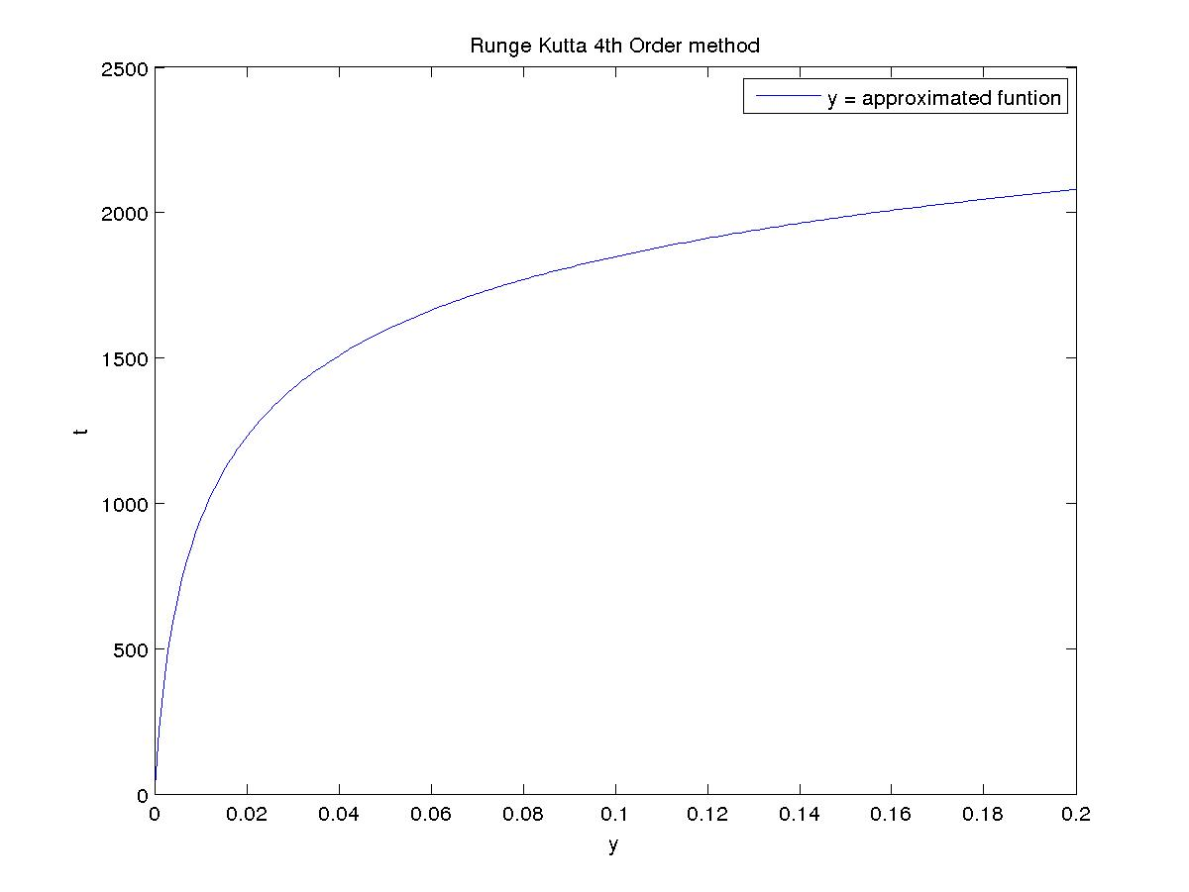

Question 4
(A)
Using exact starting values
Adams-Bashford method

N Error Order
10 1.450997e-03 4.127114
20 8.303887e-05 4.155690
40 4.659016e-06 4.106124
80 2.705377e-07 4.061157
160 1.620681e-08 4.032912
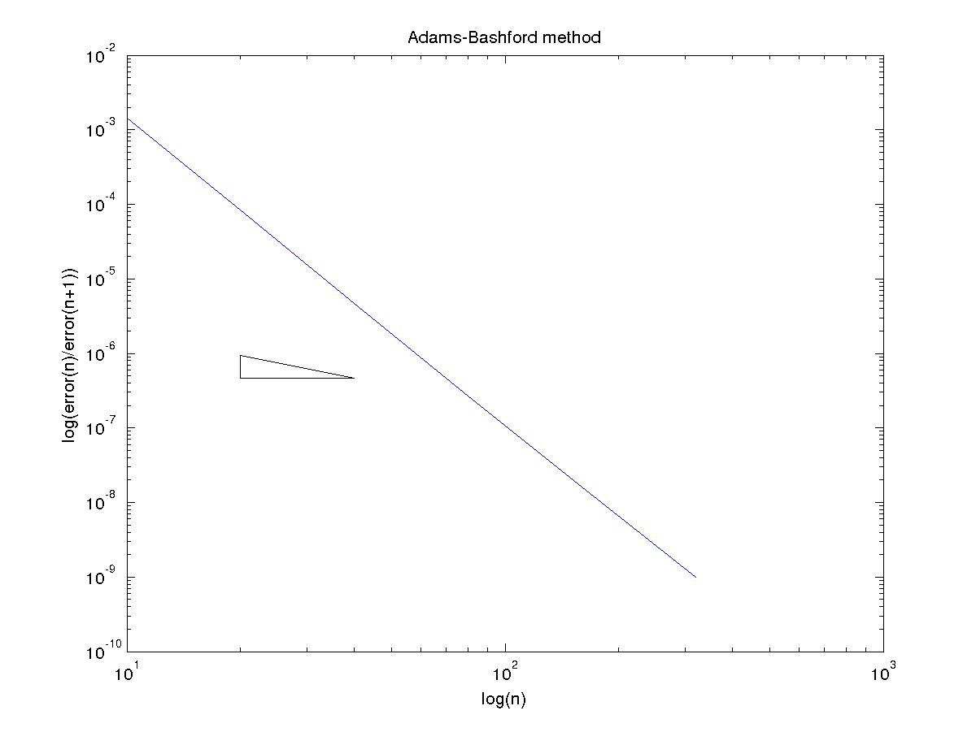

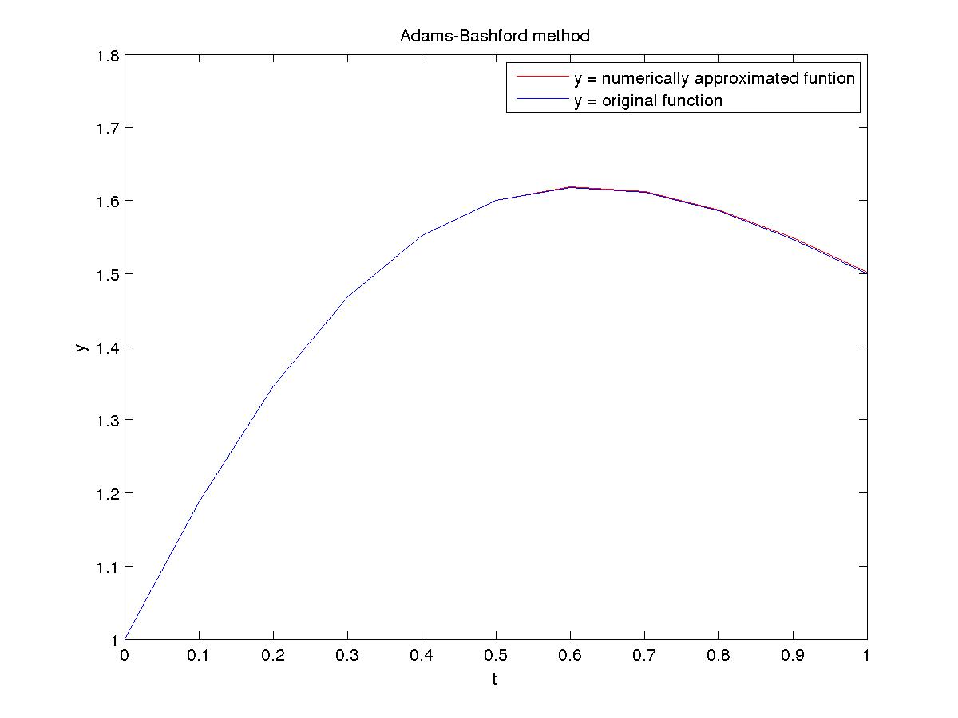
Adams-Moulton method

N Error Order
10 1.099951e-04 4.168575
20 6.116562e-06 4.147725
40 3.450783e-07 4.094071
80 2.020596e-08 4.051972
160 1.218188e-09 4.027468

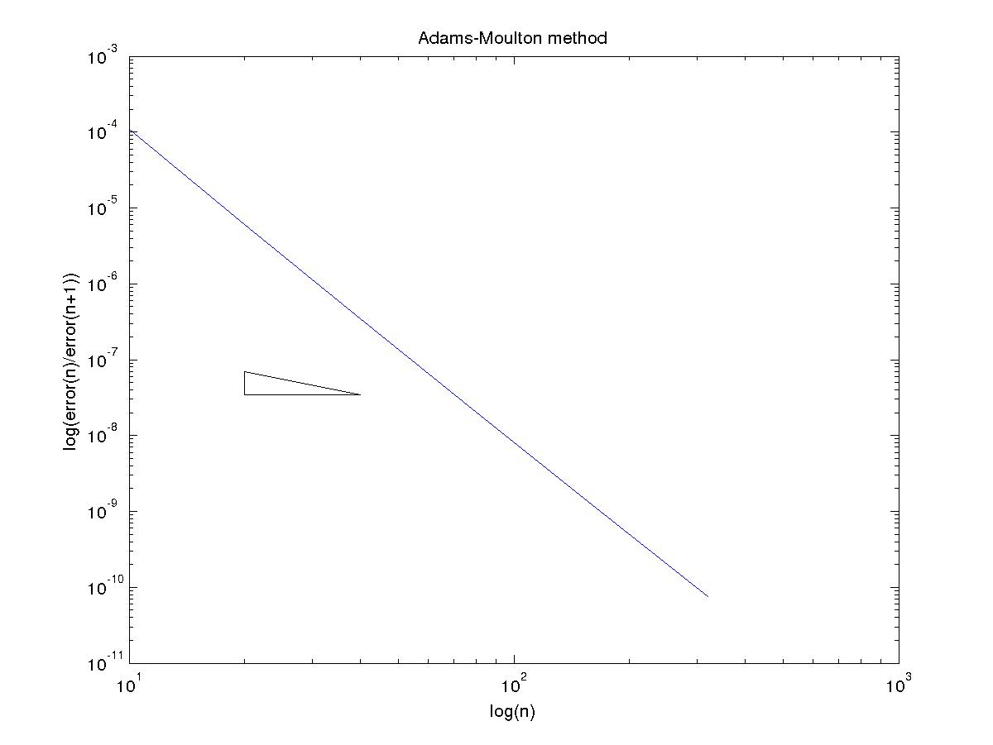
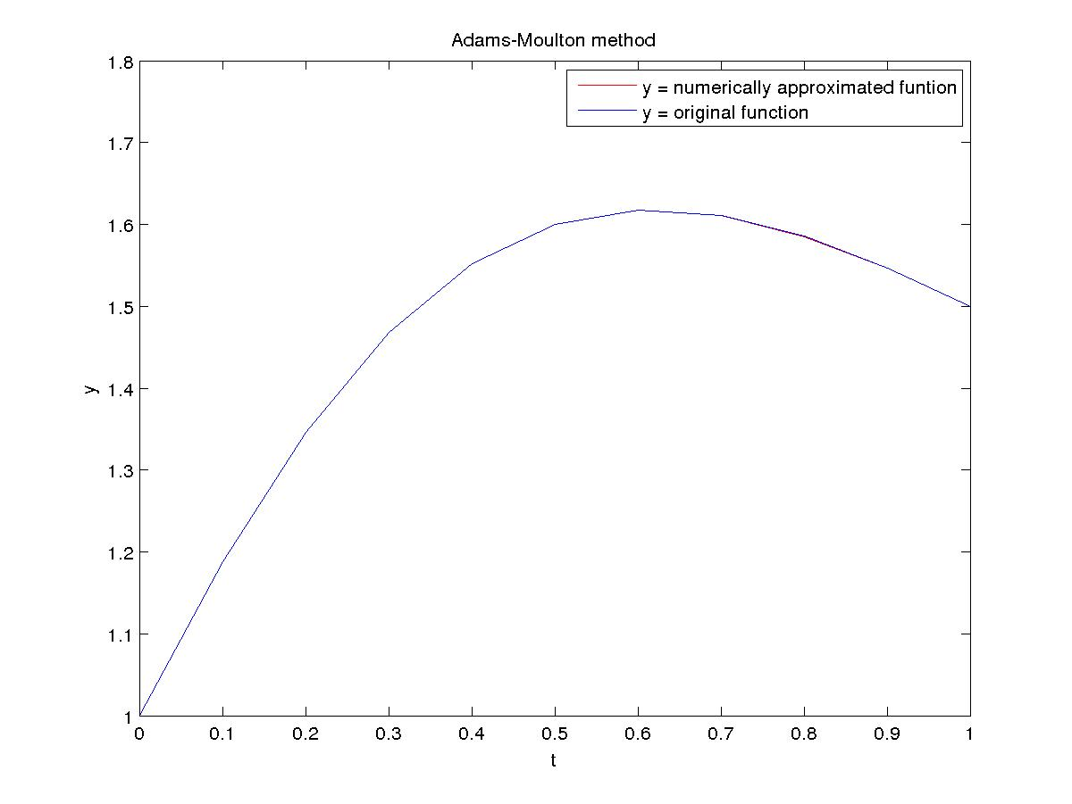

Using starting values from Runge-Kutta 4th order
Adams-Bashford method

N Error Order
10 1.450657e-03 4.126865
20 8.303378e-05 4.155623
40 4.658946e-06 4.106107
80 2.705367e-07 4.061153
160 1.620680e-08 4.032911

Adams-Moulton method

N Error Order
10 1.101454e-04 4.170044
20 6.118685e-06 4.148101
40 3.451081e-07 4.094164
80 2.020640e-08 4.051996
160 1.218195e-09 4.027475

(B)
Using exact starting values
Adams-Bashford method

N Error Order
10 2.079273e-02 2.868599
20 2.846933e-03 3.355458
40 2.781530e-04 3.596418
80 2.299608e-05 3.777475
160 1.676952e-06 3.884273

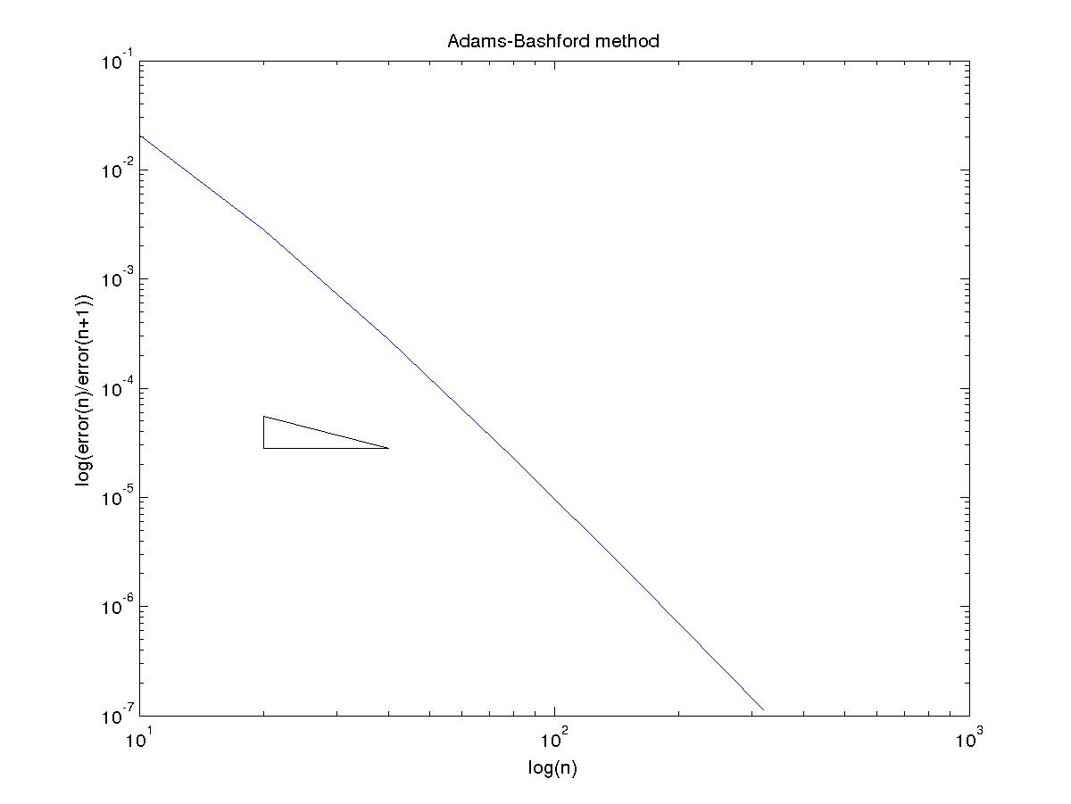

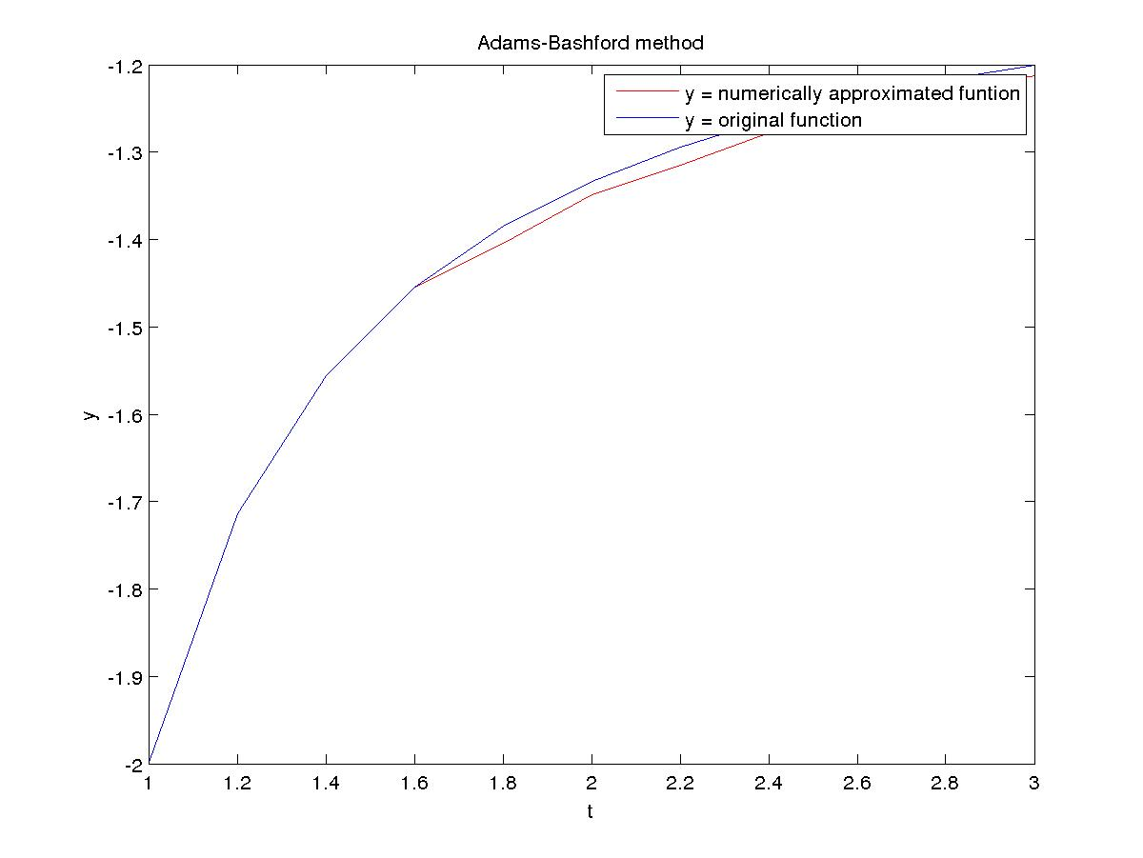

Adams-Moulton method

N Error Order
10 1.732877e-03 2.910375
20 2.304930e-04 3.350827
40 2.259219e-05 3.637163
80 1.815779e-06 3.806457
160 1.297793e-07 3.899485

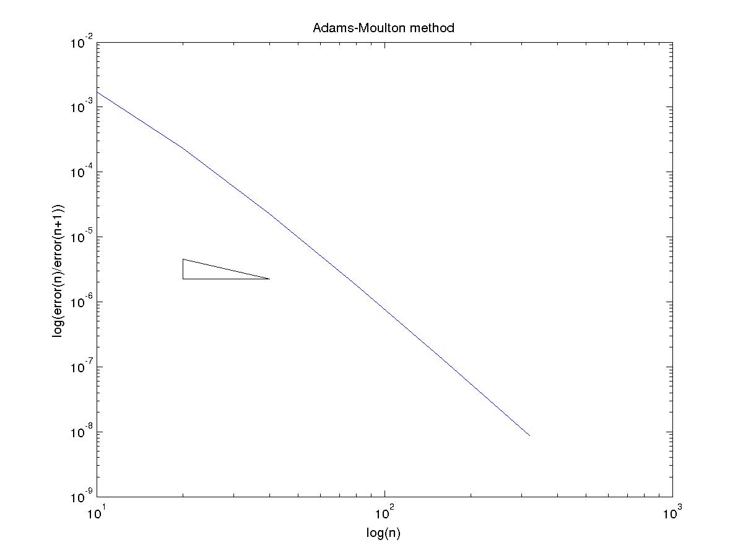
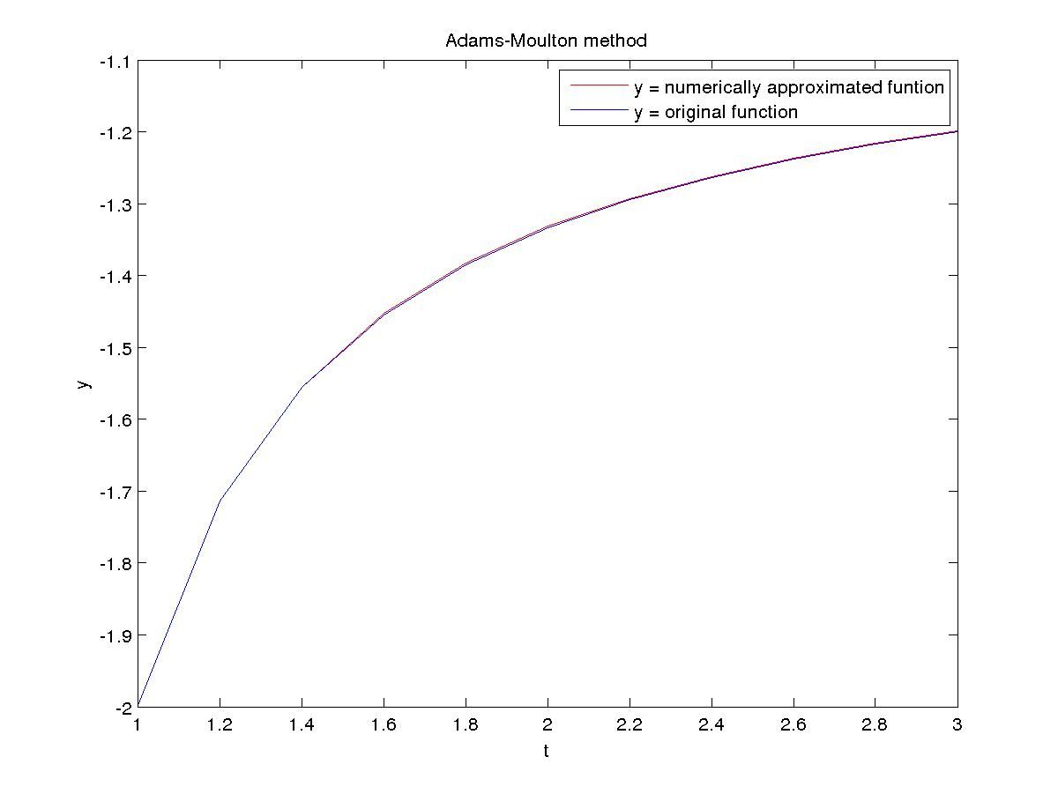

Using starting values from Runge-Kutta 4th order
Adams-Bashford method

N Error Order
10 2.078609e-02 2.868283
20 2.846647e-03 3.355268
40 2.781617e-04 3.596395
80 2.299718e-05 3.777495
160 1.677009e-06 3.884293

Adams-Moulton method

N Error Order
10 1.753780e-03 2.925572
20 2.308289e-04 3.353440
40 2.258418e-05 3.637345
80 1.814907e-06 3.806221
160 1.297381e-07 3.899287

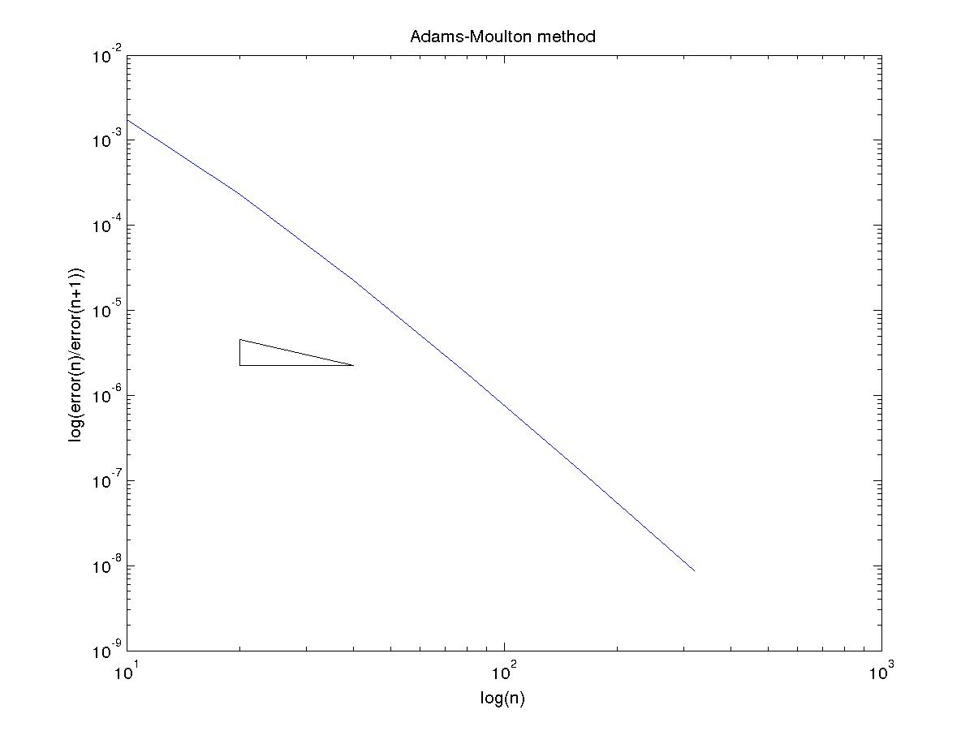

(C)
Using exact starting values
Adams-Bashford method

N Error Order
10 1.510053e-02 3.169750
20 1.678040e-03 3.543827
40 1.438812e-04 3.750966
80 1.068688e-05 3.868520
160 7.316616e-07 3.932281

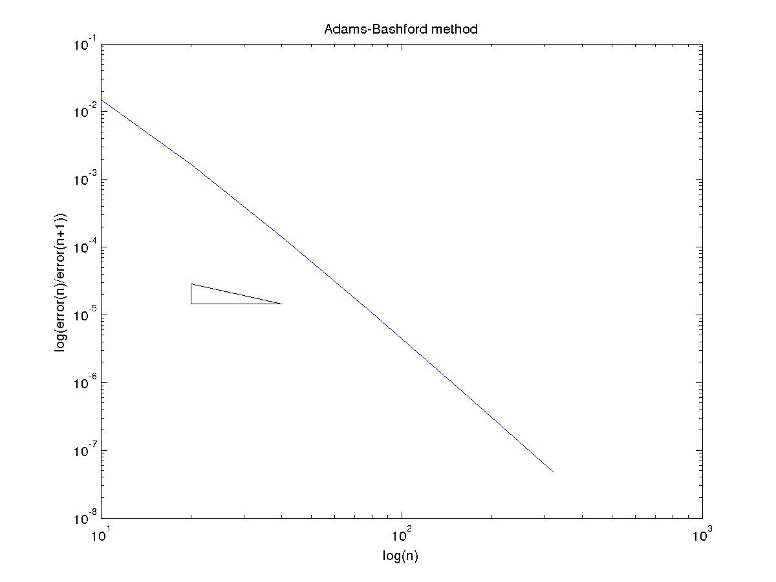

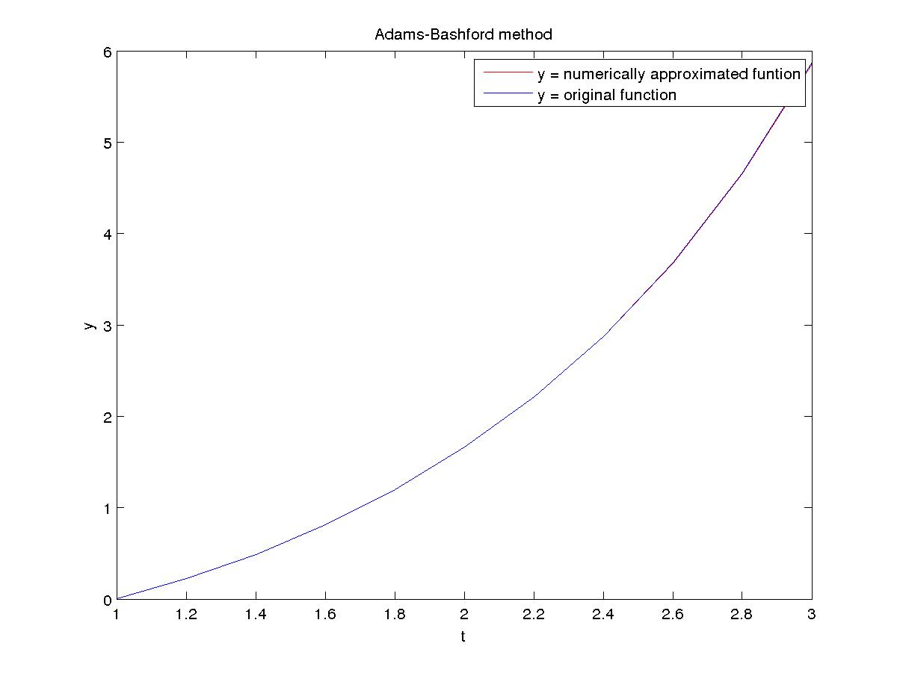

Adams-Moulton method

N Error Order
10 1.792123e-03 3.501697
20 1.582165e-04 3.698841
40 1.218399e-05 3.830313
80 8.565454e-07 3.912484
160 5.688205e-08 3.962129

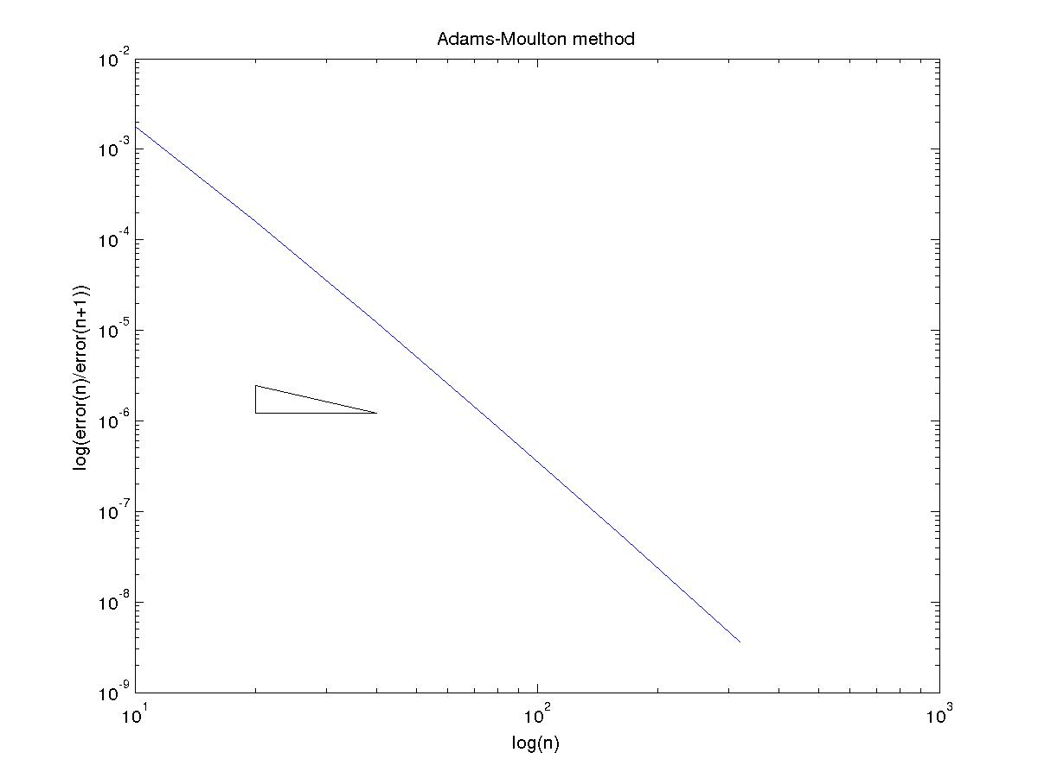
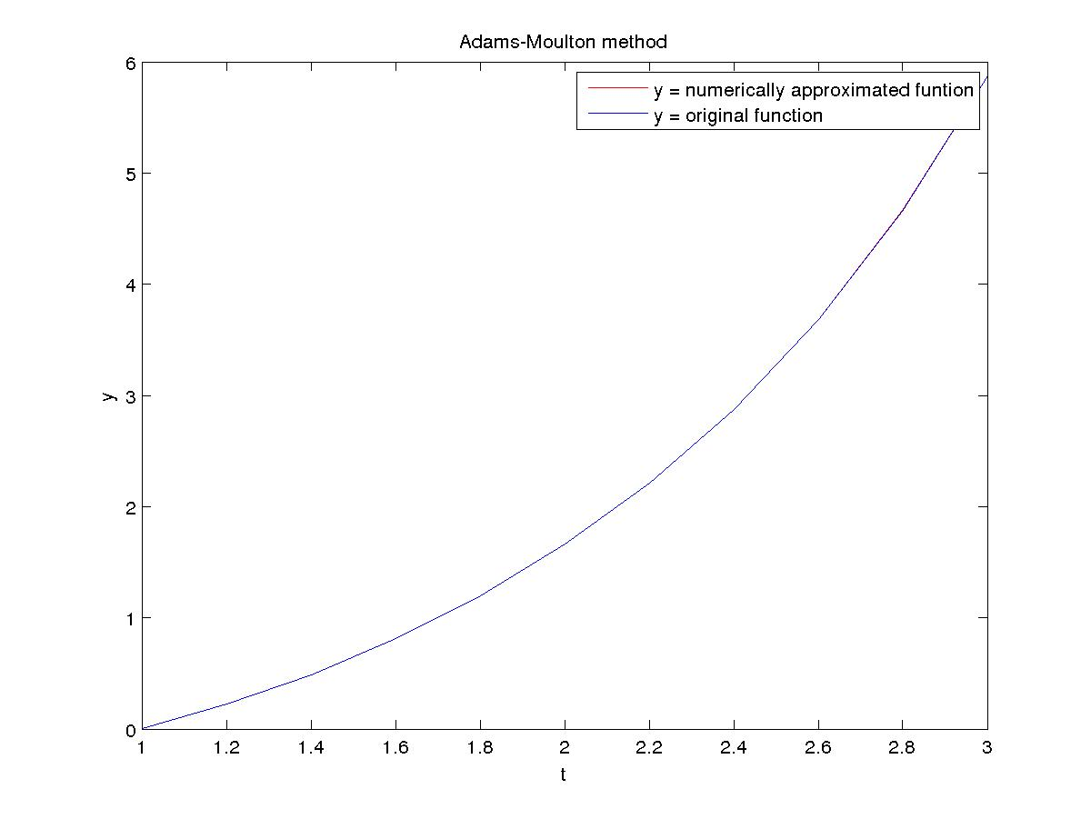

Using starting values from Runge-Kutta 4th order
Adams-Bashford method

N Error Order
10 1.510559e-02 3.172317
20 1.675619e-03 3.543296
40 1.437265e-04 3.750304
80 1.068028e-05 3.868101
160 7.314223e-07 3.932052

Adams-Moulton method

N Error Order
10 1.814826e-03 3.497032
20 1.607398e-04 3.706966
40 1.230879e-05 3.836923
80 8.613634e-07 3.916353
160 5.704882e-08 3.964189

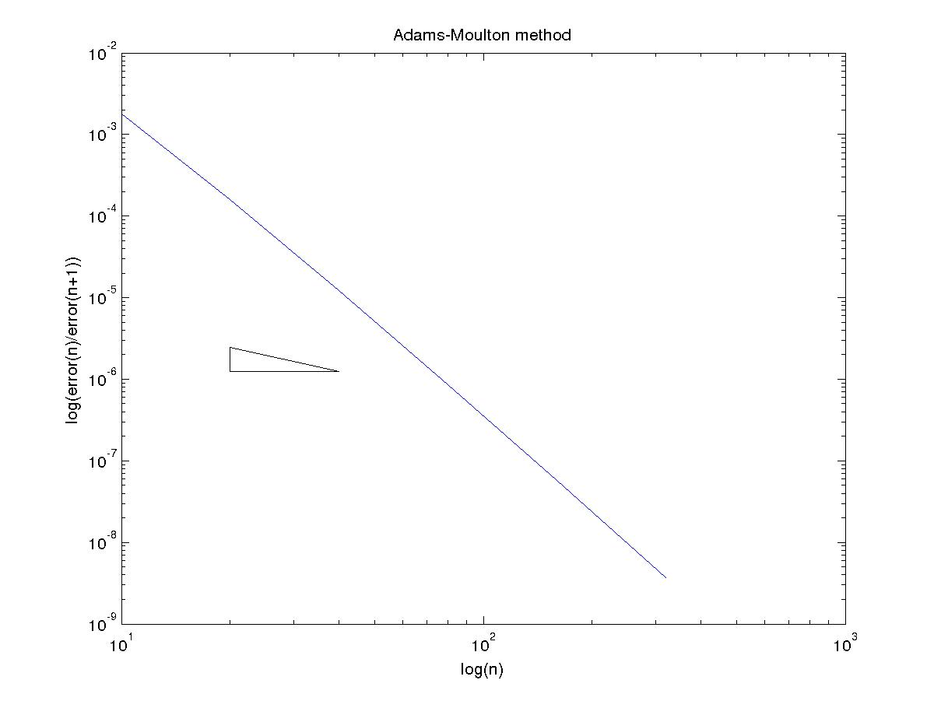

(D)
Using exact starting values
Adams-Bashford method

N Error Order
10 5.663556e-07 3.550004
20 4.835391e-08 3.805645
40 3.457948e-09 3.911109
80 2.298568e-10 3.956812
160 1.480260e-11 3.977859

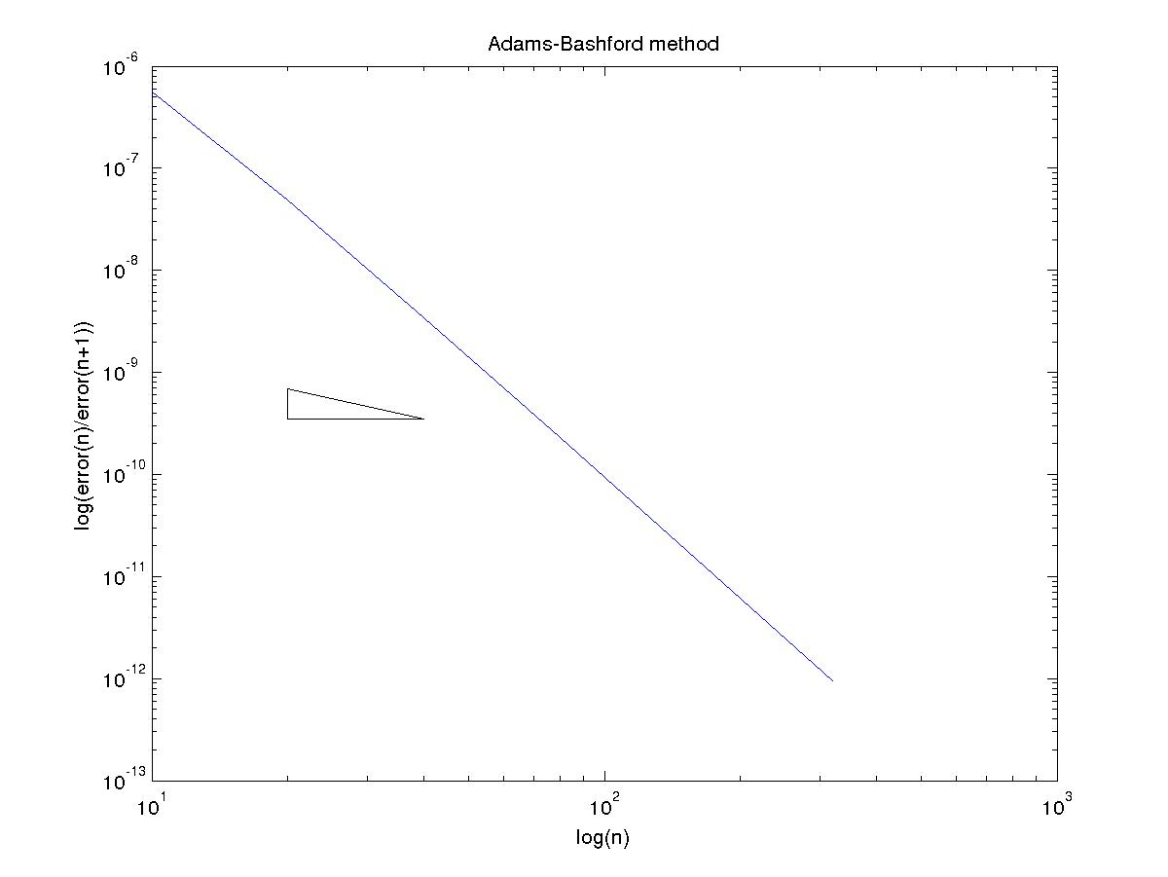

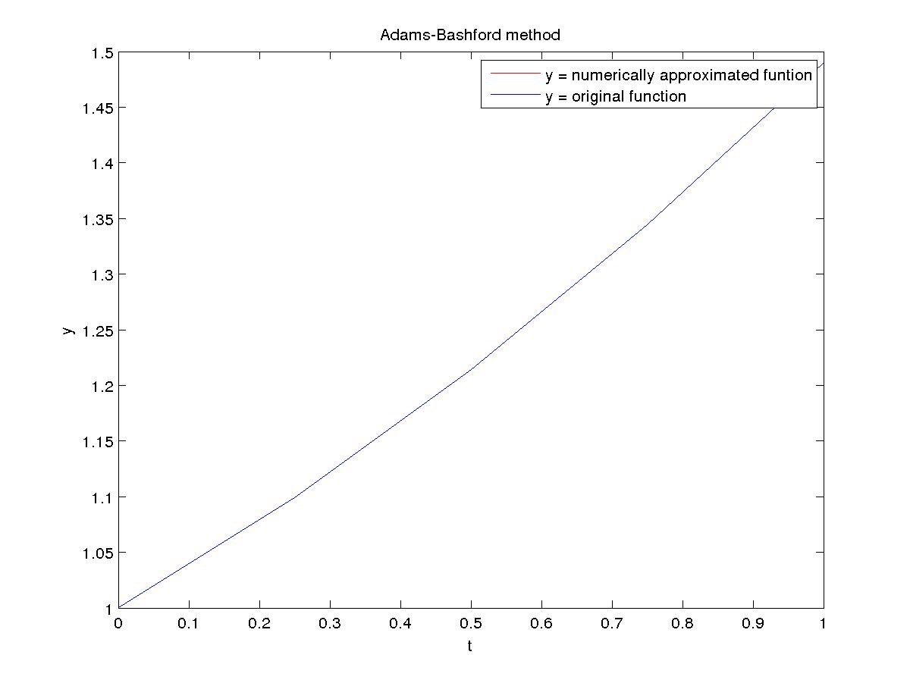

Adams-Moulton method

N Error Order
10 4.832447e-08 3.654039
20 3.838766e-09 3.845347
40 2.670710e-10 3.634761
80 2.150080e-11 3.976811
160 1.365574e-12 4.008942

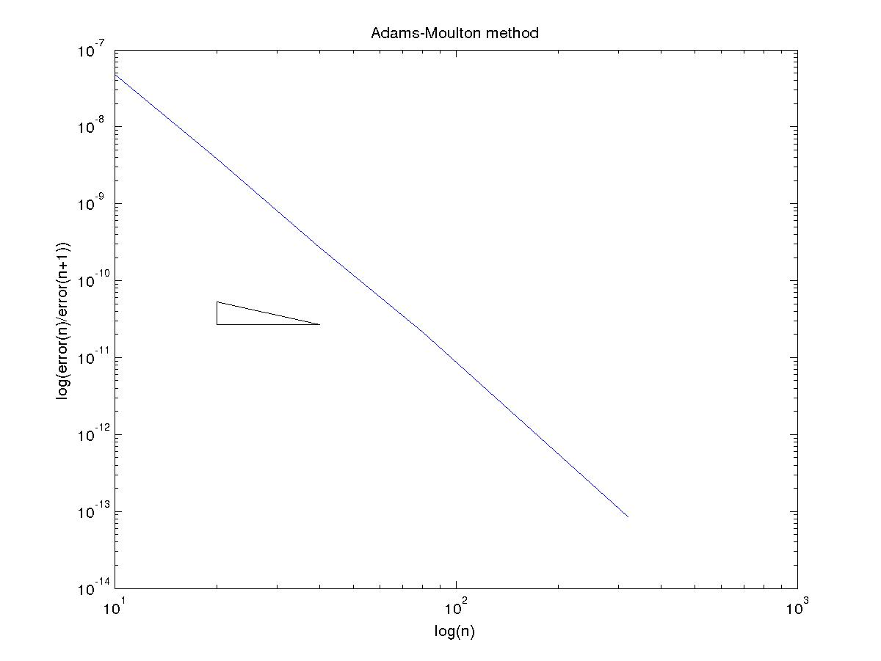
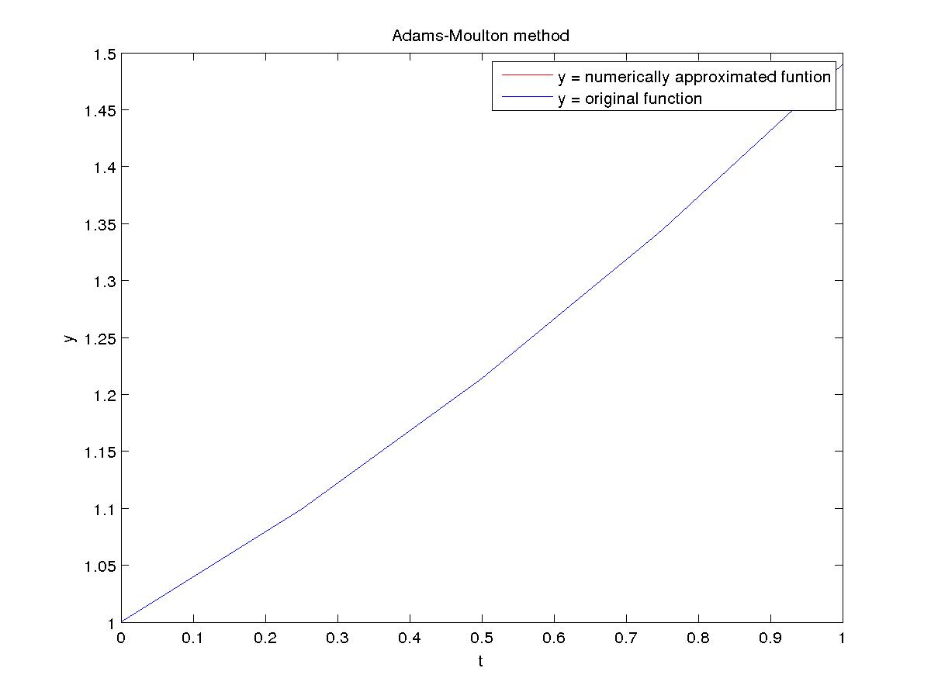

Using starting values from Runge-Kutta 4th order
Adams-Bashford method

N Error Order
10 5.781074e-07 3.569301
20 4.870145e-08 3.811686
40 3.468246e-09 3.913438
80 2.301694e-10 3.957886
160 1.481171e-11 3.978405

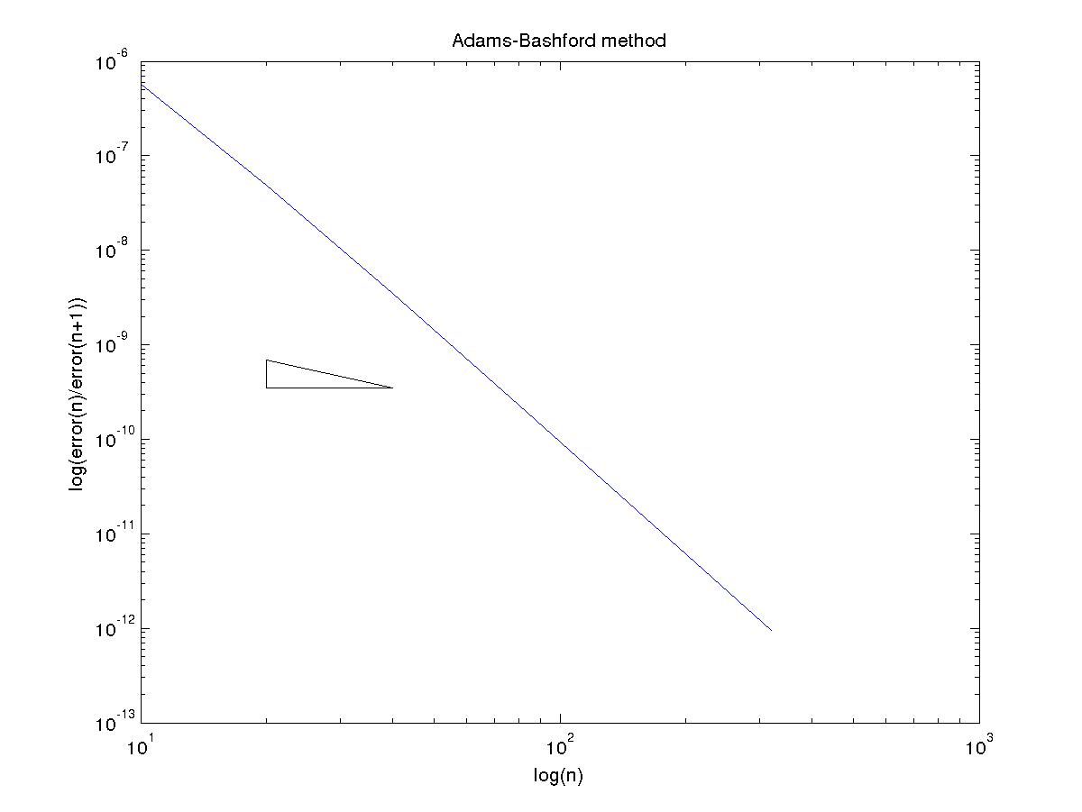

Adams-Moulton method

N Error Order
10 4.070670e-08 3.492774
20 3.616065e-09 3.796419
40 2.602556e-10 3.610879
80 2.130185e-11 3.969982
160 1.359357e-12 4.002359

