MA 374: Financial Engineering Lab
LAB 1 Report
Abheek Ghosh - 140123047

Question 1

Part 1

M European Call (initial price) European Put (initial price)
1 2.463367 1.816069
5 2.183245 1.535947
10 2.124835 1.477538
20 2.129583 1.482285
50 2.127215 1.479917
100 2.123667 1.476369
200 2.120209 1.472912
400 2.120065 1.472767

Part 2
(a)
The option prices converge with increase in M. As we can see in the V(0) vs M plot, that for small M the option value changes a lot with change in M, while for large M the option values change very less with change in M.

M increased in steps of 1

M European Call (initial price) European Put (initial price)
1 2.463367 1.816069
2 2.027777 1.380479
3 2.232984 1.585686
4 2.093211 1.445913
5 2.183245 1.535947
6 2.112539 1.465241
7 2.161837 1.514539
8 2.120739 1.473441
9 2.149955 1.502658
10 2.124835 1.477538
11 2.142407 1.495109
12 2.127061 1.479763
13 2.137188 1.489890
14 2.128318 1.481020
15 2.133366 1.486068
16 2.129026 1.481729
17 2.130447 1.483149
18 2.129407 1.482109
19 2.128144 1.480846
20 2.129583 1.482285
21 2.126281 1.478983
22 2.129627 1.482329
23 2.124743 1.477445
24 2.129584 1.482286
25 2.123452 1.476154
26 2.129483 1.482185
27 2.122352 1.475055
28 2.129344 1.482046
29 2.121405 1.474107
30 2.129178 1.481880
31 2.120580 1.473282
32 2.128996 1.481698
33 2.119856 1.472558
34 2.128803 1.481505
35 2.119214 1.471916
36 2.128604 1.481306
37 2.118642 1.471344
38 2.128402 1.481104
39 2.118129 1.470831
40 2.128199 1.480902
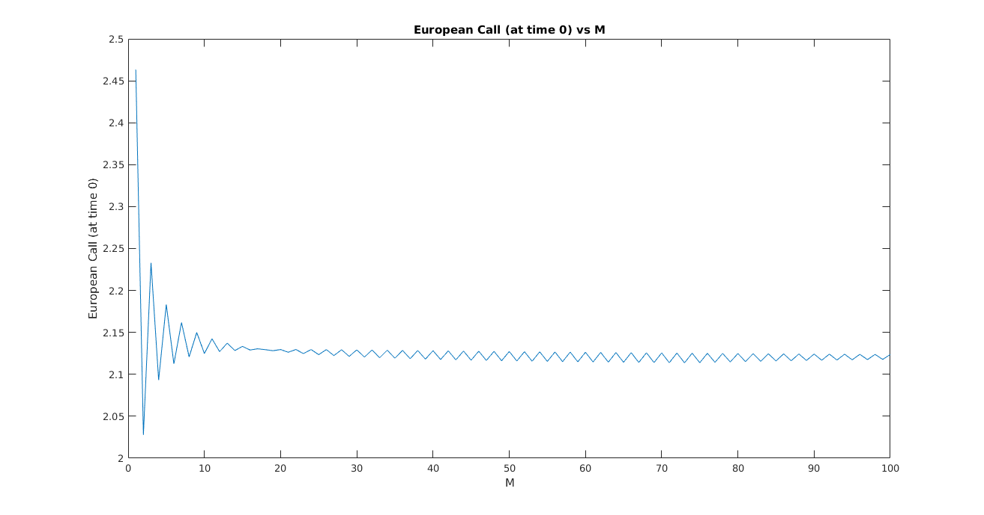
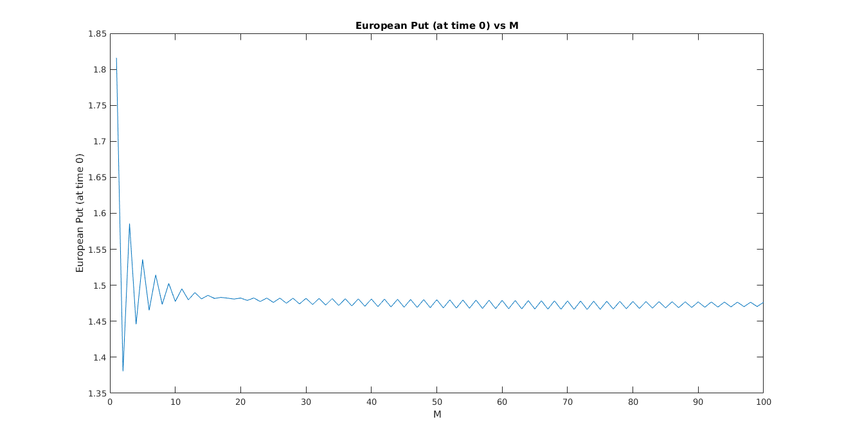

(b)
M increased in steps of 5

M European Call (initial price) European Put (initial price)
1 2.463367 1.816069
6 2.112539 1.465241
11 2.142407 1.495109
16 2.129026 1.481729
21 2.126281 1.478983
26 2.129483 1.482185
31 2.120580 1.473282
36 2.128604 1.481306
41 2.117666 1.470368
46 2.127600 1.480302
51 2.115896 1.468598
56 2.126668 1.479370
61 2.114707 1.467409
66 2.125839 1.478541
71 2.113854 1.466556
76 2.125107 1.477809
81 2.115135 1.467837
86 2.124458 1.477161
91 2.116780 1.469482
96 2.123881 1.476583
101 2.117983 1.470685
106 2.123362 1.476065
111 2.118878 1.471581
116 2.122895 1.475597
121 2.119555 1.472257
126 2.122470 1.475172
131 2.120069 1.472771
136 2.122082 1.474785
141 2.120463 1.473165
146 2.121727 1.474429
151 2.120765 1.473467
156 2.121399 1.474101
161 2.120996 1.473698
166 2.121095 1.473797
171 2.121171 1.473873
176 2.120813 1.473515
181 2.121301 1.474004
186 2.120550 1.473252
191 2.121397 1.474099
196 2.120304 1.473006

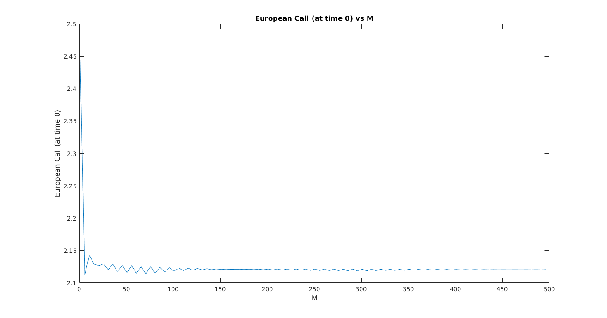
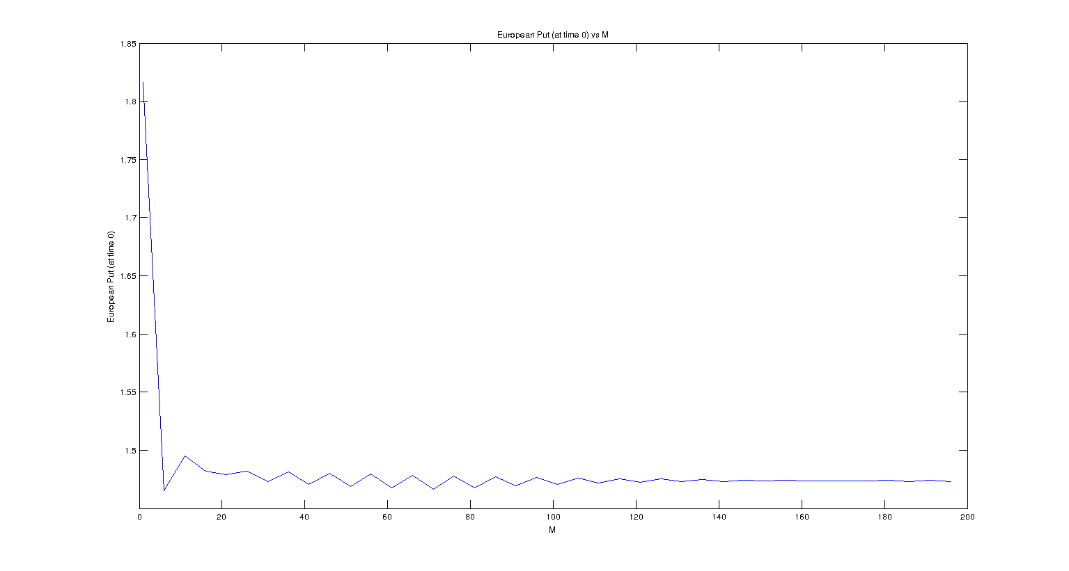

Part 3

M = 20

t (time) | European Call values at time t
0.000000 | 2.129583
0.300000 | 0.949239, 1.999168 ,3.724750
0.750000 | 0.159963, 0.487726, 1.211027, 2.544298, 4.675177, 7.740656
1.500000 | 0.000000, 0.001677, 0.021224, 0.127931, 0.493390, 1.385532, 3.071759, 5.717012, 9.393651, 14.186522, 20.279588
2.700000 | 0.000000, 0.460999, 2.145849, 5.095107, 8.997288, 13.920270, 20.131093, 27.966654, 37.851980, 50.323286, 66.057057

t (time) | European Put values at time t
0.000000 | 1.482285
0.300000 | 2.287666, 1.462989, 0.823572
0.750000 | 3.805854, 2.801752, 1.844775, 1.058212, 0.514712, 0.206202
1.500000 | 6.259199, 5.507445, 4.576464, 3.483989, 2.336561, 1.320049, 0.598321, 0.205705, 0.049775, 0.007484, 0.000522
2.700000 | 8.664051, 8.361236, 7.979206, 7.497237, 6.889186, 6.122070, 5.154278, 3.933315, 2.392950, 0.910628, 0.143787, 0.000000

