MA 374: Financial Engineering Lab
LAB 3 Report
Abheek Ghosh - 140123047

Question 1: American Call and Put Option

(a) S(0)

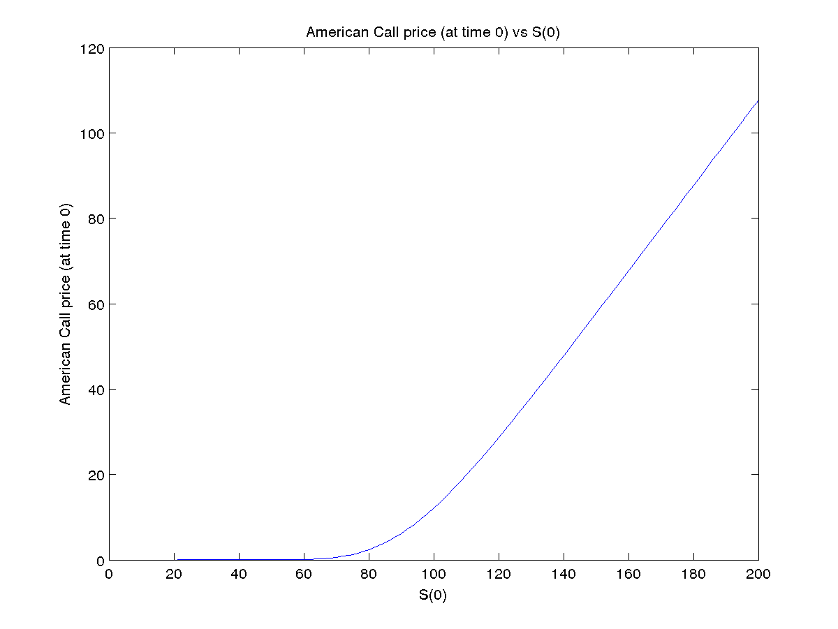
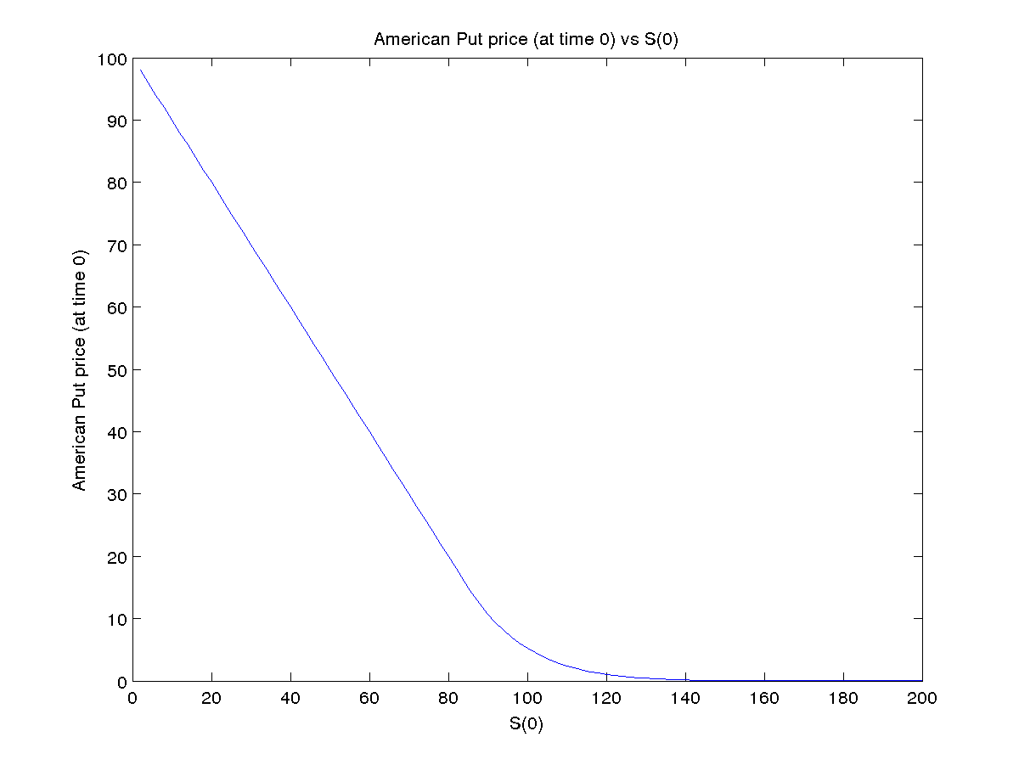
(B)
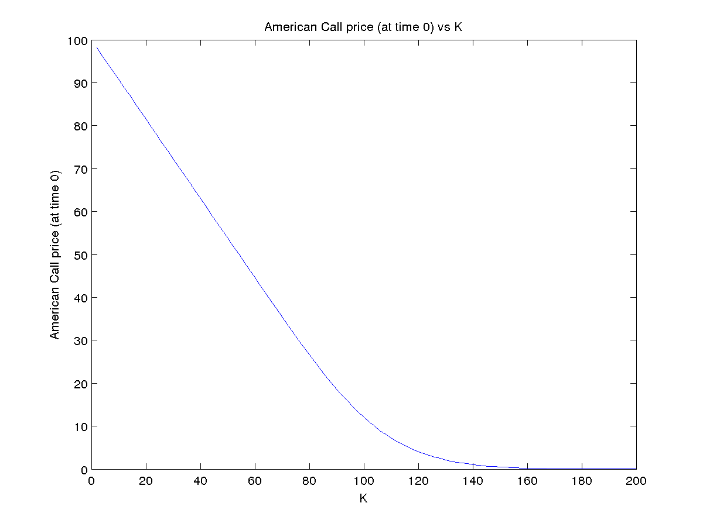
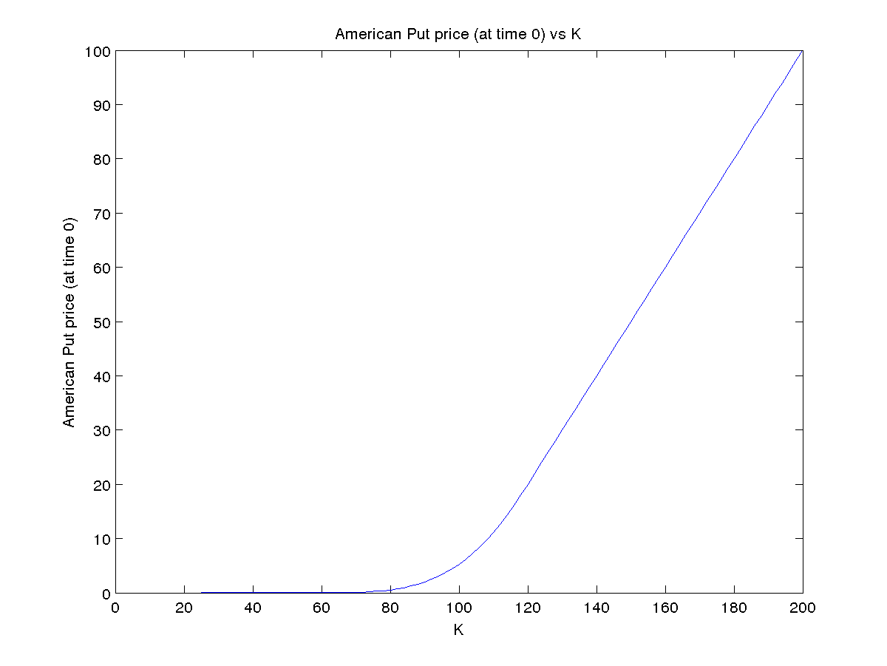
(c)
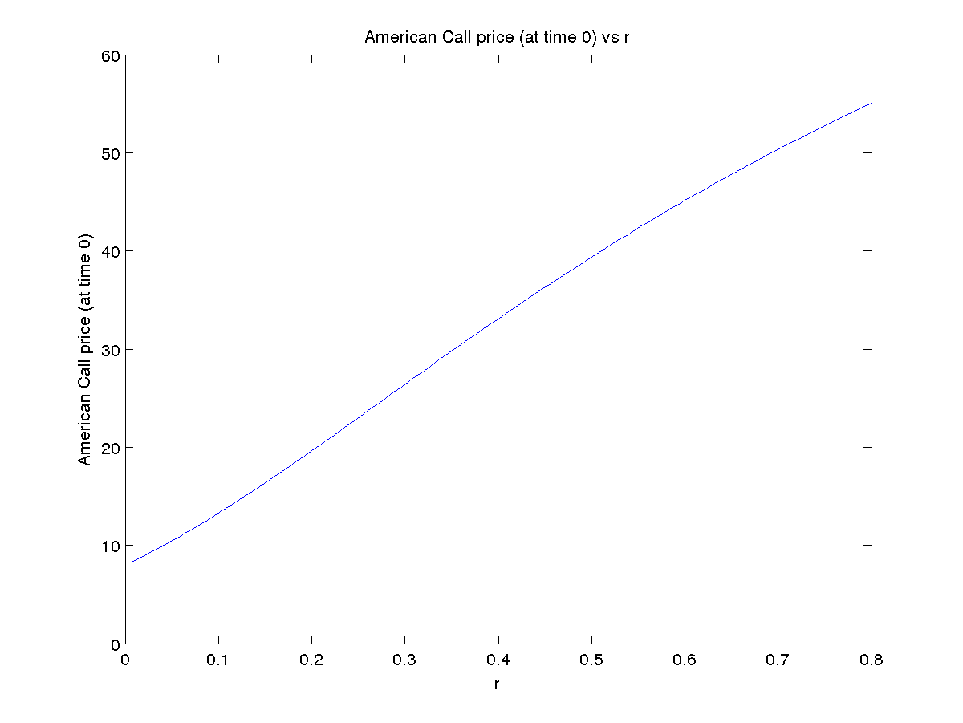
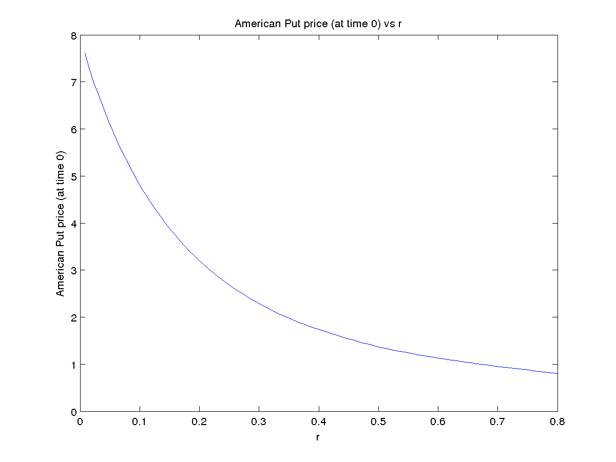
(d)
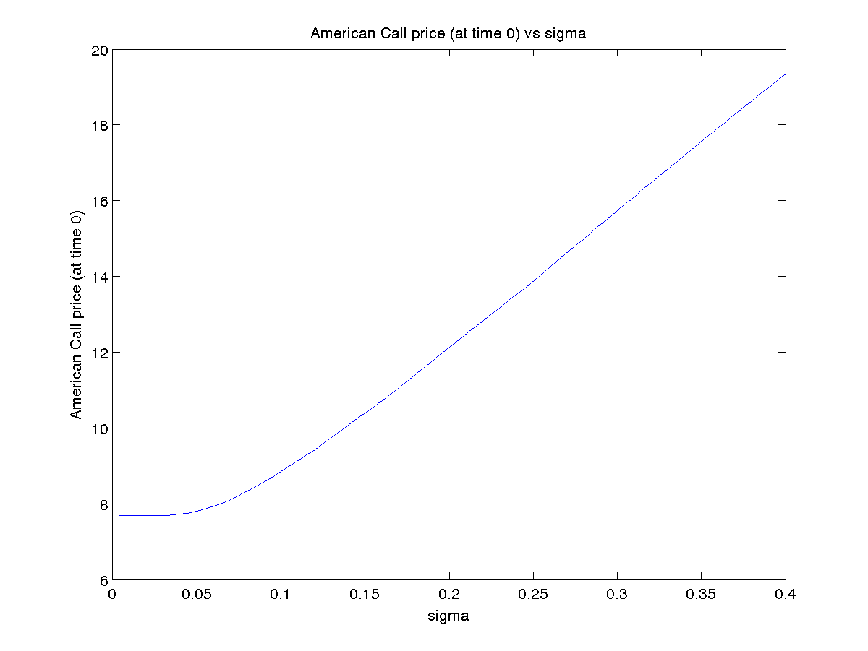
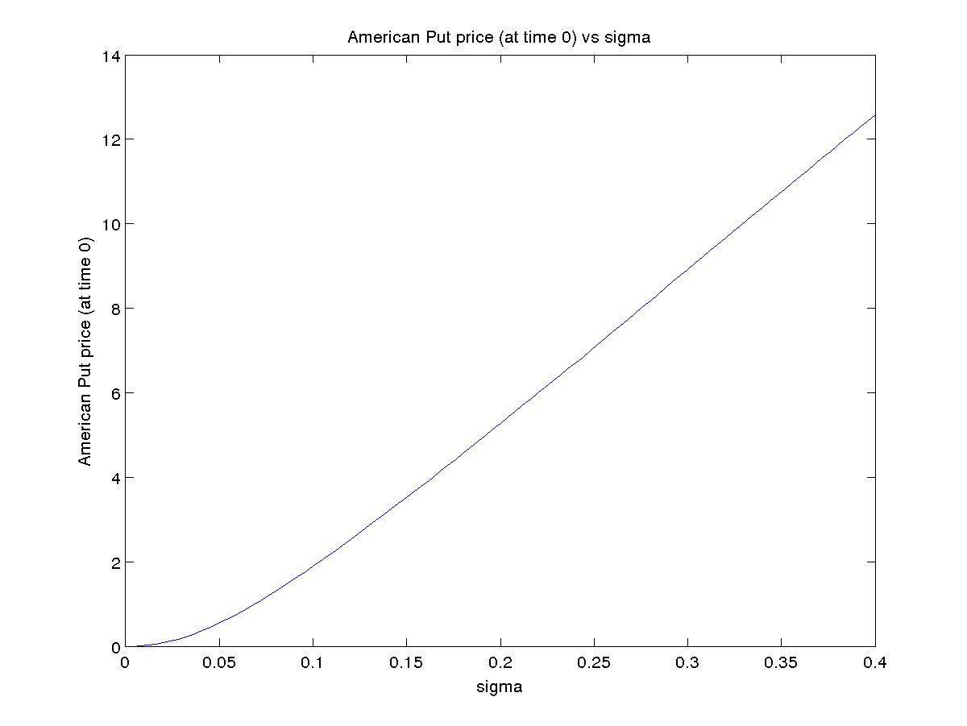
(e) K = 95
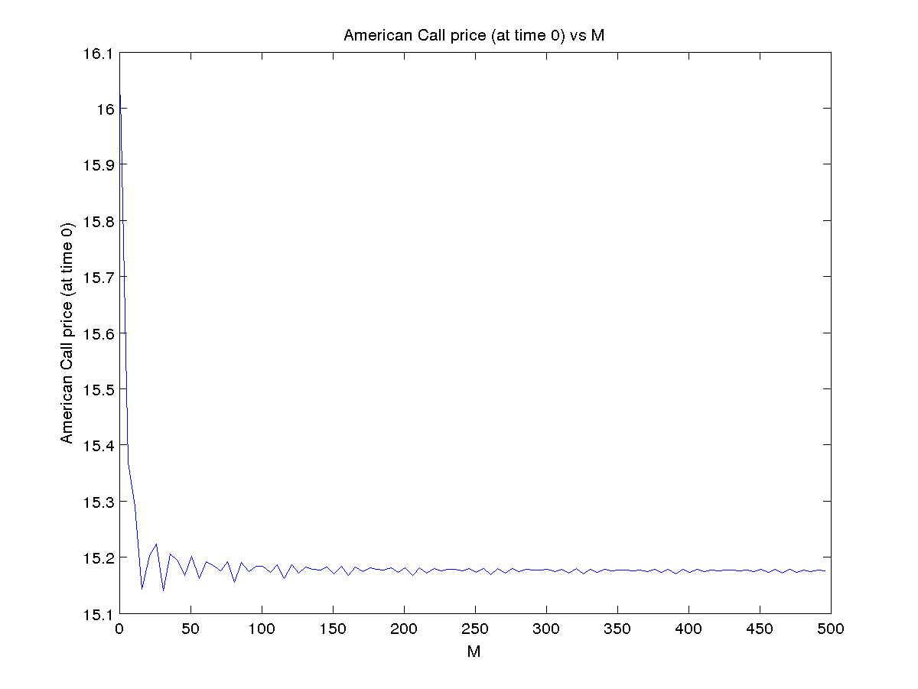
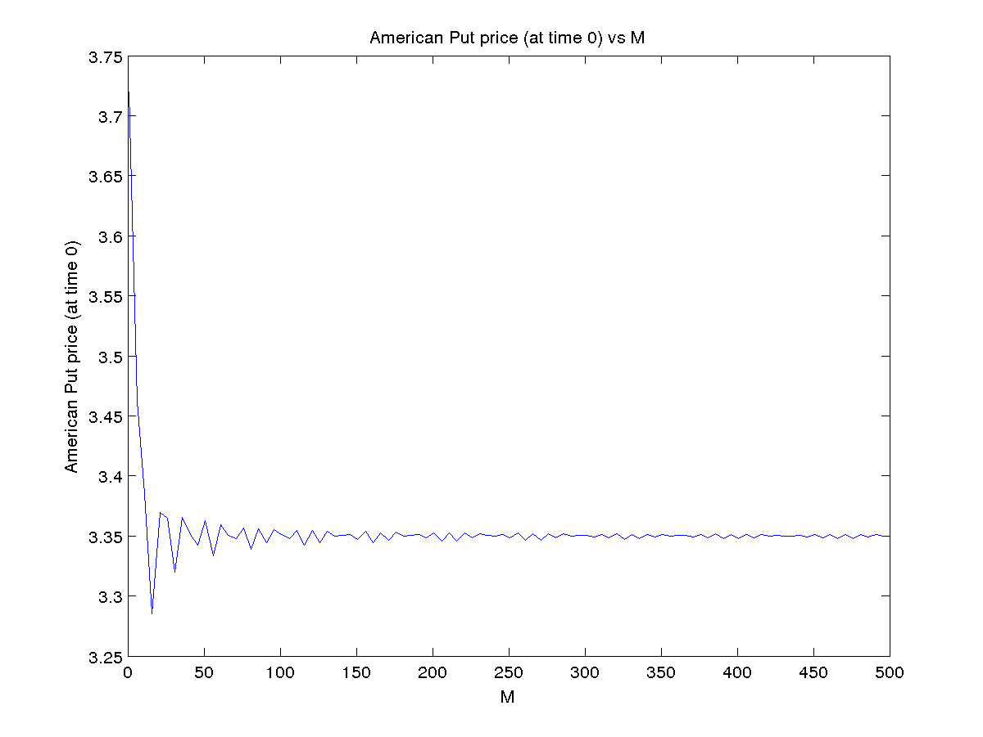

K = 100
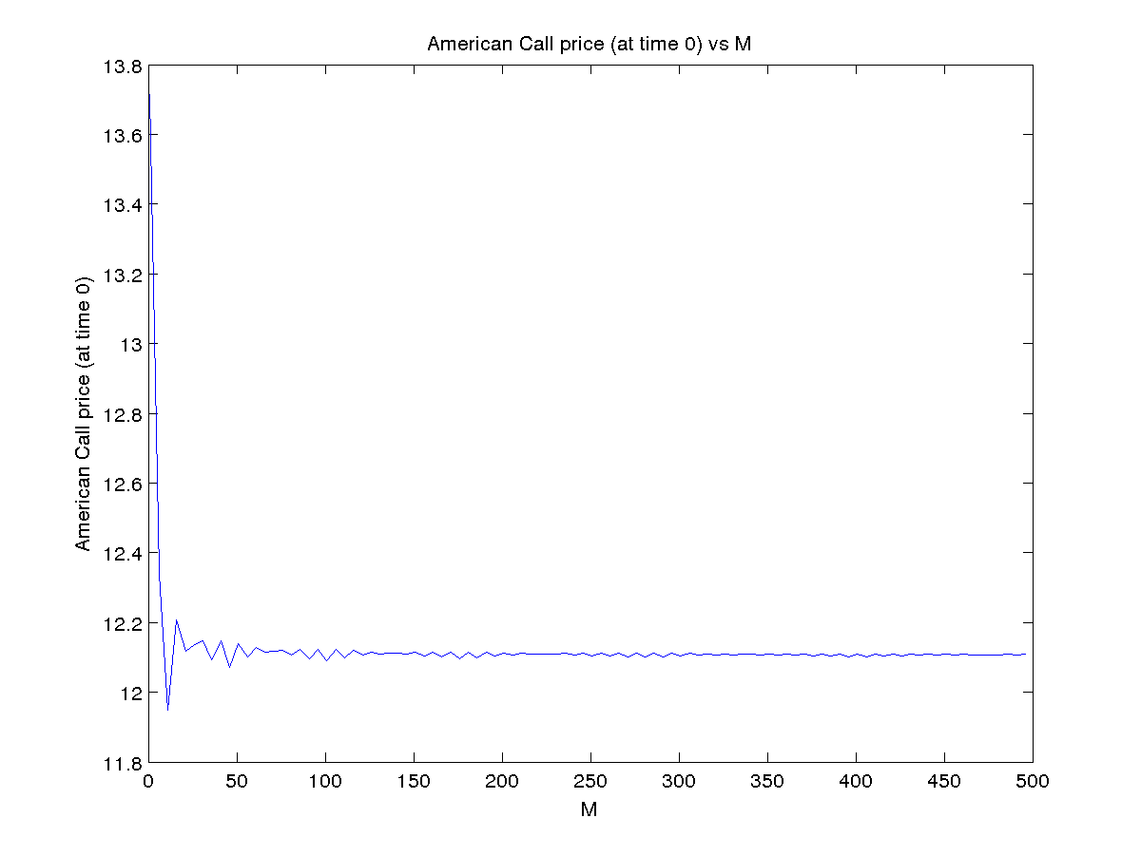
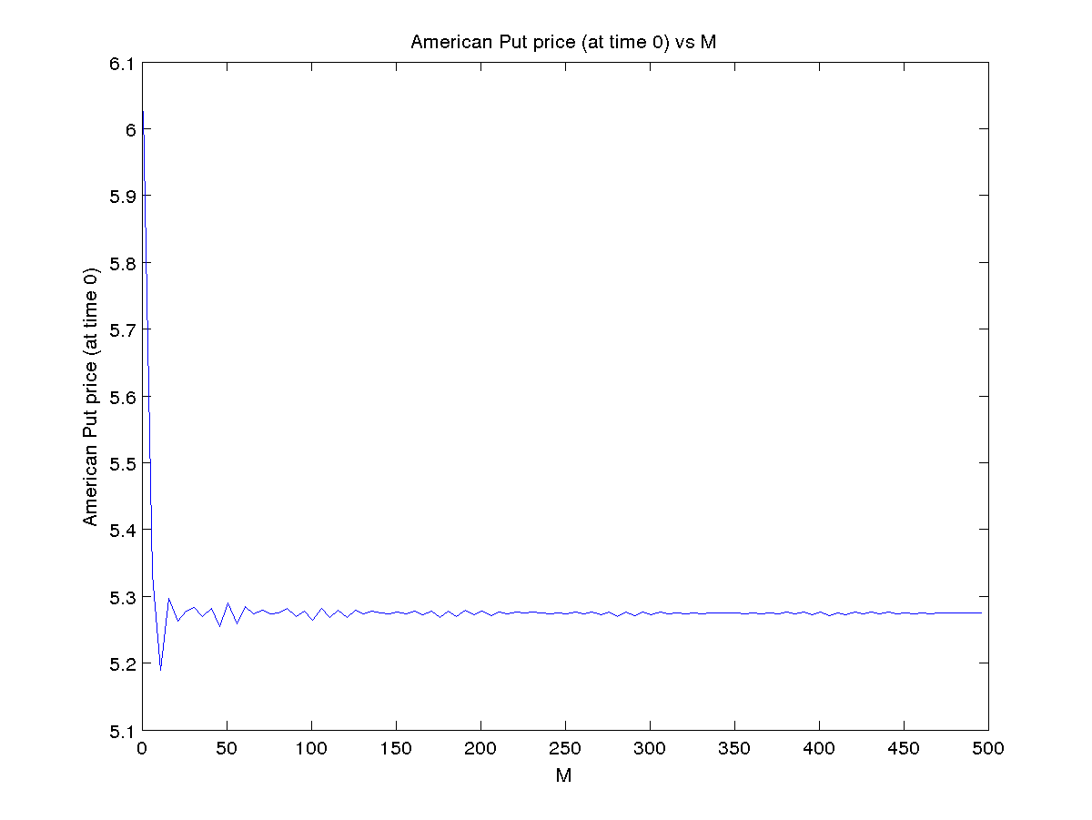

K = 105
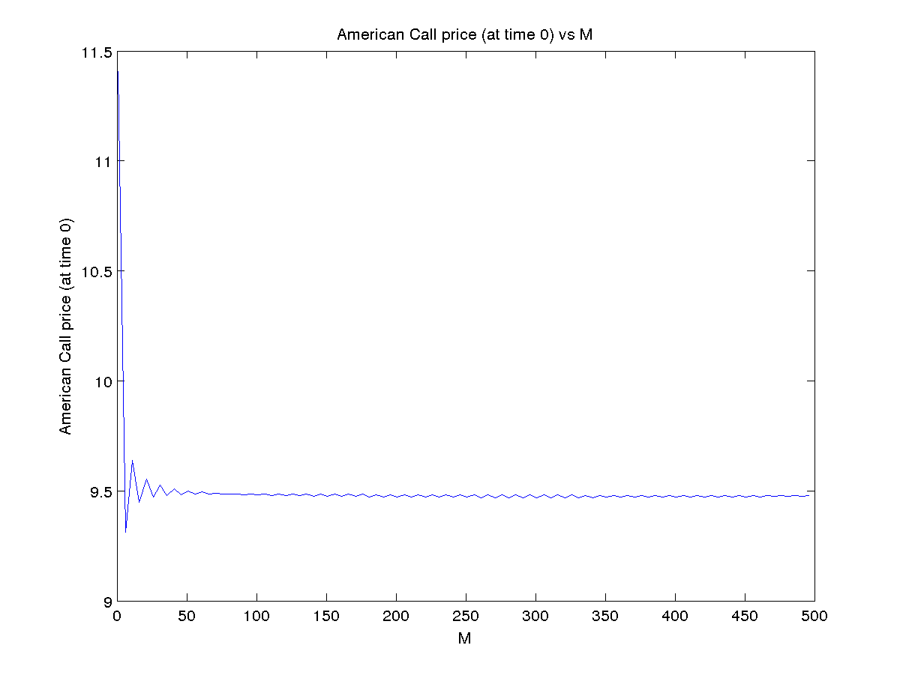
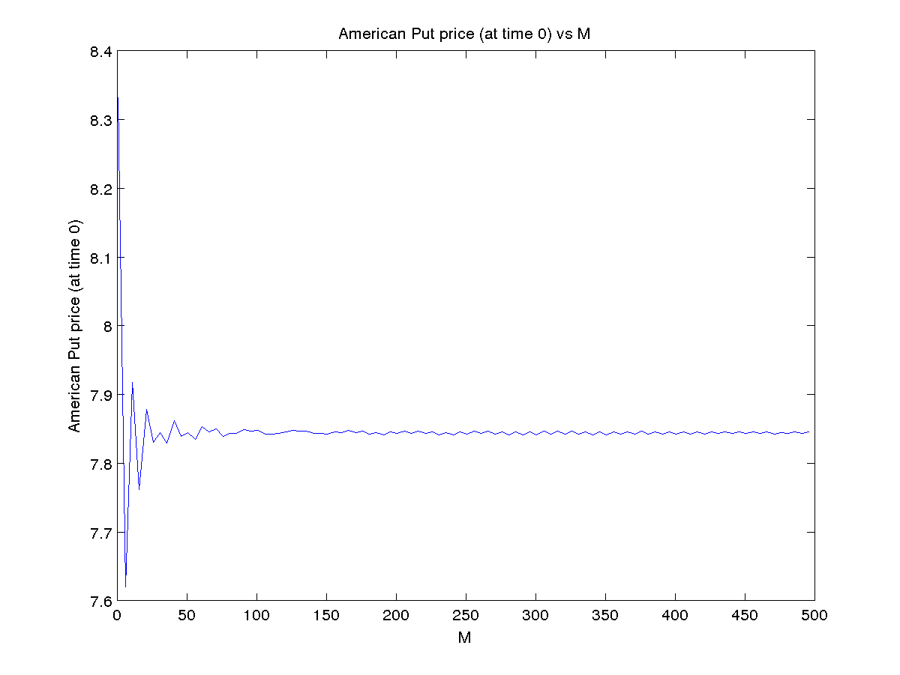

Question 2
(A)
M lookback European (initial price)
5 9.119299
7 9.609088
10 10.080583
12 10.286896
15 10.519165
17 10.647900

(B)
The value of option at time 0 is increasing with increase in M, but the slope is decreasing slowly. The option price stablizes after M has increased substantially.

M increased in steps of 1
M lookback European option (initial price)
1 6.025847
2 7.496149
3 8.262757
4 8.788076
5 9.119299
6 9.415434
7 9.609088
8 9.806368
9 9.936758
10 10.080583
11 10.175899
12 10.286896
13 10.367182
14 10.452999
15 10.519165

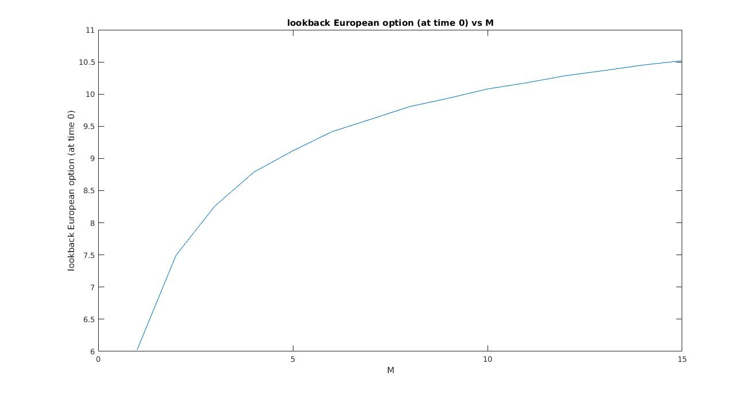
(C)
M = 5
t (time) Lookback option values at time t
0.000000 9.119299
0.200000 9.027951 9.504840
0.400000 7.147916 8.548076 9.799119 12.168665
0.600000 6.201916 7.148418 7.416771 8.324615 9.955271 13.712863 17.582063
0.800000 3.846929 4.600480 5.501639 6.680843 8.003614 9.571392 10.680904 10.680904 13.071381 15.631852 21.188089 25.051229
1.000000 0.000000 2.901350 2.901350 5.330382 6.374517 7.818416 9.349917 11.181413 13.578002 13.578002 16.266374 18.805945 18.805945 19.452692 21.234977 25.394563 29.482597 32.105394

Question 3
Markov based algorithm is significantly faster. Simple method takes exponential time with respect to M, time increases by a factor of 2, while Markov method increases by factor of about 1.4. Simple method is able to handle values upto M = 20, while in the same time Markov method can go upto 40.
(A)
M lookback European (initial price)
5 9.119299
10 10.080583
15 10.519165
20 10.805119
25 11.003495
30 11.152373

(B)
M increased in steps of 1
M lookback European option (initial price)
1 6.025847
3 8.262757
5 9.119299
7 9.609088
9 9.936758
11 10.175899
13 10.367182
15 10.519165
17 10.647900
19 10.756073
21 10.849329
23 10.931549
25 11.003495

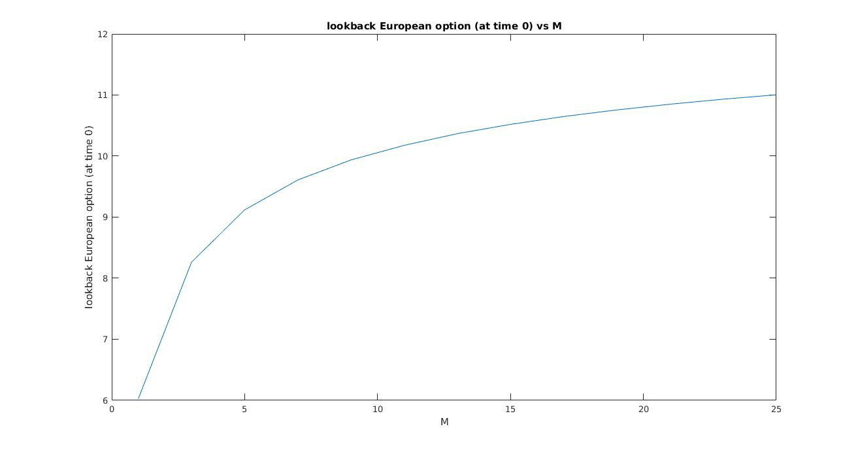

(C)
M = 20
t (time) Lookback option values at time t
0.000000 9.119299
0.200000 9.027951 9.504840
0.400000 7.147916 8.548076 9.799119 12.168665
0.600000 6.201916 7.148418 7.416771 8.324615 9.955271 13.712863 17.582063
0.800000 3.846929 4.600480 5.501639 6.680843 8.003614 9.571392 10.680904 13.071381 15.631852 21.188089 25.051229
1.000000 0.000000 2.901350 2.901350 5.330382 6.374517 7.818416 9.349917 11.181413 13.578002 13.578002 16.266374 18.805945 18.805945 19.452692 21.234977 25.394563 29.482597 32.105394 >> q3

