MA 374: Financial Engineering Lab
LAB 4 Report
Abheek Ghosh - 140123047

Question 1:
(a)
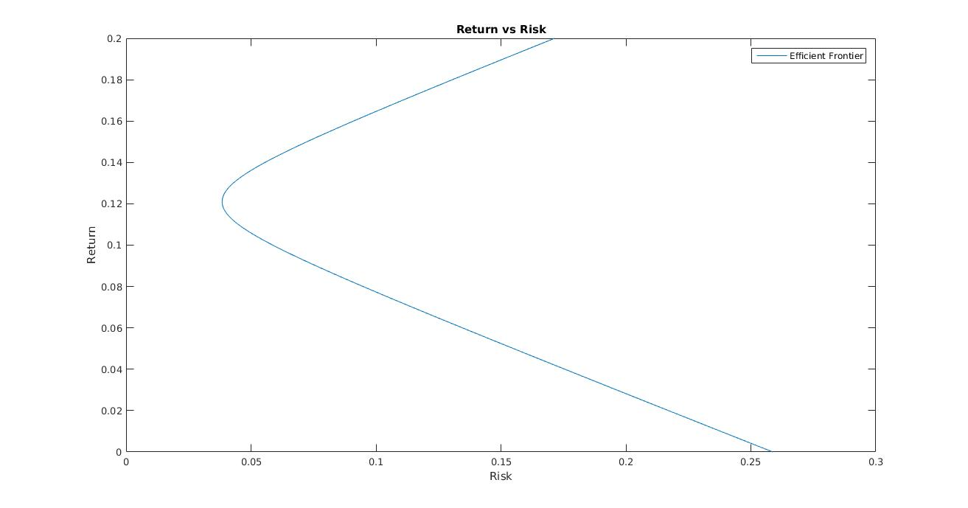
(b)

Weights Return Risk
[2.550459, -0.449541, -1.100917, ] 0.000000 0.258790
[2.121101, -0.278899, -0.842202, ] 0.030000 0.196269
[1.691743, -0.108257, -0.583486, ] 0.060000 0.134620
[1.262385, 0.062385, -0.324771, ] 0.090000 0.075999
[0.833028, 0.233028, -0.066055, ] 0.120000 0.038485
[0.403670, 0.403670, 0.192661, ] 0.150000 0.072378
[-0.025688, 0.574312, 0.451376, ] 0.180000 0.130568
[-0.455046, 0.744954, 0.710092, ] 0.210000 0.192119
[-0.884404, 0.915596, 0.968807, ] 0.240000 0.254605
[-1.313761, 1.086239, 1.227523, ] 0.270000 0.317473

(c)
Maximum and Minimum Return Portfolio for 15% risk
Weights Return Risk
[-0.162437, 0.628661, 0.533776, ] 0.189555 0.150000

Weights Return Risk
[1.799843, -0.151220, -0.648624, ] 0.052447 0.150000

(d)
Minimum Risk Portfolio for 18% return
Weights Return Risk
[-0.025688, 0.574312, 0.451376, ] 0.180000 0.130568

(e)
Market Portfolio
Weights Return Risk
[0.593750, 0.328125, 0.078125, ] 0.136719 0.050811

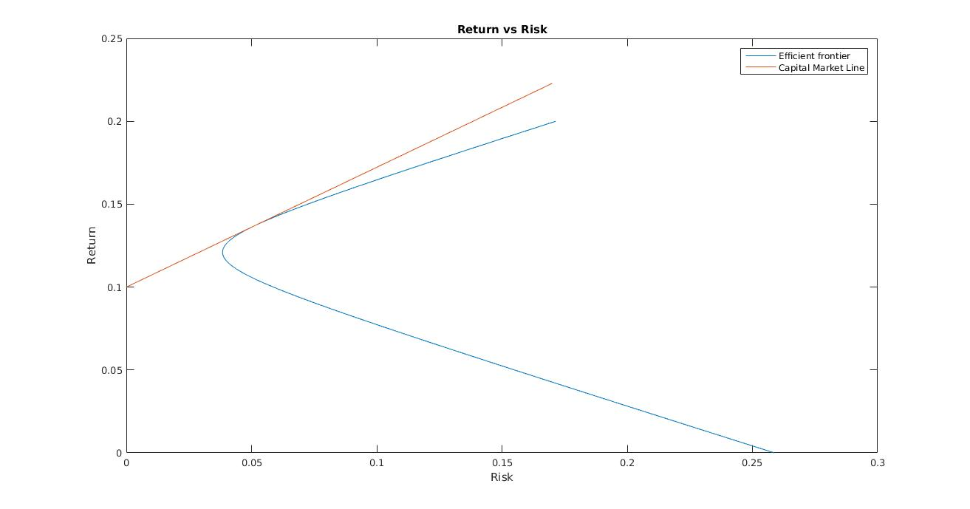
(f)

Mixed Portfolio with Risk = 0.100000
Risky Weights Risk Free Weight Return Risk
[1.168540, 0.645772, 0.153755, ] -0.968067 0.172265 0.100000

Mixed Portfolio with Risk = 0.250000
Risky Weights Risk Free Weight Return Risk
[2.921349, 1.614430, 0.384388, ] -3.920166 0.280662 0.250000

Question 2:
(a)
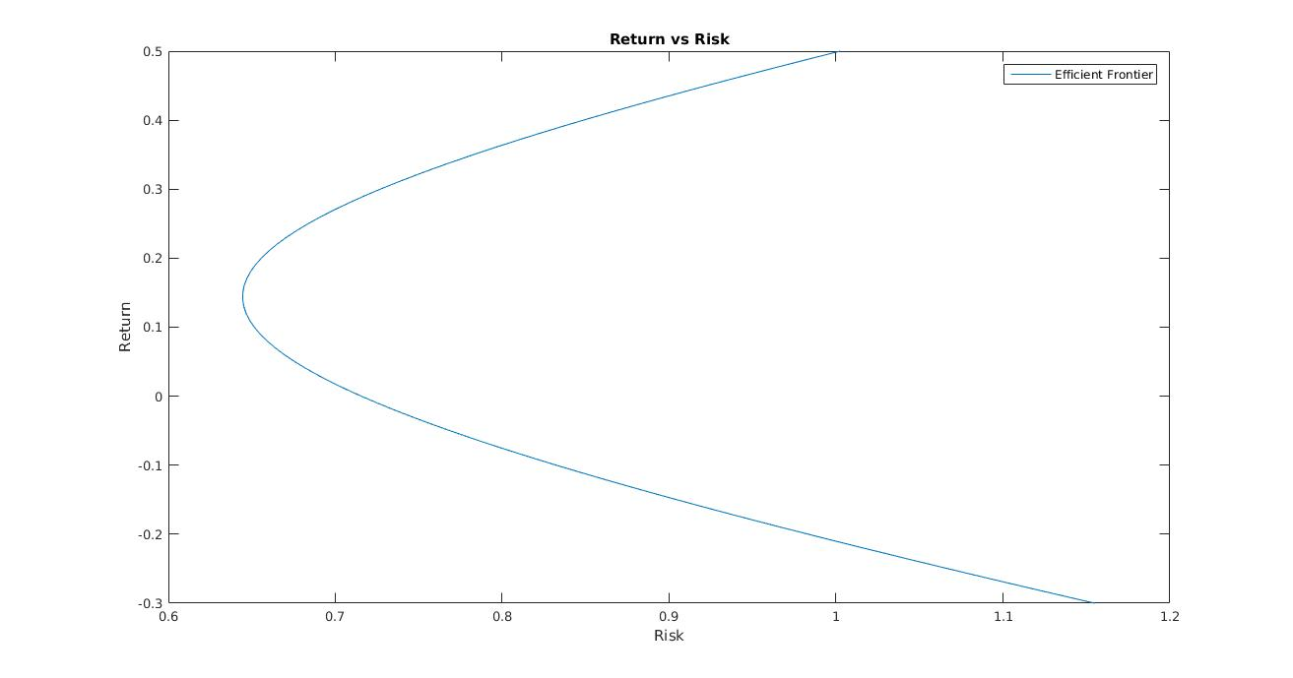

(b)
Market Portfolio
Weights: [1.154797, 0.962431, 1.804785, 0.522498, -1.332228, -0.845803, -0.612658, -0.655807, -0.604656, 0.606640, ]
Return: 1.346923
Risk: 2.674315

(c)
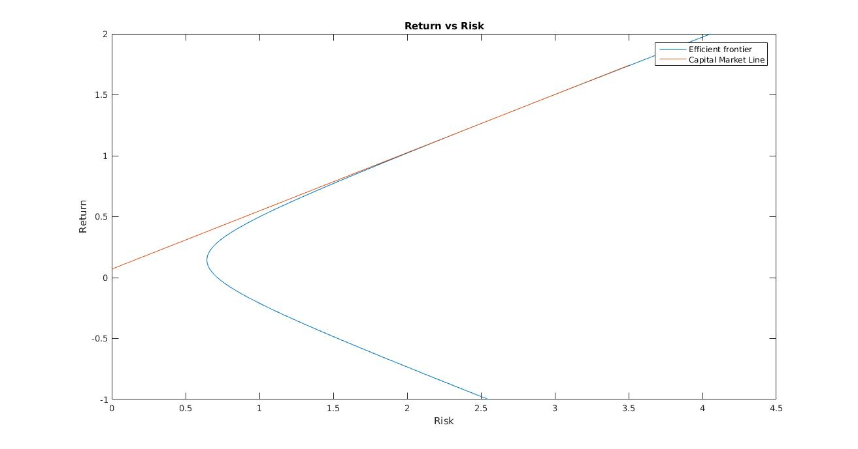
(d)
The red circles are for the individual stocks on the security market line.

