MA 374: Financial Engineering Lab
LAB 5 Report
Abheek Ghosh - 140123047

Question 1:
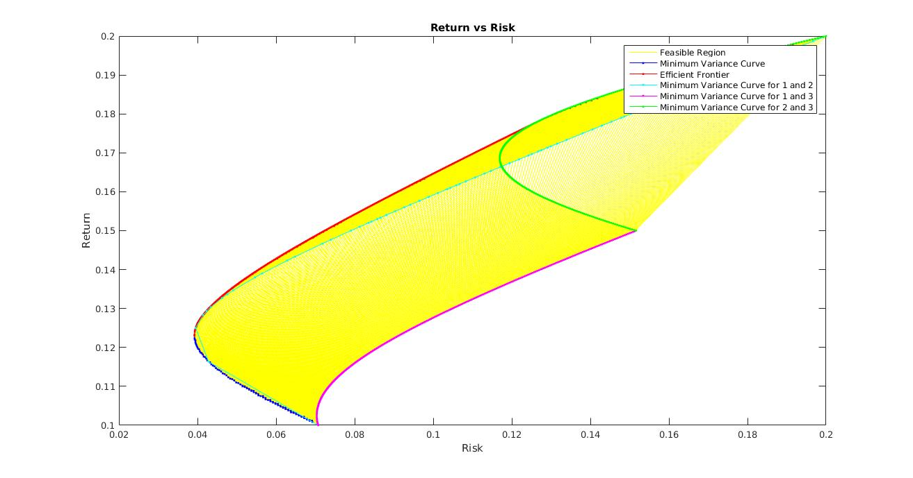
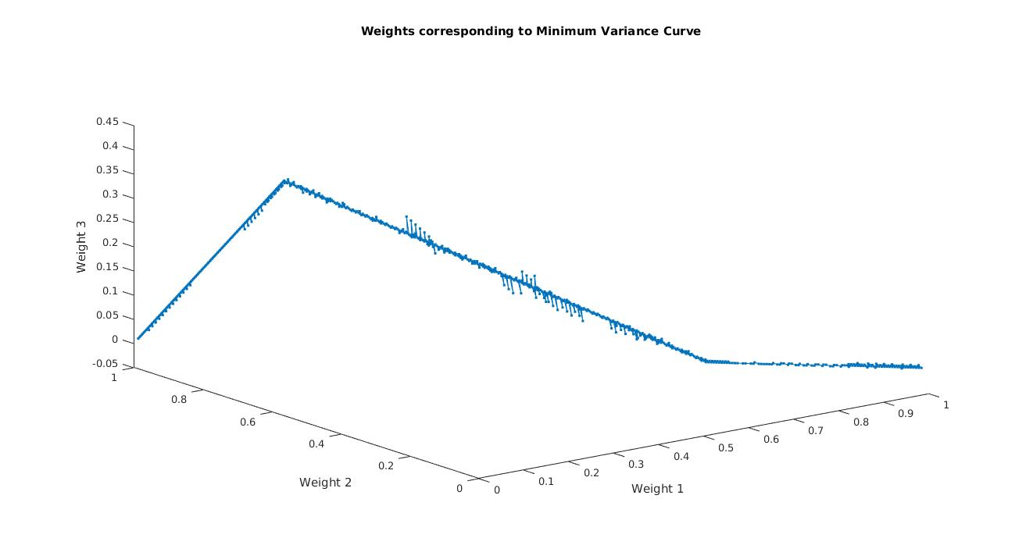

Defining suitable terms:

Weights, w = [w1, w2, w3]
Return, m = [m1, m2, m3]
Covariance matrix, C (3x3 matrix)
vector, u = [1 1 1]

Equations:
minimize: w*C*w’ (variance of portfolio)
s.t.
w * m’ = mu (given return of portfolio)
w * u’ = 1 i.e, w1 + w2 + w3 = 1
w >= [0, 0, 0] i.e, w1 >= 0, w2 >= 0, w3 >= 0,

Question 2:
BSE
Index Portfolio
Return = 0.108065, Risk = 0.151154

Stock Calculated Expected Actual Return Overpriced
beta return (CAPM)
Stock 1 (In index) 0.070971 0.054121 -0.031813 Yes
Stock 2 (In index) 0.751111 0.093613 -0.007658 Yes
Stock 3 (In index) 0.883900 0.101323 0.024756 Yes
Stock 4 (In index) 0.667974 0.088786 -0.204303 Yes
Stock 5 (In index) 0.932500 0.104145 0.347745 No
Stock 6 (In index) 0.350648 0.070360 -0.384658 Yes
Stock 7 (In index) 0.662055 0.088442 0.114579 No
Stock 8 (In index) 0.510522 0.079643 0.144018 No
Stock 9 (In index) 0.738288 0.092868 0.038892 Yes
Stock 10 (In index) 0.497800 0.078905 0.133835 No
Stock 1 (Outside index) 1.126186 0.115392 0.054552 Yes
Stock 2 (Outside index) 0.062728 0.053642 0.174838 No
Stock 3 (Outside index) 0.174625 0.060140 -0.108425 Yes
Stock 4 (Outside index) 0.194904 0.061317 0.064072 No
Stock 5 (Outside index) 0.122334 0.057103 0.073854 No
Stock 6 (Outside index) 0.586821 0.084074 -0.381465 Yes
Stock 7 (Outside index) 0.371500 0.071571 -0.016761 Yes
Stock 8 (Outside index) 0.353829 0.070545 -0.388069 Yes
Stock 9 (Outside index) 1.499518 0.137069 -0.054003 Yes
Stock 10 (Outside index) 0.876301 0.100882 0.097327 Yes

The stocks with overpriced = Yes, are overpriced i.e., have less relative return compared to market portfolio. And with overpriced = No, have more relative return relative to market portfolio, and can be invested on against market.

Comparing Beta Values
Stock Calculated beta Official beta
Stock 1 (In index) airtel 0.070971 0.55
Stock 2 (In index) coal 0.751111 0.85
Stock 3 (In index) gail 0.883900 0.93
Stock 4 (In index) infosys 0.667974 0.69
Stock 5 (In index) maruti 0.932500 0.81
Stock 6 (In index) sbi 0.350648 1.28
Stock 7 (In index) cipla 0.662055 0.93
Stock 8 (In index) hul 0.510522 0.40
Stock 9 (In index) itc 0.738288 0.64
Stock 10 (In index) reddy 0.497800 0.62
Stock 1 (Outside index) 1.126186 1.12
Stock 2 (Outside index) 0.062728 0.10
Stock 3 (Outside index) 0.174625 0.19
Stock 4 (Outside index) 0.194904 0.30
Stock 5 (Outside index) 0.122334 0.18
Stock 6 (Outside index) 0.586821 0.90
Stock 7 (Outside index) 0.371500 0.27
Stock 8 (Outside index) 0.353829 0.59
Stock 9 (Outside index) 1.499518 1.37
Stock 10 (Outside index) 0.876301 0.75

NSE
Index Portfolio
Return = 0.108295, Risk = 0.154712

Stock Calculated Expected Actual Return Overpriced
beta return (CAPM)
Stock 1 (In index) 0.045060 0.052627 0.030141 Yes
Stock 2 (In index) 0.086307 0.055031 0.057195 No
Stock 3 (In index) 0.143925 0.058390 0.410285 No
Stock 4 (In index) 0.127453 0.057430 0.113124 No
Stock 5 (In index) 0.150916 0.058798 -0.134015 Yes
Stock 6 (In index) 0.162222 0.059457 0.160404 No
Stock 7 (In index) 0.160030 0.059329 -0.217834 Yes
Stock 8 (In index) -0.023114 0.048653 -0.113722 Yes
Stock 9 (In index) 0.313309 0.068264 -0.304613 Yes
Stock 10 (In index) 0.028466 0.051659 0.055934 No
Stock 1 (Outside index) 0.150975 0.058801 0.054552 Yes
Stock 2 (Outside index) 0.171377 0.059991 0.174838 No
Stock 3 (Outside index) 0.285932 0.066669 -0.108425 Yes
Stock 4 (Outside index) -0.025433 0.048517 0.064072 No
Stock 5 (Outside index) 0.413307 0.074094 0.073854 Yes
Stock 6 (Outside index) 0.110042 0.056415 -0.381465 Yes
Stock 7 (Outside index) -0.009610 0.049440 -0.016761 Yes
Stock 8 (Outside index) 0.500230 0.079161 -0.388069 Yes
Stock 9 (Outside index) 0.144596 0.058429 -0.054003 Yes
Stock 10 (Outside index) 0.105670 0.056160 0.097327 No

The stocks with overpriced = Yes, are overpriced i.e., have less relative return compared to market portfolio. And with overpriced = No, have more relative return relative to market portfolio, and can be invested on against market.

Comparing Beta Values
Stock Calculated beta Official beta
Stock 1 (In index) acc 0.045060 0.086323
Stock 2 (In index) ambuja 0.086307 0.0613015
Stock 3 (In index) auropharma 0.143925 0.138799
Stock 4 (In index) bajaj 0.127453 0.322293
Stock 5 (In index) bhel 0.150916 0.927927
Stock 6 (In index) adani 0.162222 0.150914
Stock 7 (In index) asianpaints 0.160030 0.682959
Stock 8 (In index) axis -0.023114 0.170484
Stock 9 (In index) baroda 0.313309 0.224685
Stock 10 (In index) bpc 0.028466 0.262621
Stock 1 (Outside index) 0.150975 -
Stock 2 (Outside index) 0.171377 -
Stock 3 (Outside index) 0.285932 -
Stock 4 (Outside index) -0.025433 -
Stock 5 (Outside index) 0.413307 -
Stock 6 (Outside index) 0.110042 -
Stock 7 (Outside index) -0.009610 -
Stock 8 (Outside index) 0.500230 -
Stock 9 (Outside index) 0.144596 -
Stock 10 (Outside index) 0.105670 -

Plots for BSE

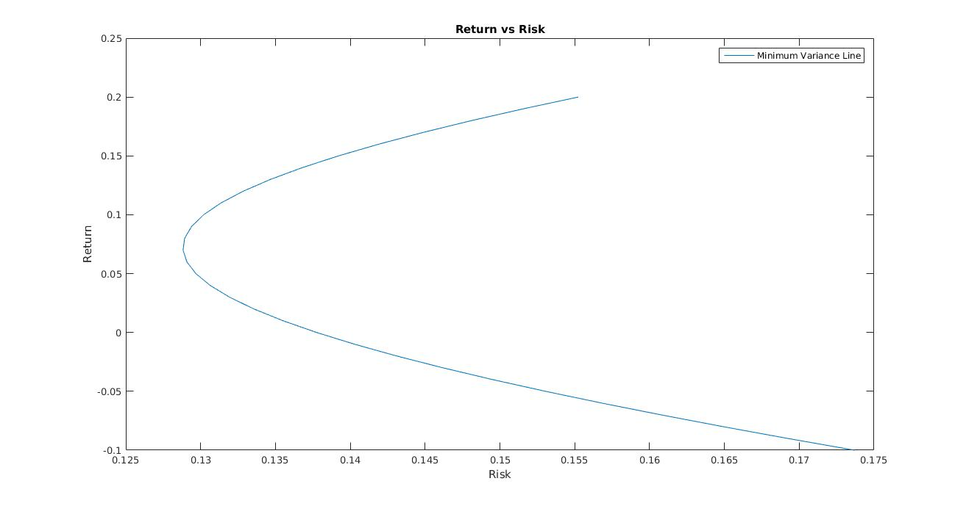
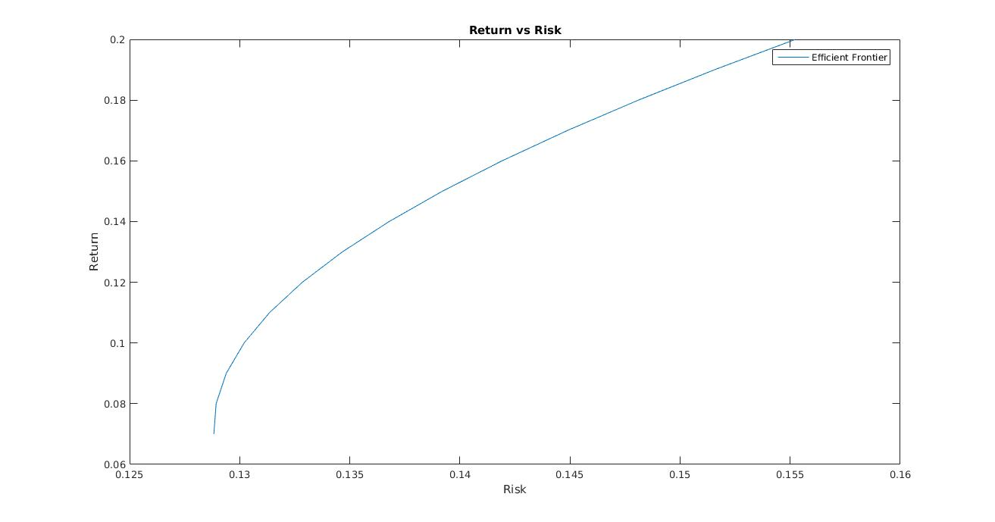

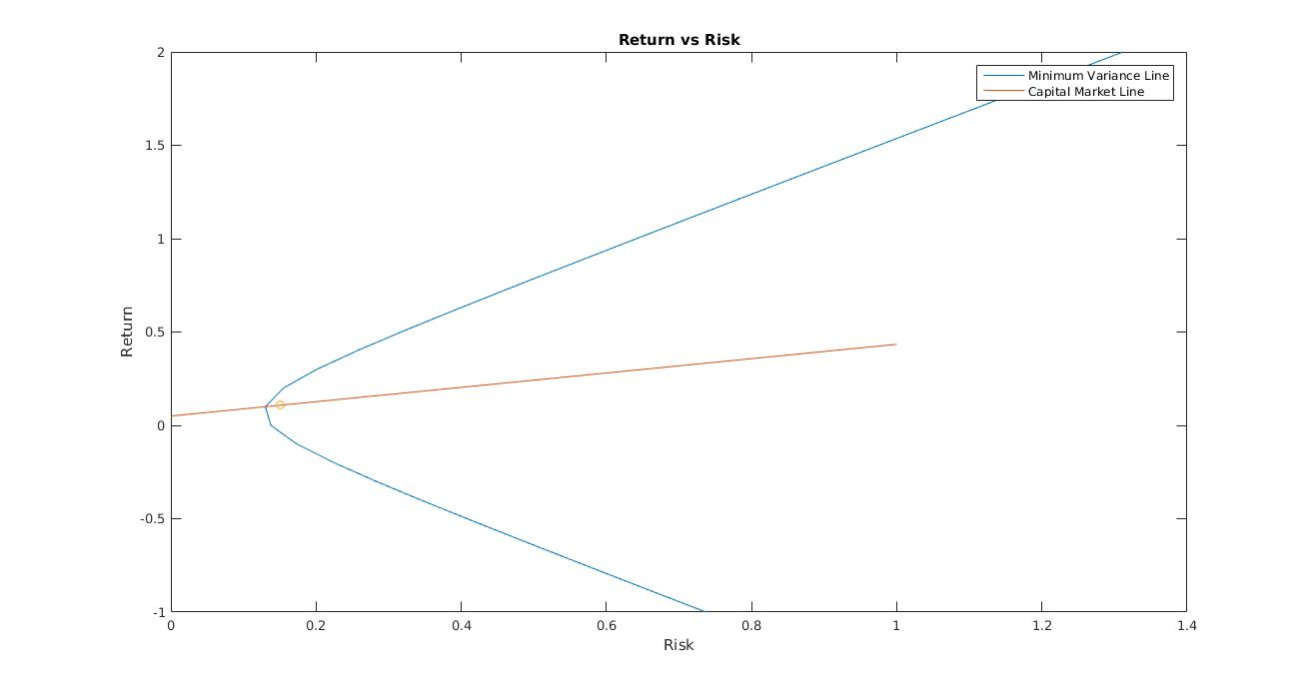
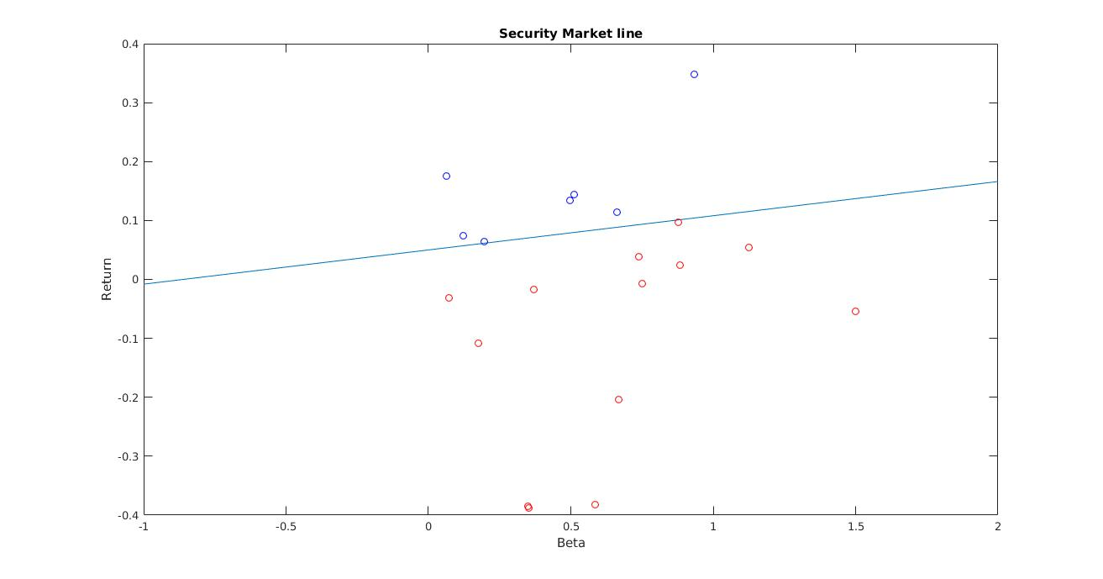
Plots for NSE

