LAB 10

By Mehul Jain
140123022

Question 1:
a.

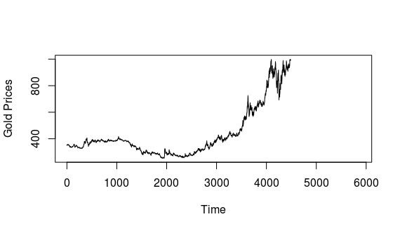
b.

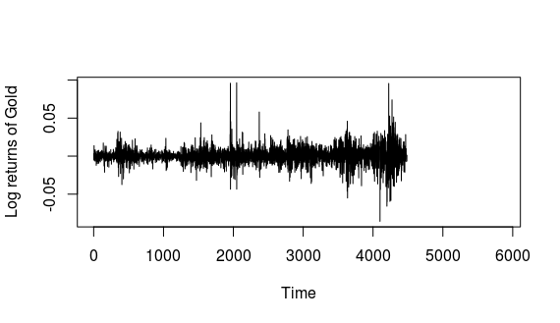

c.

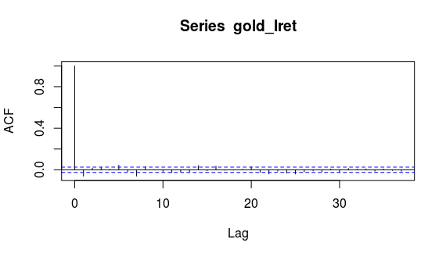
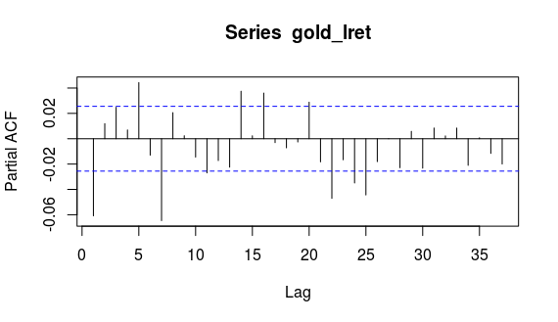
d.
AR(25) models fits the data. Yes it’s a correct model since PACF(25) is the last non-zero PACF.

e.
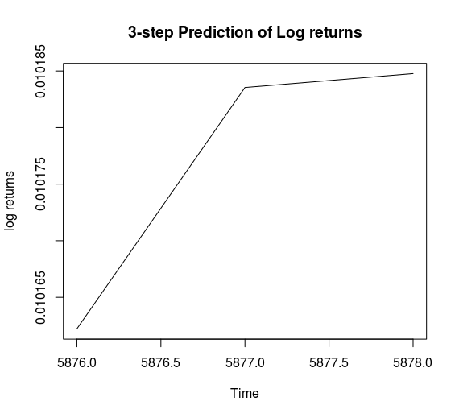

Ques2:

b.
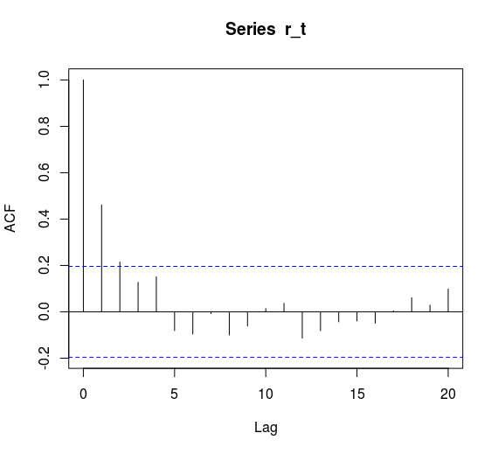
c.
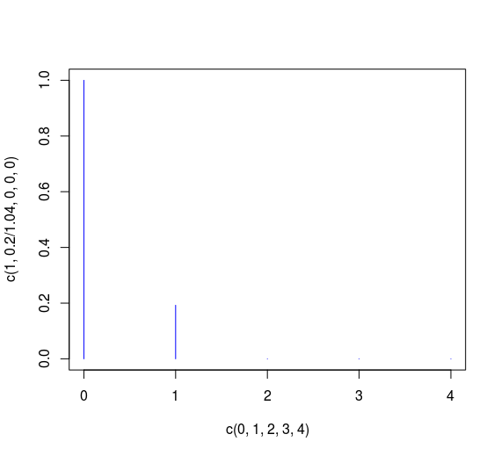

Ques3:
a.

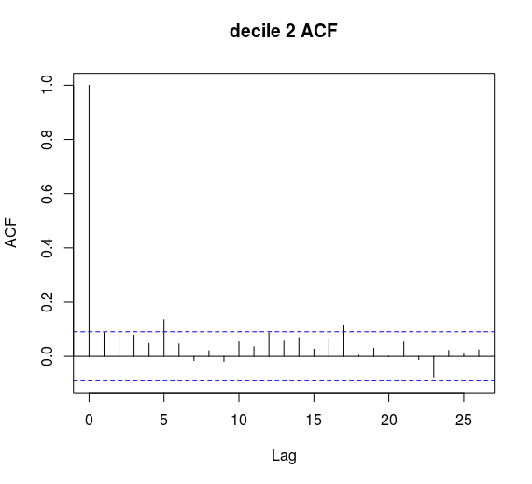
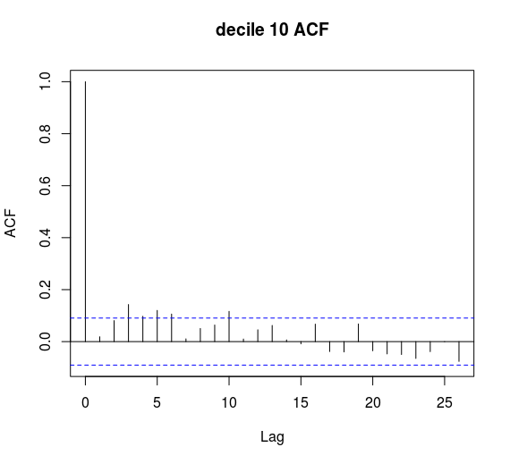

b.
ARMA(1,1)
Coefficients:
ar1 ma1
0.0463 -0.9758
s.e. 0.0481 0.0136

sigma^2 estimated as 17981: log likelihood=-2957.06
AIC=5920.11 AICc=5920.16 BIC=5932.56

c.

