Assignment 14

1. Write a command that puts the following values, in their given order, into the salespeople table: city – San Jose, name – Blanco, comm – NULL, cnum – 1100.

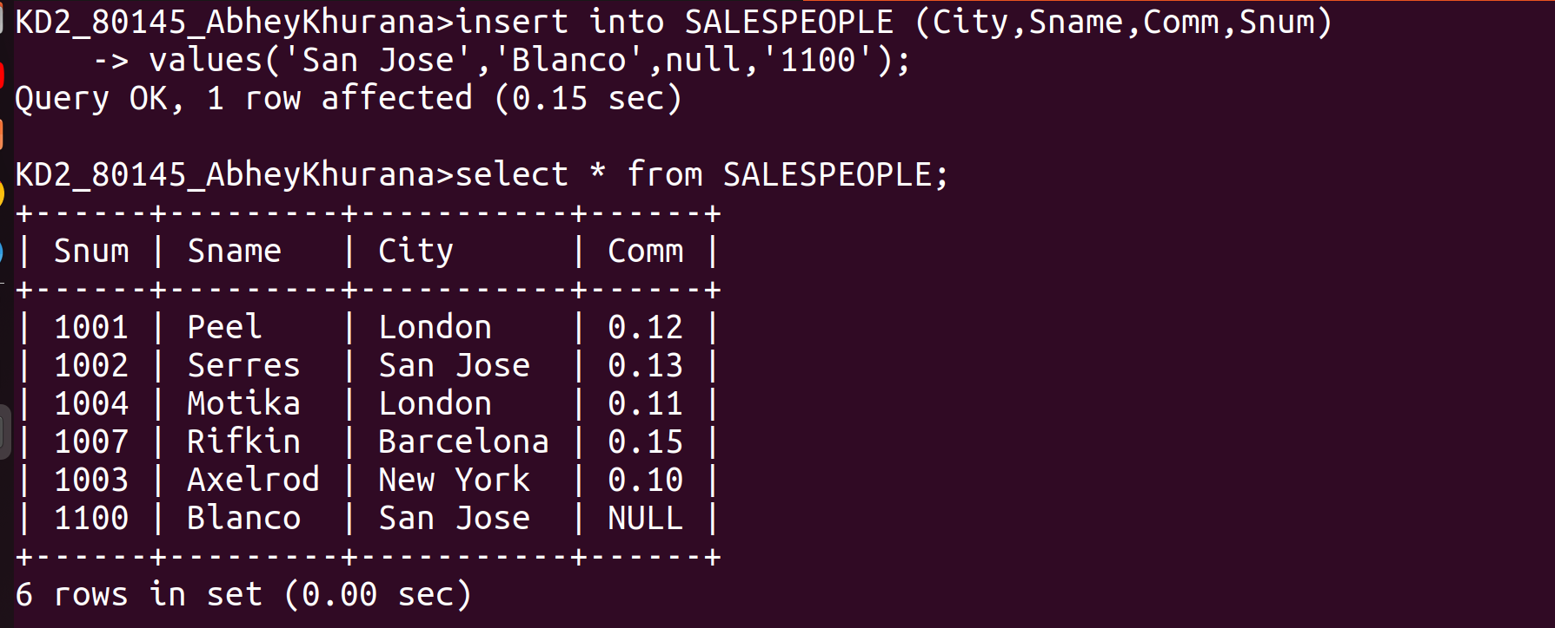
2. Write a command that removes all orders from customer clemens from the orders table.

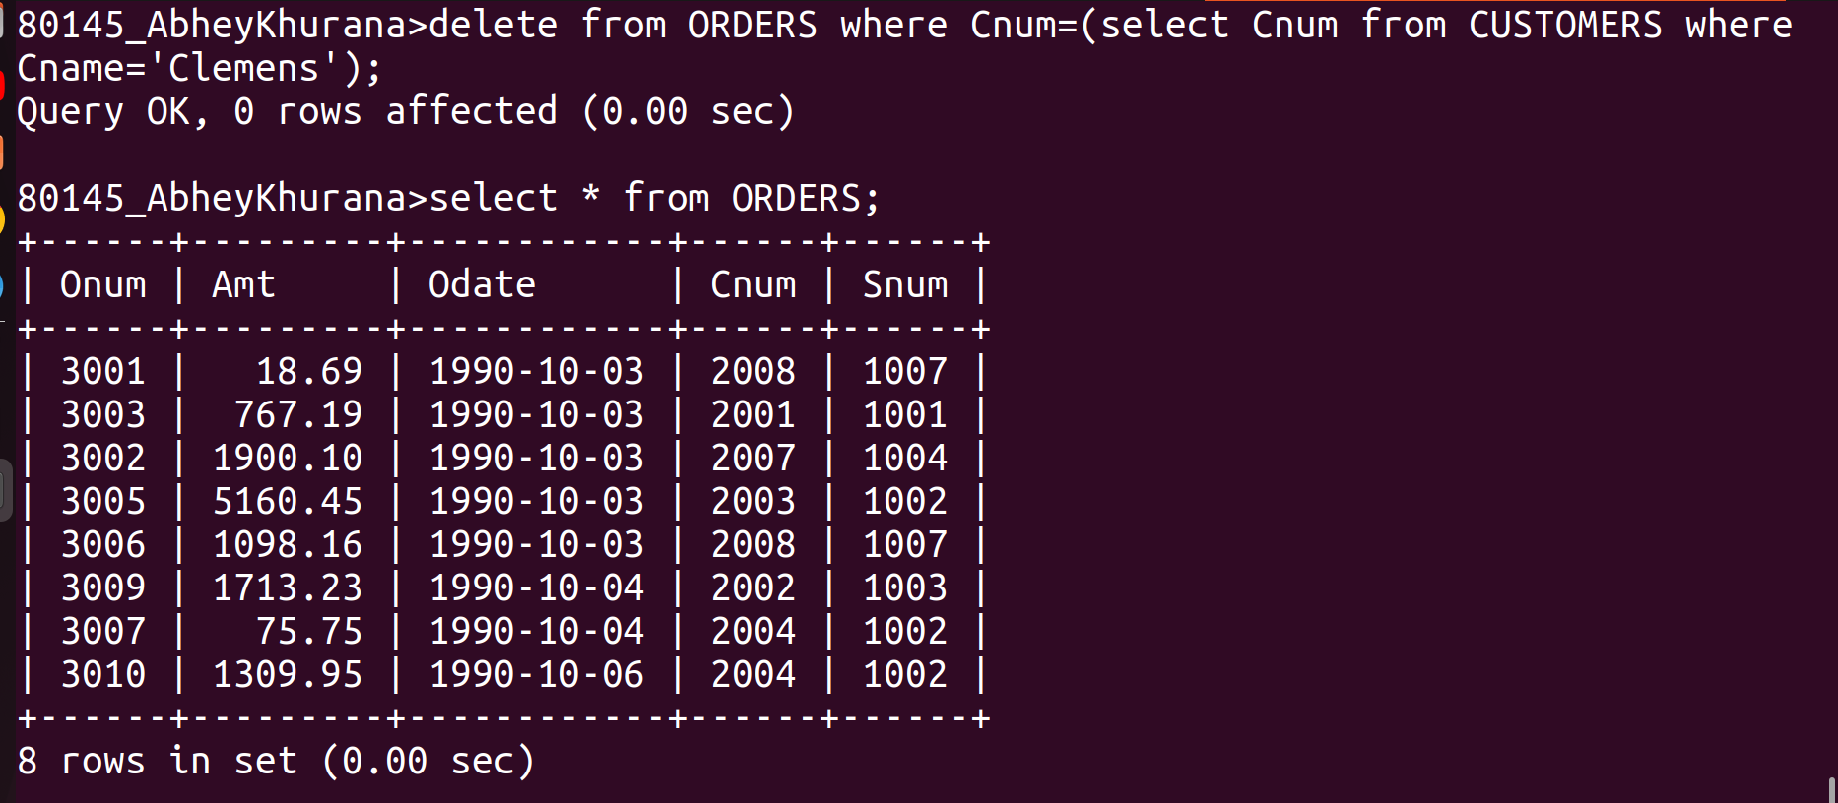

3. Write a command that increases the rating of all customers in rome by 100.

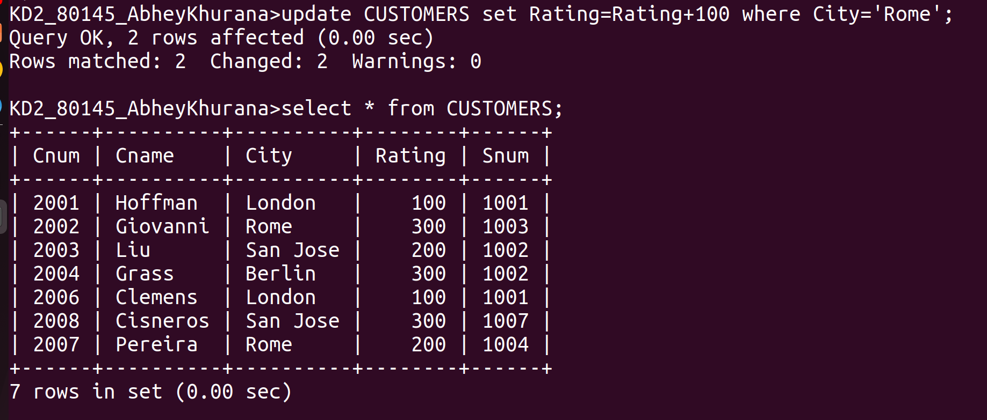

4. Salespeople Serres has left the company. Assign her customers to motika.

