SQL ASSINGMENT 13

1)Create a union of two queries that shows the names, cities, and ratings of all customers. Those with rating of 200 or greater will also have the words “High Rating”, while the others will have the words “Low Rating”.

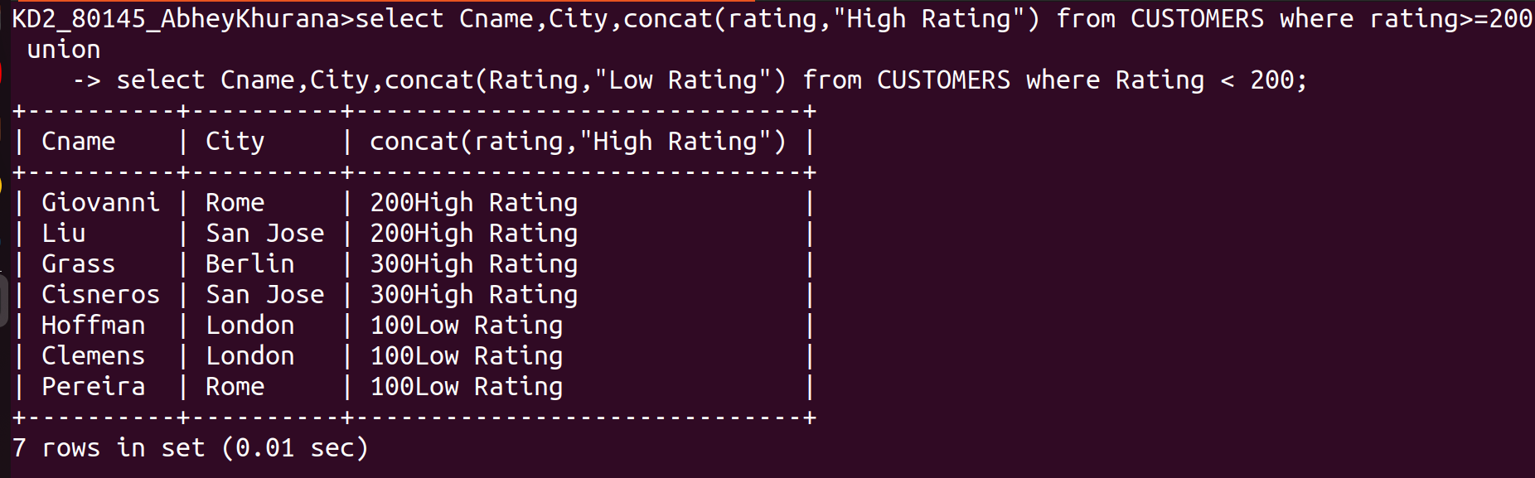
2)write a command that produces the name and number of each of salesperson and each customer with more than one current order. Put the results in alphabetical order.

