SQL ASSINGMENT 12

1)Write a query that selects all customers whose ratings are equal to or greater than ANY of the Serres’.

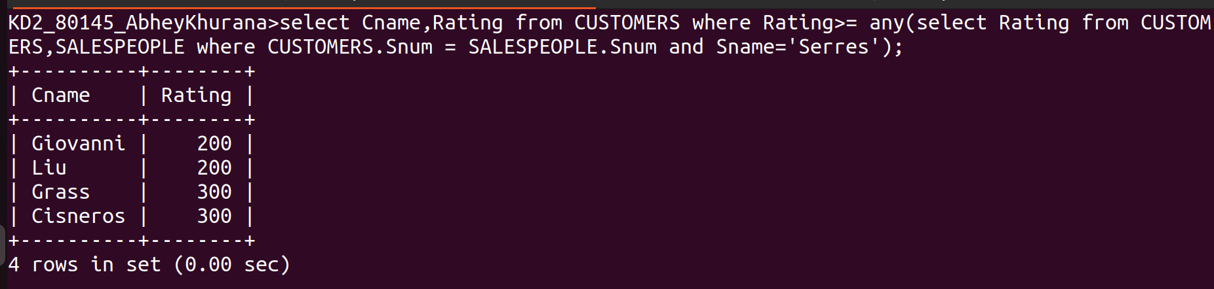

2)Write a query using ANY or ALL that will find all salespeople who have no customers located in their city.

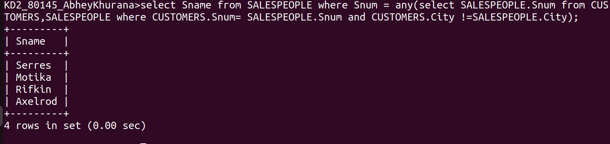
3)Write a query that selects all orders for amounts greater than any of the customers in London.

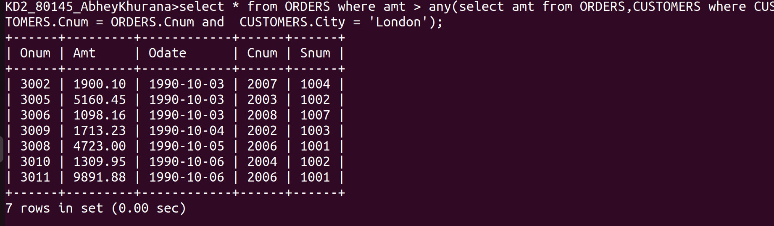

4)Write the above query using MIN or MAX.

For MAX:

For MIN:

