SQL ASSINGMENT 11(80145)

1)Write a query that uses a subquery to obtain all orders for the customer named Cisneros. Assume you do not know his customer number(cnum).

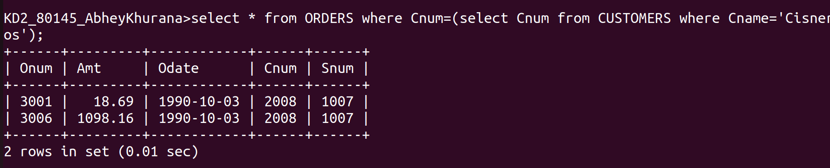
2)Write a query that produces the names and rating of all customers who have above average orders.

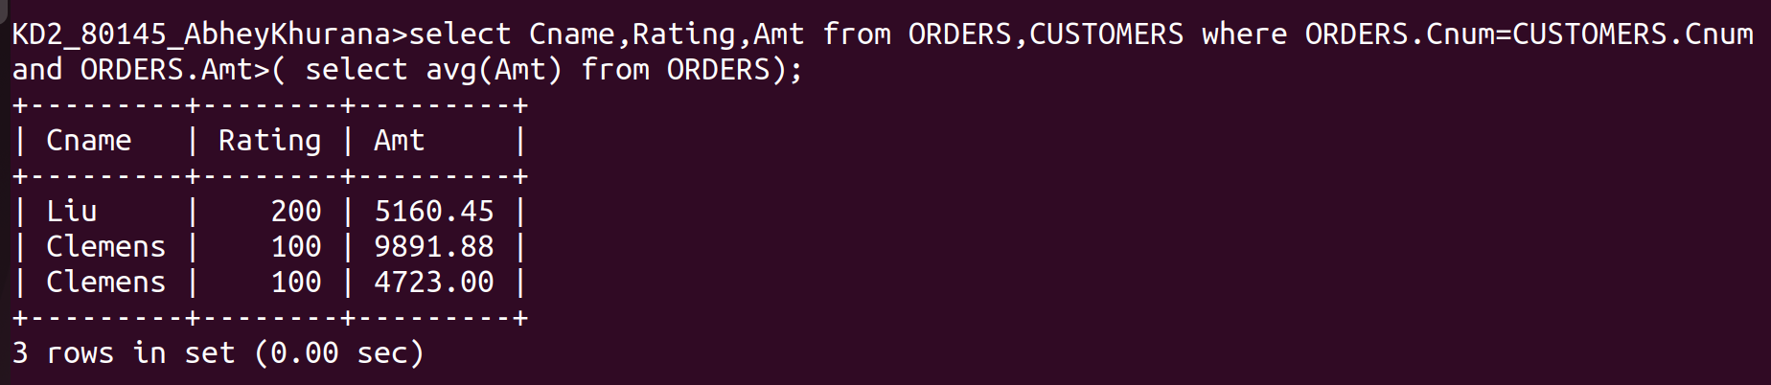

3)Write a query that selects the total amount in orders for each salesperson for whom this total is greater than the amount of the largest order in the table.

