ASSIGNMENT 6

1. Write two different queries that would produce all orders taken on October 3 or 4 ,1990.

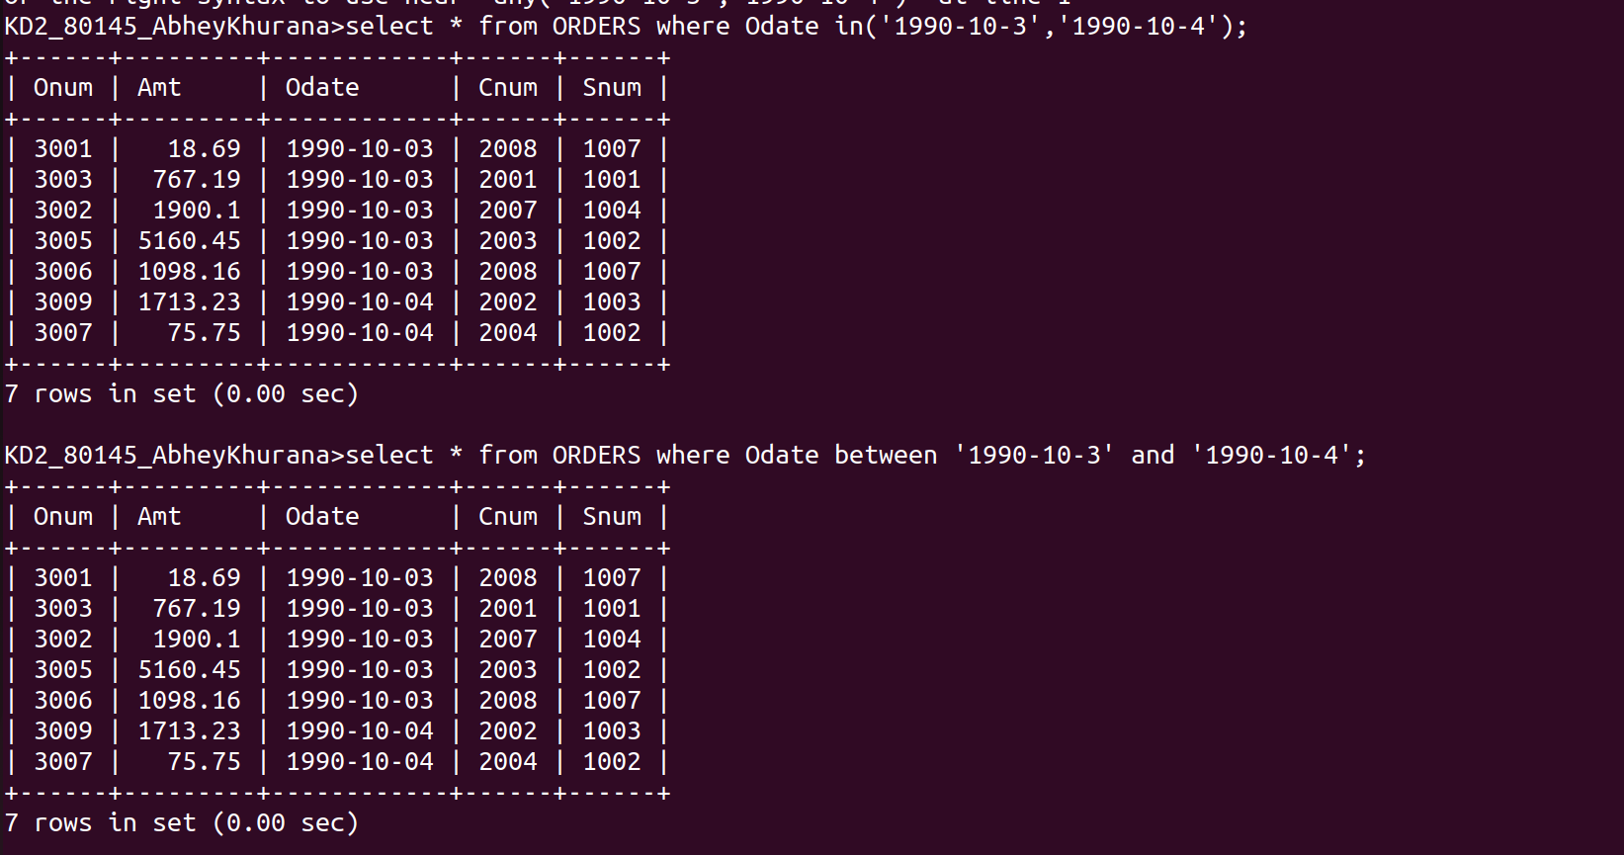
2. Write a query that selects all of the customers serviced by Peel or Motika.

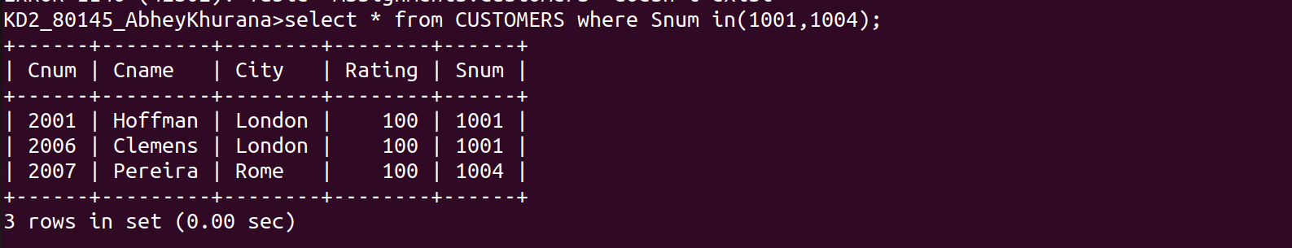
3.Write a query that will produce all the customers whose names begin with a letter from ‘A’ to ‘G’

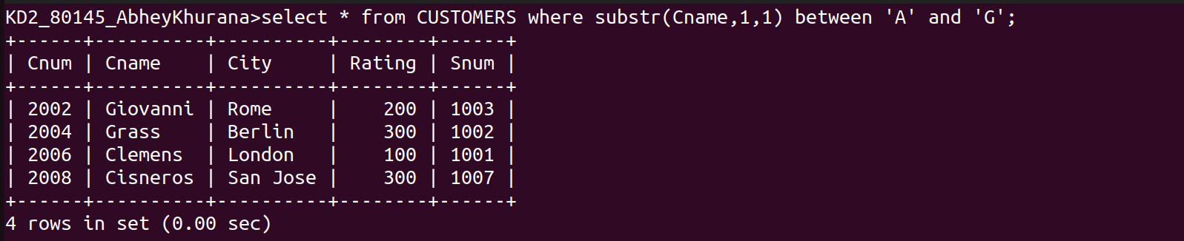
4. Write a query that selects all customers whose name begin with letter ‘C’.
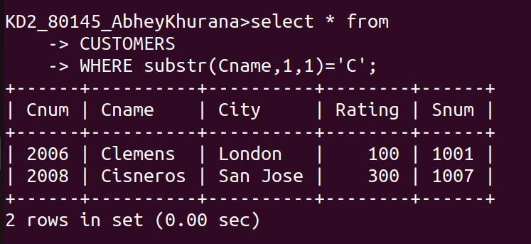
5. Write a query that selects all orders except those with zeros or NULLs in the amt field.

