Assignment 1

CREATING TABLES AND INSERTING VALUES
SALESPEOPLE
CUSTOMERS
ORDERS

KD2_80145_AbheyKhurana>create table SALESPEOPLE
-> (
-> Snum int,
-> Sname varchar(10),
-> City varchar(10),
-> Comm float(3,2)
-> );

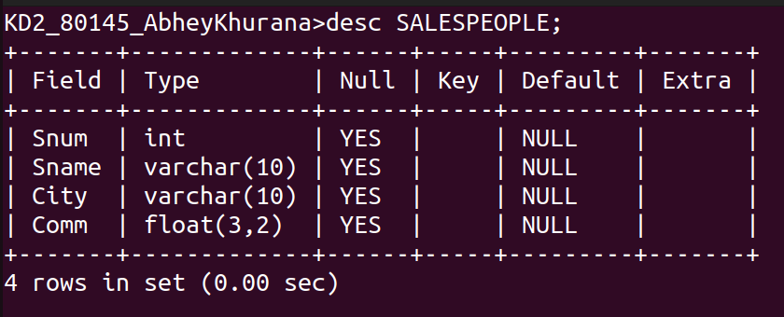

KD2_80145_AbheyKhurana>create table CUSTOMERS
-> (
-> Cnum int,
-> Cname varchar(10),
-> City varchar(10),
-> Rating int,
-> Snum int
-> );

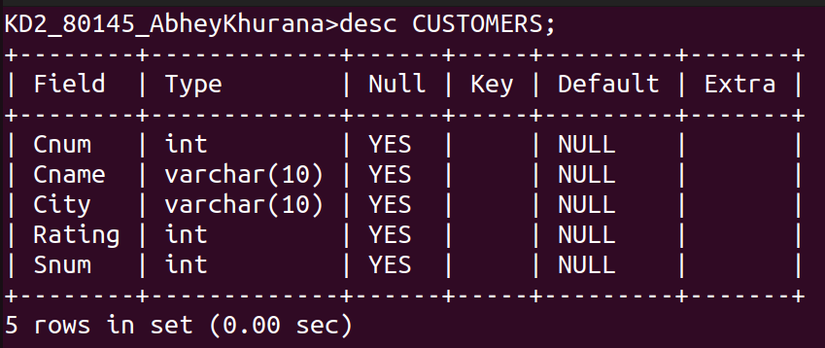

KD2_80145_AbheyKhurana>create table ORDERS
-> (
-> Onum int,
-> Amt float,
-> Odate date,
-> Cnum int,
-> Snum int
-> );

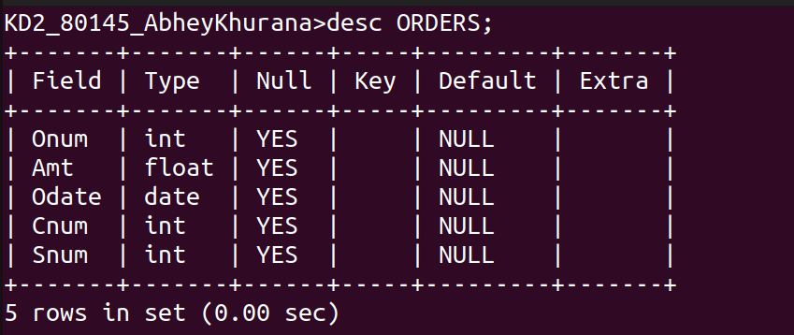

Adding Data

KD2_80145_AbheyKhurana>insert into SALESPEOPLE values ->(1001,'Peel','London',.12),
->(1002,'Serres','San Jose',.13),
->(1004,'Motika','London',.11),
->(1007,'Rifkin','Barcelona',.15),
->(1003,'Axelrod','New York',.10);

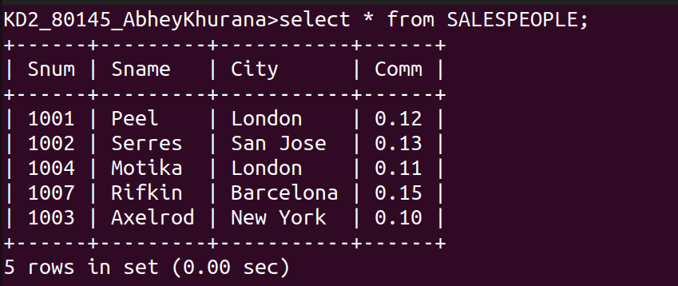

KD2_80145_AbheyKhurana>insert into CUSTOMERS values
-> (2001,'Hoffman','London',100,1001),
-> (2002,'Giovanni','Rome',200,1003),
-> (2003,'Liu','San Jose',200,1002),
-> (2004,'Grass','Berlin',300,1002),
-> (2006,'Clemens','London',100,1001),
-> (2008,'Cisneros','San Jose',300,1007),
-> (2007,'Pereira','Rome',100,1004);

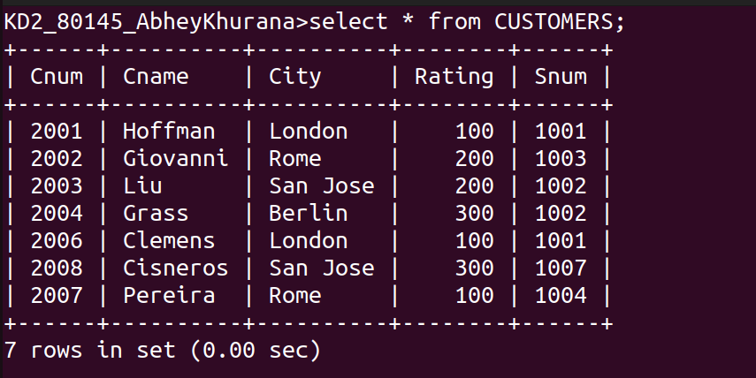

KD2_80145_AbheyKhurana>insert into ORDERS values
-> (3001,18.69,'1990-10-3',2008,1007),
-> (3003,767.19,'1990-10-3',2001,1001),
-> (3002,1900.10,'1990-10-3',2007,1004),
-> (3005,5160.45,'1990-10-3',2003,1002),
-> (3006,1098.16,'1990-10-3',2008,1007),
-> (3009,1713.23,'1990-10-4',2002,1003),
-> (3007,75.75,'1990-10-4',2004,1002),
-> (3008,4723.00,'1990-10-5',2006,1001),
-> (3010,1309.95,'1990-10-6',2004,1002),
-> (3011,9891.88,'1990-10-6',2006,1001);

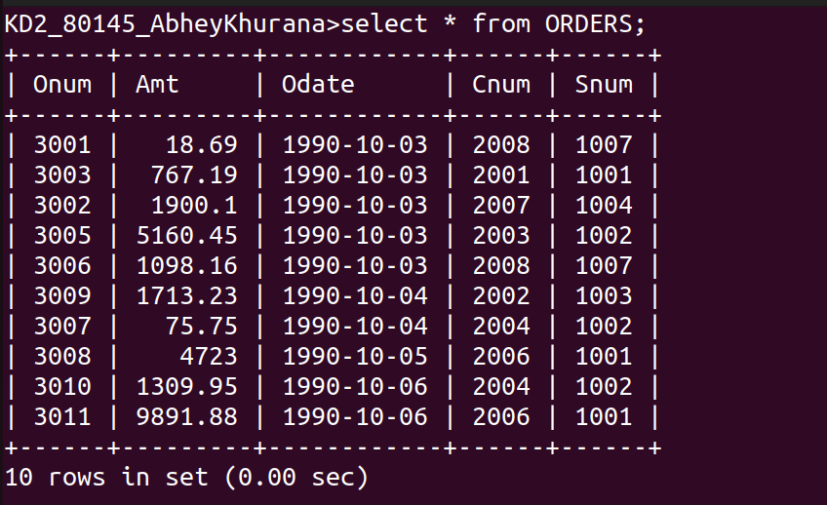

Submitted by :KD2_Abhey Khurana_80145

