ASSIGNMENT 2

1. Which field of the Customers Table is the primary key?

-> Primary Key: A column or group of columns that can uniquely identify a row.

According to this, CNUM is the primary key.

2. What is forth column of the Customers Table?
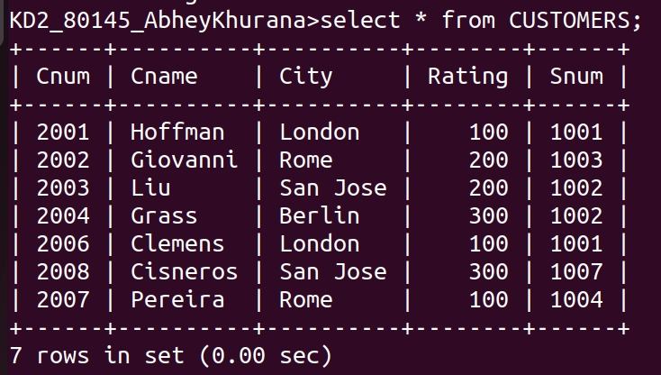
-> RATING

3.What is Another word for Row , Column?

-> ROW : Tuple,Entity
Column : Attribute

4.Why isn’t it possible to see the first five rows of a table?

-> While Insertion SQL adds the row where it finds the space available on Hard disk to speed up the insertion of new entities and support multi user prespective.So all the rows are scattered on the hard disk and we only see rows in order of their row address not in their insertion order;

