ASSIGNMENT 5

1. Write a Query that will give you all orders for more than Rs. 1000.

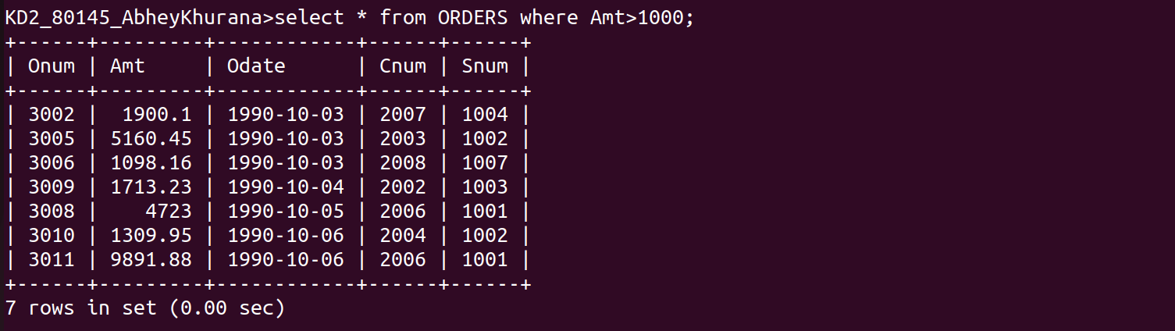
KD2_80145_AbheyKhurana>select * from ORDERS where Amt>1000;

2. Write a query that will give you the names and cities of all salespeople in London with a commission above .10.

KD2_80145_AbheyKhurana>select Sname "SalesPerson Name",City from SALESPEOPLE
->WHERE City='London' and comm>.10;

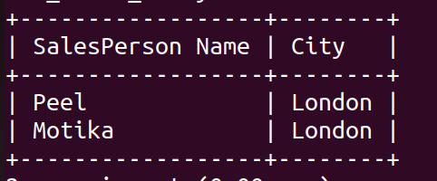

3. Write a query on the Customers table whose output will exclude all customers with a rating <=100,unless they are located in Rome.

KD2_80145_AbheyKhurana>select * from CUSTOMERS
->where rating<=100 or city='Rome';

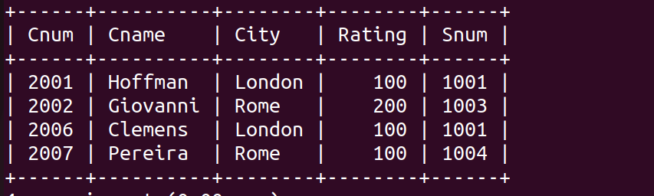

4.What will be output of the following query?
SELECT * FROM ORDERS
WHERE (AMT<1000 OR NOT(ODATE = ‘1990-10-03’ AND Cnum>2003));

->SELECT * from ORDERS;
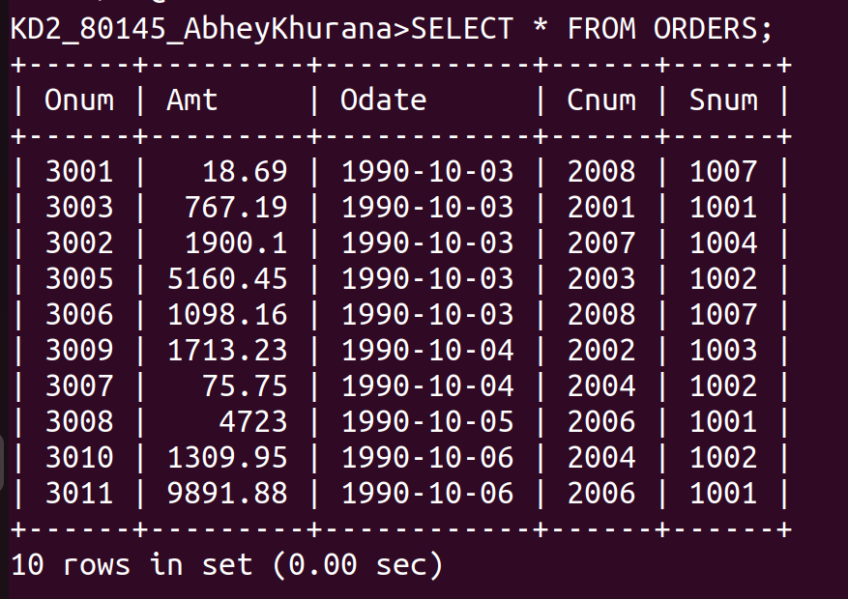

AMT<1000 Cnum 3001,3003,3007
NOT(Cnum = 3002,3006)=> All other expect 3001,3003,3007 AND 3002,3006=>3005,3009,3008,3010,3011
Cnum 3001,3003,3007,3005,3009,3008,3010,3011

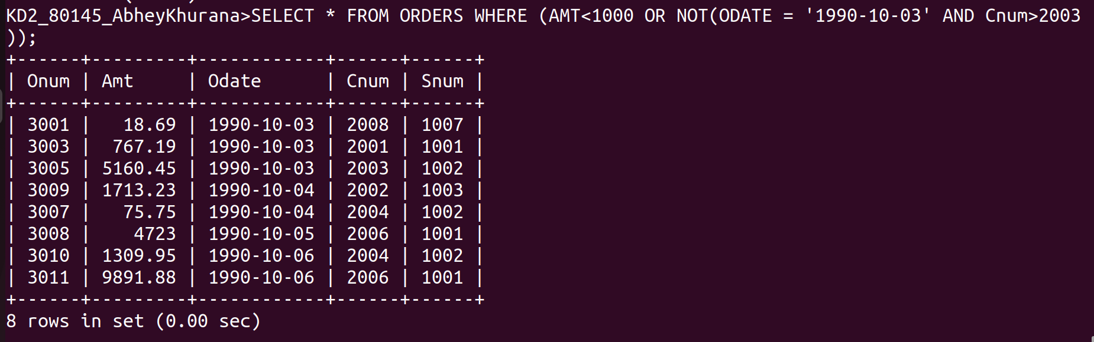
5. What will be output of the following query?

SELECT * FROM ORDERS
WHERE NOT (
(odate=’1990-10-03’ OR snum>1006) AND amt>=1500);

->SELECT * from ORDERS;
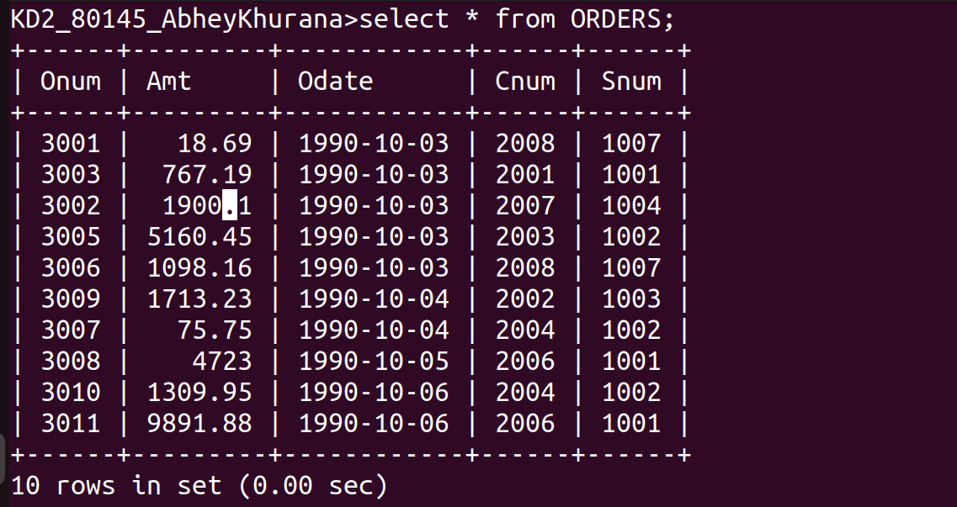

According to the Question
odate=’1990-10-’03 OR snum>1006 will give first 5 rows and then
amt>=1500 will result out 3002 and 3005 ,
There’s a NOT before it so all other rows except Onum 3002 and 3005 will be the output

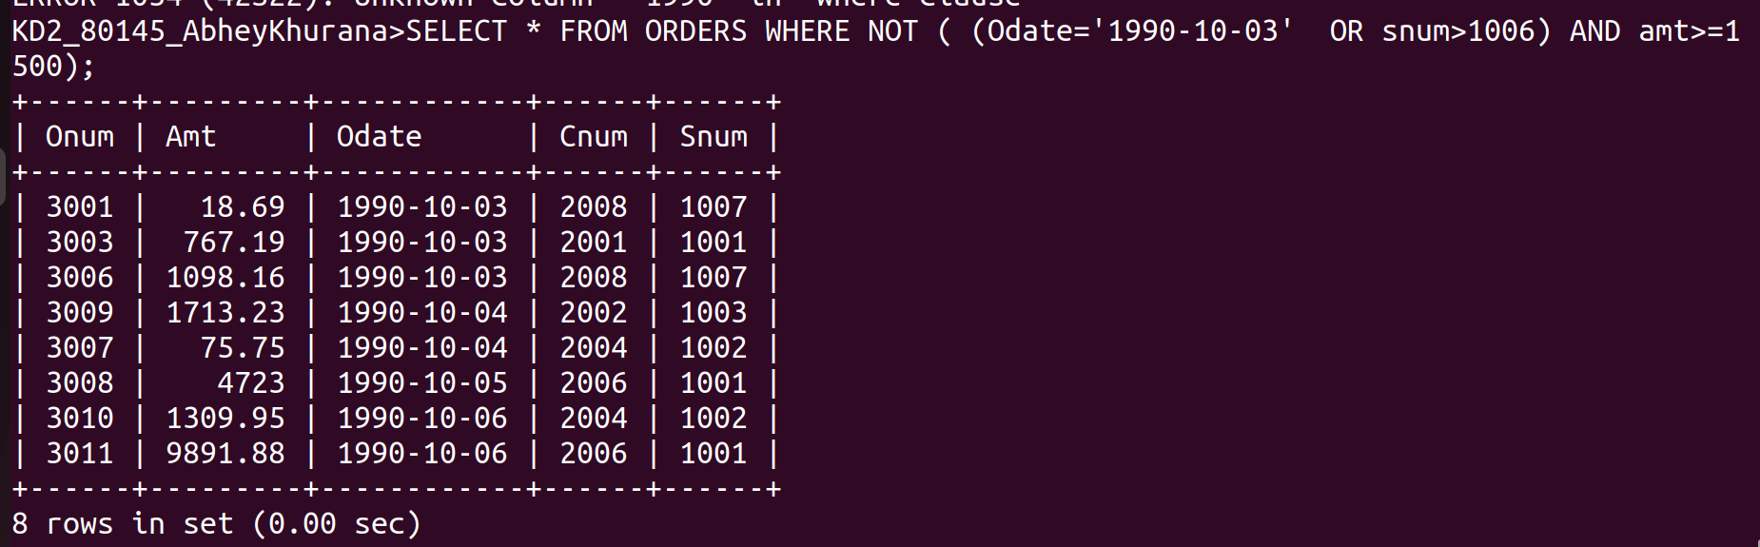

6. What is Simpler way to write this query?

SELECT snum, sname,city comm from Salespeople
WHERE comm>.12 OR comm<.14;

SELECT * FROM SALESPEOPLE;

AS according to the Query all rows will be selected;

